**Strings**

**(Advanced)**

1. Define the Trim() method in string’s methods

Ans: Trim() is a string method which removes all leading and trailing white spaces in a string. It can be overloaded by passing arguments in it. By passing arguments we can select which chars to trim.

Example: string. Trim();

string. Trim(“h”);

1. Define the Replace() method?

Ans: Replace() method is used to replace a certain chars to another set of chars in a string.

Example: string.Replace(“g”,”h”);

1. How to determine whether a string represents a numeric value?

Ans: using TryParse method we can determine whether a string contains a number or not. If the string contains nonnumeric characters or the numeric value is too large or too small for the particular type, TryParse returns false and sets out parameter to zero. Otherwise, it returns true and sets the out parameter to the numeric value of the string.

Example: int i =0;

string s = “89”;

bool result = int.TryParse(s, out i); // i=108

1. Write down the difference between Quoted string literals and Verbatim string literals.

Ans: Quoted string literals start and end with a single double quote character (") on the same line. Quoted string literals are best suited for strings that fit on a single line and don't include any escape sequences.

Example: string s = “hello”;

Verbatim string literals are more convenient for multi-line strings, strings that contain backslash characters, or embedded double quotes. Verbatim strings preserve new line characters as part of the string text. Use double quotation marks to embed a quotation mark inside a verbatim string.

Example: string s = @”hello

world”;

1. What is interpolated string?

Ans: It's a kind of template that lets you construct a single string (called the result string) from a string that includes embedded code. Interpolated string expressions are particularly useful for inserting values into a string or concatenating (joining together) several strings.

Example:

var name = "<name>";

Console.WriteLine($"Hello, {name}. It's a pleasure to meet you!");

1. How to remove duplicate characters in string?

Ans:

public class Program {

public static void Main()

{

Console.WriteLine("Enter a string");

string value = Console.ReadLine();

Console.WriteLine(RemoveDuplicateChars(value));

}

static string RemoveDuplicateChars(string key)

{

string table = "";

string result = "";

foreach (char value in key)

{

if (table.IndexOf(value) == -1)

{

table += value;

result += value;

}

} return result;}}

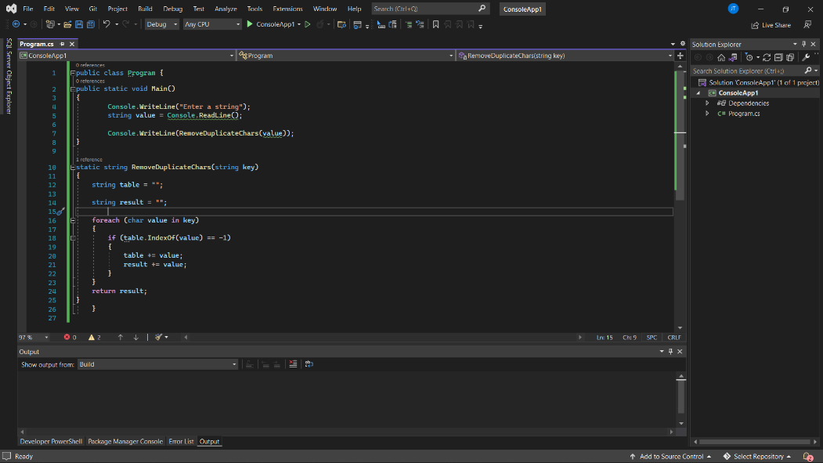

1. Write a program to replace spaces with “_”

Ans

public static class ReplaceSpace

{

public static string Replace(string s)

{

s = s.Trim();

s = s.Replace(" ", "_");

return s;

}

public static void Main()

{

Console.WriteLine("Enter a string");

string value = Console.ReadLine();

Console.WriteLine(Replace(value));

}

}

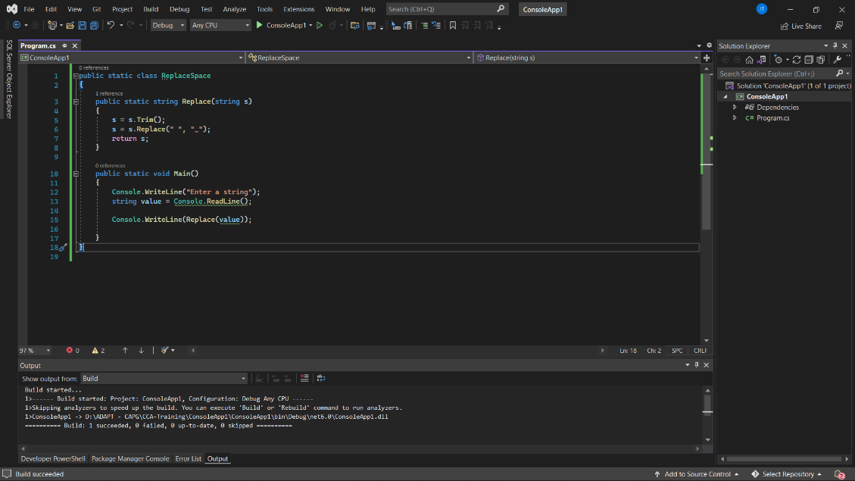

1. Write a program to return first unique character in a string

Ans

public class Program

{

public static void Main(string[] args)

{

Console.WriteLine("Enter a string");

string value = Console.ReadLine();

Console.WriteLine(FirstNonRepeatedChar(value));

}

public static char FirstNonRepeatedChar(string input)

{

bool isDuplicate;

for (int i = 0; i < input.Length; i++)

{

isDuplicate = false;

for (int j = 0; j < input.Length; j++)

{

if ((input[i] == input[j]) && i != j)

{

isDuplicate = true;

break;

}

}

if (!isDuplicate)

{

return input[i];

}

}

return default(char);

}

}

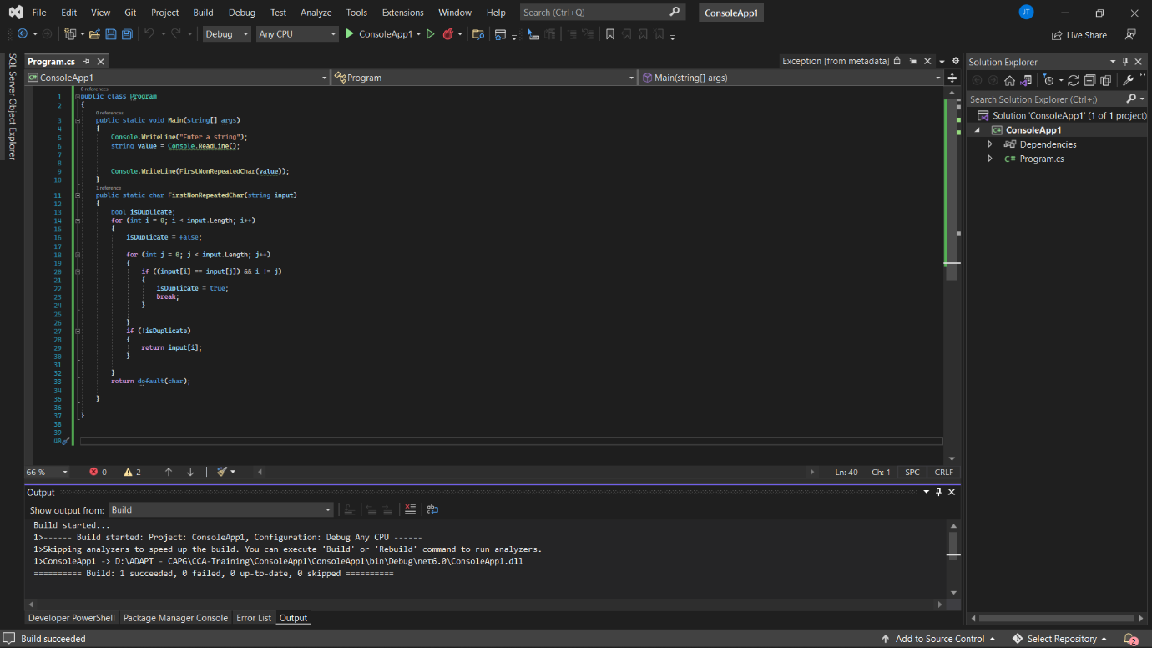

1. Write a code which takes string and shows the number of vowels and consonants

Ans:

public class Program

{

public static void Main(string[] args)

{

char[] sentence = new char[100];

int i, vowels = 0, consonants = 0, special = 0, n;

Console.WriteLine("Enter the Length of the sentence \n");

string value = Console.ReadLine();

n = value.Length;

value = value.ToUpper();

for (i = 0; i < n; i++)

{

sentence[i] = Convert.ToChar(value[i]);

}

for (i = 0; sentence[i] != '\0'; i++)

{

if ((sentence[i] == 'A' || sentence[i] == 'E' || sentence[i] ==

'I' || sentence[i] == 'O' || sentence[i] == 'U'))

{

vowels = vowels + 1;

}

else

{

consonants = consonants + 1;

}

if (sentence[i] == 't' || sentence[i] == '\0' || sentence[i] == ' ')

{

special = special + 1;

}

}

consonants = consonants - special;

Console.WriteLine("No. of vowels {0}", vowels);

Console.WriteLine("No. of consonants {0}", consonants);

Console.ReadLine();

}

}

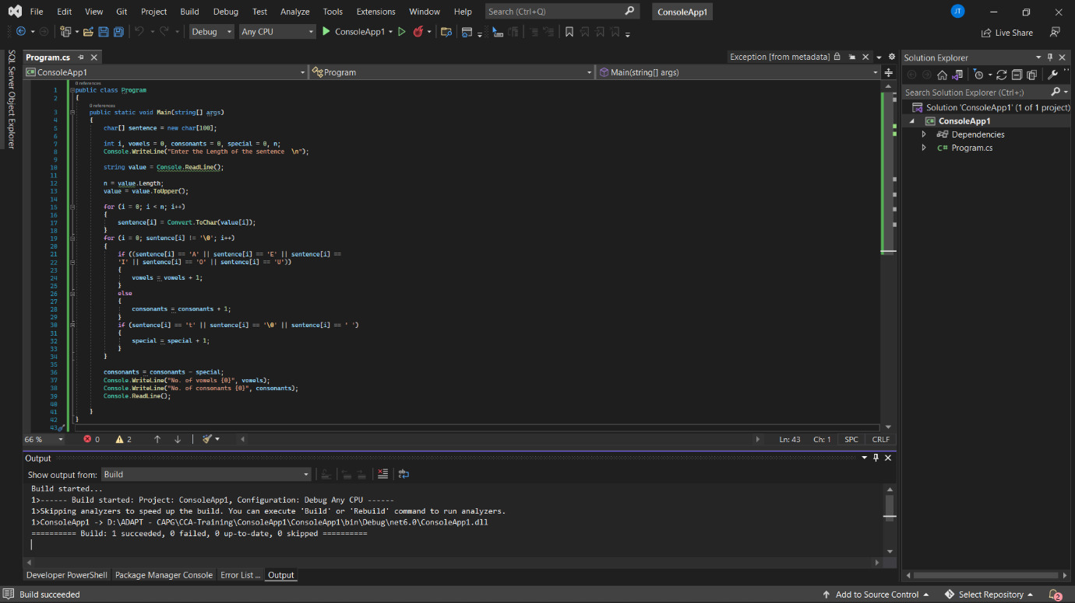

1. Write a code to find a excel column name with a given number

Ans:

class GFG

{

static String reverse(String input)

{

char[] reversedString = input.ToCharArray();

Array.Reverse(reversedString);

return new String(reversedString);

}

private static void printString(int columnNumber)

{

String columnName = "";

while (columnNumber > 0)

{

int rem = columnNumber % 26;

if (rem == 0)

{

columnName += "Z";

columnNumber = (columnNumber / 26) - 1;

}

else

{

columnName += (char)((rem - 1) + 'A');

columnNumber = columnNumber / 26;

}

}

columnName = reverse(columnName);

Console.WriteLine(columnName.ToString());

}

public static void Main(String[] args)

{

Console.WriteLine("Enter a value");

int value =0;

try

{

value = int.Parse(Console.ReadLine());

if(value == 0)

{

throw new Exception("enter a value greater than 0");

}

}

catch (Exception e)

{

Console.WriteLine(e.Message);

}

printString(value);

}

}

