4/5/2017

India interactive

32 Ajanta colony vibhav nagar

Advertisement Tax

Nagar Palika Parishad Mathura



Contents

Introduction 2

Main Functionality 2

1. Common to all user: 2

1.1 Registration 2

1.2 Login 2

1.3 Change Password 2

2. User- The Advertiser: 2

2.1 Application Form 3

3. Admin: 3

3.1 Maintain Different Type of Advertisement with details 3

3.2 Apply or update policies for Tax Rate 4

3.3 Add New Location 4

3.4 Update and Delete Location 5

3.5 View Report of Available locations 5

3.6 View Report of Reserved Locations 6

3.7 Report of illegal advertisement by mail 6

# Introduction

Nagar Palika Parishad Mathura apply some taxes for advertisement within its covered area. To accomplish the same task online Nagar Palika is going to start an online portal. This document included all the points going to be considered for this online portal. Any User who wants to submit their application for the advertisement can login into the system and apply for the same, no need to go anywhere, one click facility will provided to them.

# Main Functionality

A brief explanation of overall process is as follows:

## Common to all user:

### Registration

Registration is a familiar process, any user first required to be registered on the portal with some personal details such as Name, Current Address, Mobile Number etc. otherwise he may not get the access to this portal. After registration he get a User ID and Password generated by the system. He may change the password later but not User ID as it is fix and unique for all the user.

### 1.2 Login

To get enter into the system one has to be first login on the portal with his User ID and Password generated at the time of registration.

### 1.3 Change Password

If someone wants to change his password later, then here is a provision for change password. He can submit a form with his old and new password for the same.

## User- The Advertiser:

Advertiser is the one who submit application to place advertisement within the area of Nagar Palika Parishad. Todays, all the application can be submitted by means of an offline process. The main target of the following application is to provide an online portal by which all of these user can apply using internet without going to anywhere and can choose particular locations and type of advertisement to place their advertisement.

### 2.1 Application Form

This is the main part of the application, from where one can submit application to take permission for advertisement within the area of Nagar Palika. The details to be filled in this form with main functionality are as follows:

* Personal details of the advertiser, such as Name of the Owner, Title or name of the firm for which he wants to publish an advertisement, address, mobile number etc.
* Choose the type of advertisement such as want to place holding, banner, wall paint etc.
* Choose different locations from drop down list where he wants to place advertisement. A map will also be shown to him displaying definite location.
* Once he choose locations, a list of all holdings or any other way of advertisement allowed on that location will displayed to him.
* This list include available as well as reserved locations for advertisement.
* If someone want a particular location for his advertisement, which is reserved at that time, than he can view the details such as when that location going to be available.
* He can choose multiple locations along with different type of advertisement with variant sizes.
* After selection of different locations, he may submit his selection and total amount can be calculated based on the size and will display to him.
* He can pay this amount to finally get the location to place his advertisement. After that these locations are change to reserve.

## Admin:

Admin is the main user, The Administrator. All the administrative tasks are the responsibility of him. Some of the responsibilities and functionality handled by him are explain as follows:

### 3.1 Maintain Different Type of Advertisement with details

For Advertisement one can use many different ways to advertise such as he can place a holding or he can put a wall paint etc.

Nagar Palika Parishad Mathura gives permission to advertise for the following types.

1. Holdings
2. Cloth Banner
3. Paper Poster
4. Wall Paint
5. Uni-pole / Gate Entry
6. Pole Cross

### 3.2 Apply or update policies for Tax Rate

Admin can add or update tax rate of different advertisement based on the type of advertisement such as, is it a holding or banner, and based on the sizes, size of holding having size 8 square meter or 2 square meter likewise.

For example, Current tax rate decided by the Nagar Palika are as follows.

|  |  |  |  |  |
| --- | --- | --- | --- | --- |
| **S. No.** | **Size Details** | **Yearly Tax** | **Monthly Tax** | **Daily Tax** |
| 1 | Size 8 square meter | 4000 | 600 | 30 |
| 2 | Size 4 square meter | 2500 | 500 | 20 |
| 3 | Size 2 square meter | 2000 | 300 | 16 |
| 4 | Size 1 square meter | 1000 | 200 | 12 |
| 5 | Each Cloth Banner | 1200 | 150 | 08 |
| 6 | Paper Poster | 500 | - | - |
| 7 | Wall Paint Square meter | 500 | - | - |
| 8 | Uni-Pole / Gate Entry 8 square meter | 6000 | 800 | 40 |
| 9 | Pole Cross | 2400 | 300 | 20 |

### 3.3 Add New Location

If Nagar Palika have decided and declare a new location for advertisement than an Admin can add details of that location into the system. For Example if Nagar Palika allow a new holding to place at XYZ location, than Admin have to be add this location with all details such as location name and address, location Map, Holding size (length and width) etc.

It might be possible that one location have multiple number of different source of advertisement, for example, one location have 5 different source of advertisement like 3 holdings and 2 banner with different sizes of 3 holding like one is of size 20 X 30, another is of size 20 X 20 and third one is of size 10 X 20.

To do the same admin can follow these steps:

* First of all he may enter name of the location
* Declare total number of source of advertisement
* Add details of each source such as type (for example it is a banner, holding or wall paint etc.) and size (for example holding is of 20 X 20 or 30 X 20 etc.)
* Upload Map of that location (sample of map is shown in image below)
* Finally Save these details and add the location.

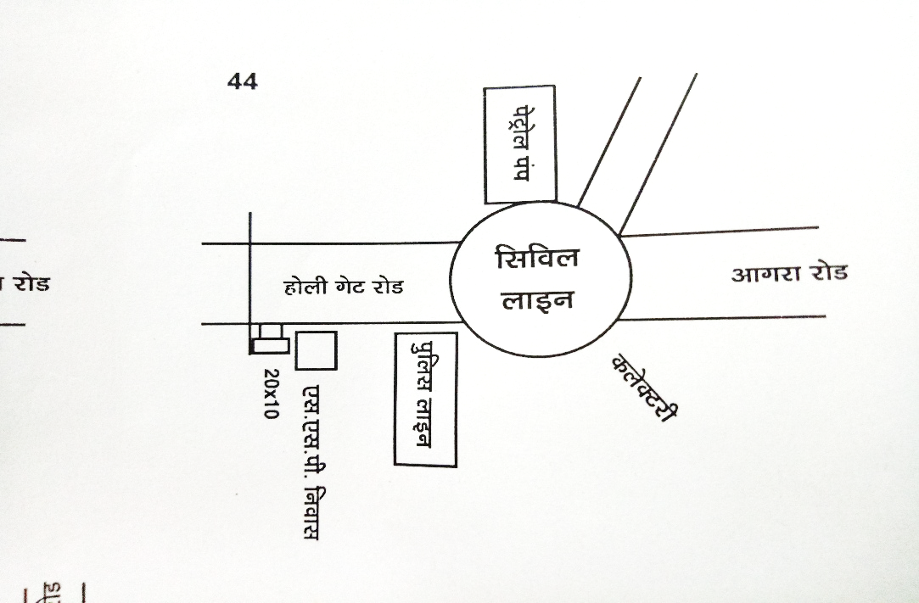

### 3.4 Update and Delete Location

If location will changed for any than an admin can update details of that particular location with location Map. Admin also have the rights to delete any particular location as and when it going to be removed.

Steps are as follows:

* Search and Select the location want to update
* Update the details accordingly
* Upload new map according to updated details
* Save and update the location.

### 3.5 View Report of Available locations

Admin can view the report of all available locations according to places and sizes. For Example, if there are 3 different location having 2, 3 and 4 holdings respectively than Admin can view a report with details that each location have 2, 3 or 4 number of holdings respectively. Similarly, if 3 holdings are available on a specific location, Admin can view the report of these three according to 3 different sizes.

To view the report follow these steps:

* It is the one click process specify area or location or select all to view all available source
* According to your selection, details are drawn containing total number of source available at that location with all sub details like type of source and size.

### 3.6 View Report of Reserved Locations

Admin can view the report of reserved locations with all details according to places as well as firm by which they reserved. For Example, if there are 3 holdings are situated at any location and 2 are reserved from them than a report is generated having details of number of reserved holding out of total number of present holding at each and every location.

Similarly, Admin can view a report of reserved locations by any specific firm or person. For Example, if a particular firm have reserved holdings at 20 different locations, a report is generated having a list of these locations with details of each holding such as size.

To view the report follow these steps:

* Specify area or location or select all to view all reserved source
* Choose name of the particular firm or select all to view details of all
* According to your selection, details are drawn containing total number of source reserved by a particular firm at that location with all sub details like type of source and size.

### 3.7 Report of illegal advertisement by mail

When a location is allocated to someone a unique number is assigned to him for each and every advertisement, and it is compulsory to display that number with advertisement. If that number is not display with advertisement, that particular advertisement is declared illegal. If employees of Nagar Palika report an advertisement illegal, it takes some action against those illegal advertisement. To follow this process online by means of this portal, an enquiry form is given for the employee. He can fill the details of illegal advertisement and an auto generated mail is send to Admin.

Employee of Nagar Palika who want to submit enquiry against illegal advertisement follow this steps:

* Fill the details of illegal advertisement in enquiry form
* Enter the location where advertisement
* Give at least one reason why advertisement is illegal
* Send enquiry by clicking on the submit button.
* A mail is automatically send onwards.