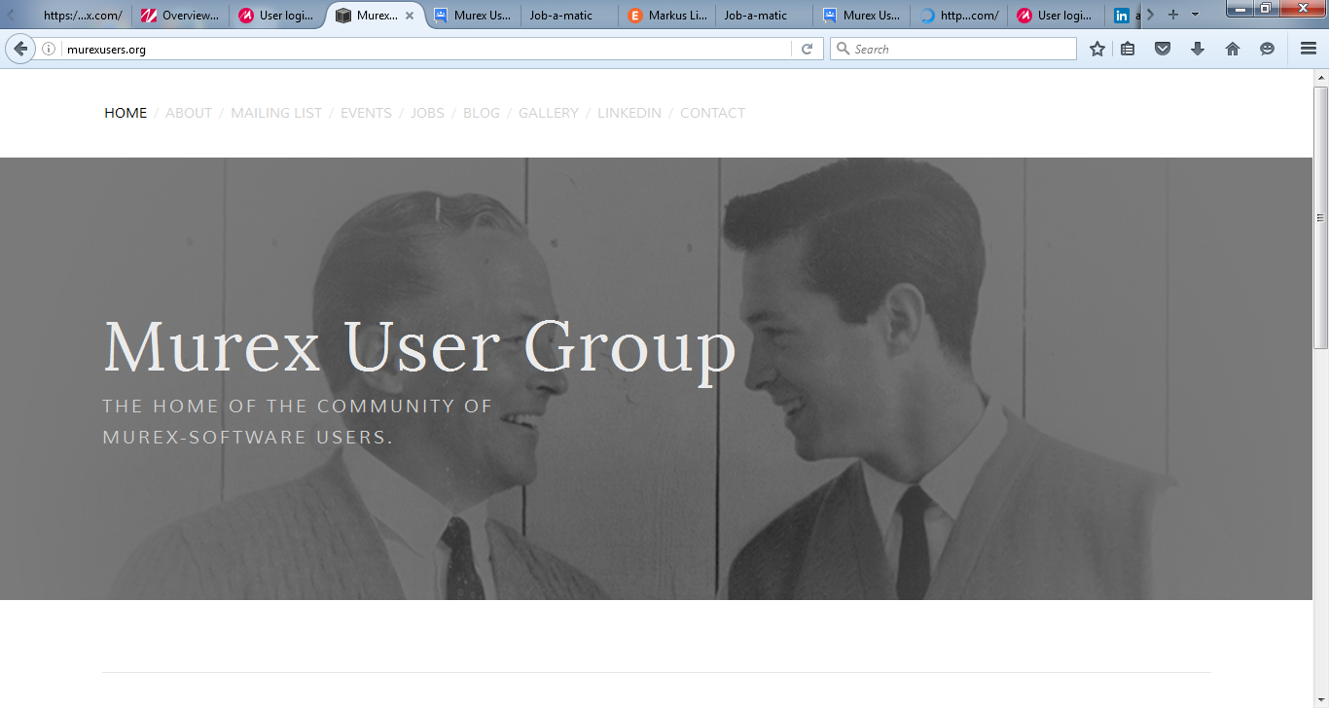

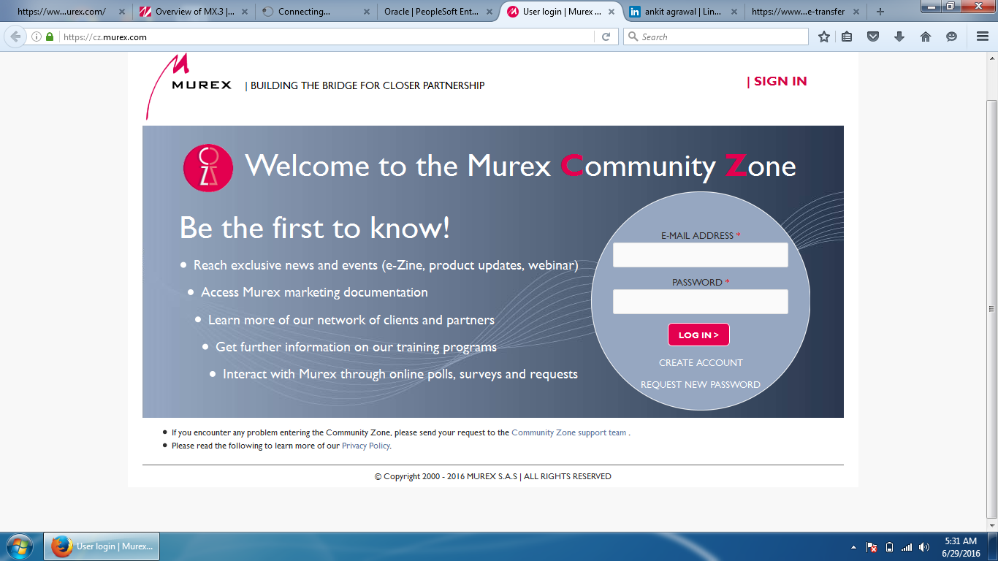

IdoMurex

Welcome to the Murex Consultants World.

iDoMurex.com is a single repository of Murex configuration experts across the globe. The goal of the site is to allow registered members to document their Mx work experience into this single database so that hiring managers & companies can view their profiles easily and connect directly with them.

Not everyone is at ease with LinkedIn Groups, innumerable job portals and I, myself as a Murex consultant, finds it very hard where to update my profile and the same goes for hiring managers. This leaves no option but to contact recruiters worldvide to source Mx Talent.  
You can find a sample of the existing vacancies we have under the 'Jobs' tab located next to 'Conversations'  
This is not a job portal site where we will post murex jobs but rather a single database of Murex configuration experts. It would become easy for hiring managers to see your Mx experience through our website.

Please note that there are restrictions if you are not working hands-on with Murex-software. [Contact us](mailto:markus.linke@linke.de) before you register

