DSC 140B Final Project Report
Human Baseline
Add your human accuracy from the SoCalGuessr game here.
Insert your screenshot of the confusion matrix here.
Add a short note about what visual cues were easiest or hardest for you as a human player.
Final Model Architecture
My final model is a convolutional neural network based on MobileNetV3-Small with transfer learning. I used the ImageNet-pretrained MobileNetV3-Small backbone from torchvision and replaced the final classifier so that the network predicts one of the six SoCalGuessr classes: Anaheim, Bakersfield, Los_Angeles, Riverside, SLO, and San_Diego. The input images were resized to 224 x 384, which preserves the panoramic shape of the Street View images better than forcing them into a square image.
Required architecture details:
- Number of hidden layers: the classifier head has 1 hidden linear layer.
- Units in each hidden layer: the hidden layer has 1024 units.
- Number of parameters: the full model has 1,524,006 parameters.
- Activations used: the backbone uses ReLU, Hardswish, and Hardsigmoid, and the classifier head uses Hardswish.
In terms of hidden layers, the network contains the standard MobileNetV3-Small feature extractor followed by a two-layer classifier head. The classifier head has one hidden linear layer with 1024 units and one output layer with 6 units. After the convolutional backbone, the model applies adaptive average pooling, then a fully connected layer from 576 features to 1024 hidden units, followed by the final linear layer from 1024 to 6 logits.
The model has 1,524,006 total parameters. The activations used in the network are primarily ReLU and Hardswish inside the MobileNetV3-Small backbone, along with Hardsigmoid inside the squeeze-and-excitation blocks. In the classifier head, I used a Hardswish activation after the hidden linear layer. I also used Dropout(p = 0.2) before the final output layer as regularization.
The final prediction pipeline also uses multi-view test-time augmentation. For each image, the model makes predictions on six views: the resized image, a horizontally flipped version, a left crop, a flipped left crop, a right crop, and a flipped right crop. The logits from these six views are averaged before taking the final class prediction. This does not change the number of model parameters, but it improves accuracy by making the final prediction less sensitive to the exact framing of the panorama.
I chose MobileNetV3-Small because it is compact enough to stay far below the project's 50 MB size limit while still being expressive enough to learn useful visual cues from Street View images. The saved weight file for the final model is about 5.9 MB, and the final submission zip is still comfortably below the 50 MB limit.
Training Procedure
I trained the model in PyTorch using the AdamW optimization algorithm. The loss function was cross-entropy loss with label smoothing set to 0.05. I trained on the provided labeled image set and created a stratified validation split containing 20% of the data so that each city remained roughly equally represented in both the training and validation sets.
Required training details:
- Training algorithm: AdamW.
- Loss function: cross-entropy loss with label smoothing 0.05.
- Training time: about 165.03 seconds total, or about 2.75 minutes.
- Training curve: included below, showing epoch number versus empirical risk.
Before feeding images into the model, I resized them to 224 x 384 and normalized them using the standard ImageNet channel means and standard deviations. During training, I applied data augmentation using random resized crops, random horizontal flips, and mild color jitter. These augmentations were intended to reduce overfitting and help the model become less sensitive to small visual changes across locations.
For the run used to create the final weights, I trained for 3 epochs with batch size 128. I used a learning rate of 3e-4, weight decay of 1e-4, and a cosine annealing learning-rate schedule. During this run, I froze the pretrained backbone and trained the classifier head. The full training run took about 165.03 seconds total, which is approximately 2.75 minutes. The epoch times were about 62.40, 50.95, and 51.45 seconds respectively.
The training curve showed a steady decrease in empirical risk across epochs. The training loss decreased from 1.4451 in epoch 1 to 0.9435 in epoch 3, while the validation loss decreased from 1.2694 to 0.9368. Validation accuracy also improved steadily from 54.60% to 69.95% to 72.84%. This suggests that the model learned meaningful geographic features quickly and that transfer learning was important for getting strong performance with a relatively small network and a short training time.
After training, I evaluated the saved checkpoint with stronger inference-time averaging. A simple horizontal-flip average improved the validation score slightly, and the final six-view multi-view inference setup improved validation accuracy to 73.33%. I also experimented with a stronger EfficientNet-B0 backbone, but it performed worse on the validation split than MobileNetV3-Small, so I kept the MobileNet model as the final submission.
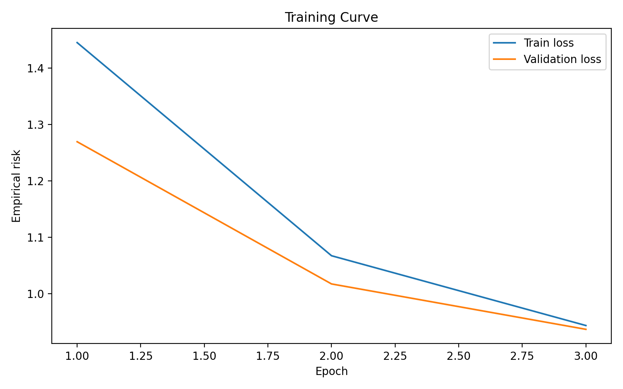
Training curve for the final MobileNetV3-Small training run.

