**#2**

INCLUDE Irvine32.inc

.data

start Dword 1

chars Byte "H","A","C","E","B","D","F","G"

links Dword 0,4,5,6,2,3,7,0

charscopys Byte lengthof chars DUP(0)

linkscopys Dword lengthof links DUP(0)

datatype dword ?

.code

main PROC

;先印一次原本順序char

mov esi ,offset chars

mov ecx,lengthof chars

mov ebx,type chars

call dumpmem

;取址

mov esi,offset chars

mov edi,offset charscopys

mov ebx,type charscopys

;呼叫procedure

call correctChar

;印出變更後的

mov esi,offset charscopys

mov ecx,lengthof charscopys

mov ebx,Type charscopys

call Dumpmem

;先印一次原本順序links

mov esi ,offset links

mov ecx,lengthof links

mov ebx,type links

call dumpmem

mov esi,offset links

mov edi,offset linkscopys

mov ebx,type links

call correctLink

;印出變更後的

mov esi,offset linkscopys

mov ecx,lengthof linkscopys

mov ebx,Type linkscopys

call Dumpmem

call waitmsg

exit

main ENDP

correctChar PROC

mov datatype,ebx

mov eax,[esi+1]

mov [edi],eax

inc edi

mov eax,[esi+4]

mov [edi],eax

inc edi

mov eax,[esi+2]

mov [edi],eax

inc edi

mov eax,[esi+5]

mov [edi],eax

inc edi

mov eax,[esi+3]

mov [edi],eax

inc edi

mov eax,[esi+6]

mov [edi],eax

inc edi

mov eax,[esi+7]

mov [edi],eax

inc edi

mov eax,[esi+0]

mov [edi],eax

ret

correctChar Endp

correctLink PROC

mov datatype,ebx

mov eax,[esi+1*4]

mov [edi],eax

add edi,4

mov eax,[esi+4*4]

mov [edi],eax

add edi,4

mov eax,[esi+2*4]

mov [edi],eax

add edi,4

mov eax,[esi+5*4]

mov [edi],eax

add edi,4

mov eax,[esi+3*4]

mov [edi],eax

add edi,4

mov eax,[esi+6*4]

mov [edi],eax

add edi,4

mov eax,[esi+7*4]

mov [edi],eax

add edi,4

mov eax,[esi+0]

mov [edi],eax

ret

correctLink Endp

END main

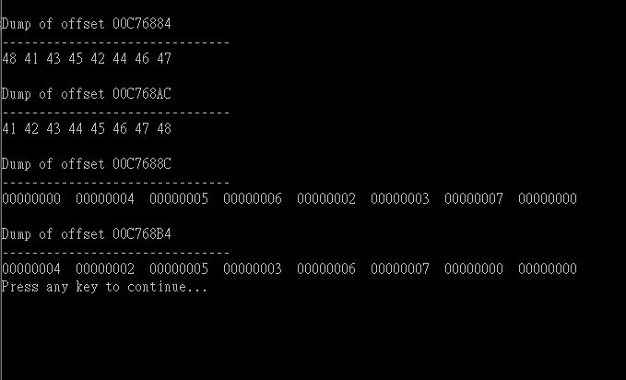

**#5**

INCLUDE Irvine32.inc

.data

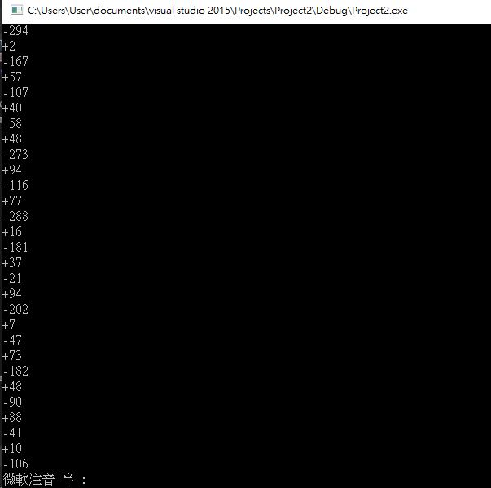.code

main PROC

mov ecx,50

L1:

mov ebx,-300

mov eax,100

call betterrandomrange

LOOP L1

call waitmsg

exit

main ENDP

BetterRandomRange ProC

mov eax,ebx

neg eax

call randomrange

neg eax

call writeInt

call crlf

mov eax,100

call randomrange

call writeint

call crlf

ret

BetterRandomRange EndP

END main

**#7**

INCLUDE Irvine32.inc

.data

rows byte ?

cols byte ?

Drows Dword ?

Dcols Dword ?

.code

main PROC

mov ecx,100

L1: call getmaxxy

mov rows,al

movzx eax,al

mov cols,dl

movzx edx,dl

movzx eax,al

call randomrange

mov Drows,eax

movzx eax,dl

call randomrange

mov Dcols,eax

mov dh,BYTE PTR Drows

mov dl, BYTE PTR Dcols

call gotoxy

mov al,"A"

call writechar

mov eax,100

call delay

Loop L1

call waitmsg

exit

main ENDP

END main

