Google Codelab Completion Guide

Overview
This document can be referenced to see how successful completion of the Google Codelab: Build and Deploy an ADK Agent on Cloud Run looks like. The following steps were completed end-to-end, including environment setup, agent development, Cloud Run deployment, testing, and resource cleanup.

Step 1 : Project Setup & Credits
The Google Cloud project 'agentdeployzoo' was created and the TryGCP Instrumentless credit ($5.00, one-time) was confirmed as available with 100% remaining. This credit was used to cover all compute and Cloud Run costs during the lab.

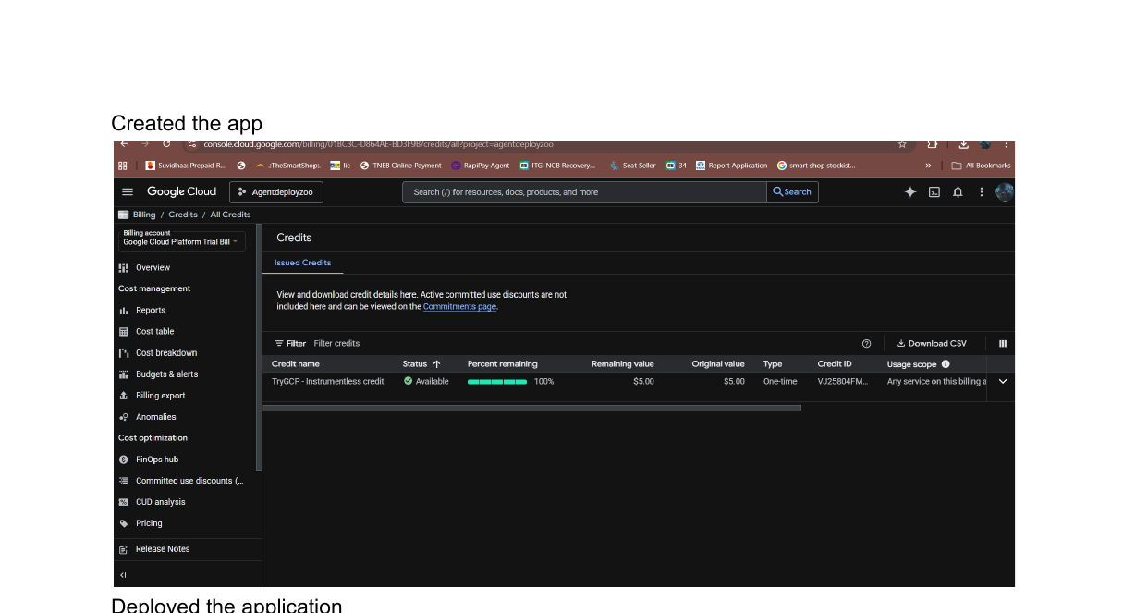
Google Cloud Billing — TryGCP credit ($5.00) confirmed available

Step 2 : Application Deployment to Cloud Run
The zoo guide agent application was built using the Agent Development Kit (ADK) and containerized with Docker. The container was deployed to Cloud Run via the ADK CLI. Key deployment details:
- Service name: zoo-tour-guide
- Service URL: https://zoo-tour-guide-1062518094918.europe-west1.run.app
- Revision: zoo-tour-guide-00001-frq — serving 100% of traffic
- Unauthenticated invocations: Allowed (y)

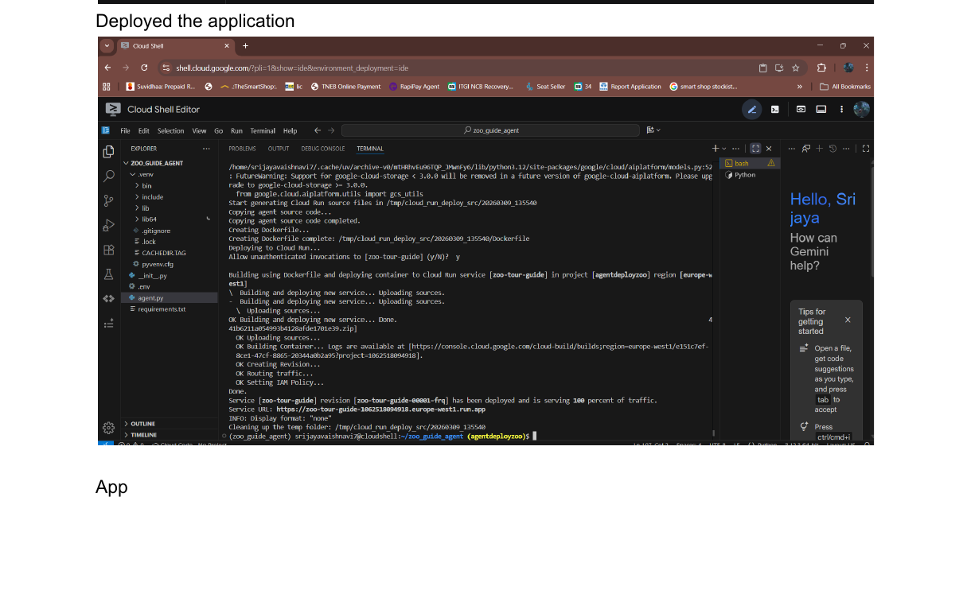
Cloud Shell — successful Docker build and Cloud Run deployment

Step 3 : Agent Testing in ADK Dev UI
The deployed agent was tested through the Agent Development Kit Dev UI. A session was initiated and the agent was queried about zoo animals. The agent correctly:
- Greeted the user and offered zoo information
- Called tools: add_prompt_to_state, transfer_to_agent, wikipedia
- Answered the query about polar bears' diet by fetching Wikipedia data

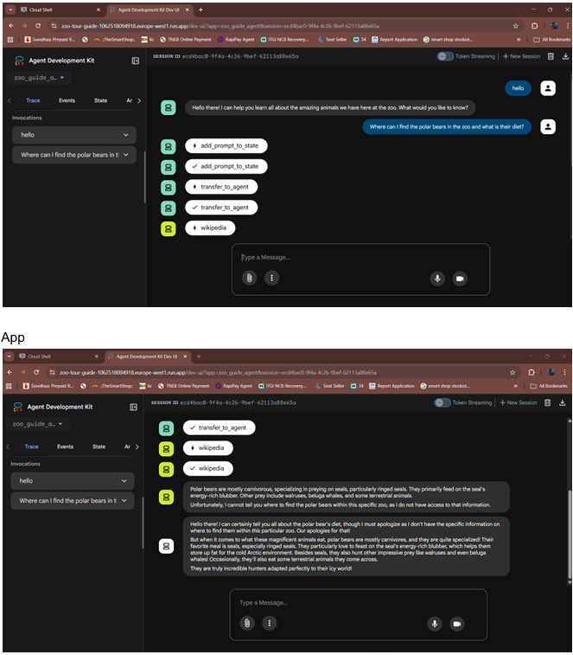
ADK Dev UI — agent responding to polar bear query with tool invocations visible

Step 4 : Resource Cleanup
After successful testing, all provisioned resources were deleted to avoid ongoing charges. The cleanup commands executed:
- gcloud run services delete zoo-tour-guide --region europe-west1 --quiet
- gcloud artifacts repositories delete cloud-run-source-deploy --location europe-west1 --quiet

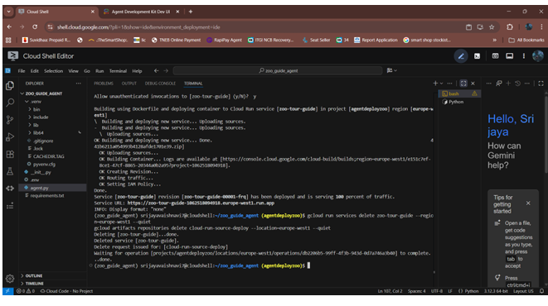
Cloud Shell — resource deletion confirmed (service and artifact repo removed)

Step 5 : Codelab Completion
The codelab was successfully completed, including all steps and the final survey. The completion screen verified the lab's finish.

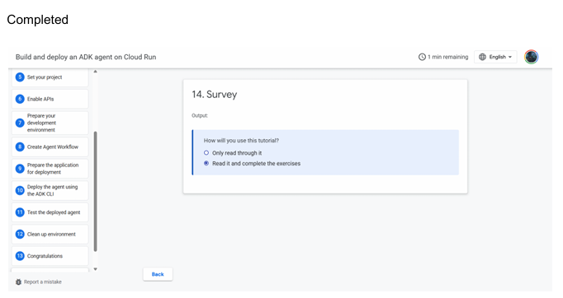
Codelab completion screen — all steps checked, survey submitted

Step 6 : Share your screenshot
Share any one of these screenshot on the Hack2skill Platform. Please complete all 14 required steps of the Codelab that you are attempting and submit the screenshot (as shared above - of the terminal or of the testing step) on the Hack2skill platform.

Running App:


Submit here in the Forms Tab:
For Build and deploy an ADK agent on Cloud Run
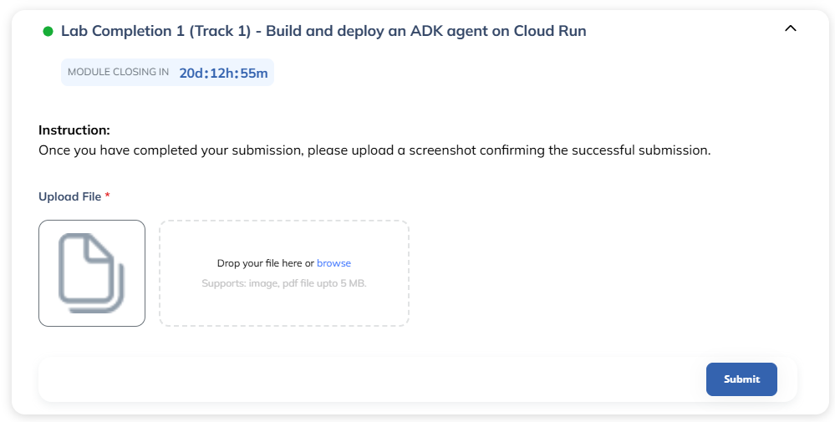

For Building AI Agent with ADK: The Foundation
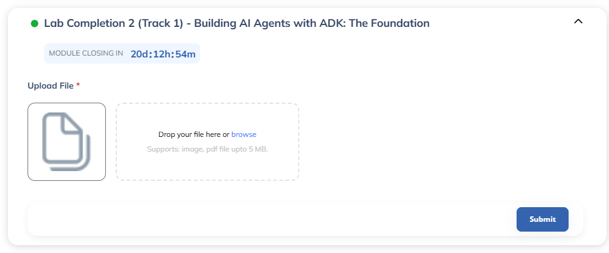

Please complete all 14 required steps of the Codelab that you are attempting and submit the screenshot (as shared above - of the terminal or of the testing step) on the Hack2skill platform.

