Worksheet 05

**Story Teller II**

# Preparing the setup

1. Download the folder C273_L05StoryTeller from LEO and place it in the htdocs folder on your laptop.
2. Using NetBeans, create a new PHP Project (with existing sources) titled **C273_L05StoryTeller** that points to the folder above.
3. Start phpmyadmin from XAMPP, and make sure that the database c203_p13 is still there. If you do not have that database, create it and import the tables and data using the sql file c203_p13.sql provided in your problem package.
4. Follow the instructions in the document **Web templates with jQuery.docx** in LEO “Resources” Learning Path, to create an offline Bootstrap web project (Step 1-5)
5. Your project structure should look like below:

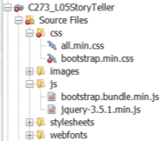

# Navs

#### This section of the worksheet shows you how to create Bootstrap navigation controls.

Resource:  [https://www.youtube.com/watch?v=YRLOf5V1eHoI](https://www.youtube.com/watch?v=ew8Wj4URVnI) [12:55 mins]

<https://www.w3schools.com/bootstrap4/bootstrap_navs.asp>

<https://getbootstrap.com/docs/4.1/components/navs/>

1. **TODO:** Create a new html file called **1_navs.html**. In order to use any Bootstrap components, you need to include 3 links to external resources:

|  |  |
| --- | --- |
| **1**  **2**  **3** | <link href="css/bootstrap.min.css" rel="stylesheet" type="text/css"/>  <script src="js/jquery-3.5.1.min.js" type="text/javascript"></script>  <script src="js/bootstrap.bundle.min.js" type="text/javascript"></script> |

Line 1 – Link the bootstrap css file to the current document in order to adopt Bootstrap’s look and feel

Line 2,3 – Bootstrap javascript file (bootstrap.bundle.min.js in Line 3) requires jQuery libraries thus the need to use jquery.min.js

1. Copy and paste the code below.

|  |  |
| --- | --- |
| **1**  **2**  **3**  **4**  **5**  **6**  **7**  **8**  **9**  **10**  **11**  **12**  **13**  **14** | <ul class="nav">  <li class="nav-item">  <a class="nav-link active" href="#">Active</a>  </li>  <li class="nav-item">  <a class="nav-link" href="#">Link</a>  </li>  <li class="nav-item">  <a class="nav-link" href="#">Link</a>  </li>  <li class="nav-item">  <a class="nav-link disabled" href="#">Disabled</a>  </li>  </ul> |

Line 1 – create a simple horizontal menu, add the .nav class to a <ul> element. Add the .flex-column class to create a vertical nav.

Line 2-13 – Add links by adding the .nav-item class for each <li> and add the .nav-link class to their links.

1. Run the file and make your observations.

Try the following exercises:

**Exercise 1**

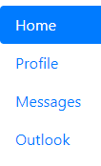

|  |
| --- |
| Copy & paste your code here  <html lang="en" dir="ltr">  <head>  <meta charset="utf-8">  <title></title>  <link href="css/bootstrap.min.css" rel="stylesheet" type="text/css" />  <script src="js/jquery-3.5.1.min.js" type="text/javascript"></script>  <script src="js/bootstrap.bundle.min.js" type="text/javascript"></script>  <script>  $(document).ready(function() {  $(".nav-item").mouseover(function() {  $(this).addClass("bg-primary")  }).mouseout(function(){  $(this).removeClass("bg-primary");  });  });  </script>  </head>  <body>  <ul class="nav flex-column">  <li class="nav-item">  <a class="nav-link active" href="#">Home</a>  </li>  <li class="nav-item">  <a class="nav-link" href="#">Profile</a>  </li>  <li class="nav-item">  <a class="nav-link" href="#">Message</a>  </li>  <li class="nav-item">  <a class="nav-link" href="#">Outlook</a>  </li>  </ul>  </body>  </html> |

**Exercise 2**

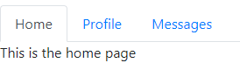

|  |
| --- |
| Copy & paste your code here  <html lang="en" dir="ltr">  <head>  <meta charset="utf-8">  <title></title>  <link href="css/bootstrap.min.css" rel="stylesheet" type="text/css" />  <script src="js/jquery-3.5.1.min.js" type="text/javascript"></script>  <script src="js/bootstrap.bundle.min.js" type="text/javascript"></script>  <script>  $(document).ready(function() {  $(".nav-item").mouseover(function() {  $(this).addClass("bg-primary");  $("#message").html(`This is a ${$(this).text()} page`);  }).mouseout(function(){  $(this).removeClass("bg-primary");  $("#message").html("");  });  });  </script>  </head>  <body>  <ul class="nav">  <li class="nav-item">  <a class="nav-link active" href="#">Home</a>  </li>  <li class="nav-item">  <a class="nav-link" href="#">Profile</a>  </li>  <li class="nav-item">  <a class="nav-link" href="#">Message</a>  </li>  <li class="nav-item">  <a class="nav-link" href="#">Outlook</a>  </li>  </ul>  <div id="message"></div>  </body>  </html> |

# Navbar

#### Navbars are responsive meta components that serve as navigation headers for your application or site.

**Resources**: <https://getbootstrap.com/docs/4.1/components/navbar/>

<https://www.w3schools.com/bootstrap4/bootstrap_navbar.asp>

1. **TODO:** Create a new html file called **2_navbar.html**. Make sure the links to the bootstrap.min.css, jquery-3.5.1.min.js and bootstrap.bundle.min.js are in the <head> section of the html file.
2. Copy and paste the code below.

|  |  |
| --- | --- |
| **1**  **2**  **3**  **4**  **5**  **6**  **7**  **8**  **9**  **10**  **11**  **12**  **13**  **14**  **15**  **16**  **17**  **18**  **19**  **20**  **21**  **22**  **23**  **24**  **25**  **26**  **27**  **28**  **29**  **30**  **31**  **32**  **33**  **34** | <nav class="navbar navbar-expand-lg navbar-light bg-light">  <a class="navbar-brand" href="#">Navbar</a>  <button class="navbar-toggler" type="button" data-toggle="collapse" data-target="#navbarSupportedContent">  <span class="navbar-toggler-icon"></span>  </button>  <div class="collapse navbar-collapse" id="navbarSupportedContent">  <ul class="navbar-nav mr-auto">  <li class="nav-item active">  <a class="nav-link" href="#">Home</a>  </li>  <li class="nav-item">  <a class="nav-link" href="#">Link</a>  </li>  <li class="nav-item dropdown">  <a class="nav-link dropdown-toggle" href="#" id="navbarDropdown" data-toggle="dropdown">  Dropdown  </a>  <div class="dropdown-menu">  <a class="dropdown-item" href="#">Action</a>  <a class="dropdown-item" href="#">Another action</a>  <div class="dropdown-divider"></div>  <a class="dropdown-item" href="#">Something else here</a>  </div>  </li>  </ul>  <form class="form-inline">  <input class="form-control" type="search" placeholder="Search">  <button class="btn btn-outline-success" type="submit">Search</button>  </form>  </div>  </nav> |

Line 1 – A standard navigation bar is created with the .navbar class, followed by a responsive collapsing class: .navbar-expand-xl|lg|md|sm (stacks the navbar vertically on extra large, large, medium or small screens). To create a black navigation bar, change the class bg-light to **bg-dark** and navbar-light to **navbar-dark**. To make the navigation bar fixed at the top/bottom, add the class **fixed-top** or **fixed-bottom**

Line 2 – The .navbar-brand class is used to highlight the brand/logo/project name of your page

Line 3-6: Creates a collapsible navigation bar that shows  on small screens. Use a button with class="navbar-toggler", data-toggle="collapse" and data-target="#thetarget". Then wrap the navbar content (links, etc) inside a div element with class="collapse navbar-collapse", followed by an id that matches the data-target of the button: "thetarget".

Line 9-28 – Menu items are placed here within the <ul> element with class="navbar-nav mr-auto". mr-auto means margin on the right automatically takes up all the remaining space, resulting in a left-justified alignment. To add links inside the navbar, add <li> elements with a .nav-item class followed by an <a> element with a .nav-link class.

Line 29-32: Add a <form> element with class="form-inline" to group inputs and buttons side-by-side.

1. Run the file and make your observations.

Copy **2_navbar.html** and paste as **exercise3.html** and try the following exercise:

**Exercise 3**





|  |
| --- |
| Copy & paste your code here  <html lang="en" dir="ltr">  <head>  <meta charset="utf-8">  <title></title>  <meta name="viewport" content="width=device-width, initial-scale=1">  <link href="css/bootstrap.min.css" rel="stylesheet" type="text/css" />  <script src="js/jquery-3.5.1.min.js" type="text/javascript"></script>  <script src="js/bootstrap.bundle.min.js" type="text/javascript"></script>  </head>  <body>  <nav class="navbar navbar-expand-lg navbar-dark bg-dark">  <a class="navbar-brand" href="#">My World</a>  <button class="navbar-toggler" type="button" data-toggle="collapse" data-target="#navbarSupportedContent">  <span class="navbar-toggler-icon"></span>  </button>  <div class="collapse navbar-collapse" id="navbarSupportedContent">  <ul class="navbar-nav ml-auto">  <li class="nav-item active">  <a class="nav-link" href="#">Home</a>  </li>  <li class="nav-item">  <a class="nav-link" href="#">About</a>  </li>  <li class="nav-item">  <a class="nav-link" href="#">Service</a>  </li>  <li class="nav-item">  <a class="nav-link" href="#">Contact</a>  </li>  </ul>  </div>  </nav>  </body>  </html> |

Copy **2_navbar.html** and paste as **exercise4.html** and try the following exercises:

**Exercise 4**

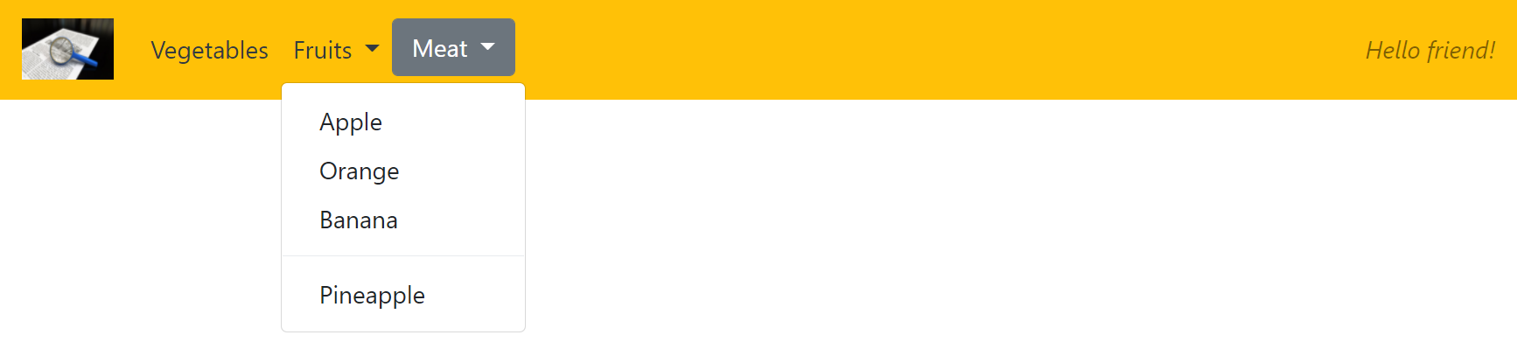

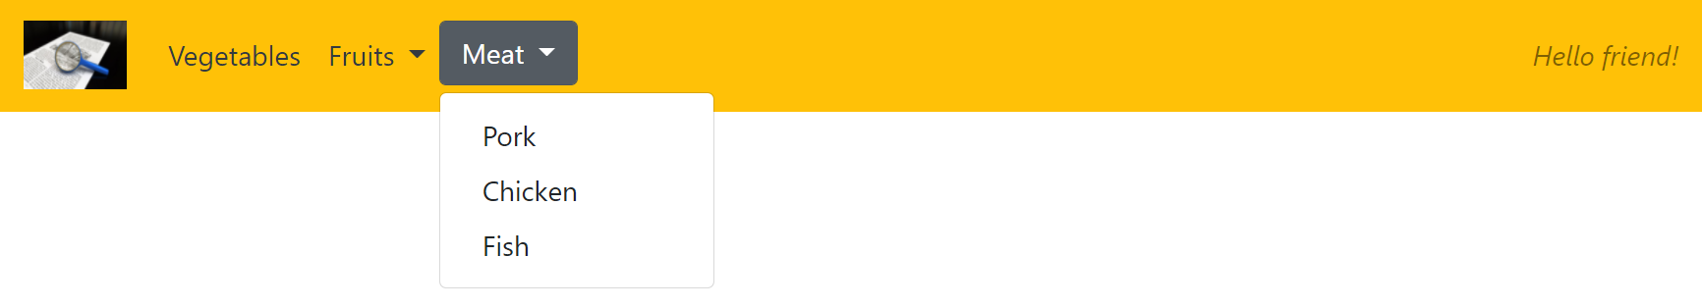



|  |
| --- |
| Copy & paste your code here  <html lang="en" dir="ltr">  <head>  <meta charset="utf-8">  <title></title>  <link href="css/bootstrap.min.css" rel="stylesheet" type="text/css" />  <script src="js/jquery-3.5.1.min.js" type="text/javascript"></script>  <script src="js/bootstrap.bundle.min.js" type="text/javascript"></script>  </head>  <body>  <nav class="navbar navbar-expand-lg navbar-light bg-warning">  <a class="navbar-brand" href="#"><img src="./images/adventureCurious.jpg" alt="logo" style="width:40px;"></a>  <button class="navbar-toggler" type="button" data-toggle="collapse" data-target="#navbarSupportedContent">  <span class="navbar-toggler-icon"></span>  </button>  <div class="collapse navbar-collapse" id="navbarSupportedContent">  <ul class="navbar-nav mr-auto">  <li class="nav-item active">  <a class="nav-link" href="#">Vegetable</a>  </li>  <li class="nav-item dropdown">  <a class="nav-link dropdown-toggle" href="#" id="navbarDropdown" data-toggle="dropdown">  Fruits  </a>  <div class="dropdown-menu">  <a class="dropdown-item" href="#">Apple</a>  <a class="dropdown-item" href="#">Orange</a>  <a class="dropdown-item" href="#">Banana</a>  <div class="dropdown-divider"></div>  <a class="dropdown-item" href="#">Pineapple</a>  </div>  </li>  <li class="nav-item dropdown">  <a class="nav-link dropdown-toggle" href="#" id="navbarDropdown" data-toggle="dropdown">  Meat  </a>  <div class="dropdown-menu">  <a class="dropdown-item" href="#">Pork</a>  <a class="dropdown-item" href="#">Chicken</a>  <a class="dropdown-item" href="#">Fish</a>  </div>  </li>  </ul>  <label class="ml-auto" style="font-style: italic">Hello friend!</label>  </div>  </nav>  </body>  </html> |

# Carousels

#### The Bootstrap carousel is a flexible, responsive way to add a slider to your site.

**Resource**: <https://getbootstrap.com/docs/4.1/components/carousel/>

1. **TODO:** Create a new html file called **3_carousels.html**. Make sure the links to the bootstrap.min.css, jquery-3.5.1.min.js and bootstrap.min.js are in the <head> section of the html file.
2. Copy and paste the code below. The images can be found in the images/sliders/ folder.

|  |  |
| --- | --- |
| **1**  **2**  **3**  **4**  **5**  **6**  **7**  **8**  **9**  **10**  **11**  **12**  **13**  **14**  **15**  **16**  **17**  **18**  **19**  **20**  **21**  **22**  **23**  **24**  **25**  **26**  **27**  **28**  **29** | <div id="myCarousel" class="carousel slide" data-ride="carousel">   <!-- Indicators -->   <ol class="carousel-indicators">     <li data-target="#myCarousel" data-slide-to="0" class="active"></li>     <li data-target="#myCarousel" data-slide-to="1"></li>     <li data-target="#myCarousel" data-slide-to="2"></li>   </ol>    <!-- Wrapper for slides -->   <div class="carousel-inner">     <div class="carousel-item active">       <img src="images/sliders/slider1.jpg">     </div>     <div class="carousel-item">       <img src="images/sliders/slider2.jpg">     </div>     <div class="carousel-item">       <img src="images/sliders/slider3.jpg">     </div>   </div>    <!-- Left and right controls -->   <a class="carousel-control-prev" href="#myCarousel" data-slide="prev">     <span class="carousel-control-prev-icon"></span>   </a>   <a class="carousel-control-next" href="#myCarousel" data-slide="next">     <span class="carousel-control-next-icon"></span>   </a> </div> |

Line 1 - Carousels require the use of an id (in this case id="myCarousel") for carousel controls to function properly. The class="carousel" specifies that this <div> contains a carousel. The .slide class adds a CSS transition and animation effect, which makes the items slide when showing a new item. Omit this class if you do not want this effect. The data-ride="carousel" attribute tells Bootstrap to begin animating the carousel immediately when the page loads.

Line 3-7 - The indicators are the little dots at the bottom of each slide (which indicates how many slides there is in the carousel, and which slide the user is currently viewing). The indicators are specified in an ordered list <ol> with class .carousel-indicators. The data-target attribute points to the id of the carousel. The data-slide-to attribute specifies which slide to go to, when clicking on the specific dot.

Line 23-28 - This code adds "left" and "right" buttons that allows the user to go back and forth between the slides manually. The data-slide attribute accepts the keywords "prev" or "next", which alters the slide position relative to its current position.

1. Run the file and make your observations.
2. You notice that as you click the “right” arrow, this arrow will jump. This is because the images are of different heights, causing the arrows to bounce up and down to adjust to the new height.

**TODO:** To prevent this, add the following CSS code within the <head> tags.

|  |  |
| --- | --- |
| **1**  **2**  **3**  **4**  **5**  **6** | <style>  .carousel-inner{  width:100%;  max-height: 500px;  }  </style> |

Line 4 – The max-height attribute is used to prevent the image’s height to be larger than this value. You can set the maximum height to the height of the tallest image.

# Solution: Completing the webpages

**For all php pages except navbar.php:**

Remove style.css in the <head> portion and make sure all the 3 links below are in the page:

|  |  |
| --- | --- |
| **1**  **2**  **3** | <link href="css/bootstrap.min.css" rel="stylesheet" type="text/css"/>  <script src="js/jquery-3.5.1.min.js" type="text/javascript"></script>  <script src="js/bootstrap.bundle.min.js" type="text/javascript"></script> |

**navbar.php** – Using exercise2.html as an example, add the navbar and fontawesome icons fa-book-open :

Navigation bar (when not logged in)



Navigation bar (when logged in as member)



**index.php** – Using exercise3.html as an example, add the carousel:



**storyList.php** – Create this file with the tab content by retrieving stories based on each category from the database table stories.

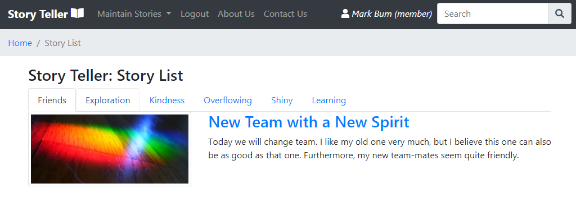

**storyDetails.php** – Use Bootstrap Grid system to create one row with 2 equal columns and display the contents as below:

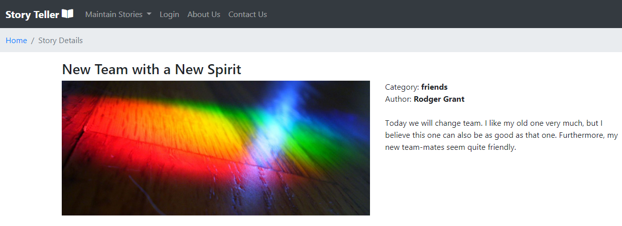

**login.php** and **addStory.php -** Convert both forms to a Bootstrap form. <https://getbootstrap.com/docs/4.1/components/forms/>

For login.php, use input group <https://getbootstrap.com/docs/4.1/components/input-group/>

**doLogin.php and doAddStory.php** – Use Alerts <https://getbootstrap.com/docs/4.1/components/alerts/> to show successful or unsuccessful messages

**searchStory.php** and **doSearchStory.php** – You can remove searchStory.php as the search inline form is now on the navbar. You need to change doSearchStory.php to make it Bootstrap ready and to use the Bootstrap table class “table-hover” for the search results.

Add the breadcrumbs to every php page except navbar.php by using this resource:

<https://getbootstrap.com/docs/4.1/components/breadcrumb/>



# Download ready-made Bootstrap themes

1. If you do not want to mess around with hexadecimal colour codes and want a downloadable Bootstrap theme, BootSwatch is for you! Go to [www.bootswatch.com](http://www.bootswatch.com) and click on “Themes” menu option to select your preferred theme.

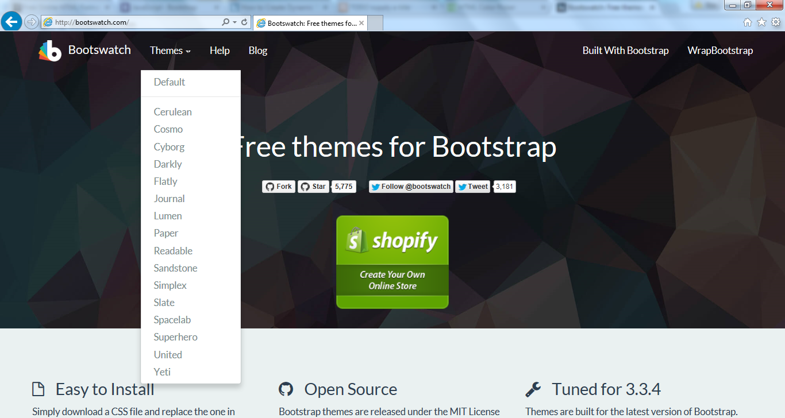

1. Click on “Download” menu option and select “bootstrap.min.css”. Replace this css file with the one in your project’s “css” folder.

