Analysis Results
General Information

Analysis date | 2025/03/24 11:51:14
Sample name | aru_900 | Measurement date | 2025/03/24 10:49:10
File name | Aru_900.raw | Operator | Rigaku
Comment

Measurement profile
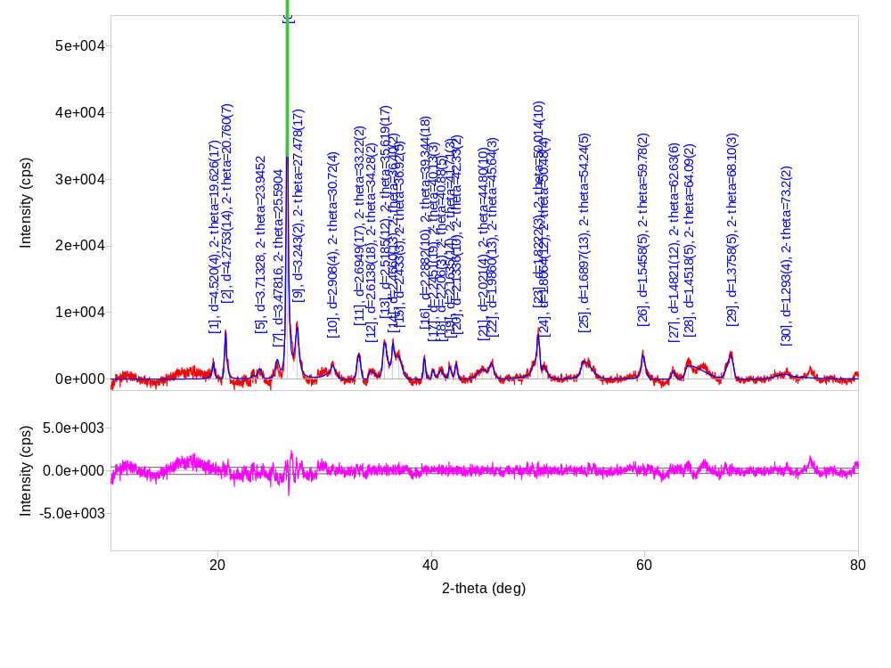

Measurement conditions

X-Ray | 40 kV , 40 mA | Scan speed / Duration time | 5.0000 deg./min.
Goniometer |  | Step width | 0.0200 deg.
Attachment | - | Scan axis | 2Theta/Theta
Filter | K-beta filter | Scan range | 10.0000 - 80.0000 deg.
CBO selection slit | - | Incident slit | Open
Diffrected beam mono. |  | Length limiting slit | -
Detector | D/teX Ultra | Receiving slit #1 | Open
Scan mode | CONTINUOUS | Receiving slit #2 | Open

Qualitative analysis results

Phase name | Formula | Figure of merit | Phase reg. detail | DB card number
a-Si O2, quartz a | Si O2 | 0.225 | ICDD (PDF-2 2024) | 01-089-8936
Microcline | K ( Al Si3 O8 ) | 1.167 | ICDD (PDF-2 2024) | 01-084-0709
Potassium Aluminum Silicate | K1.25 Al1.25 Si0.75 O4 | 1.107 | ICDD (PDF-2 2024) | 00-032-0731

Phase name | Formula | Space group | Phase reg. detail | DB card number
a-Si O2, quartz a | Si O2 | 154 : P3221 | ICDD (PDF-2 2024) | 01-089-8936
Microcline | K ( Al Si3 O8 ) | 2 : C-1 | ICDD (PDF-2 2024) | 01-084-0709
Potassium Aluminum Silicate | K1.25 Al1.25 Si0.75 O4 | 200 : Pm-3 | ICDD (PDF-2 2024) | 00-032-0731

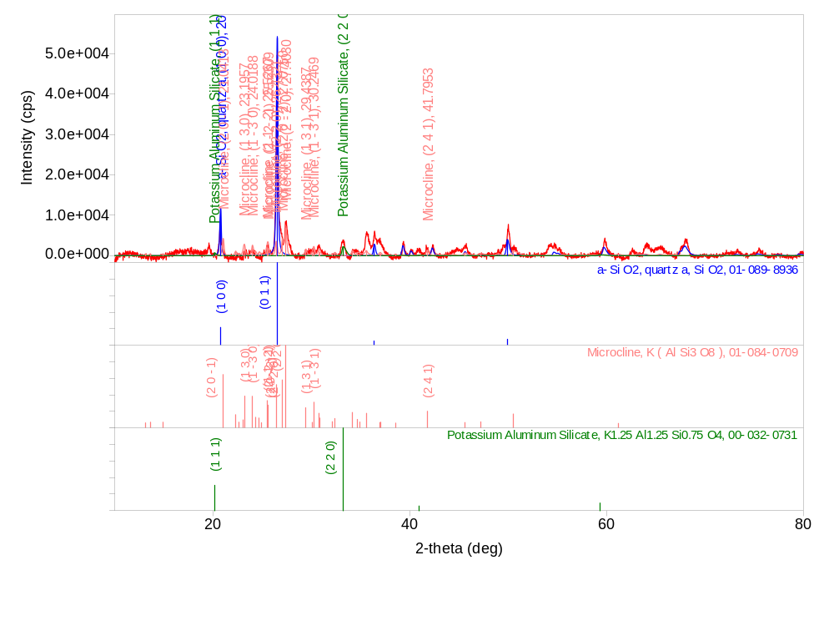

Peak list

No. | 2-theta(deg) | d(ang.) | Height(cps) | FWHM(deg) | Int. I(cps deg) | Size(ang.) | Phase name
1 | 19.626(17) | 4.520(4) | 2467(101) | 0.22(4) | 963(89) | 376(66) | Unknown
2 | 20.760(7) | 4.2753(14) | 7013(171) | 0.207(10) | 2067(109) | 408(21) | a-Si O2, quartz a(1,0,0)
3 | 23.3184 | 3.81165 | 477.042 | 0.413223 | 204.935 | 205.026 | Microcline(2,0,0),Unknown
4 | 23.8668 | 3.72529 | 131.682 | 0.413223 | 200.118 | 205.231 | Unknown
5 | 23.9452 | 3.71328 | 2541.47 | 0.413223 | 473.02 | 205.26 | Microcline(1,-3,0)
6 | 25.5512 | 3.4834 | 71.1104 | 0.413223 | 691.283 | 205.892 | Microcline(1,1,-2)
7 | 25.5904 | 3.47816 | 517.995 | 0.413223 | 396.904 | 205.908 | Microcline(2,-2,-1)
8 | 26.512(4) | 3.3592(5) | 49059(452) | 0.205(5) | 15275(198) | 416(10) | a-Si O2, quartz a(0,1,1),Microcline(2,2,0)
9 | 27.478(17) | 3.243(2) | 7164(173) | 0.41(3) | 4403(212) | 207(14) | Microcline(2,0,-2)
10 | 30.72(4) | 2.908(4) | 1926(90) | 0.65(6) | 1895(182) | 133(13) | Microcline(2,2,-2)
11 | 33.22(2) | 2.6949(17) | 3732(125) | 0.384(19) | 1527(109) | 225(11) | Potassium Aluminum Silicate(2,2,0)
12 | 34.28(2) | 2.6138(18) | 1218(71) | 0.65(10) | 840(147) | 134(22) | Microcline(3,1,-2)
13 | 35.619(17) | 2.5185(12) | 4756(141) | 0.43(3) | 2185(298) | 202(14) | Microcline(3,1,0)
14 | 36.40(2) | 2.4660(13) | 2723(107) | 0.21(2) | 620(109) | 408(45) | a-Si O2, quartz a(1,1,0)
15 | 36.92(5) | 2.433(3) | 3459(120) | 1.22(12) | 4478(383) | 72(7) | Microcline(1,5,-1)
16 | 39.344(18) | 2.2882(10) | 3151(115) | 0.234(18) | 860(78) | 377(28) | a-Si O2, quartz a(1,0,2),Microcline(0,4,2),Potassium Aluminum Silicate(3,1,1)
17 | 40.13(3) | 2.2451(19) | 1311(74) | 0.28(4) | 396(52) | 314(45) | a-Si O2, quartz a(1,1,1),Microcline(2,2,-3)
18 | 40.88(5) | 2.206(3) | 1321(74) | 0.50(5) | 715(58) | 176(19) | Microcline(2,-2,-3),Potassium Aluminum Silicate(2,2,2)
19 | 41.71(3) | 2.1635(14) | 1820(87) | 0.33(3) | 638(49) | 272(29) | Microcline(1,-5,1)
20 | 42.33(2) | 2.1336(10) | 2332(99) | 0.27(2) | 685(68) | 326(26) | a-Si O2, quartz a(2,0,0)
21 | 44.80(10) | 2.021(4) | 1418(77) | 1.0(2) | 1583(285) | 86(18) | Microcline(3,-1,1)
22 | 45.64(3) | 1.9860(13) | 2048(92) | 0.51(6) | 1106(289) | 177(20) | a-Si O2, quartz a(2,0,1),Microcline(2,2,2)
23 | 50.014(10) | 1.8222(3) | 6378(163) | 0.375(17) | 3959(278) | 244(11) | a-Si O2, quartz a(1,1,2),Microcline(2,6,-2)
24 | 50.48(4) | 1.8064(12) | 1966(91) | 0.54(7) | 1396(273) | 171(21) | a-Si O2, quartz a(0,0,3),Microcline(1,7,0)
25 | 54.24(5) | 1.6897(13) | 2688(106) | 1.12(5) | 3474(172) | 83(3) | a-Si O2, quartz a(0,2,2),Microcline(1,-3,3)
26 | 59.78(2) | 1.5458(5) | 3623(123) | 0.42(3) | 1998(139) | 228(17) | a-Si O2, quartz a(1,2,1),Microcline(3,-3,2)
27 | 62.63(6) | 1.4821(12) | 1172(70) | 0.39(5) | 483(61) | 251(35) | Microcline(5,1,-4)
28 | 64.09(2) | 1.4518(5) | 2015(92) | 1.94(8) | 4161(206) | 50(2) | a-Si O2, quartz a(1,1,3),Microcline(4,6,0)
29 | 68.10(3) | 1.3758(5) | 3535(121) | 0.65(3) | 2463(80) | 153(6) | a-Si O2, quartz a(2,0,3),Microcline(6,2,-3)
30 | 73.2(2) | 1.293(4) | 714(55) | 2.0(3) | 2231(262) | 53(9) | a-Si O2, quartz a(1,0,4),Potassium Aluminum Silicate(5,3,1)

Parameters used for WPPF
Profile parameters

Common parameter | Background | Data | Aru_900
 |  | Function name | B-spline
 |  | param0 | 50032.88491175259
 |  | param1 | 40906.881275981526
 |  | param2 | 39181.302360763402
 |  | param3 | 43300.076164308062
 |  | param4 | 35848.973267550726
 |  | param5 | 29401.676773079704
 |  | param6 | 29015.7658280287
 |  | param7 | 24340.401532154003
 |  | param8 | 24999.676448184979
 |  | param9 | 22052.848853907071
 |  | param10 | 21871.259807442631
 |  | param11 | 23227.712577523951
 |  | param12 | 19950.085223626786
 |  | param13 | 20144.072040071645
 |  | param14 | 19445.160618606424
 |  | node0 | 10
 |  | node1 | 14.92
 |  | node2 | 19.84
 |  | node3 | 24.760000000000002
 |  | node4 | 29.739999999999998
 |  | node5 | 34.200000000000003
 |  | node6 | 38.659999999999997
 |  | node7 | 43.159999999999997
 |  | node8 | 48.280000000000001
 |  | node9 | 53.439999999999998
 |  | node10 | 60.280000000000001
 |  | node11 | 70.120000000000005
 |  | node12 | 80
Common parameter | Peak shift
 |  | Function name | Shift axial displacement
 |  | param0 | 0
 |  | param1 | 0
 |  | param2 | 0
a-Si O2, quartz a | Scale factor | s | 147(5)
 | FWHM | U | 0.8791
 |  | V | -0.2494
 |  | W | 0.0526
 | Asym. factor | A0 | 1.0204
 |  | A1 | 3.8308
 | Decay rate factor | etaL0/mL0 | 0.6445
 |  | etaL1/mL1 | -0.1950
 |  | etaL2/mL2 | 0.0000
 |  | etaH0/mH0 | 0.7007
 |  | etaH1/mH1 | -0.1950
 |  | etaH2/mH2 | 0.0000
 | Preferred orientationMarch-Dollase | h | 0
 |  | k | 0
 |  | l | 0
 |  | March coefficient | 1.000000
Microcline | Scale factor | s | 19.9(9)
 | FWHM | U | 1.2766
 |  | V | -0.3966
 |  | W | 0.0766
 | Asym. factor | A0 | 0.9118
 |  | A1 | 3.6156
 | Decay rate factor | etaL0/mL0 | 0.7209
 |  | etaL1/mL1 | -0.3315
 |  | etaL2/mL2 | 0.0000
 |  | etaH0/mH0 | 0.6765
 |  | etaH1/mH1 | -0.3315
 |  | etaH2/mH2 | 0.0000
 | Preferred orientationMarch-Dollase | h | 0
 |  | k | 0
 |  | l | 0
 |  | March coefficient | 1.000000
Potassium Aluminum Silicate | Scale factor | s | 12(2)
 | FWHM | U | 2.5000
 |  | V | 0.0000
 |  | W | 0.0001
 | Asym. factor | A0 | -1.0901
 |  | A1 | 0.0000
 | Decay rate factor | etaL0/mL0 | 0.0000
 |  | etaL1/mL1 | 0.2689
 |  | etaL2/mL2 | 0.0000
 |  | etaH0/mH0 | 0.0976
 |  | etaH1/mH1 | 0.1471
 |  | etaH2/mH2 | 0.0000
 | Preferred orientationMarch-Dollase | h | 0
 |  | k | 0
 |  | l | 0
 |  | March coefficient | 1.000000

Structure parameters

Data set name | Phase Name | Element | x | y | z | Occupancy | Temperature factor

Data set name | Rwp | Rp | Re | S | Chi^2 | Maximum shift/e.s.d.
Aru_900 | 0 | 0 | 0 | 0 | 0 | 0

Lattice constants
Angular correction

No correction

Analysis results

Data set name | a(A) | b(A) | c(A) | alpha(deg) | beta(deg) | gamma(deg)
Aru_900 | 4.932581 | 4.932581 | 5.428401 | 90.000000 | 90.000000 | 120.000000
Aru_900 | 8.569917 | 12.960445 | 7.221008 | 90.647003 | 115.945999 | 87.640999
Aru_900 | 7.624383 | 7.624383 | 7.624383 | 90.000000 | 90.000000 | 90.000000

Phase name | a(A) | b(A) | c(A) | alpha(deg) | beta(deg) | gamma(deg) | V(A^3)
a-Si O2, quartz a | 4.932581 | 4.932581 | 5.428401 | 90.000000 | 90.000000 | 120.000000 | 114.380231
Microcline | 8.569917 | 12.960445 | 7.221008 | 90.647003 | 115.945999 | 87.640999 | 720.565708
Potassium Aluminum Silicate | 7.624383 | 7.624383 | 7.624383 | 90.000000 | 90.000000 | 90.000000 | 443.214682

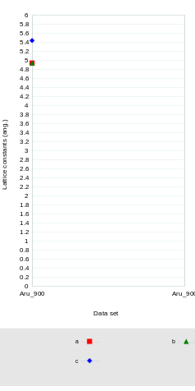

Crystallinity

Data set name | Crystallinity(%)

CrystallinityGraph.emf

Crystallite size and lattice strain
Williamson-Hall method

Data set name | Crystallite size(A) | Strain(%)
Aru_900 | 68(25) | 0.000000
Aru_900 | - | -
Aru_900 | - | -

Phase name | Crystallite size(A) | Distribution RSD | Strain(%) | Distribution type
a-Si O2, quartz a | 68(25) | - | 0.000000 | -
Microcline | - | - | - | -
Potassium Aluminum Silicate | - | - | - | -

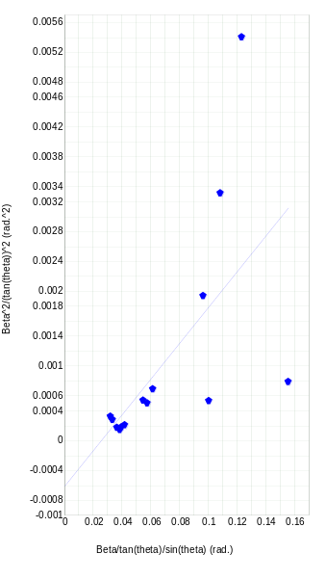

Quantitative analysis results (RIR)

Phase name | Content(%)
a-Si O2, quartz a | 3.43(18)
Microcline | 97(8)
Potassium Aluminum Silicate | 0.000000

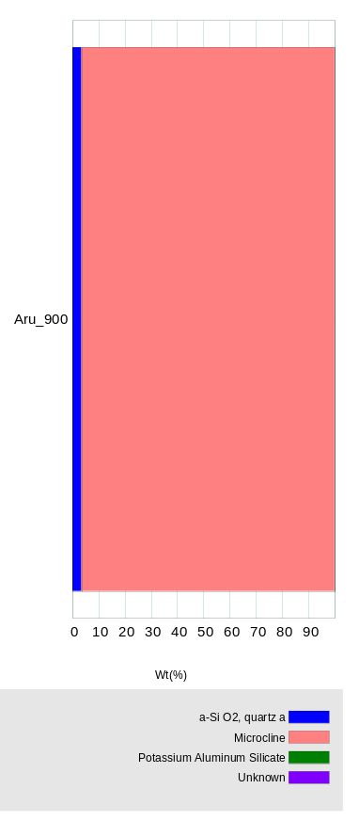

Quantitative analysis results (WPPF)

Quantitative analysis results (standard addition method)
Calibration data
QuantityCalibration.emf

Quantitative analysis results (External Standard method)
Calibration data
QuantityCalibration.emf

Quantitative analysis results (internal standard method)
Calibration Data
QuantityCalibration.emf

Stress
Stress constants

Analytical conditions

Analysis results

StressGraph.emf

Cluster analysis results
Dendrogram

ClusterDendrogram.emf

Measurement profiles

Cluster

Sample well

ClusterSamplePlate.emf

PCA view

ClusterPCA3DGraph.emf
Eigenvalue graph

ClusterPCAGraph.emf

Crystallite size distribution analysis results
Crystallite size distribution

Crystallite size distribution graph

SizeDistribution.emf

Crystal structure analysis results
Indexing

Phase name | Formula | Figure of merit | Phase reg. detail | DB card number
a-Si O2, quartz a | Si O2 | 0.225 | ICDD (PDF-2 2024) | 01-089-8936
Microcline | K ( Al Si3 O8 ) | 1.167 | ICDD (PDF-2 2024) | 01-084-0709
Potassium Aluminum Silicate | K1.25 Al1.25 Si0.75 O4 | 1.107 | ICDD (PDF-2 2024) | 00-032-0731

Quantitative analysis results

Lattice information

Phase name | a(A) | b(A) | c(A) | alpha(deg) | beta(deg) | gamma(deg) | V(A^3)
a-Si O2, quartz a | 4.932581 | 4.932581 | 5.428401 | 90.000000 | 90.000000 | 120.000000 | 114.380231
Microcline | 8.569917 | 12.960445 | 7.221008 | 90.647003 | 115.945999 | 87.640999 | 720.565708
Potassium Aluminum Silicate | 7.624383 | 7.624383 | 7.624383 | 90.000000 | 90.000000 | 90.000000 | 443.214682

Phase name | Space group | Z | Z' | Calc. density(g/cm^3)
a-Si O2, quartz a | 154 : P3221 | 3 | 0.500 | 2.617
Microcline | 2 : C-1 | 2 | 0.500 | 1.283
Potassium Aluminum Silicate | 200 : Pm-3 | - | 0.000 | 0.000

Structure determination

Refinement

Measurement range: 10.0000-80.0000deg Refinement range: 10.0000-80.0000deg (1.20 A)
Number of refined parameters: 0
Phase name | Atomic coords | # of indep. reflns
a-Si O2, quartz a | - | 35
Microcline | - | 439
Potassium Aluminum Silicate | - | 63

Rwp = - S = -

Crystal structure

CrystalGraph.emf

