THERMAL-KINETIC STUDY OF ESTONIAN CLAYS AND CALCIUM/SULPHUR-RICH INDUSTRIAL BY-PRODUCT UNDER VARIED CALCINATION ATMOSPHERES

Ademola Michael Adegbile¹*, Can Rüstü Yörük¹, Nata-Ly Patsenko², Mai Uibu¹, Adheena Thomas¹, Mustafa Cem Usta¹, Andres Trikkel¹

¹ Department of Materials and Environmental Technology, Tallinn University of Technology, Tallinn, Estonia.
² Department of Geology, Tallinn University of Technology, Tallinn, Estonia.
* E-mail: aadegb@taltech.ee

- Introduction
In the pursuit of the European Union's 2050 climate neutrality goal, the search for sustainable options to conventional Portland cement has gained momentum. One of the main strategies involves the use of supplemental cementitious materials (SCMs), which can considerably reduce cement production's carbon footprint. Among these, natural clays and alkaline industrial by-products stand out as abundant, low-cost supplies for SCM development [1–3]. Limestone Calcined Clay Cement (LC³) exemplifies a blended system that integrates calcined clay, limestone, and gypsum, allowing for the substitution of up to 50% of ordinary Portland cement (OPC). LC³ has gained substantial interest for its ability to reduce CO₂ emissions by as much as 40% while delivering comparable strength and durability to regular cement [4,5]. The effective partial substitution of Ordinary Portland Cement (OPC) with LC³ highlights the promise of clay-rich materials when integrated with calcite- and sulphate-containing additions such as limestone and gypsum, prompting further investigation into alternate configurations utilizing various calcite and sulphate-containing sources.
Clay minerals, particularly those exhibiting moderate to high pozzolanic properties, have long been exploited in construction. When thermally activated, clays undergo structural modifications that enhance their reactivity, enabling them to react with calcium hydroxide to generate strength-contributing cementitious phases [6,7]. Although current study largely emphasizes kaolin-rich clays because of their high reactivity, illite-rich clays which are defined as 2:1 phyllosilicates of an octahedral sheet sandwiched between two tetrahedral sheets are still inadequately researched [8]. Despite their prevalence, illite-rich clays comprise approximately 7.7 wt.% of the Earth's top crust and are prevalent in areas such as Estonia [9,10].
The thermal activation of illite-rich clays proceeds through several stages. Initial dehydration (100–200 °C) is succeeded by dehydroxylation (typically 450–900 °C), a pivotal change that augments pozzolanic reactivity by the elimination of structural hydroxyls. Illite tends to sustain crystallinity through this procedure due to its lower structural water content compared to kaolinite [11–13]. Above around 900°C, recrystallization into stable crystalline phases diminishes pozzolanic potential [14]. Optimizing thermal activation necessitates accurate identification of transformation pathways and reactivity thresholds.
Parallel to this, Estonia faces a significant industrial waste challenge which is its oil shale-fired power stations creating 7–8 million tons of oil shale ash (LOSA) annually. Traditionally considered an environmental liability, LOSA is becoming viewed as a potential SCM particularly when paired with other reactive components [15,16]. Its high carbonate content, mostly in the form of calcite, undergoes thermal breakdown generally between 700 and 800°C, releasing CO₂ and forming reactive CaO. It has also been reported to contain a normal sulphate level of between roughly 1-2 % [17,18].
Indeed, the atmosphere during calcination plays a key role in both clay mineral and carbonate breakdown. In CO₂-rich environments, for instance, calcite decomposition is delayed to higher temperatures, resulting in increased reaction activation energy, changing decomposition kinetics, and delaying CO₂ release [19,20]. Likewise, atmospheric environment influences mineralogical changes in clays: oxidizing atmospheres encourage hematite formation and red hues, while reducing environments generate magnetite and darker results [21]. Understanding these atmospheric impacts is especially crucial when co-calcining materials like illite-rich clays and LOSA, which interact thermochemically during heating and create CO₂ in situ.
Recent research has shown the potential of co-calcination to increase SCM performance. For example, co-calcining kaolinitic clays with bauxite or industrial dregs has resulted in increased reactivity and mechanical strength, with cement substitutions of up to 30 wt.% performing favourably compared to traditional cement mixes [22,23]. However, while the thermal behaviours of Estonian clays and LOSA have been explored for various applications [24,25], there remains a deficiency of systematic thermal-kinetic studies examining the influence of varied calcination atmospheres on their thermal decomposition behaviour geared towards co-calcination.
This study tackles that gap by undertaking an extensive thermal-kinetic analysis of Estonian illite-rich clays and LOSA under both oxidizing (air) and CO₂-rich (flue gas) atmospheres. Using thermogravimetric and kinetic modeling tools, it looks to analyse the thermal decomposition paths of essential components of these materials and the influence of atmospheric gas composition on reaction rates and transformation products. The results aim to find the optimum parameters for calcination such as thermal activation temperature and duration that allow for the effective use of these abundant local materials in making low-carbon, high-quality cementitious products.

- Materials and Methods
Materials
This study utilized Estonian illite-rich clays and landfilled oil shale ash (LOSA) as the principal materials for thermal and kinetic investigation. The illite-rich clays were obtained from three distinct locations in Estonia to capture regional mineralogical variation: Arumetsa clay (LECA EESTI, Pärnu County), Aseri clay (Wienerberger AS, Lääne-Viru County), and Kunda clay (Heidelberg Materials AS, Lääne-Viru County). The LOSA was sourced from the ash field of the Balti Power Plant in Narva, where oil shale serves as the main combustion fuel.

Characterization of Materials
All raw materials were initially obtained as damp clumps and were subjected to a standard pre-treatment method. Samples were oven-dried at 105 ± 2 °C for 24 h using a BINDER FD Series oven to eliminate physically bonded moisture. Following drying, materials were cooled under ambient conditions for 24 h. The dry materials were then comminuted using a Retsch PM100 planetary ball mill at 350 rpm for 3 min to achieve smaller particle sizes, and subsequently sieved to obtain a homogenous particle size fraction below 200 µm.
Physical characterization consisted of particle size distribution (PSD) and specific surface area (SSA) analysis. PSD was calculated using a Horiba Partica LA-950V2 laser diffraction analyser, whereas SSA was measured by nitrogen adsorption using the Brunauer–Emmett–Teller (BET) method on a Costech Kelvin Sorptometer 1042.
The chemical composition of the samples was analyzed by X-ray fluorescence (XRF) using a ------------, which provided quantitative data on elemental oxides. Mineralogical composition was assessed by X-ray diffraction (XRD), performed on a ------ equipped with ---- radiation (λ = ---- Å), operated at -- kV and --- mA. Data were collected over a 2θ range of --- – --- with a step size of ---. In addition, Fourier-transform infrared spectroscopy (FTIR) was conducted using a Bruker ALPHA spectrometer in attenuated total reflectance (ATR) mode to identify functional groups and assess structural features relevant to thermal transformation.
Physical Characterization
The particle size distribution (shown in Figure 1 and Table 1) and surface area (shown in Table 1) data showed considerable differences across the four samples—Arumetsa-C, Aseri-C, Kunda-C, and LOSA. Arumetsa-C has the finest particle size distribution (d₅₀ = 13.50 µm) and the largest specific surface area (SSA_{BET} = 46.70 m² g⁻¹), indicating a moderately fine and porous structure. In contrast, LOSA has a substantially coarser distribution (d₅₀ = 61.83 µm) and the lowest surface area (32.51 m² g⁻¹), implying a significantly bigger particle shape and lower porosity. Aseri-C and Kunda-C fall between these extremes, with Kunda-C displaying a broader size distribution (d₉₀ = 68.44 µm) than Aseri-C, although with slightly higher surface area. These changes in particle size and surface area may considerably alter thermal analysis conclusions, since finer and more porous materials like Arumetsa-C are expected to exhibit higher thermal reactivity and faster decomposition kinetics compared to coarser samples such as LOSA.

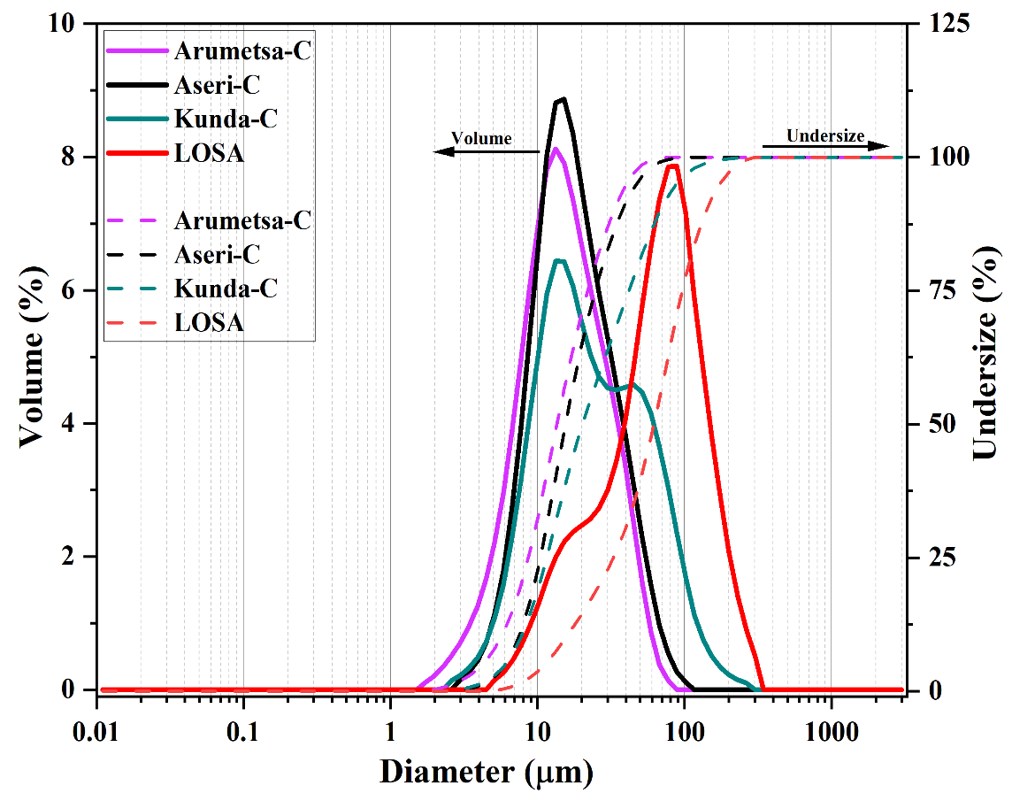
Figure 1. Particle size distribution curve of Arumetsa-C, Aseri-C, Kunda-C and LOSA

Table 1: PSD (d₁₀, d₅₀ and d₉₀) and SSA_{BET} for Arumetsa-C, Aseri-C, Kunda-C and LOSA
 | Arumetsa-C | Aseri-C | Kunda-C | LOSA
d₁₀ µm | 5.61 | 7.39 | 7.69 | 15.53
d₅₀ µm | 13.50 | 15.46 | 20.15 | 61.83
d₉₀ µm | 33.04 | 37.67 | 68.44 | 140.95
SSA_{BET} (m² g⁻¹) | 46.70 | 37.28 | 39.67 | 32.51

Chemical Characterization
The chemical and mineralogical compositions of the all samples shown in Table 2 and Table 3 reveal distinct (except Aseri-C and Kunda-C which both originate from Estonia’s Lääne-Viru County having about the same composition) geochemical and mineralogical characteristics that reflect their differing origins and potential applications. Arumetsa-C, Aseri-C, and Kunda-C are silica- and alumina-rich, with high SiO₂ (52.77–60.59%) and Al₂O₃ (17.48–21.05%) contents, indicating their clay-rich nature, further supported by the dominance of phyllosilicate minerals such as illite occurring alongside illite-smectite and mica which is the dominant phase in these clays (45.60 -51.10%). Kaolinite, which is significantly more present in Arumetsa-C compared to the other clays by a magnitude of about 8 times, could play a significant role in its dehydroxylation step. In contrast, LOSA has markedly lower SiO₂ (14.43%) and Al₂O₃ (3.20%) but is enriched in CaO (38.61%) and LOI (27.54%), consistent with a calcite- and portlandite-bearing composition indicative of a calcareous or cementitious nature. Mineralogically, LOSA is distinguished by the presence of secondary cement hydration products like ettringite, thaumasite, and C₂S, absent in the other samples.
Table 2: Chemical composition of Arumetsa-C, Aseri-C, Kunda-C and LOSA
Component | Arumetsa-C | Aseri-C | Kunda-C | LOSA
SiO₂ (%) | 52.77 | 60.59 | 60.03 | 14.43
TiO₂ (%) | 0.97 | 0.87 | 0.88 | 0.19
Al₂O₃ (%) | 21.05 | 17.48 | 17.91 | 3.20
Fe₂O₃ (%) | 8.61 | 6.88 | 7.11 | 3.29
MnO (%) | 0.07 | 0.04 | 0.04 | 0.07
MgO (%) | 2.92 | 2.38 | 2.29 | 5.77
CaO (%) | 1.18 | 0.53 | 0.26 | 38.61
Na₂O (%) | 0.60 | 0.12 | 0.12 | 0.09
K₂O (%) | 4.93 | 5.89 | 5.84 | 1.07
P₂O₅ (%) | 0.15 | 0.08 | 0.09 | 0.11
SO₃ (%) | 0.04 | 0.06 | 0.10 | 5.45
L.O.I | 6.46 | 4.59 | 4.91 | 27.54

Table 3: Phase composition of Arumetsa-C, Aseri-C, Kunda-C and LOSA
Component | Arumetsa-C | Aseri-C | Kunda-C | LOSA
Quartz | 15.80 | 29.3 | 32.60 | 11.60
Illite+illite-smectite+mica | 45.60 | 57.10 | 57.00 | -
K-feldspar | 7.70 | 5.30 | 4.00 | -
Plagioclase | 4.90 | - | - | -
Chlorite | 5.00 | 4.10 | 3.10 | -
Kaolinite | 16.30 | 2.50 | 2.30 | -
Anatase | 1.20 | 0.90 | 1.00 | -
Dolomite | 0.80 | tr. | - | 2.20
Calcite | tr. | - | - | 37.90
Hematite | 1.30 | - | - | 1.70
Amphibole | 0.80 | - | - | 5.45
Orthoclase | - | - | - | 4.90
Portlandite | - | - | - | 10.10
Brucite | - | - | - | 3.40
Hydrocalumite | - | - | - | 3.40
Melilite | - | - | - | 2.30
Akermanite | - | - | - | 1.80
C₂S | - | - | - | 4.60
Illite | - | - | - | 3.00
Ettringite | - | - | - | 5.10
Thaumasite | - | - | - | 7.60

Sample Preparation and Thermal-Kinetic Characterization
Four materials, namely Arumetsa clay, Kunda clay, Aseri clay, and landfilled oil shale ash (LOSA), were selected for thermal-kinetic characterization. Kunda and Aseri clays, both originating from Estonia’s Lääne-Viru County, exhibited nearly identical mineralogical compositions based on prior XRD analysis. As a result, only one (Kunda clay) was retained for a limited set of co-calcination trials to avoid redundancy in experimental design.
The primary objective of this study was to investigate the thermal decomposition behaviour and reaction kinetics of the individual materials under varied calcination atmospheres. A secondary, exploratory aim was to conduct preliminary co-calcination tests of illite-rich clay with LOSA. These tests were designed to provide early insights into the dehydroxylation behaviour of clays in a CO₂-rich environment, induced by calcite decomposition in LOSA, and to assess the basic compatibility of these materials for potential use in blended systems. All materials were prepared as described in the material characterization section above. Dried, milled, and sieved powders (≤200 µm) were weighed to a mass of 25 ± 0.5 mg and placed in alumina (Al₂O₃) crucibles for thermal analysis.
Thermal Analysis
Thermal analysis was carried out using a Setaram Setsys Evo 1750 thermoanalyzer coupled with a Pfeiffer OmniStar mass spectrometer, enabling simultaneous thermogravimetric analysis (TGA), differential thermal analysis (DTA), and evolved gas analysis via mass spectrometry (MS). Each sample was subjected to four different linear heating rates: 2.5, 5.0, 7.5, and 10.0 K min⁻¹, covering a temperature range from 30 °C to 1000 °C.
Two atmospheric conditions were used during the analysis: (1) a simulated air mixture (21% O₂ / 79% Ar) and (2) a simulated flue gas environment (16% CO₂ / 6% O₂ / 78% N₂). The total gas flow rate was maintained at 30 ml min⁻¹ for all experiments. This dual-atmosphere setup allowed for comparative evaluation of thermal behaviour under oxidizing and CO₂-rich conditions, relevant to real-world calcination scenarios involving industrial by-products. The schematic of this setup is shown in Figure 2.
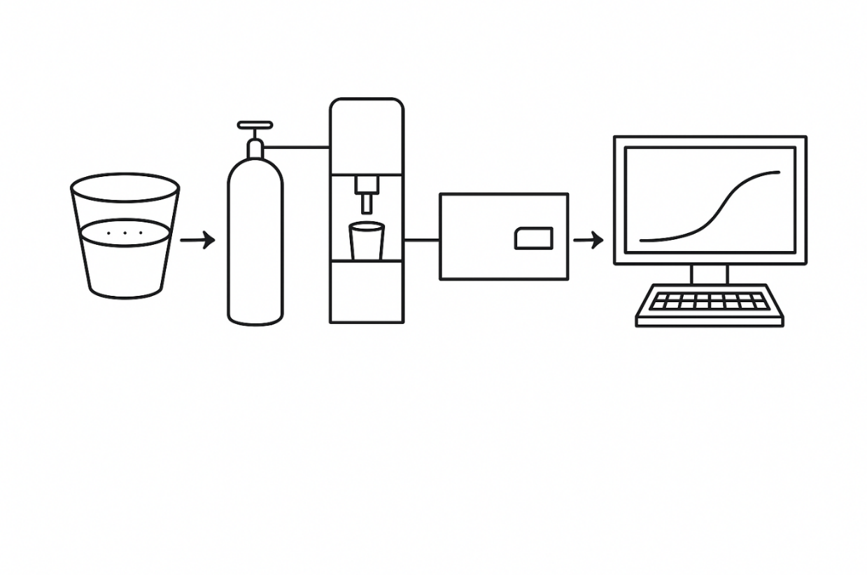
Figure 2: Schematic of experimental procedure
Kinetic Modelling (In progress)
Kinetic modeling was performed to evaluate the thermal decomposition behaviour of the selected materials and quantify their apparent activation energies (E_{a}) across the reaction progress. A differential isoconversional approach, based on the Friedman method, was applied to non-isothermal thermogravimetric data acquired at four linear heating rates (2.5, 5.0, 7.5, and 10.0 K min⁻¹).
---------Friedmann Isoconversional Method paragraph------
To complement the isoconversional analysis and better understand the underlying reaction mechanisms, selected integral model-fitting approaches were applied to key decomposition intervals identified in the TG-DTA data. These included commonly referenced solid-state reaction models such as diffusion, geometrical contraction, and nth-order models.
To support the isoconversional analysis and better understand the underlying reaction mechanisms, selected integral model-fitting methodologies were applied to important decomposition intervals identified in the TG-DTA data. These included regularly referred solid-state reaction models such as diffusion, geometrical contraction, and nth-order models. This integrated method provided a comprehensive assessment of both the kinetic parameters and probable mechanistic routes of dehydroxylation in the illite-rich clays and decarbonation in LOSA, particularly under diverse calcination atmospheres.

References
1. Action DG for C. Going climate-neutral by 2050 – A strategic longterm vision for a prosperous, modern, competitive and climateneutral EU economy. Publications Office; 2019.
2. Shubbar AA, Sadique M, Kot P, Atherton W. Future of clay-based construction materials – A review. Constr Build Mater. 2019;210:172–87.
3. Wang X, Wang X, Fu P, Shi J, Xu M. Performance Optimization of Alkaline Multi-Industrial Waste-Based Cementitious Materials for Soil Solidification. Materials. 2024;17(20):5077.
4. Hu Y, Xiong L, Yan Y, Geng G. Performance of Limestone Calcined Clay Cement (LC3) Incorporating low-grade Marine Clay. Case Studies in Construction Materials. 2024;20:e03283–e03283.
5. Sirangi B, Prasad V. A Low Carbon Cement (LC3) as a Sustainable Material in High Strength concrete: Green Concrete. Materiales De Construccion [Internet]. 2023;73(352):e326–e326. Available from: https://materconstrucc.revistas.csic.es/index.php/materconstrucc/article/view/3551
6. Okashah AM, Zainal FF, Hayazi NF, Nordin MN, Abdullah A. Pozzolanic Properties of Calcined Clay in Geopolymer concrete: a Review. PROCEEDINGS OF GREEN DESIGN AND MANUFACTURE 2020. 2021;
7. Hazarika A, Huang L, Babaahmadi A. Characterisation, activation, and Reactivity of Heterogenous Natural Clays. Mater Struct. 2024;57(4).
8. Keppert M, Pommer V, Šádková K, Krejsová J, Vejmelková E, Černý R, et al. Thermal activation of illitic-kaolinitic mixed clays. J Therm Anal Calorim. 2024;149(19):10533–44.
9. Felipe YM, VAN LM, FERNANDEZ UO, NÉMETH T, BALÁZS RB, KERESZTES MA, et al. Clay Mineral Inventory in Soils of Europe Based on LUCAS Survey Soil Samples. JRC Publications Repository [Internet]. 2024; Available from: https://publications.jrc.ec.europa.eu/repository/handle/JRC136950
10. Ito A, Wagai R. Global distribution of claysize minerals on land surface for biogeochemical and climatological studies. Sci Data [Internet]. 2017;4(1):170103. Available from: https://doi.org/10.1038/sdata.2017.103
11. Overmann S, Vollpracht A, Matschei T. Reactivity of Calcined Clays as SCM—A Review. Materials [Internet]. 2024;17(2):312. Available from: https://www.mdpi.com/1996-1944/17/2/312
12. Snellings R, Almenares Reyes R, Hanein T, Irassar EF, Kanavaris F, Maier M, et al. Paper of RILEM TC 282-CCL: mineralogical characterization methods for clay resources intended for use as supplementary cementitious material. Mater Struct. 2022;55(5).
13. Földvári M. Handbook of Thermogravimetric System of Minerals and Its Use in Geological Practice. Geological Institute Of Hungary; 2011.
14. Koutsouradi A, Muzenda TR, Jensen PA, Ricardo W, Damø AJ, Georget F, et al. Impact of clay calcination method on the physicochemical properties of limestone calcined-clay cement. Constr Build Mater. 2025;473:140939.
15. Pihu T, Konist A, Puura E, Liira M, Kirsmae K. Properties and Environmental Impact of Oil Shale Ash Landfills. Oil Shale. 2019;36(2):257.
16. Rabab’ah SR, Sharo AA, Alqudah MM, Ashteyat AM, Saleh HO. Effect of using Oil Shale Ash on geotechnical properties of cement-stabilized expansive soil for pavement applications. Case Studies in Construction Materials. 2023;19:e02508–e02508.
17. Maaten B, Pikkor H, Konist A, Siirde A. Determination of the Sulphur Content of Oil Shale by Using Different Analytical Methods. Oil Shale. 2018;35(2):144.
18. Karunadasa KSP, Manoratne CH, Pitawala HMTGA, Rajapakse RMG. Thermal Decomposition of Calcium Carbonate (calcite polymorph) as Examined by in-situ high-temperature X-ray Powder Diffraction. Journal of Physics and Chemistry of Solids [Internet]. 2019;134:21–8. Available from: https://www.sciencedirect.com/science/article/abs/pii/S0022369719301970#:~:text=X%2Dray%20diffractogram%20of%20decomposed
19. Tian LN, Chen HP, Yang HP, Wang XH, Zhang SH. Study of Limestone Thermal Decomposition in O2/CO2 Atmosphere. Springer eBooks. 2012;1283–9.
20. Hotta M, Favergeon L, Koga N. Kinetic Insight into the Effect of Self-Generated CO2 on the Thermal Decomposition of Inorganic Carbonates in an Inert Gas Atmosphere: ZnCO3 and CaCO3. The Journal of Physical Chemistry C. 2023;127(27):13065–80.
21. Martirena Hernández JF, Almenares-Reyes R, Zunino F, Alujas-Diaz A, Scrivener KL. Color control in industrial clay calcination. RILEM Technical Letters. 2020;5:1–7.
22. Peys A, Hertel T, Snellings R. Co-Calcination of Bauxite Residue With Kaolinite in Pursuit of a Robust and High-Quality Supplementary Cementitious Material. Front Mater. 2022;9.
23. Adesanya ED, Marsh ATM, Krishnan S, Yliniemi J, Bernal SA. Co-calcination of kaolinitic clay and green liquor dregs to produce supplementary cementitious materials. Case Studies in Construction Materials. 2025;22:e04520.
24. Kaljuvee T, Štubňa I, Húlan T, Uibu M, Einard M, Traksmaa R, et al. Thermal Behavior of Ceramic Bodies Based on Estonian Clay from the Arumetsa Deposit with Oil Shale Ash and Clinker Dust Additives. Processes. 2021;10(1):46.
25. Kaljuvee T, Štubňa I, Somelar P, Mikli V, Kuusik R. Thermal behavior of some Estonian clays and their mixtures with oil shale ash additives. J Therm Anal Calorim. 2014;118(2):891–9.

