**Project Plan: Physically-based Simulation**

*Julia Giger, 13-934-039 (jgiger)*

*Yannick Huber, 14-922-595 (huberya)*

*Ueli Wechsler, 11-920-444 (wueli)*

1. Motivation

Figure 1: Ball pit

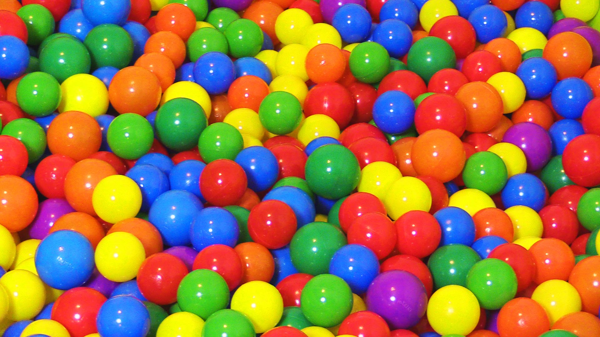

Jumping into a sea of colorful plastic balls is the dream of every child. We would like to model a similar, but slightly simplified scenario in our project.

The aim of our project is to create a slide alike construction, which ends in a pool containing a multitude of small objects. We want to simulate a vehicle sliding into this pool and especially the subsequent interactions of the vehicle with the objects in the pool (See figure 1).

The basic goal is to implement a rigid body simulation where the objects in the pool are little balls.

If this minimal goal is achieved, we would like to extend our implementation by adding a user interface with different options. The user can choose the size and the number of the objects in the pool. Furthermore, the shape and the physical properties, like for example elasticity, of the objects are adjustable. In addition, we would like to model a person sitting in the cart.

In the optimal case, we will be able to simulate the fluttering of the hair and the cloths of the person placed in the cart. The most ambiguous goal is to fill the pool with a fluid instead of the objects and handle the interaction of the cart diving into the fluid.

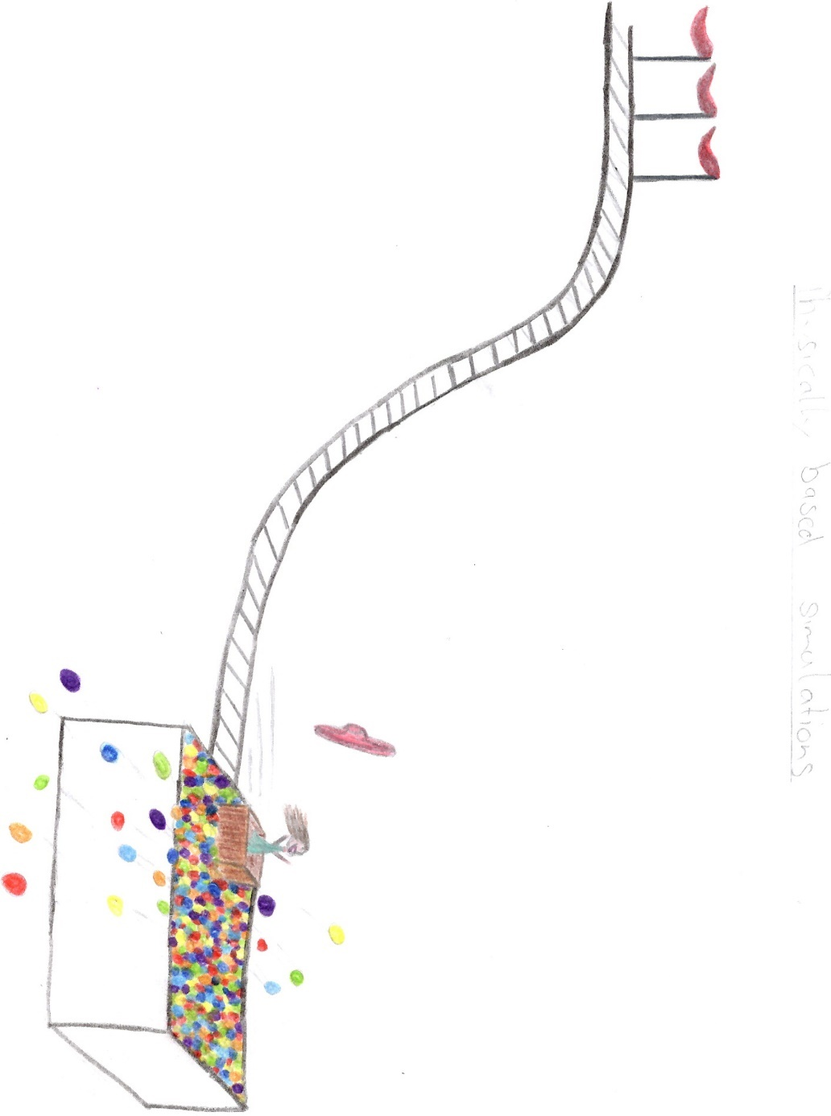

Figure 2: Conceptual drawing of the scene

1. Theoretical Background

We will use one of the open source game engines (e.g. Unreal Engine 4) as 3D framework since they are known for good performance optimization and good functionalities. For the simulation, a (convex) rigid body simulation with emphasis on collision handling will be implemented. As starting point, we consider [1] as well as [2], [3] to get an overview on the subject. Furthermore, we will intensify the literature review to find a high performance solver for the rigid body simulation.

1. Milestones

|  |  |
| --- | --- |
| **Date** | **Target** |
| 2.11 | Project plan due! |
| 9.11 | Exercise 3 due | Literature review completed Framework and solver |
| 16.11 |  |
| 23.11 | 3D-Environment | Implementation of solver testing with separate particles |
| 30.11 | Integrate cart into solver environment. |
| 7.12 | Multiple body simulation |
| 14.12 | Visual representation |
| 21.12 | Project due! |

Minimal:

* Pool filled with balls, collision and interaction with a simple cart

Desired:

* Basic UI for adjusting the number and size of the balls
* Varying the objects in the pool (shape, physical properties, etc.)
* Add a figure to the cart

Optimal:

* Implement cloth and hair simulation for the figure
* Option to fill pool with a fluid (add fluid solver)

1. Bibliography

[1] D. Baraff, “Physically Based Modeling: Rigid Body Simulation,” 2001.

[2] J. Bender, M. Müller, M. A. Otaduy, and M. Teschner, “Position-based Methods for the Simulation of Solid Objects in Computer Graphics,” 2013.

[3] J. Bender, K. Erleben, J. Trinkle, and E. Coumans, “Interactive Simulation of Rigid Body Dynamics in Computer Graphics,” 2012.