**Chapter 4**

**JPSreport**

This module focuses on the analysis of pedestrian characteristics based on trajectories obtained from video recordings as well as simulations.

## Configuration

An open source library (Boost C++) is necessary in this module, which is used to obtain Voronoi diagram from positions of pedestrians.

**Version**: Boost C++ Libraries Version 1.53.0

**Download**: <http://www.boost.org/users/history/version_1_53_0.html>

**Configuration:** Copy it directly to the directory ..\mingw64\include\**

## Initial files

* **Input.xml**: defines the measurement method, variations to be analyzed, measurement area etc.

Command line arguments:

* **geo.xml**: define geometry polygon to determine the boundary for analysis
* **Trajectory.xml**: trajectories will be analyzed.

A small program for transferring trajectory data from format ‘.txt’ to ‘.xml’

**Command**: run txt2xml.py –s 0 –f 16

## Command line arguments

**Measurement Methods (A, B, C, D):** refer to reference [zhang2011].

Method A:

Input parameters:

* + - Location of **reference line** (Start point (x, y) and End point (x, y))
    - Value of **time interval** (frame)

Output:

* File 1: N-t (the accumulative number of pedestrians passing the reference line and the corresponding time in frame)
* File 2: the mean flow and velocity over the given time interval.

Note that: All the obtained data is based on the same reference line.

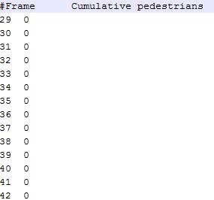 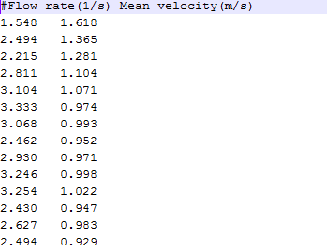

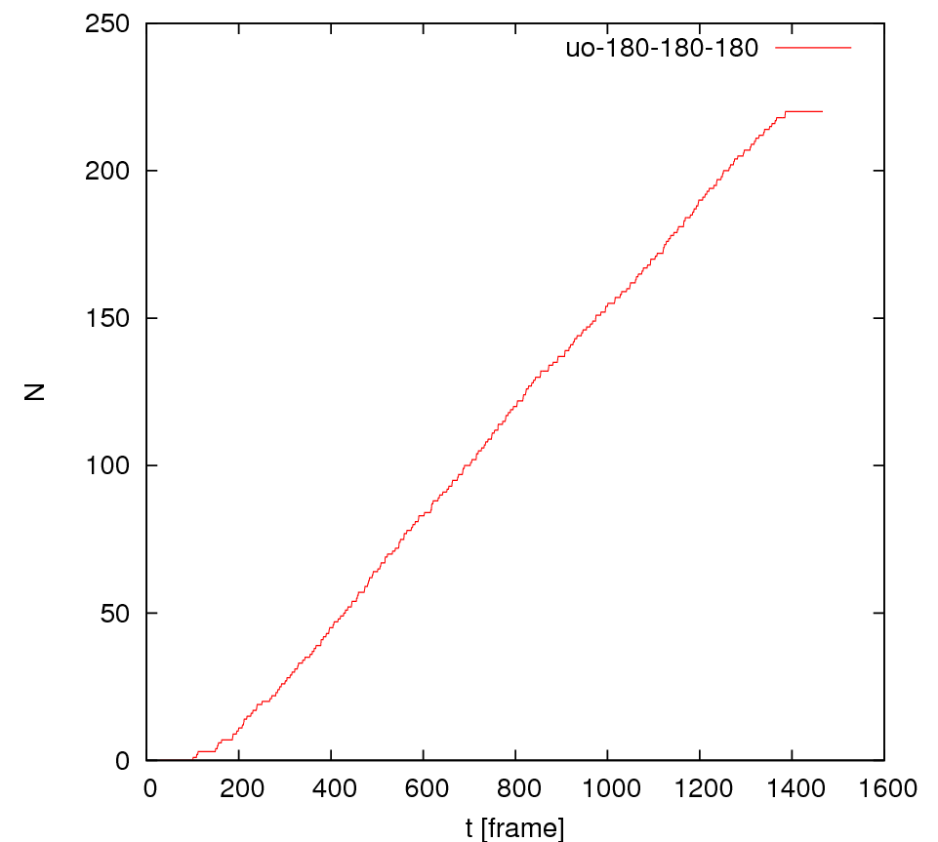 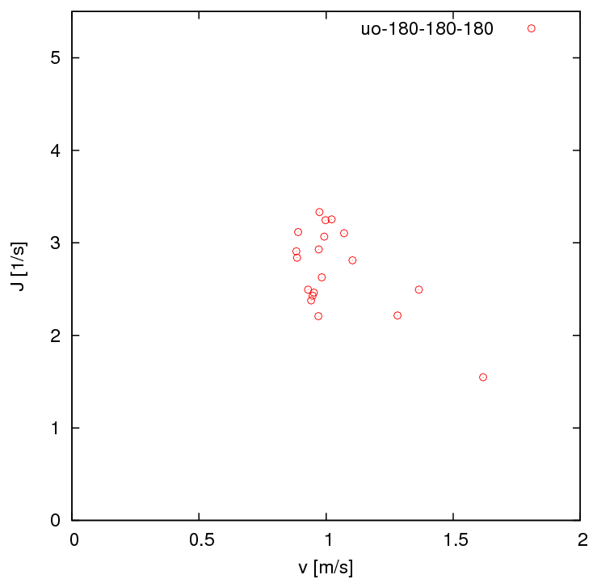

Method B:

Input parameters:

* + - **Rectangle measurement area** (p1 (x, y), p2 (x, y), p3 (x, y), p4 (x, y))
    - **Moving direction** (e.g. from start point (p1) to end (p4))

Output: mean density and velocity of each pedestrian

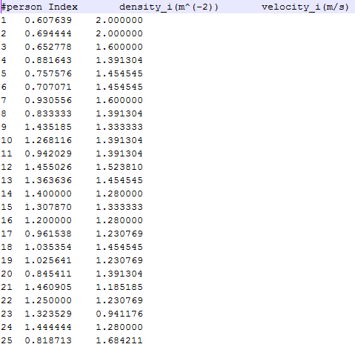 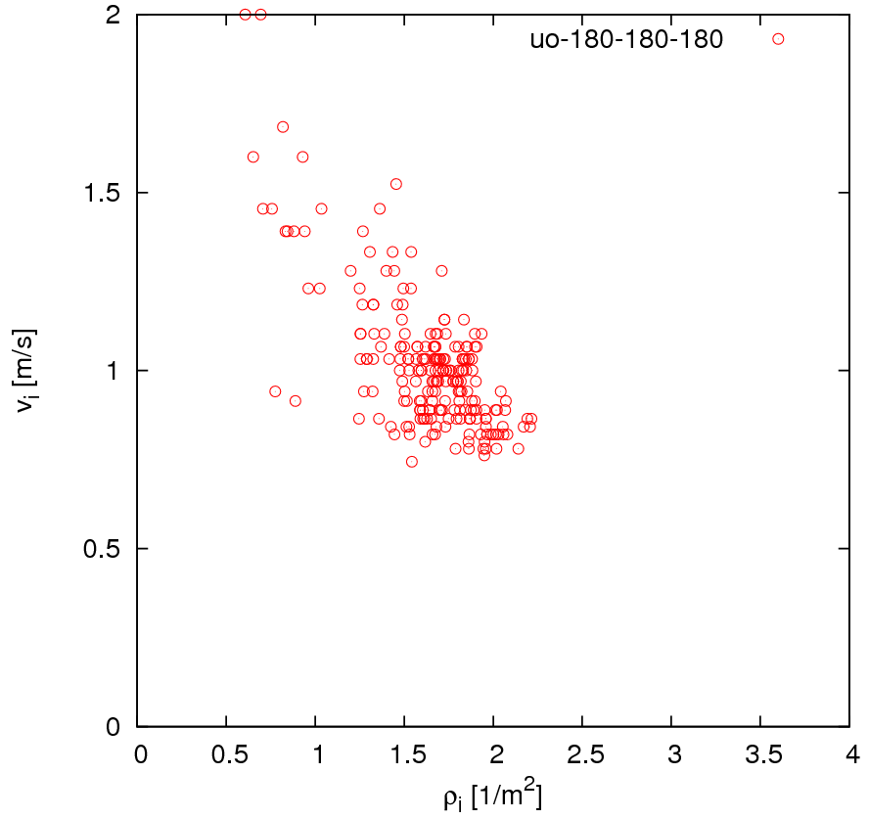

Method C:

Input parameters:

* + - **measurement area** (p1 (x, y), p2 (x, y), p3 (x, y), p4 (x, y))

Output: mean density and velocity over time

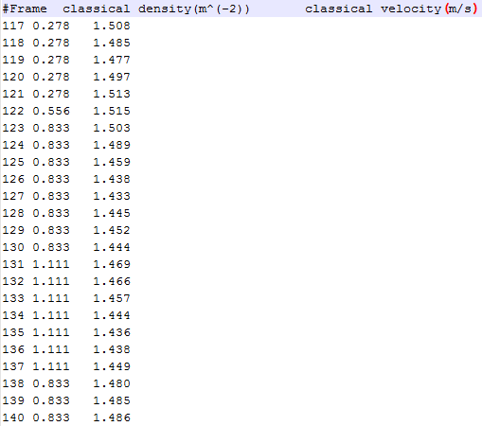

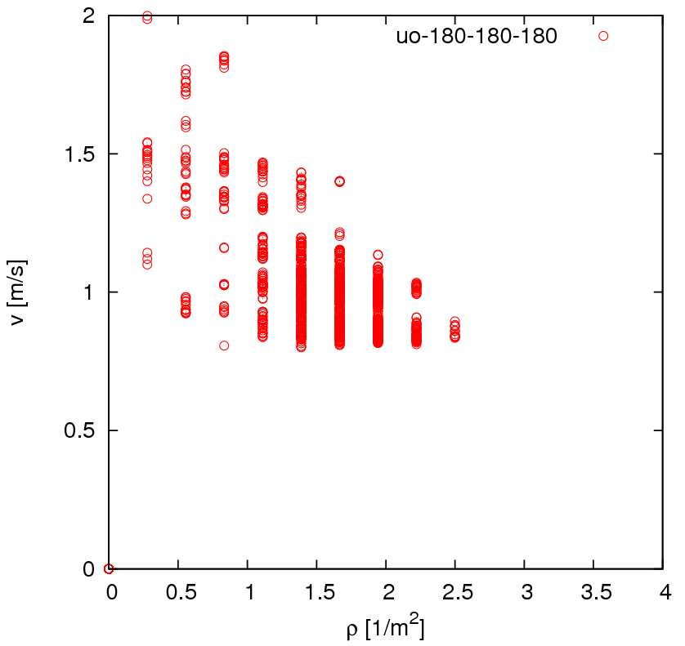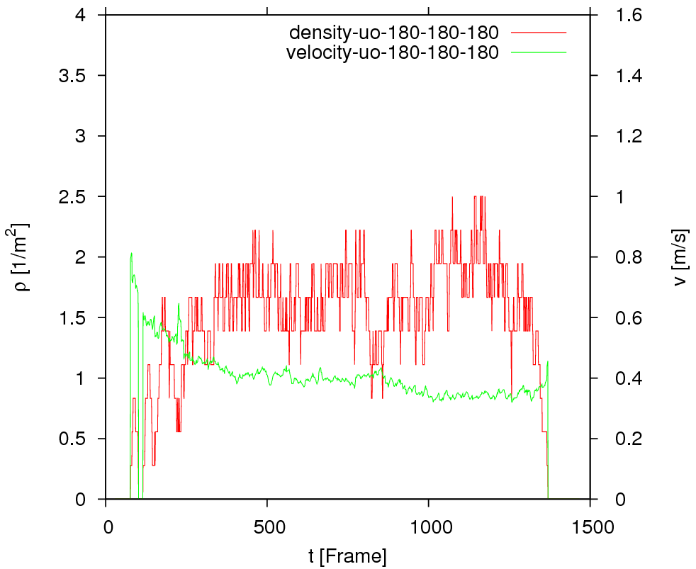

Method D:

Input parameters:

* + - **measurement area** (p1 (x, y), p2 (x, y), p3 (x, y), p4 (x, y))
    - **IsOutputGraph**: to determine whether output data for visualizing the Voronoi diagram or not. If it is true, files including Voronoi cells, speed and the coordinates of pedestrian corresponding to each cell will be output.
    - **cutbycircle**: to determine whether cut each cell by circle. (this takes long time!!!!)
    - **IndividualFDdata**: to determine whether output the data for individual fundamental diagram, which is based on the Voronoi density and velocity and each pedestrian but not averaged value over space
    - **GetProfile**: To determine whether calculate the profiles over time and space. If yes, the resolution which is decided by the parameters ‘**scale_x**’ and ‘**scale_y**’ should be set.

Output:

* mean density and velocity over time

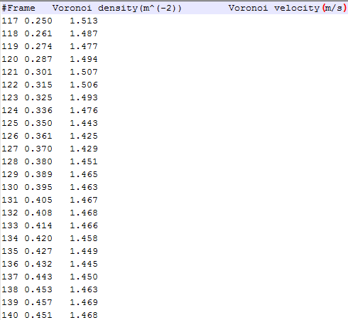

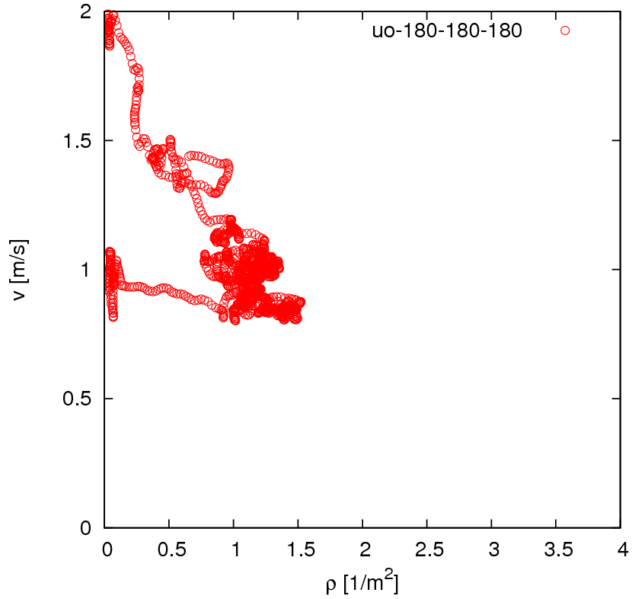 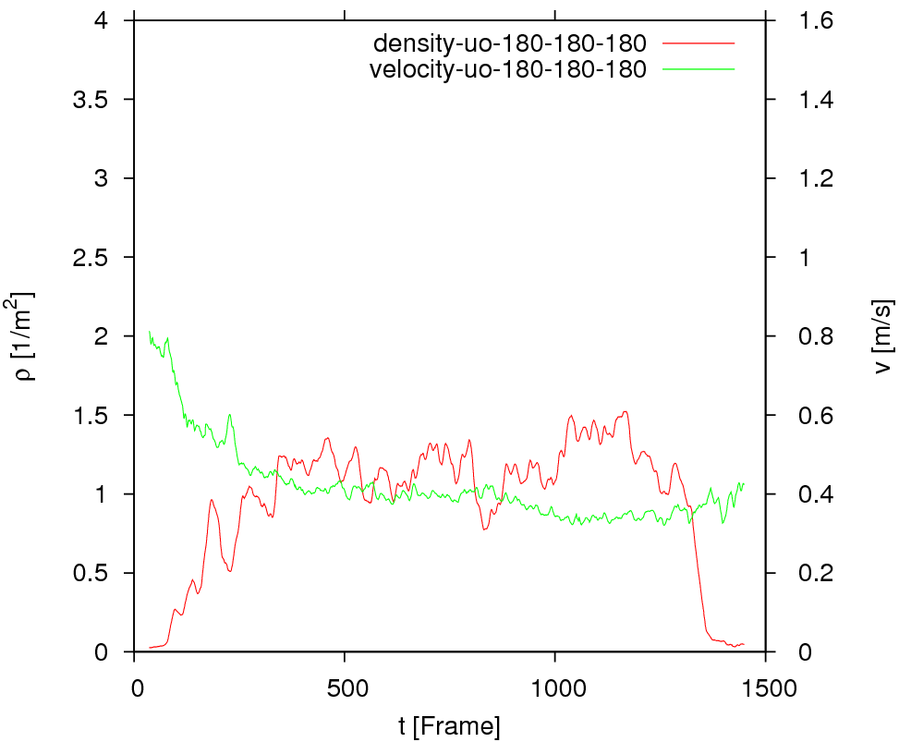

* Data for plotting Voronoi cells

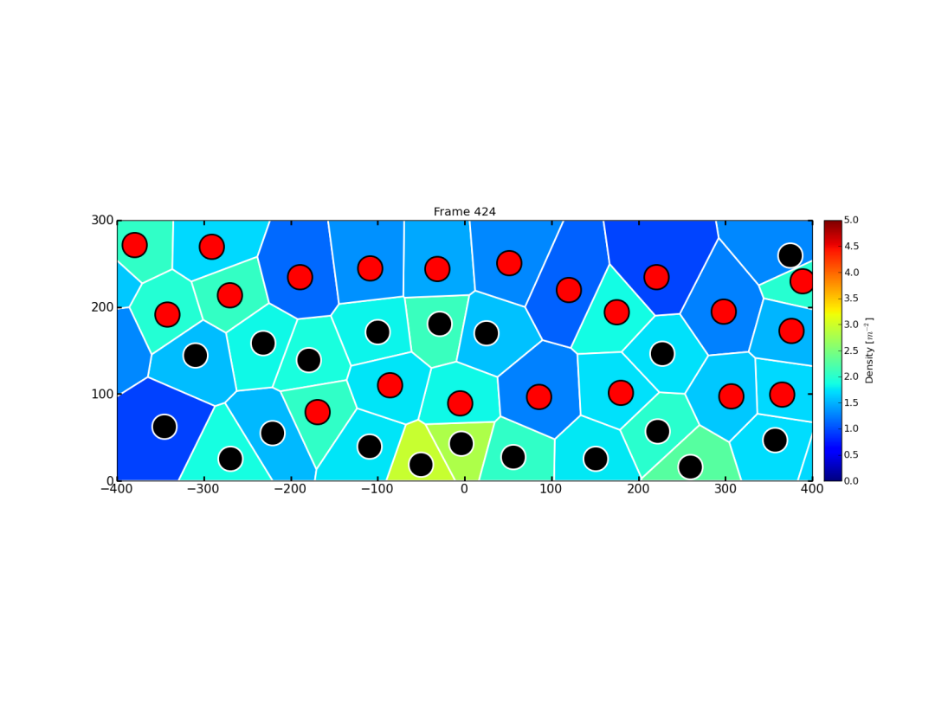

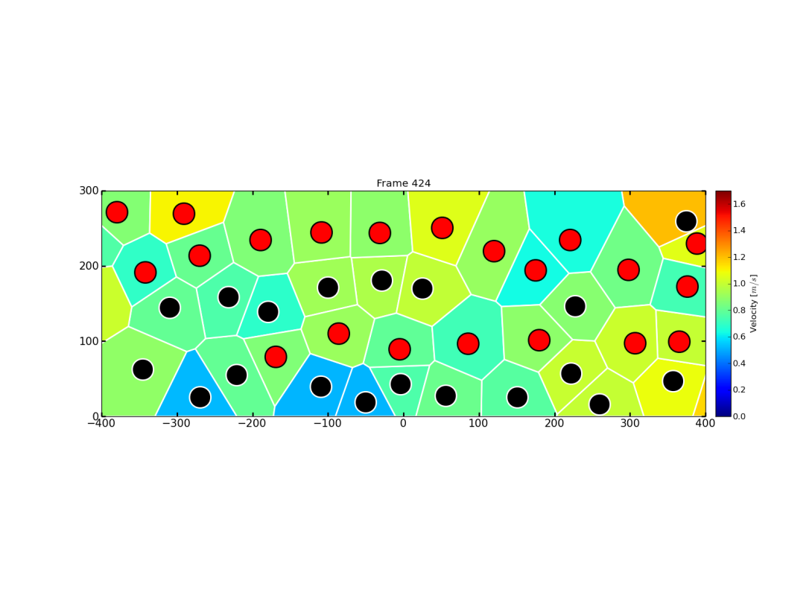

* Data for plotting profiles

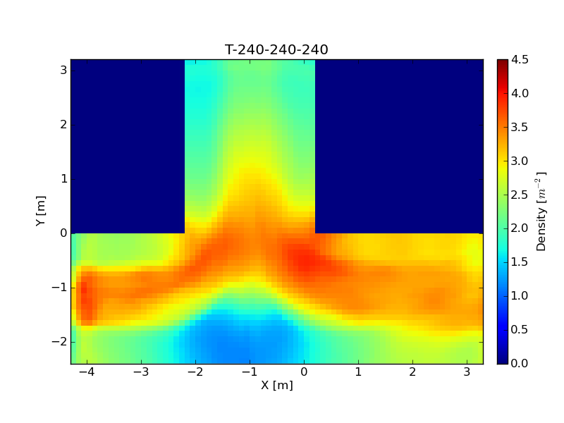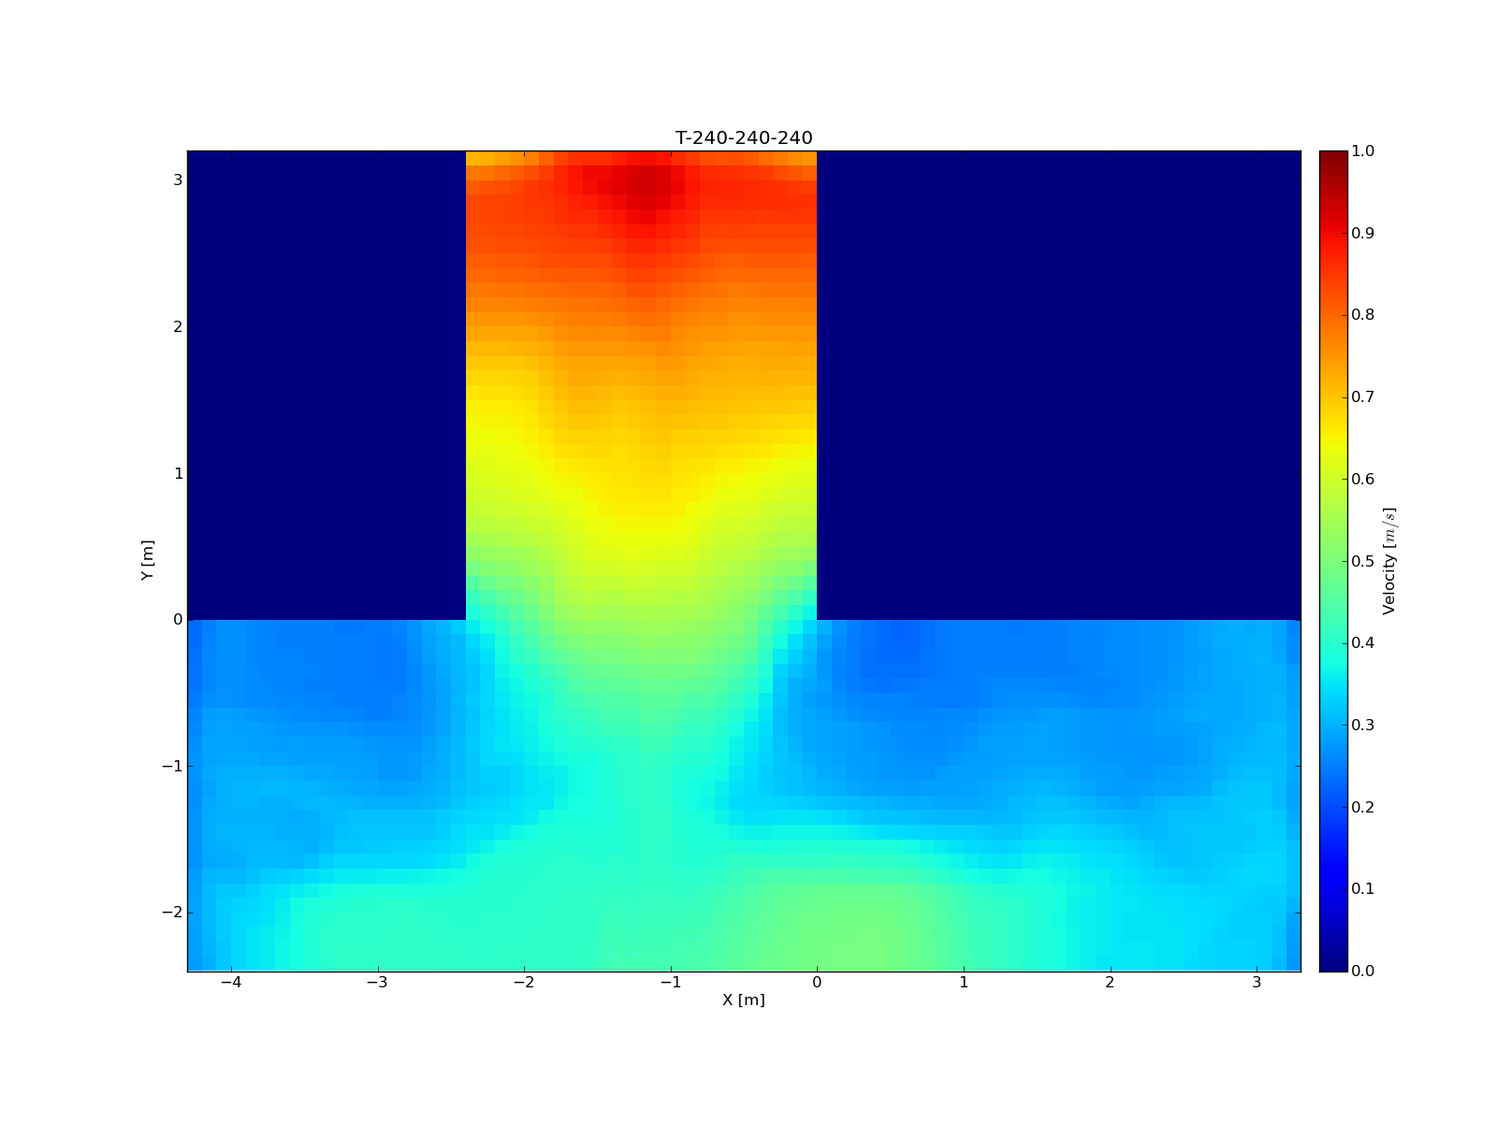

* Individual FD

