**Project Title:** TaskHub

* **Members:** Justin Alvey, Sean O'Neal, Brandon Spitler, and Lucy Wilkinson
* **Project Tracker:** Trello

**Link:** [**https://trello.com/b/RvlwbWtg/csci-3308-project**](https://trello.com/b/RvlwbWtg/csci-3308-project)

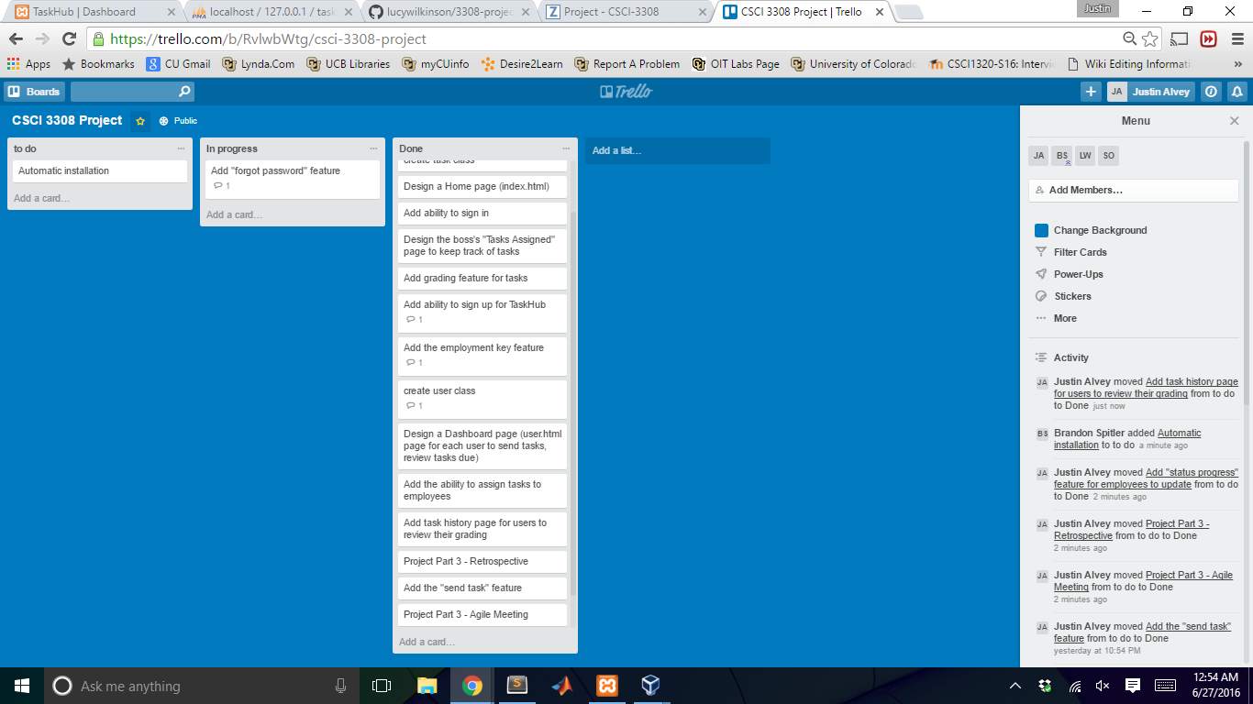

* **Video Demonstration:**
* **VCS:**
  + **Link:** [**https://github.com/lucywilkinson/3308-project**](https://github.com/lucywilkinson/3308-project)
  + **Source Code:**

1. All folders (bootstrap, css, dist, font-awesome, fonts, functions, img, includes, js, pages, plugins, scss, styles, template)
2. index.php
3. home.php
4. editTask.php
5. addingTaskPopUp.php
6. login.php
7. network.php
8. user_input.php
9. tasks_sent_dash.php
10. change_grade.php
11. emp_req.php
12. Insert_emp.php

**Note: For more information on how the code runs and works together,**

**see our README.md file:**

**(**[**https://github.com/lucywilkinson/3308-project/blob/master/README.md**](https://github.com/lucywilkinson/3308-project/blob/master/README.md)**)**

* **Auto-doc Documents:** 
  + **Doxygen was used**
  + **Link to Generated Docs:**
    - [**https://github.com/lucywilkinson/3308-project/tree/master/AutoDocHTML**](https://github.com/lucywilkinson/3308-project/tree/master/AutoDocHTML)
  + **Link to Generate HTML Pages:**
    - [**http://lucywilkinson.github.io/3308-project/**](http://lucywilkinson.github.io/3308-project/)
  + **If the links don’t open correctly, try retyping them as github doesn’t like PDFs for some reason**
* **Video of Demo:**
* **READMe.md:**
  + [**https://github.com/lucywilkinson/3308-project/blob/master/README.md**](https://github.com/lucywilkinson/3308-project/blob/master/README.md)
* **This Project Part 4 Document:**
  + [**https://github.com/lucywilkinson/3308-project/blob/master/TaskHub_Part4Finish.pdf**](https://github.com/lucywilkinson/3308-project/blob/master/TaskHub_Part4Finish.pdf)
* **GitHub Contributions:**

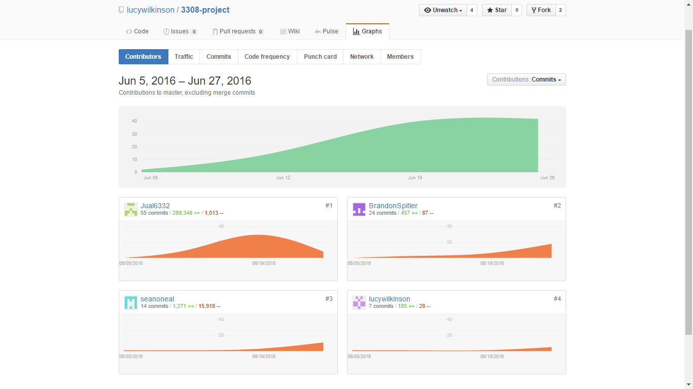

* **Deployment Environment:**
  + **Taskhub makes use of the LAMP stack in software development**
    - Linux, Apache, MySQL, and PHP
  + **Linux operating system**
  + **Apache local server**
  + **MySQL for database management**
  + **PHP scripting language to connect to mysql database and webpage**
  + **TaskHub was not concretely deployed to an online server**
    - ***TaskHub.site is coming soon***
    - But for now, TaskHub is run on a local Apache server
    - Xampp is a popular platform used for this project, and runs both Apache and MySQL
      * From the control panel, click “Start” for both Apache and MySQL
  + **For step-by-step instructions in running this software locally, see the “Deployment ” section of the ReadME.md file**
    - **TaskHub also works on Windows. Setup is** [**here**](https://github.com/lucywilkinson/3308-project/blob/master/README.md#deployment-environment-setup---windows)