Practica 1

Jose Navarro Cervantes

Ing. Mecatrónica

8°B T/M

Cinemática de robots

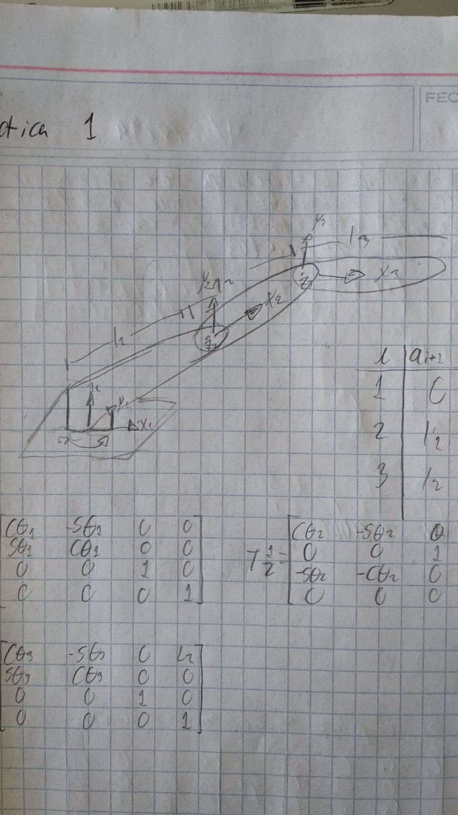

|  |  |  |  |  |
| --- | --- | --- | --- | --- |
| i | ai-1 |  | di |  |
| 1 | 0 | -90 | 0 |  |
| 2 | L1 | 0 | 0 |  |
| 3 | L2 | 0 | 0 |  |

