**mpbMathDebounce.c**

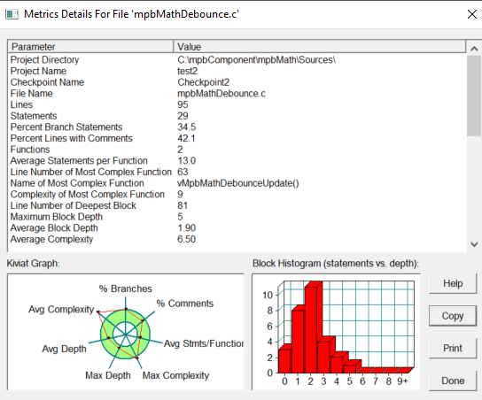

|  |  |  |  |  |  |  |  |
| --- | --- | --- | --- | --- | --- | --- | --- |
| Max. complexity | | Nesting level | | Number of statements | | Comment frequency | |
| objective | Real metrics | objective | Real metrics | objective | Real metrics | objective | Real metrics |
| <=15 | 9 | <=5 | 5 | <=100 | 29 | >20% | 42.1 |