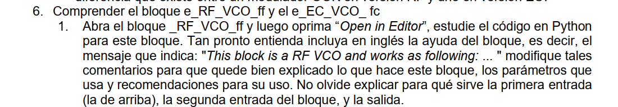

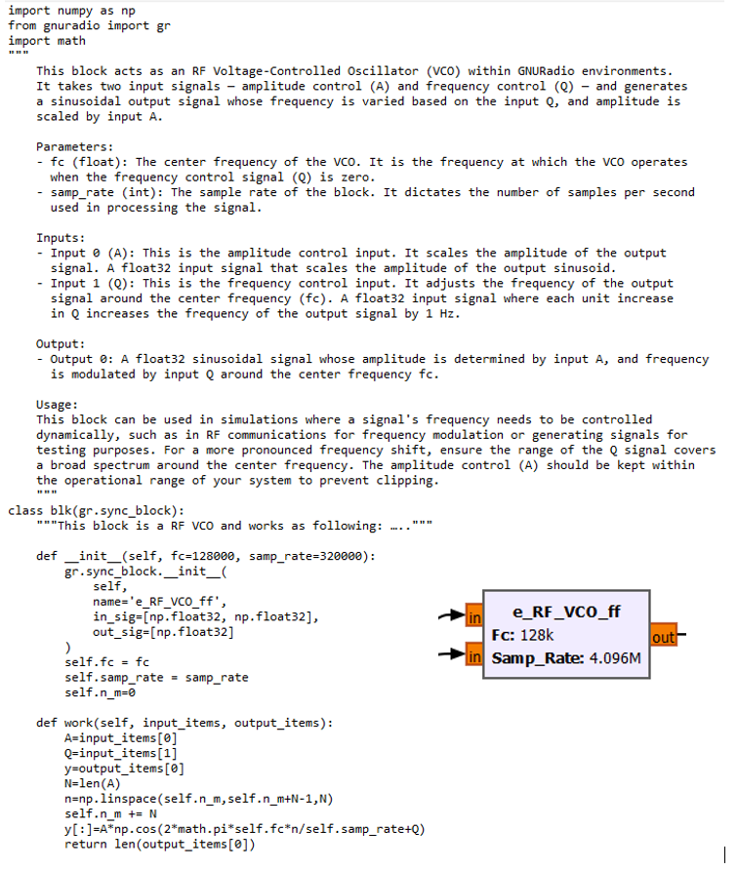

Figura 11x. Descripción bloque e_RF_VCO_ff.



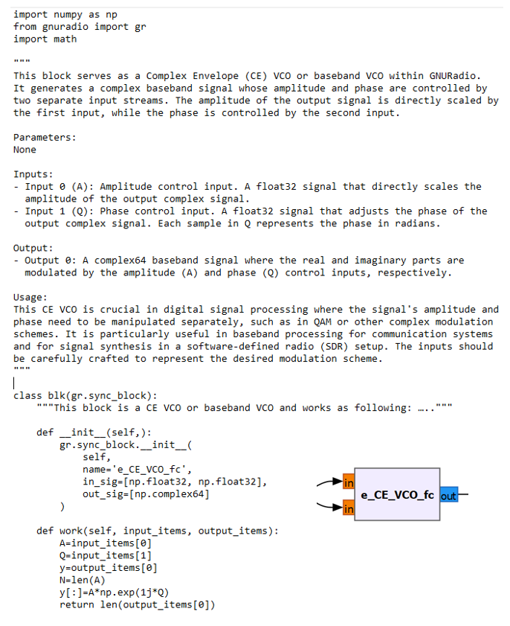

Figura 12x. Descripción bloque e_CE_VCO_fc.

Con el fin de comprender el funcionamiento de los bloques mencionados anteriormente, se analizó detenidamente el código del bloque, también realizando múltiples pruebas y se consultó información disponible en la web, posteriormente se realizó una descripción con el propósito de especificar el funcionamiento de los bloques, así como de brindar ayuda para sus usos. A continuación, se presentan los textos incluidos para cada bloque.



1. **Bloque e_RF_VCO_ff:**

This block functions as an RF Voltage-Controlled Oscillator (VCO) within GNU Radio. It processes two inputs, amplitude control (A) and frequency control (Q), to produce a sinusoidal output. The output's frequency is varied by the input Q, while its amplitude is scaled by input A.

Parameters:

* fc (float): Center frequency for the VCO, active when Q is zero.
* samp_rate (int): The block's sample rate, dictating processing samples

per second.

Inputs:

* Input 0 (A): Amplitude control. Float32 that scales the output's amplitude.
* Input 1 (Q): Frequency control. Float32 where each unit increases the output frequency by 1 Hz.

Output:

* Output 0: Float32 sinusoidal signal, amplitude determined by A, and frequency modulated by Q around fc.

Usage:

Ideal for simulations where dynamic frequency control is needed, such as in RF comms. The Q input's range should be set to cover the desired frequency spectrum. Keep the A input within your system's range to avoid clipping.

1. **Bloque e_CE_VCO_fc.**

This block serves as a Complex Envelope (CE) VCO or baseband VCO within GNURadio.It generates a complex baseband signal whose amplitude and phase are controlled by two separate input streams. The amplitude of the output signal is directly scaled by the first input, while the phase is controlled by the second input.

Parameters:

None

Inputs:

* Input 0 (A): Amplitude control input. A float32 signal that directly scales the amplitude of the output complex signal.
* Input 1 (Q): Phase control input. A float32 signal that adjusts the phase of the output complex signal. Each sample in Q represents the phase in radians.

Output:

* Output 0: A complex64 baseband signal where the real and imaginary parts are modulated by the amplitude (A) and phase (Q) control inputs, respectively.

Usage:

This CE VCO is crucial in digital signal processing where the signal's amplitude and pase need to be manipulated separately, such as in QAM or other complex modulation schemes. It is particularly useful in baseband processing for communication system and for signal ynthesis in a software-defined radio (SDR) setup. The inputs should be carefully crafted to represent he desired modulation scheme.