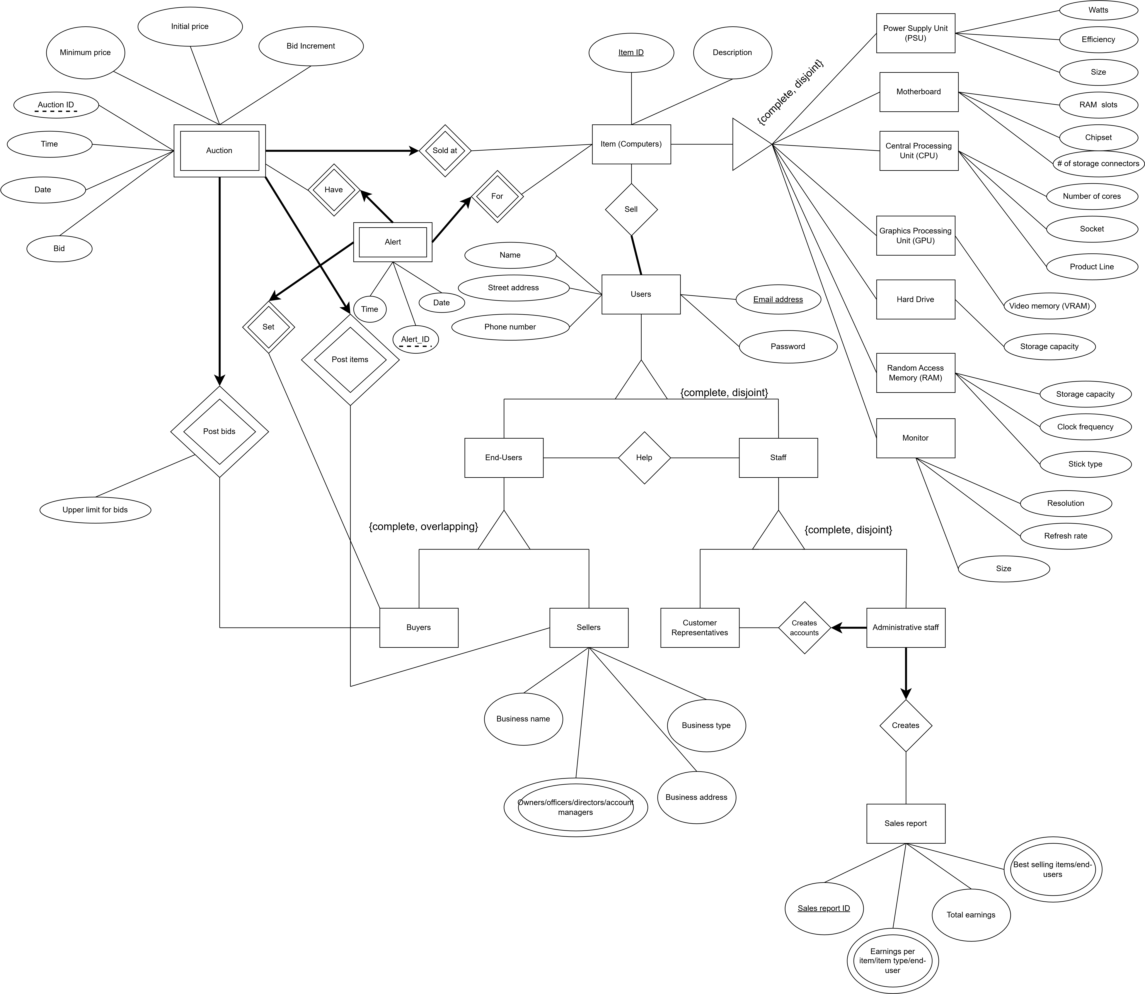

ER Diagram:

Relational Schema:

Auction(AuctionID: int, EndAuction: datetime, MinimumPrice: float, BidIncrement: float, InitialPrice: float, Seller: varchar(100), CurrentBid: float, CurrentBuyer: varchar(100), itemid: int, primarykey(AuctionID, CurrentBid, itemid), foreign key(Seller) references Users, foreign key (CurrentBuyer) references Users, foreign key(item) references Item).

Item(itemID: int, Description: varchar(100), isPSU: boolean, watts: float, efficiency: float, size: float, isMotherboard: bool, RAMSlots: int, Chipset: varchar(10), numStorageConnectors: int, isCPU: boolean, numCores: int, socket: varchar(20), productLine: varchar(20), isGPU: boolean, VRAM: int, isHD: boolean, storagesize: int, isRAM: boolean, ramcapacity: int, clockfrequency: float, sticktype: varchar(25), isMonitor: boolean, monitorSize: float, refreshrate: int, resolution: varchar(20), primary key(intemID))

Sell(itemID: int, email_address:varchar(100), primary key(itemID, email_address), foreign key(itemID) references Item, foreign key(email_address) references Users)

Users(name: varchar(100), street_address:varchar(300), phone_number: varchar(15), email_address:varchar(100), password:varchar(30), primary key(email_address))

End-users(name: varchar(100), street_address:varchar(300), phone_number: varchar(15), email_address:varchar(100), password:varchar(30), business_name:varchar(100), owners:varchar(100), officers:varchar(100), directors:varchar(100), account_managers:varchar(100), business_address:varchar(300), business_type:varchar(100), primary key(email_address))

Staff(name: varchar(100), street_address:varchar(300), phone_number: varchar(15), email_address:varchar(100), password:varchar(30), primary key(email_address))

Help(staff_email: varchar(100), user_email:varchar(100), primary key(staff_email, user_email), foreign key(staff_email) references Staff, foreign key(user_email) references End-user)

Customer_representative(name: varchar(100), street_address:varchar(300), phone_number: varchar(15), email_address:varchar(100), password:varchar(30), primary key(email_address))

Administrative_staff(name: varchar(100), street_address:varchar(300), phone_number: varchar(15), admin_email_address:varchar(100), customer_rep_email:varchar(100), password:varchar(30), sales_report_ID:int, primary key(admin_email_address), foreign key(sales_report_ID) references Sales_report, foreign key(customer_rep_email) references Customer_representative not null)

Sales_report(sales_report_ID:int, total_earnings:float, best_selling_item:varchar(100), best_selling_user:varchar(100), earnings_per_item:float, earnings_per_type:float, earnings_per_end_user:float, primary key(sales_report_ID))

Alert(alert_ID:int, auction_ID:int, item_ID:int, buyer_email_address:varchar(100), time:datetime, date:datetime, primary key(alert_ID, auction_ID, item_ID, buyer_email_address), foreign key(auction_ID) references Auction, foreign key(item_ID) references Item, foreign key(buyer_email_address) references End_users)