**Week 2 Module 2.3 Assignment**

Juan Macias Vasquez

Bellevue University

CSD310-H323 Database Development and Use (2255-DD)

**Adam Bailey**

June 8th, 2025

Module 2.3 Assignment

**Assignment: Business Rules Paradigm & NoSQL data structure**

**Business Rules Paradigm**

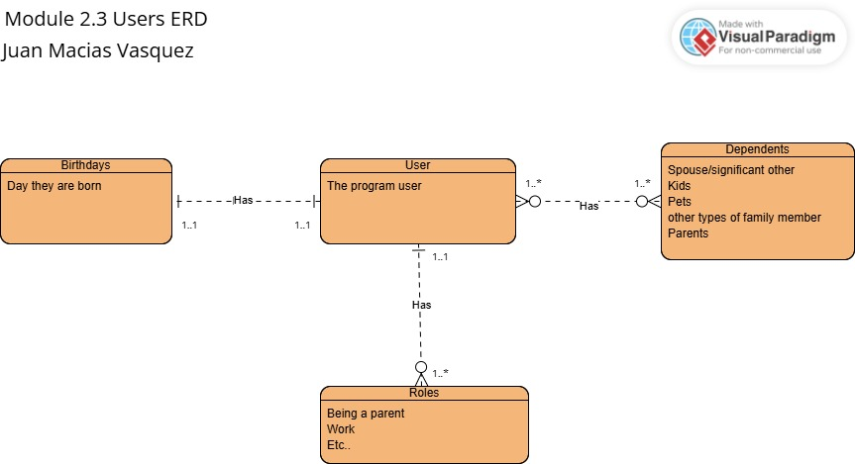

Made in Visual Paradigm online

<https://online.visual-paradigm.com/diagrams/features/erd-tool/>

**NoSQL data structure**

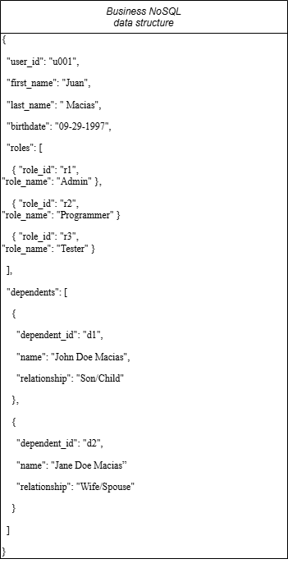

Made in Draw.io

**Text version**

{

"user_id": "u001",

"first_name": "Juan",

"last_name": " Macias",

"birthdate": "09-29-1997",

"roles": [

{ "role_id": "r1", "role_name": "Admin" },

{ "role_id": "r2", "role_name": "Programmer" }

{ "role_id": "r3", "role_name": "Tester" }

],

"dependents": [

{

"dependent_id": "d1",

"name": "John Doe Macias",

"relationship": "Son/Child"

},

{

"dependent_id": "d2",

"name": "Jane Doe Macias”

"relationship": "Wife/Spouse"

}

]

}