**Week 5 Module 6.2 Assignment Movies: Setup**

Juan Macias Vasquez

Bellevue University

CSD310-H323 Database Development and Use (2255-DD)

**Adam Bailey**

June 28th, 2025

Module 6.2 Assignment Movies: Setup

Lines after running SQL script

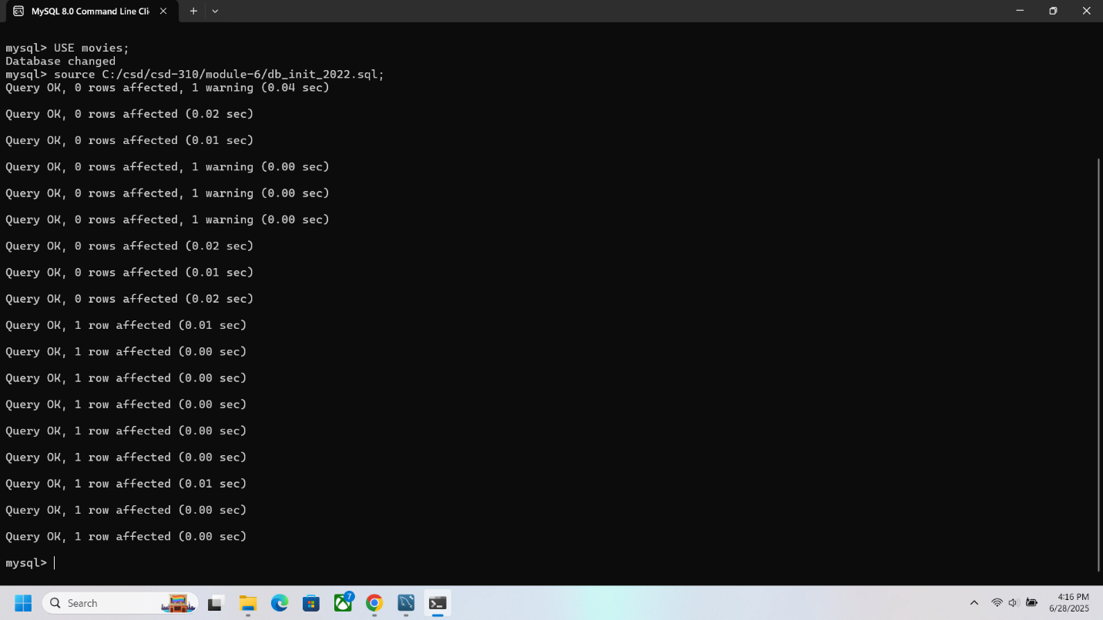

Movies after table update

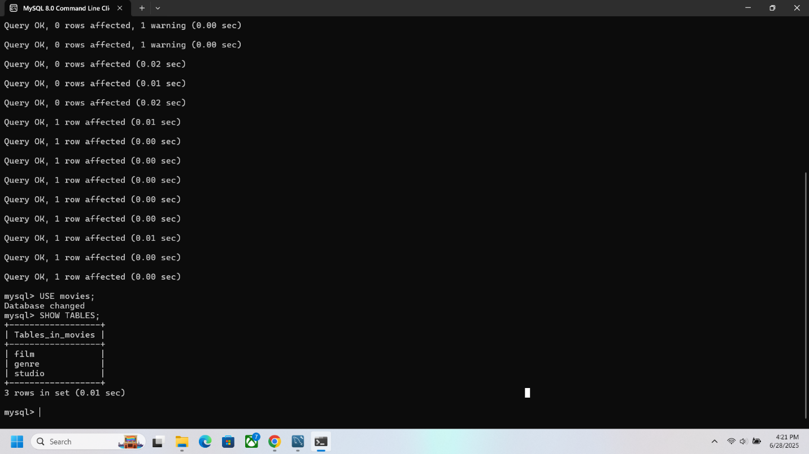

Python program mysql_test after running 