**Week 7 Module 10.2 Assignment: GUI ToDo**

Juan Macias Vasquez

Bellevue University

CSD325-H323 Advanced Python (2255-DD)

**Jack Lusby**

July 13th, 2025

Module 10.2 Assignment: GUI ToDo

Results Document

Pictures of original code testing

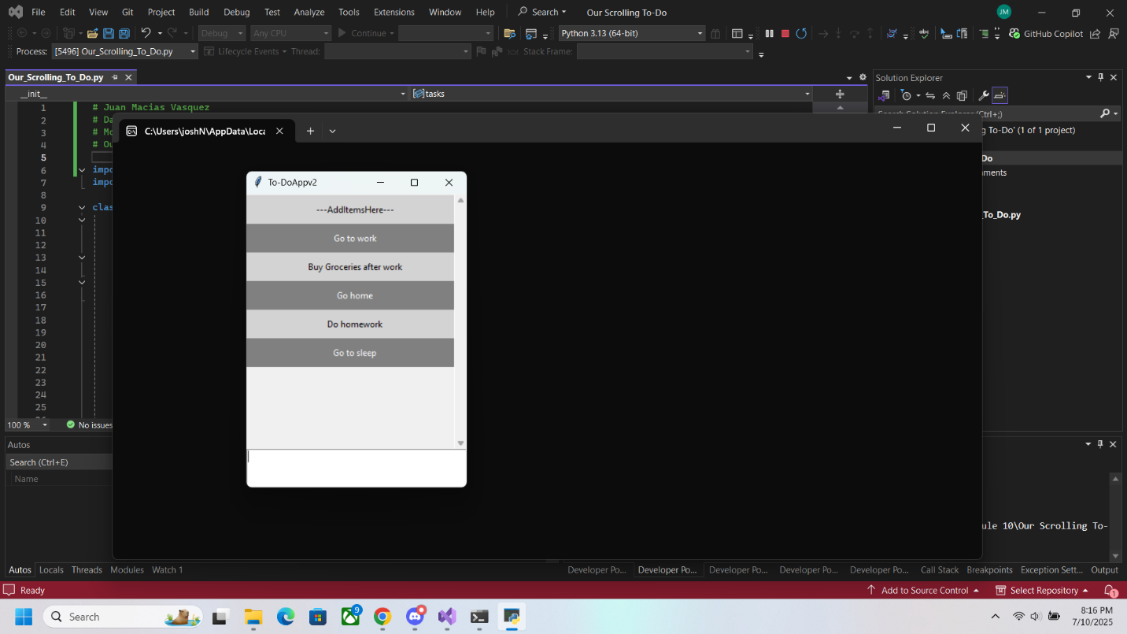

**Code of New version**

Changes to color, easier way to exit, and right click to delete task

# Juan Macias Vasquez

# Date 07/10/2025

# Module 10.2 GUI ToDo

# Macias_To-Do.py

import tkinter as tk

import tkinter.messagebox as msg

class Todo(tk.Tk):

def __init__(self, tasks=None):

super().__init__()

if not tasks:

self.tasks = []

else:

self.tasks = tasks

# Set title and size

self.title("Macias-ToDo") # Replaced with my last name

self.geometry("300x400")

# Create menu bar

menubar = tk.Menu(self, bg="purple", fg="white")

file_menu = tk.Menu(menubar, tearoff=0, bg="yellow", fg="black")

file_menu.add_command(label="Exit", command=self.destroy)

menubar.add_cascade(label="File", menu=file_menu)

self.config(menu=menubar)

# Scrollable canvas and frames

self.tasks_canvas = tk.Canvas(self)

self.tasks_frame = tk.Frame(self.tasks_canvas)

self.text_frame = tk.Frame(self)

self.scrollbar = tk.Scrollbar(self.tasks_canvas, orient="vertical", command=self.tasks_canvas.yview)

self.tasks_canvas.configure(yscrollcommand=self.scrollbar.set)

self.task_create = tk.Text(self.text_frame, height=3, bg="white", fg="black")

self.tasks_canvas.pack(side=tk.TOP, fill=tk.BOTH, expand=1)

self.scrollbar.pack(side=tk.RIGHT, fill=tk.Y)

self.canvas_frame = self.tasks_canvas.create_window((0, 0), window=self.tasks_frame, anchor="n")

self.task_create.pack(side=tk.BOTTOM, fill=tk.X)

self.text_frame.pack(side=tk.BOTTOM, fill=tk.X)

self.task_create.focus_set()

# Instructional label

todo1 = tk.Label(

self.tasks_frame,

text="--- Items Added --- ** Right Click Item to Delete **",# Instructions in the label on how to delete a task.

bg="purple", fg="white", pady=10

)

todo1.bind("<Button-3>", self.remove_task)

self.tasks.append(todo1)

for task in self.tasks:

task.pack(side=tk.TOP, fill=tk.X)

# Event bindings

self.bind("<Return>", self.add_task)

self.bind("<Configure>", self.on_frame_configure)

self.bind_all("<MouseWheel>", self.mouse_scroll)

self.bind_all("<Button-4>", self.mouse_scroll)

self.bind_all("<Button-5>", self.mouse_scroll)

self.tasks_canvas.bind("<Configure>", self.task_width)

self.colour_schemes = [{"bg": "purple", "fg": "white"}, {"bg": "gold", "fg": "black"}] #Menu and submenu with complementary colors (e.g., purple + yellow/gold).

def add_task(self, event=None):

task_text = self.task_create.get(1.0, tk.END).strip()

if len(task_text) > 0:

new_task = tk.Label(self.tasks_frame, text=task_text, pady=10)

self.set_task_colour(len(self.tasks), new_task)

new_task.bind("<Button-3>", self.remove_task) #Task deletion is triggered by right-click (<Button-3>).

new_task.pack(side=tk.TOP, fill=tk.X)

self.tasks.append(new_task)

self.task_create.delete(1.0, tk.END)

def remove_task(self, event):

task = event.widget

if msg.askyesno("Really Delete?", "Delete '" + task.cget("text") + "'?"):

self.tasks.remove(task)

task.destroy()

self.recolour_tasks()

def recolour_tasks(self):

for index, task in enumerate(self.tasks):

self.set_task_colour(index, task)

def set_task_colour(self, position, task):

_, task_style_choice = divmod(position, 2)

scheme = self.colour_schemes[task_style_choice]

task.configure(bg=scheme["bg"], fg=scheme["fg"])

def on_frame_configure(self, event=None):

self.tasks_canvas.configure(scrollregion=self.tasks_canvas.bbox("all"))

def task_width(self, event):

canvas_width = event.width

self.tasks_canvas.itemconfig(self.canvas_frame, width=canvas_width)

def mouse_scroll(self, event):

if event.delta:

self.tasks_canvas.yview_scroll(int(-1 * (event.delta / 120)), "units")

else:

move = 1 if event.num == 5 else -1

self.tasks_canvas.yview_scroll(move, "units")

if __name__ == "__main__":

todo = Todo()

todo.mainloop()

**Pictures of updated version**

Adding to the list with new colors

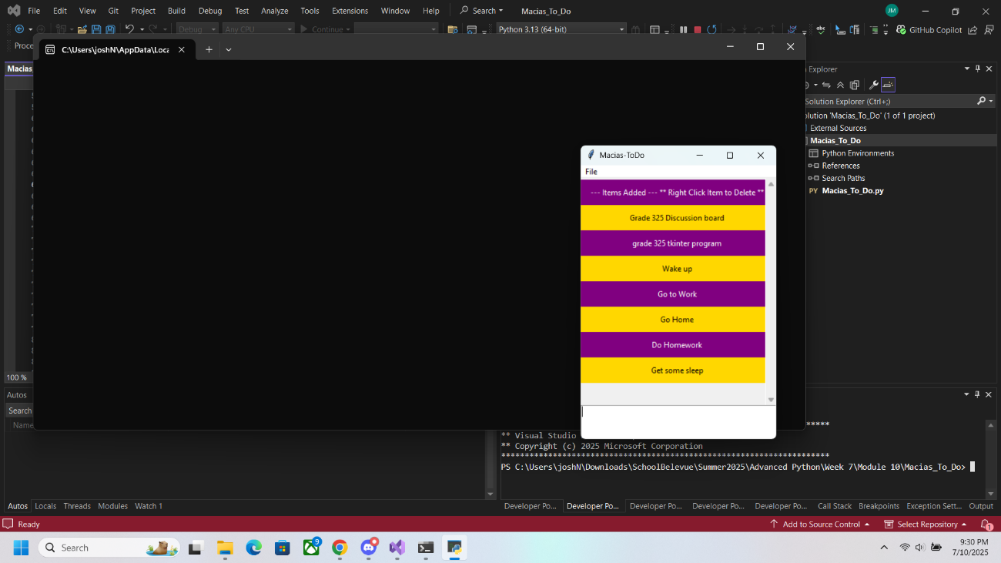

Showing the new File exit button

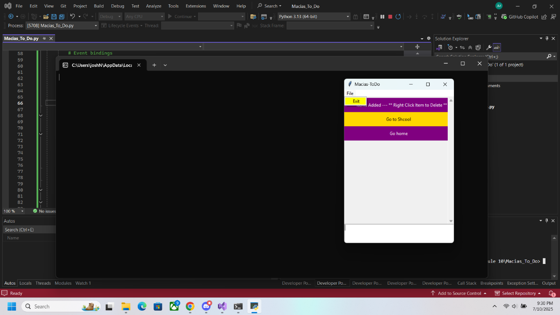

Showing the delete task from to do list

