**Week 8 Module 11.2 Assignment Django Basics**

Juan Macias Vasquez

Bellevue University

CSD325-H323 Advanced Python (2255-DD)

**Jack Lusby**

July 20th, 2025

Module 11.2 Assignment Django Basics

Showing directory

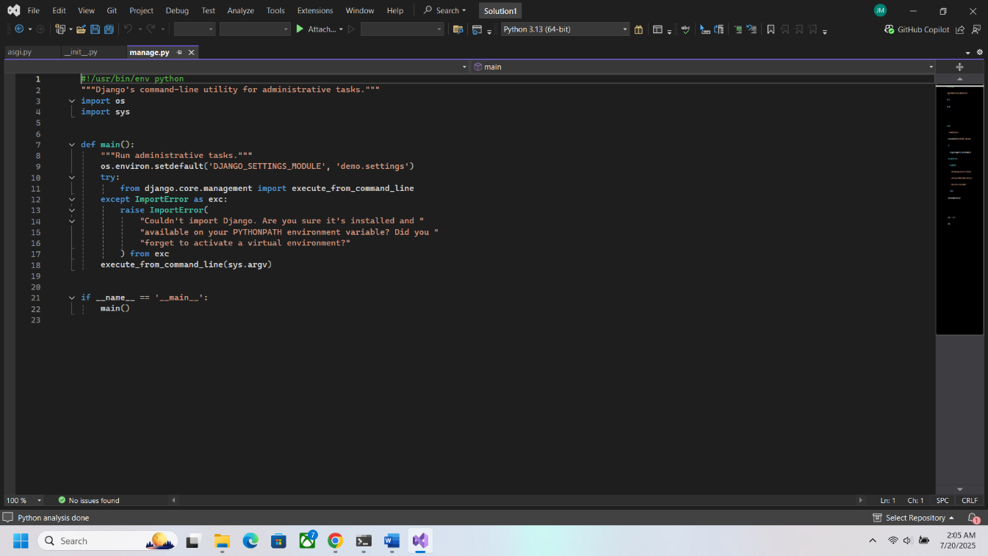

Showing Python files

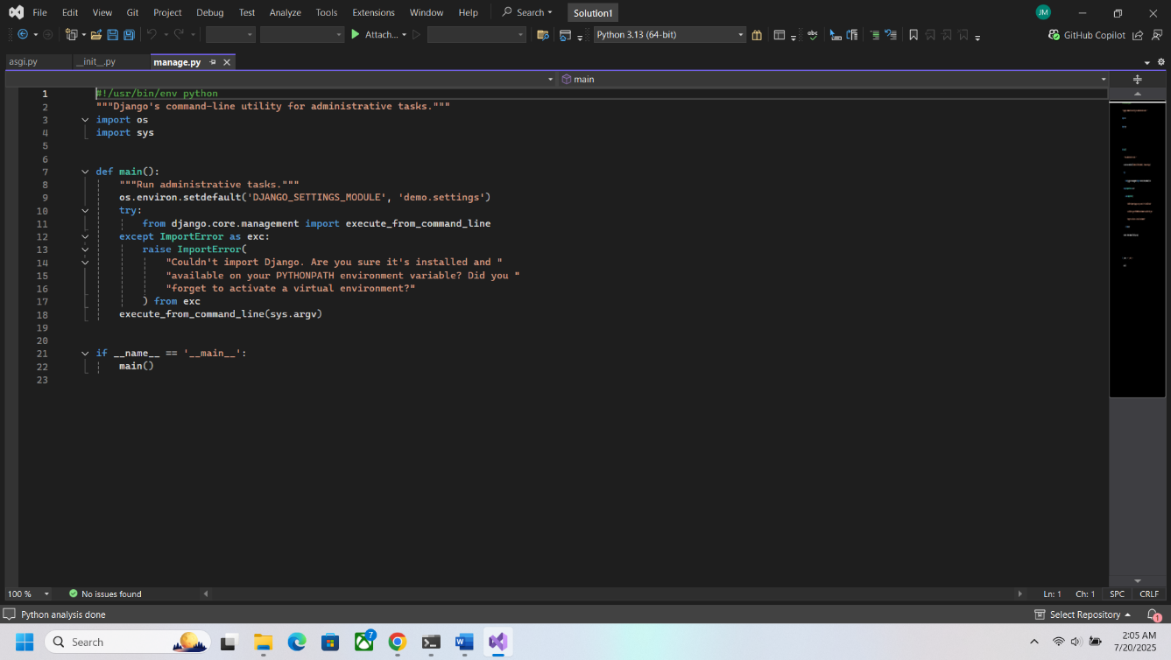

With DIR function from windows

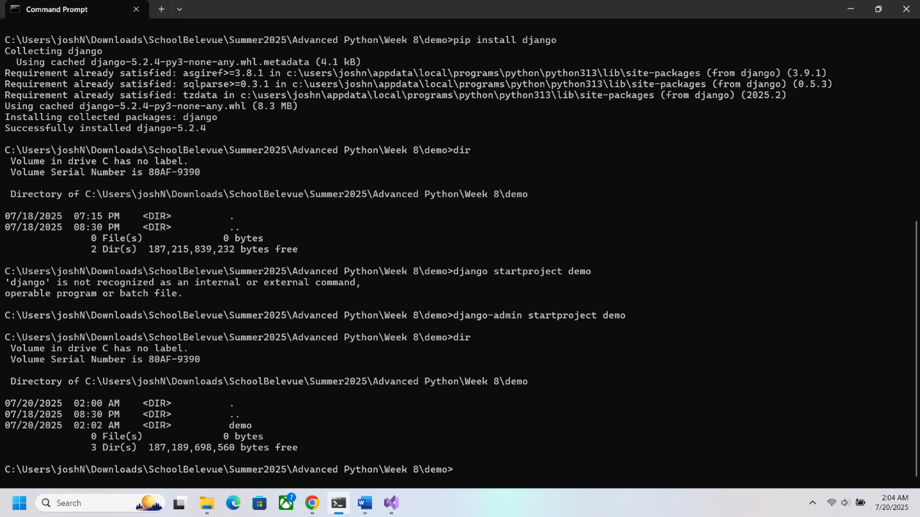

Showing the Django website running from program

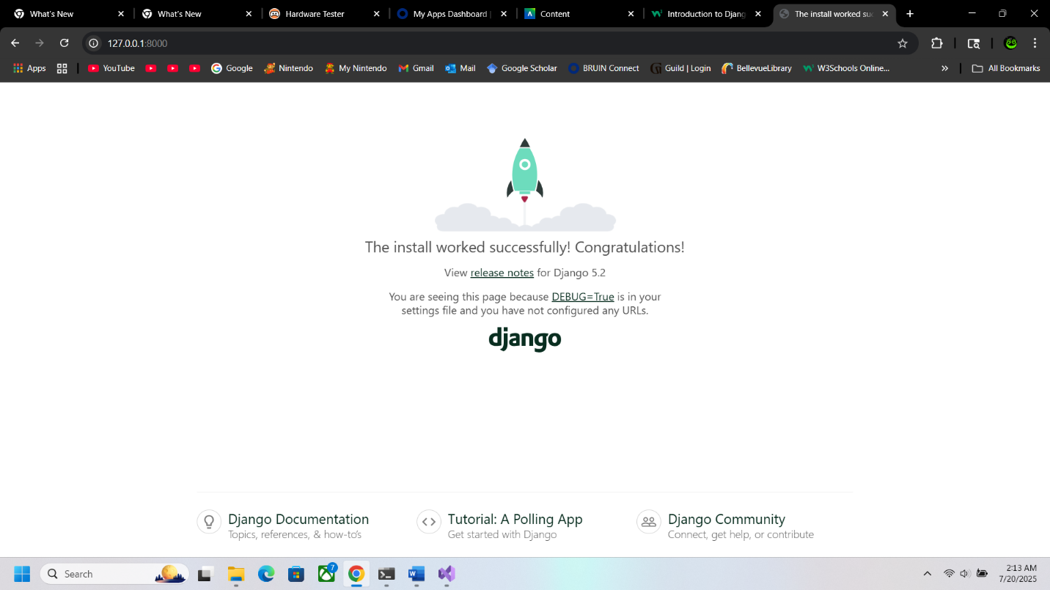

Macias says Hello!

