**Week 6 Module 9.** **2 Assignment: APIs**

Juan Macias Vasquez

Bellevue University

CSD325-H323 Advanced Python (2255-DD)

**Jack Lusby**

July 4th, 2025

Module 9.2 Assignment: APIs

Results Document

Part 1 status code

Code of program

# Juan Macias Vasquez

# Date 07/05/2025

# Module 9.2 APIs

# api_test_connection.py

import requests

response = requests.get('http://www.google.com')

print("Status Code:", response.status_code)

Picture of code running

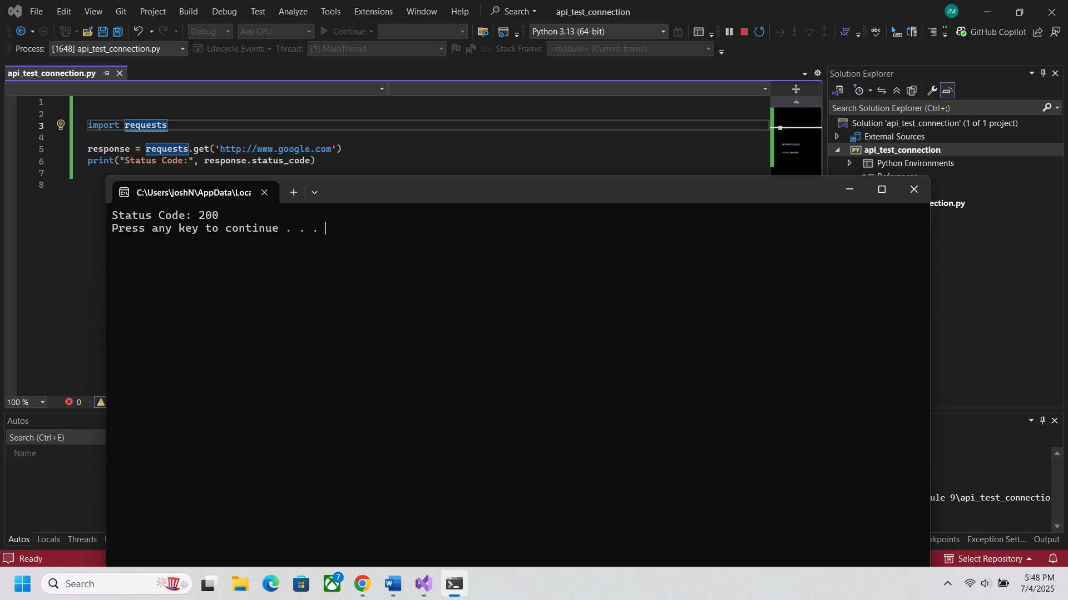

Part 2 Retrieving Current Astronauts

Using this end point

<http://api.open-notify.org/astros.json>

Code of program

# Juan Macias Vasquez

# Date 07/05/2025

# Module 9.2 APIs

# current_astronauts.py

import requests

# API endpoint for current astronauts

url = 'http://api.open-notify.org/astros.json'

response = requests.get(url)

# Test connection

print("Status Code:", response.status_code)

# Raw output

print("Raw Response:", response.text)

# Pretty formatted output

if response.status_code == 200: # to know its connecting right

data = response.json()

print("\nThere are", data['number'], "people in space:\n")

for person in data['people']:

print(person['name'], "on", person['craft'])

Picture of code running

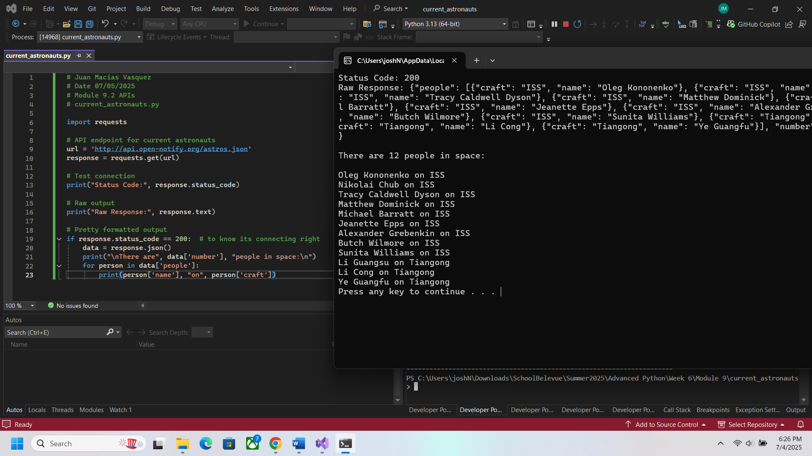

Part 3

Using this end point

Ice and Fire: <https://anapioficeandfire.com/api/characters/583>

Code of program

# Juan Macias Vasquez

# Date 07/05/2025

# Module 9.2 APIs

# ice_and_fire_api_example.py

import requests

# Ice and Fire API - Get data about Jon Snow (character 583)

url = "https://anapioficeandfire.com/api/characters/583"

# Step 1: Test the connection

response = requests.get(url)

print("Status Code:", response.status_code)

# Step 2: Print raw JSON response

print("\nRaw Response:")

print(response.text)

# Step 3: Print formatted output

if response.status_code == 200:

data = response.json()

print("\nFormatted Response:")

print("Name:", data['name'])

print("Gender:", data['gender'])

print("Culture:", data['culture'])

print("Born:", data['born'])

print("Died:", data['died'] if data['died'] else "Still alive")

print("Titles:", ", ".join(data['titles']) if data['titles'] else "No titles")

print("Aliases:", ", ".join(data['aliases']) if data['aliases'] else "No aliases")

Picture of code running

