**Week 1 Module 1.3 Assignment**

Juan Macias Vasquez

Bellevue University

CSD340-H323 Web Development with HTML and (2261-DD)

**Adam Bailey**

August 15th, 2025

Module 1.3 Assignment GitHub

**GitHub Link**

<https://github.com/Juan551School/csd-340>

**First run with Errors in HTML code**

Errors Shown

1. **Error: Element**title**must not be empty.**

[From line 4, column 12; to line 4, column 19](https://validator.w3.org/nu/#l4c19)

<title></title>↩</hea

1. **Error: Saw an end tag after**body**had been closed.**

[From line 11, column 1; to line 11, column 7](https://validator.w3.org/nu/#l11c7)

↩</body>↩↩</thml>

1. **Error: Stray end tag**thml**.**

[From line 11, column 1; to line 11, column 7](https://validator.w3.org/nu/#l11c7)

↩</body>↩↩</thml>

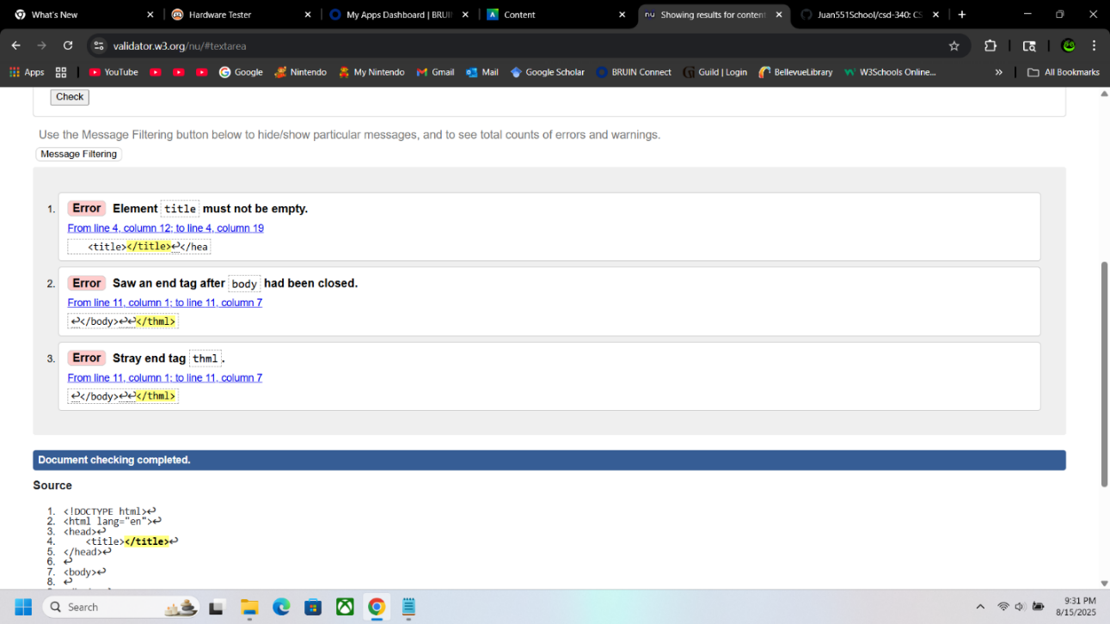

**Updated with no errors**

Code:

<!DOCTYPE html>

<html lang="en">

<head>

<meta charset="UTF-8">

<title>Assignment 1.2</title>

</head>

<body>

</body>

</html>

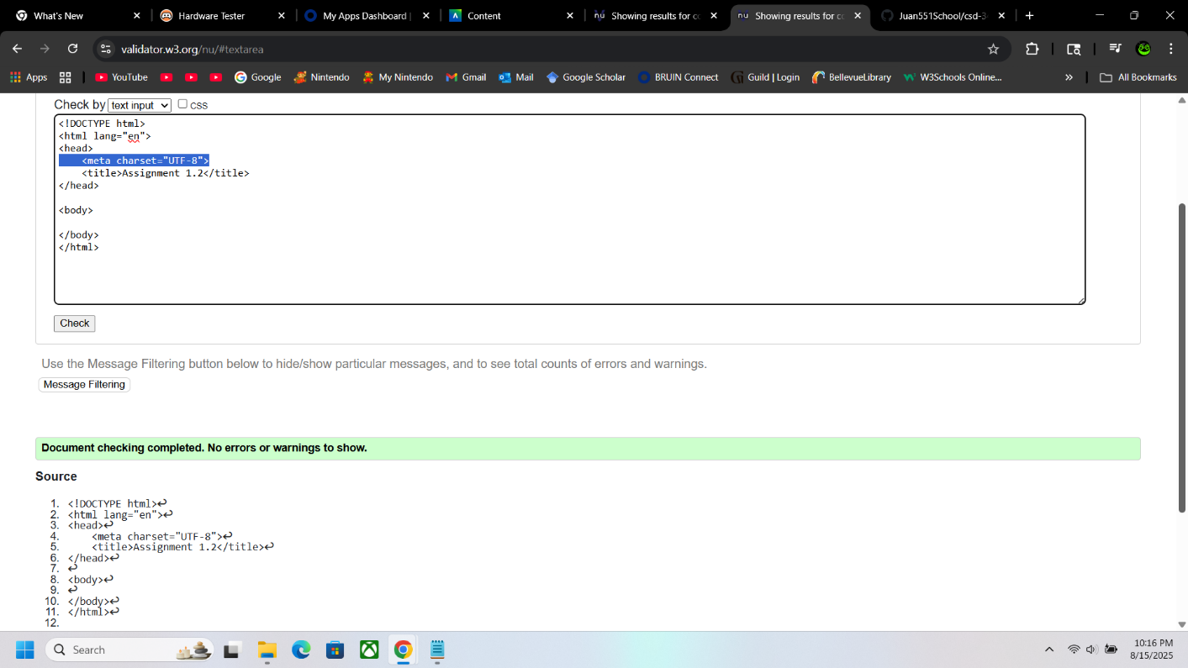

**Final Version with updates**

<!DOCTYPE html>

<html lang="en">

<head>

<meta charset="UTF-8">

<title>CSD 340 Web Development with HTML and CSS</title>

</head>

<body>

<h1>Assignment 1.3 – Building a Web Page Exercise, Part 1</h1>

<p>Today’s weather in Arvada, Colorado, is 85&deg;F and sunny.</p>

</body>

</html>

