**Week 6 Module 9.3 Assignment**

Juan Macias Vasquez

Bellevue University

CSD340-H323 Web Development with HTML and CSS (2261-DD)

**Adam Bailey**

September 20th, 2025

**Module 9.3**

**JavaScript Exercise, Part 1**

**GitHub Repository Link**

<https://github.com/Juan551School/csd-340>

**Link to GitHub pages landing page**

<https://juan551school.github.io/csd-340/>

**Project 9.3 Page**

<https://juan551school.github.io/csd-340/module-9/Macias_Mod9_3.html>

**HTML Code Macias_Mod9_3.html**

<!-- Juan Carlos Macias Vasquez

Week 6 Module 9.3 Assignment

CSD340-H323 Web Development with HTML and CSS(2261-DD)

September 21st, 2025

JavaScript Exercise, Part 1

Html file

-->

<!DOCTYPE html>

<html lang="en">

<head>

<meta charset="UTF-8">

<meta name="author" content="Juan Macias">

<meta name="description" content="Assignment 9.3 – JavaScript Part 1">

<meta name="viewport" content="width=device-width, initial-scale=1.0">

<title>CSD 340 Web Development with HTML and CSS</title>

<!-- Link to external CSS -->

<link rel="stylesheet" href="Macias_Mod9_3.css">

<script>

// Four variables for blanks

var firstWord = "journey";

var secondWord = "family";

var thirdWord = "learning";

var fourthWord = "future";

</script>

</head>

<body>

<div id="container">

<h1>Assignment 9.3: JavaScript - Part 1</h1>

<h2>About Me</h2>

<p class="intro">

Hello, my name is Juan Macias Vasquez and my academic <span id="journey">_________</span> has been great in Bellevue.

I loved taking classes her specially compared to my last school.

I live with my <span id="family">_________</span>, that includes my father, mother, two sisters, and there are three cats in my house.

I have my own cat named and each of my sisters have their own cat but my cat and my youngest sister’s cat don’t get along.

</p>

<p>

I love <span id="learning">_________</span> about new technology mainly that focus on video games.

I liked seeing how I can connect the things I learned in class to things I use a lot like having code reading a file is how video games load save data

or having different types of code interact with each other even by just reading the other one’s file.

For this project it has the option of using JavaScript and I haven’t use it before only Python, currently learning Java, and very little C++

but I hope to learn more about JavaScript and how to use it.

</p>

<p>

What excites me most about this class is learning new things link connecting web pages together

Technology is always evolving, and I enjoy keeping up with new skills.

I look forward to using these skills in my future classes and building <span id="future">_________</span> carrier in programming.

For this project it has the option of using JavaScript and I haven’t use it before only Python, currently learning Java, and very little C++

but I hope to learn more about JavaScript and how to use it.

</p>

<p>

<!-- Buttons for each blank -->

<button type="button" onclick="document.getElementById('journey').innerHTML = firstWord">journey</button><br><br>

<button type="button" onclick="document.getElementById('family').innerHTML = secondWord">family</button><br><br>

<button type="button" onclick="document.getElementById('learning').innerHTML = thirdWord">learning</button><br><br>

<button type="button" onclick="document.getElementById('future').innerHTML = fourthWord">future</button>

</p>

<hr />

<address>

<p><a href="https://www.bellevue.edu" target="_blank">Bellevue University</a></p>

<p>1000 Galvin Road South</p>

<p>Bellevue, NE 68005</p>

</address>

</div>

<!-- Footer -->

<footer>

<p style="float:left;">&copy; Copyright 2025 - Macias</p>

<p><a href="../index.html">back to Landing Page</a></p>

</footer>

</body>

</html>

**CSS Code Macias_Mod9_3.css**

/* Juan Carlos Macias Vasquez

Week 6 Module 9.3 Assignment

CSD340-H323 Web Development with HTML and CSS(2261-DD)

September 21st, 2025

JavaScript Exercise, Part 1

This CSS file styles the HTML document for the assignment.

*/

/* Base styles */

html, body {

font-size: 16px;

font-family: Arial, Helvetica, sans-serif;

margin: 0;

padding: 0;

}

/* Container styling */

#container {

width: 80%;

margin: 0 auto;

}

/* Heading styles */

h1 {

font-weight: 700;

text-transform: uppercase;

text-align: center;

margin-bottom: 20px;

}

h2 {

font-weight: 500;

text-align: left;

padding-top: 15px;

margin-bottom: 15px;

}

/* Paragraph styles */

p {

font-weight: 400;

line-height: 1.4em;

margin-bottom: 15px;

text-align: justify;

}

.intro {

text-indent: 2em;

}

/* Highlighted sentence */

.sentence {

font-style: italic;

}

/* Address styling */

address {

text-align: center; /* to mkae sure the address is centered */

font-style: normal;

margin-top: 20px;

}

address p {

text-align: center;

margin: 0;

}

/* Website link styling */

address a {

font-weight: bold;

font-size: 1.25em;

color: #4F3674;

text-decoration: none;

}

/* Hover effect */

address a:hover {

text-decoration: underline;

background-color: #D6A800;

}

/* Visited link effect */

address a:visited {

color: #800080; /* purple for visited links */

}

/* Footer */

footer {

background-color: purple;

position: fixed;

bottom: 0;

left: 0;

width: 100%;

}

footer p {

color: white;

font-weight: 400;

padding-right: 10px;

font-style: italic;

float: right;

}

footer a {

text-decoration: none;

color: white;

}

footer a:hover {

text-decoration: underline;

}

**Pictures of Website Working**

**At start**

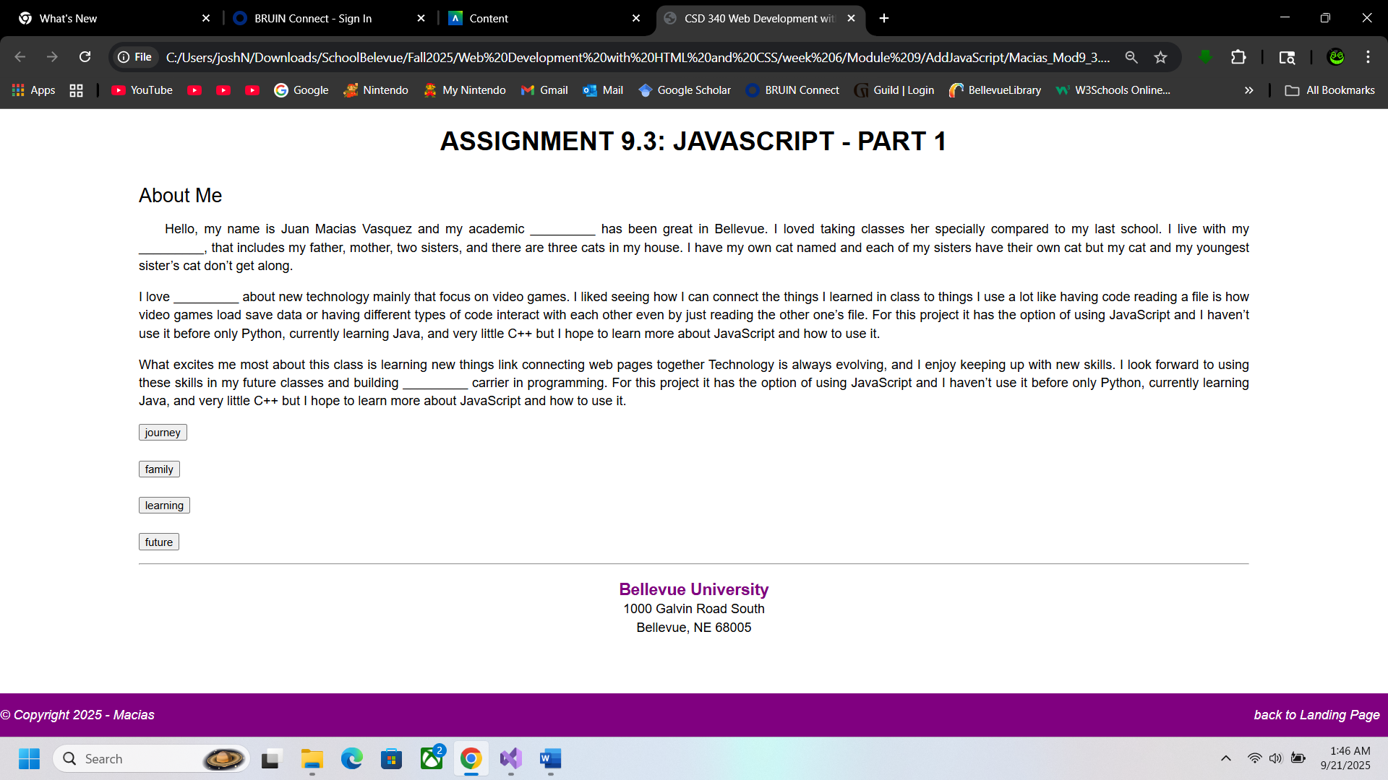

**After Clicking the Words**

