Week 8 Module 10.2 Assignment
Shared Code Repository - Git Exercise

Juan Macias Vasquez
Bellevue University
CSD380-H323 DevOps (2265-DD)
Adam Bailey
March 7th, 2026

Module 10.2
Shared Code Repository - Git Exercise
GitHub Repository Link:
https://github.com/ZaccBaker/GitLab
Group Team Members:
Joel Atkinson, Zachary Baker, Kyle Klausen, Juan Macias Vasquez, Brittaney Perry-Morgan
Group Roles:
Release Manager: Zac Baker
Developer 1: Joel Atkinson
Developer 2: Brittaney
Developer 3: Juan Carlos Macias
UI/UX Developer: Kyle
My Role Developer 3
GitHub User Name: Juan551School
Pictures of the process
1st picture of GitHub Group Repository
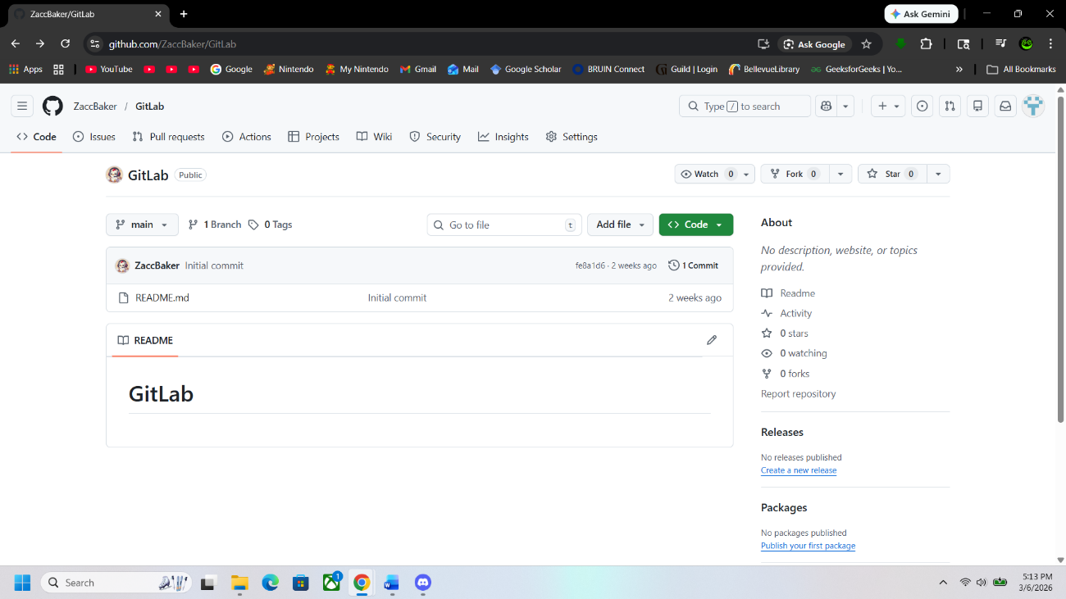

Command Prompt When doing Developer 3 parts
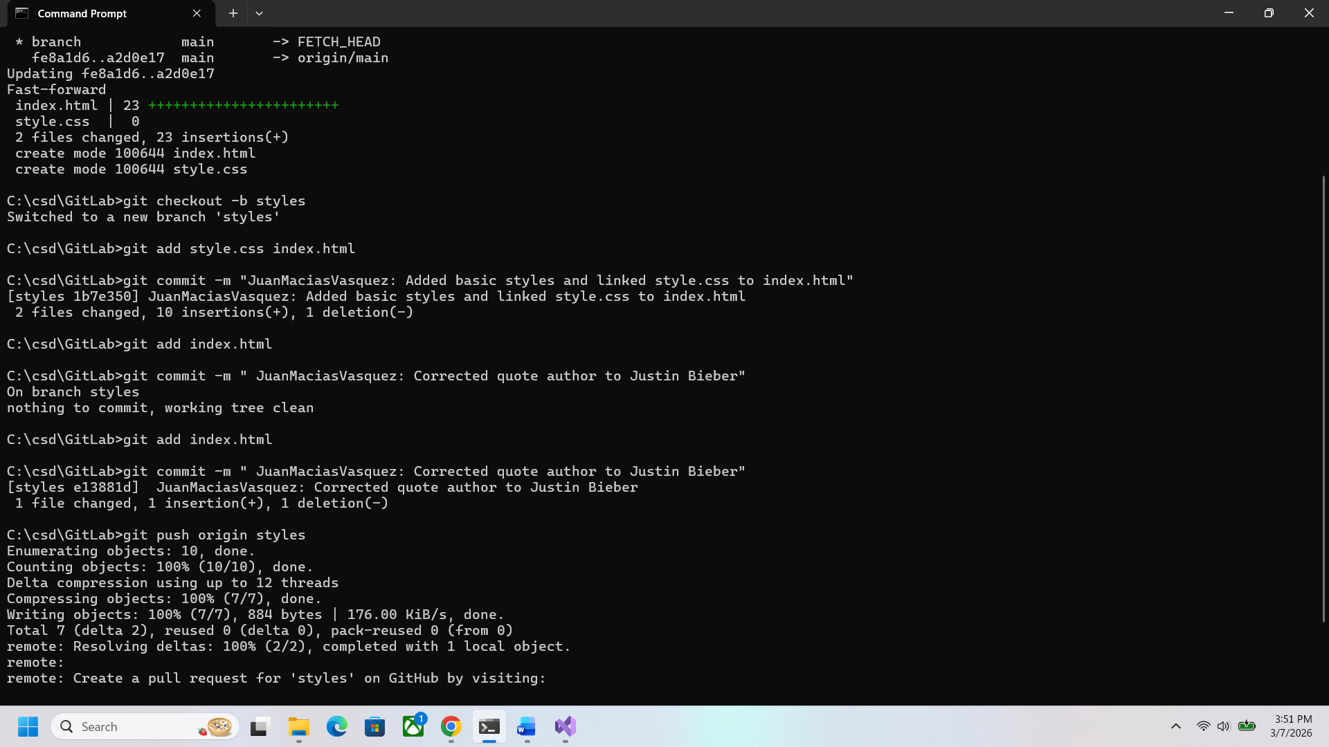
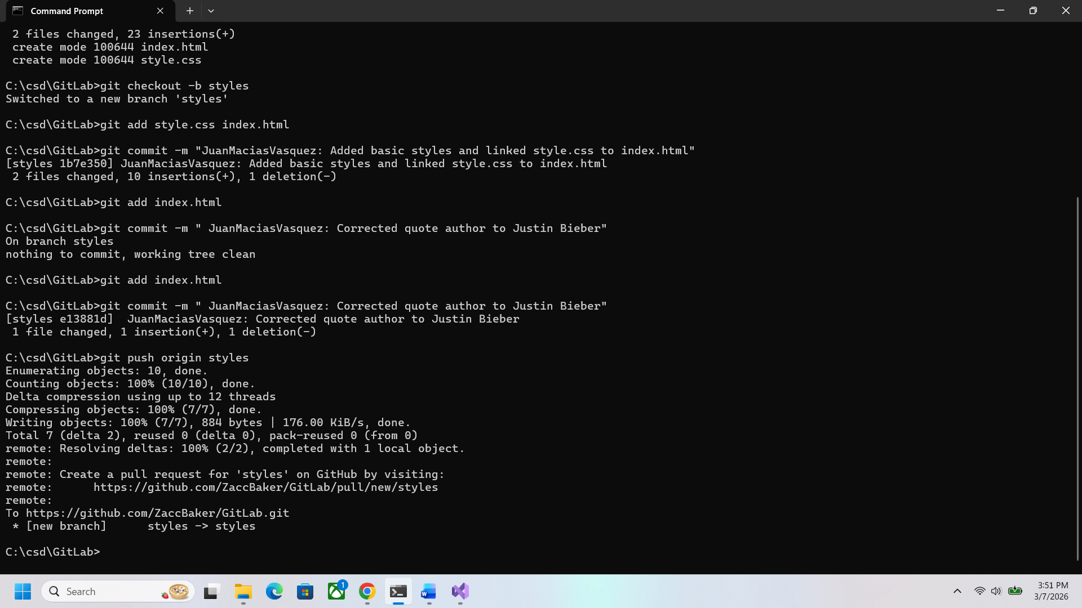

GitHub Pull Request Page 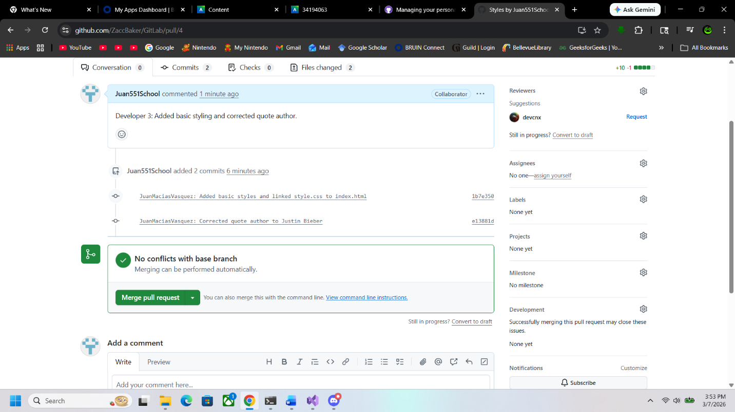
GitHub Post Developer 3 Part
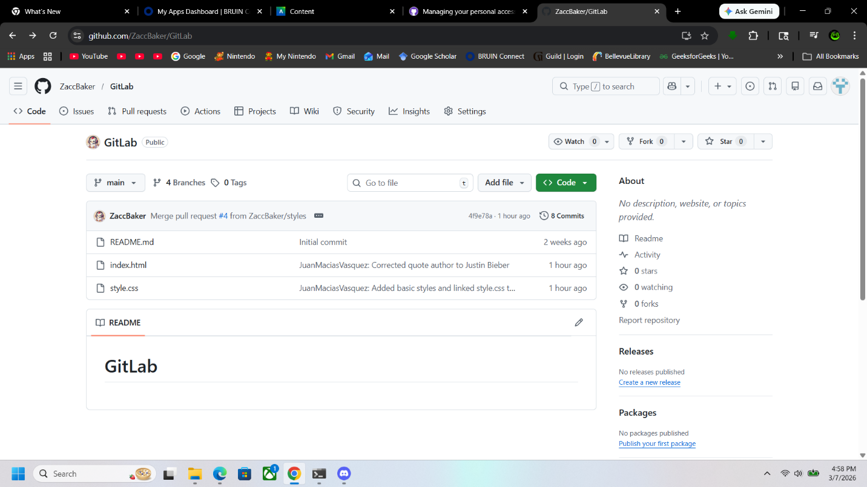

Second set of Steps Pull Request
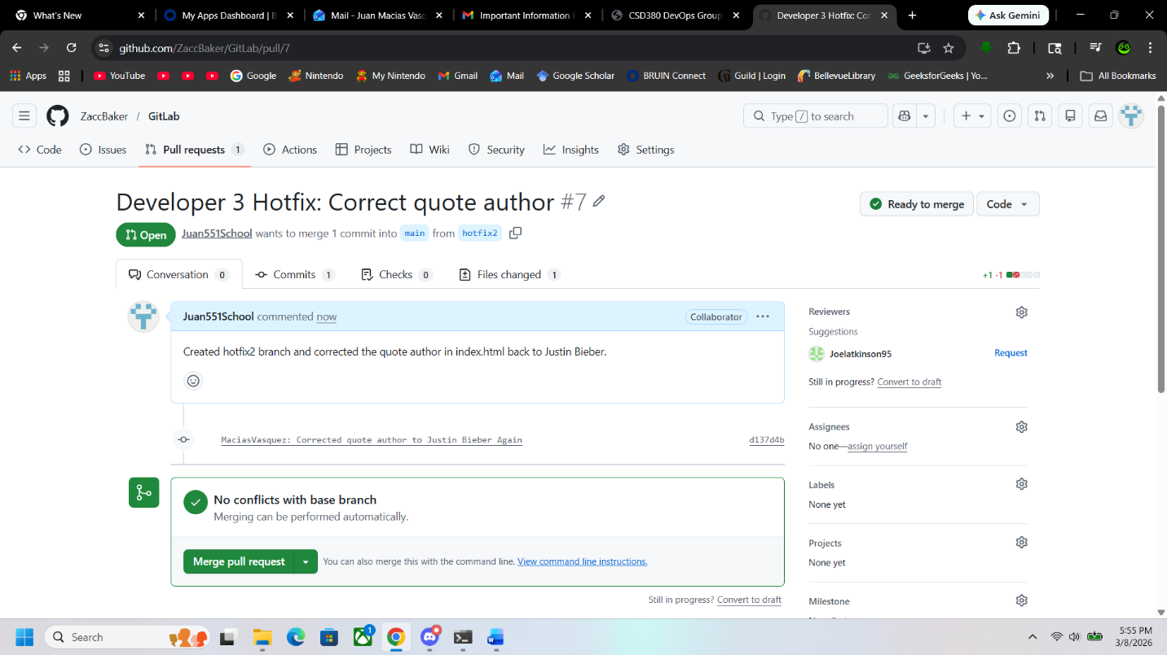
Final Version of Pull Requests
