Week 1 Module 1.2 Assignment
The Technology Value Stream

Juan Macias Vasquez
Bellevue University
CSD380-H323 DevOps (2265-DD)
Adam Bailey
January 18th, 2026
Module 1.2
The Technology Value Stream
GitHub Repository Link:
https://github.com/Juan551School/csd-380
Pictures used
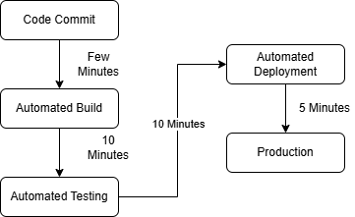

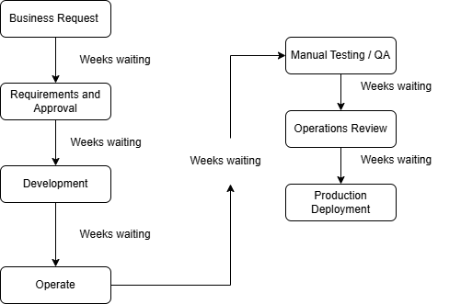

Pictures where made in Draw.io

Sources
https://www.geeksforgeeks.org/devops/introduction-to-devops/
https://www.geeksforgeeks.org/devops/devops-tutorial/
https://itrevolution.com/wp-content/uploads/2022/06/DOHB2_Excerpt.pdf
https://red-green-refactor.com/2020/11/04/book-club-the-devops-handbook-chapter-1-agile-continuous-delivery-and-the-three-ways/

