Week 5 Module 5.2 Assignment
Value Stream Mapping (VSM)

Juan Macias Vasquez
Bellevue University
CSD380-H323 DevOps (2265-DD)
Adam Bailey
February 14th, 2026
Module 5.2
Value Stream Mapping (VSM)
GitHub Repository Link:
https://github.com/Juan551School/csd-380
Assignment: Value Stream Mapping (VSM)
Average Friday with Module Assignment
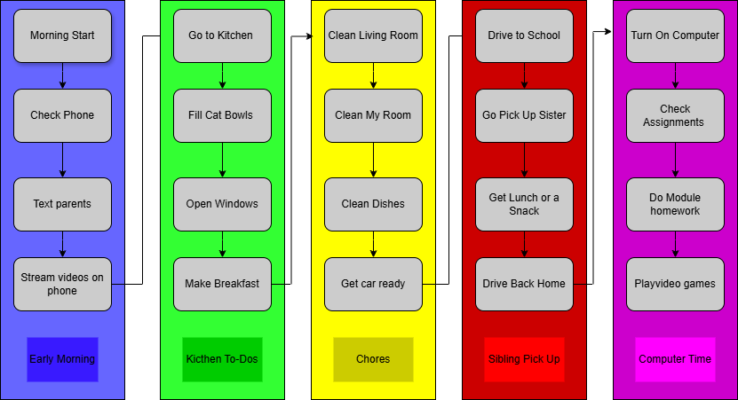
Picture made in Draw.io
Estimated Average Flow Time
Process | Time
Early Morning | 30 mins
Kitchen To-Dos | 60 mins
Chores | 90 mins
Sibling Pick up | 60 mins
School Work | 180 mins
Estimated Cycle Total | 7hrs

Optimizing Morning Routine
Eliminating Waste - I could Get rid of watching videos in the Moring and Playing video games after doing my homework It would eliminate about 10 to 15 minutes in the “Early Morning” Section and 30 minutes to an hour in the “Computer Time” Section.
Workflow Orchestration - If my sister didn’t have school then I can have more time for doing homework because it would eliminate “Go pick up Sister” and she would do the “Clean Dishes”
Governance Models – It would need extra security steps like adding
- Closing the Windows before exiting the kitchen
- Locking the door when leaving the house to the car
- Locking the car when going back into the house
- Turing off the computer when finished using it

New Estimated Time After Optimization
Process | Time
Early Morning | 20 mins
Kitchen To-Dos | 60 mins
Chores | 90 mins
Sibling Pick up | 60 mins
School Work | 150 mins
Estimated Cycle Total | 6.3333hrs

Possible Future Optimization
Could also do things like prep before going to sleep the night before like get the lunch or snacks prepped for my sister.
Another could be getting an automated food dispenser for the cats.

Sources
https://www.connectall.com/3-easy-steps-for-using-vsm-in-everyday-life/

