Project: Test Plan – Zac Baker
Course: CSD380: DevOps
Description: Test plan draft for Todo Business
Date: 2026/02/04

TABLE OF CONTENTS
Visit URL 2
Create Task Item 3
View List 4
Delete Task Item 5
Edit Task Item 6

Test 1 | Visit URL
 | Test Objective: Website should be visited through https://buwebdev.github.io/todo/ | Developer: Zac Baker  Date tested: 2026/02/04 | Peer tester: Juan Macias Vasquez  Date tested: <20226/02/06>
Step | Action | Expected results: | Developer  pass/fail | Tester pass/fail  + Screenshot
1 | Enter https://buwebdev.github.io/todo/ into search bar. | URL is exactly as shown and navigates to the correct website. | Yes | Yes  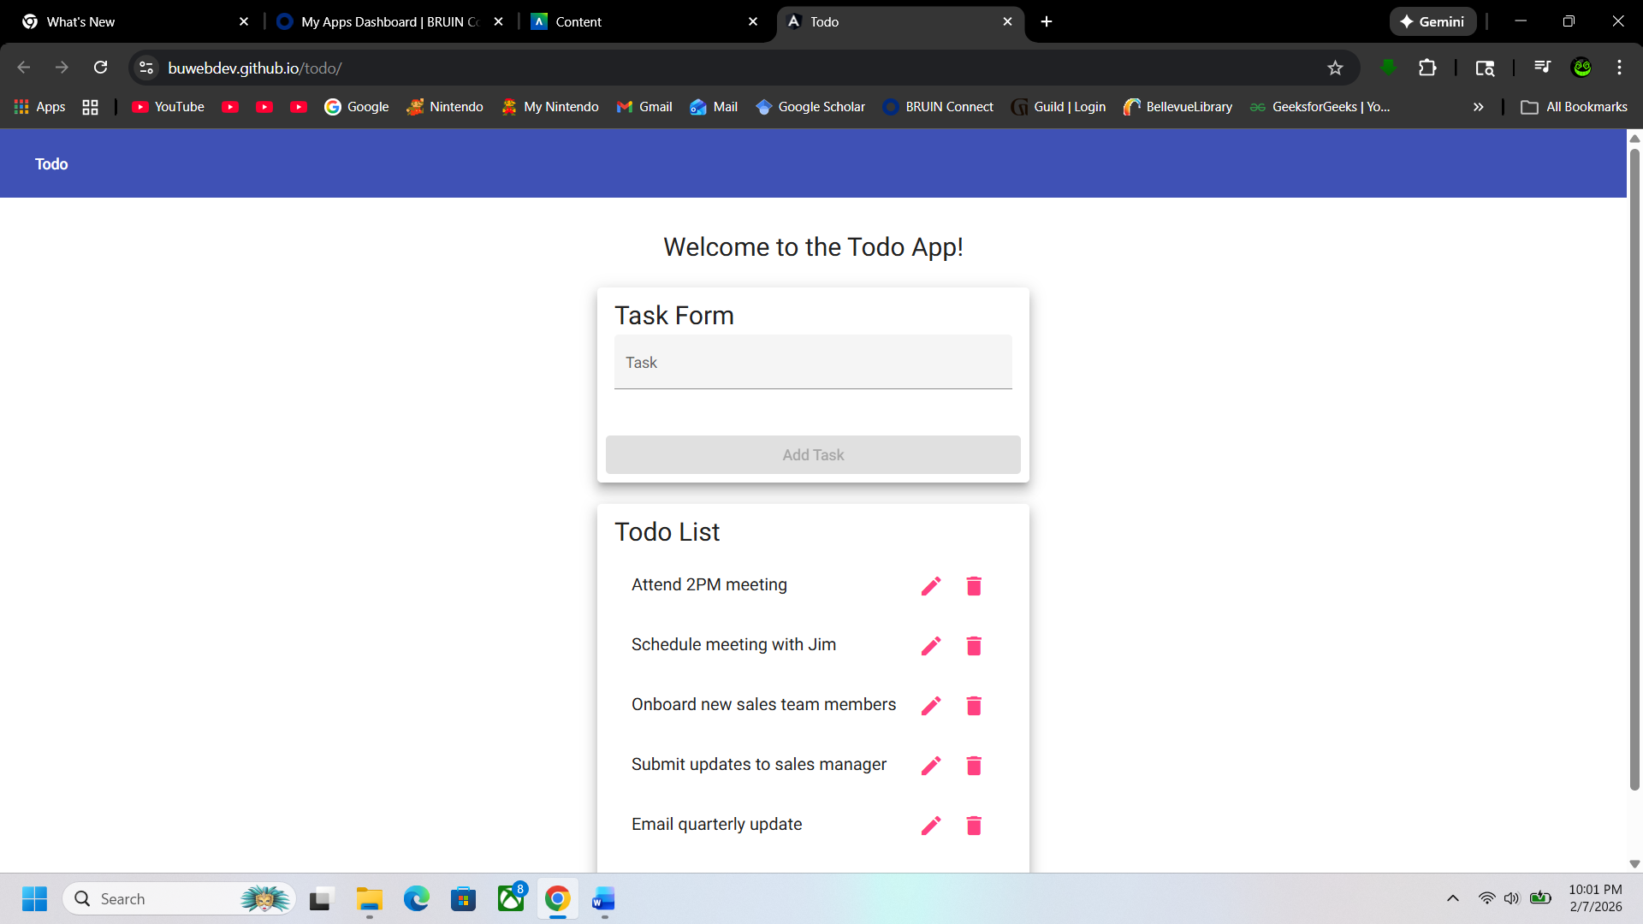
2 | Confirm the page loads correctly without any errors. | Todo main page loads without any errors. | Yes | Yes
3 | Refresh the browser page. | Todo page refreshes and navigates back to the main page. | Yes | Yes
4 | Confirm the page loads correctly without any errors. | Main page loads with the default values for the Todo list. | Yes | Yes  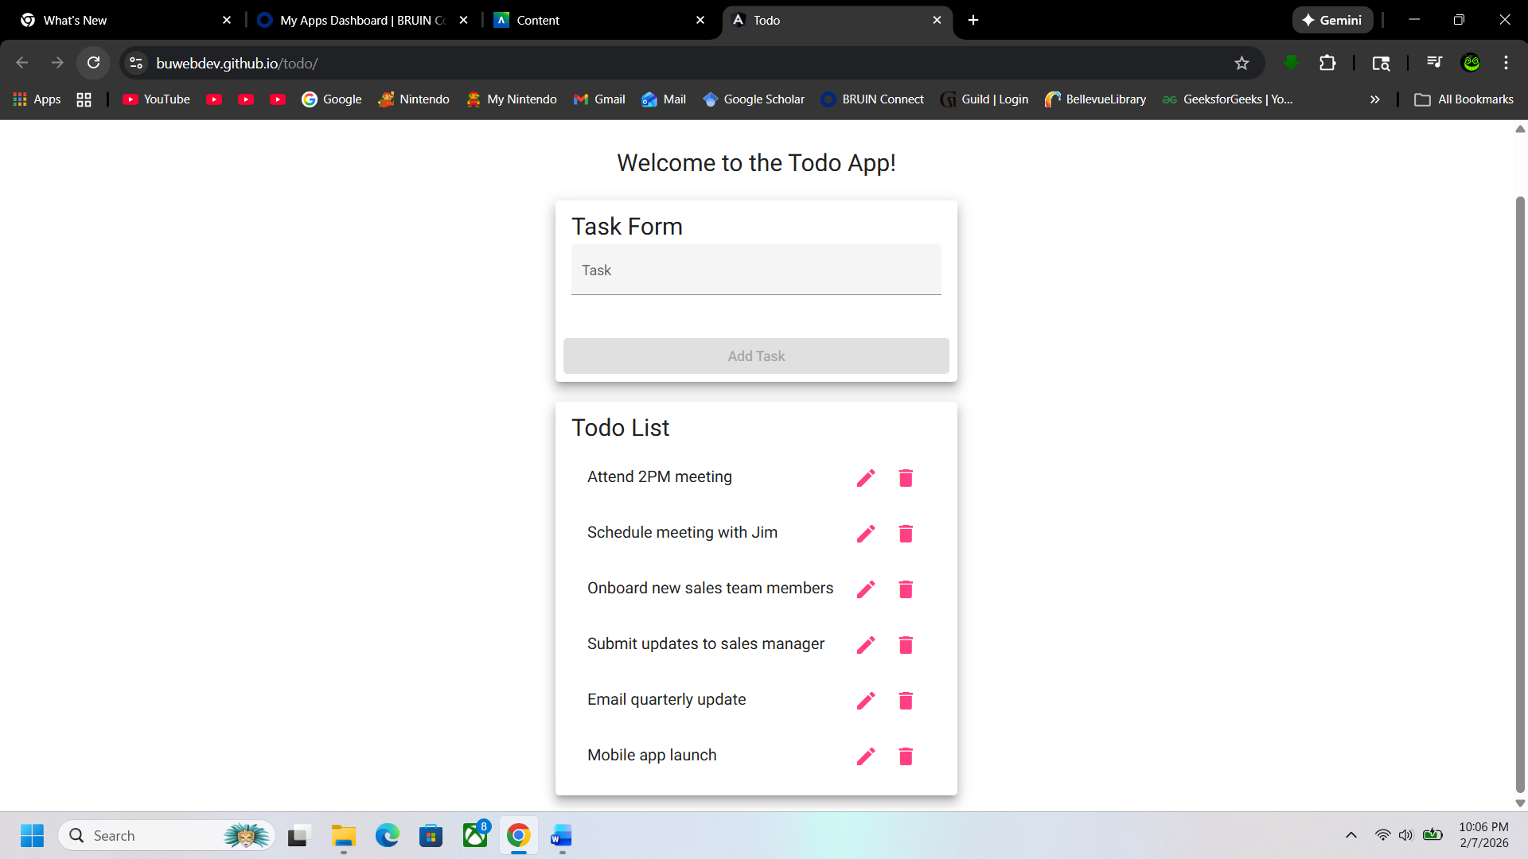
Comments | Juan “Everything works as intended when visiting the URL and saw no issues”

Test 2 | Create Task Item
 | Test Objective: Users can create task items for the Todo list. | Developer: Zac Baker  Date tested: 2026/02/04 | Peer tester: Juan Macias Vasquez  Date tested: <20226/02/06>
Step | Action | Expected results: | Developer  pass/fail | Tester pass/fail  + Screenshot
1 | Type out task item. | A combination of numbers, letters, and symbols can be used in the input bar. | Yes | Yes  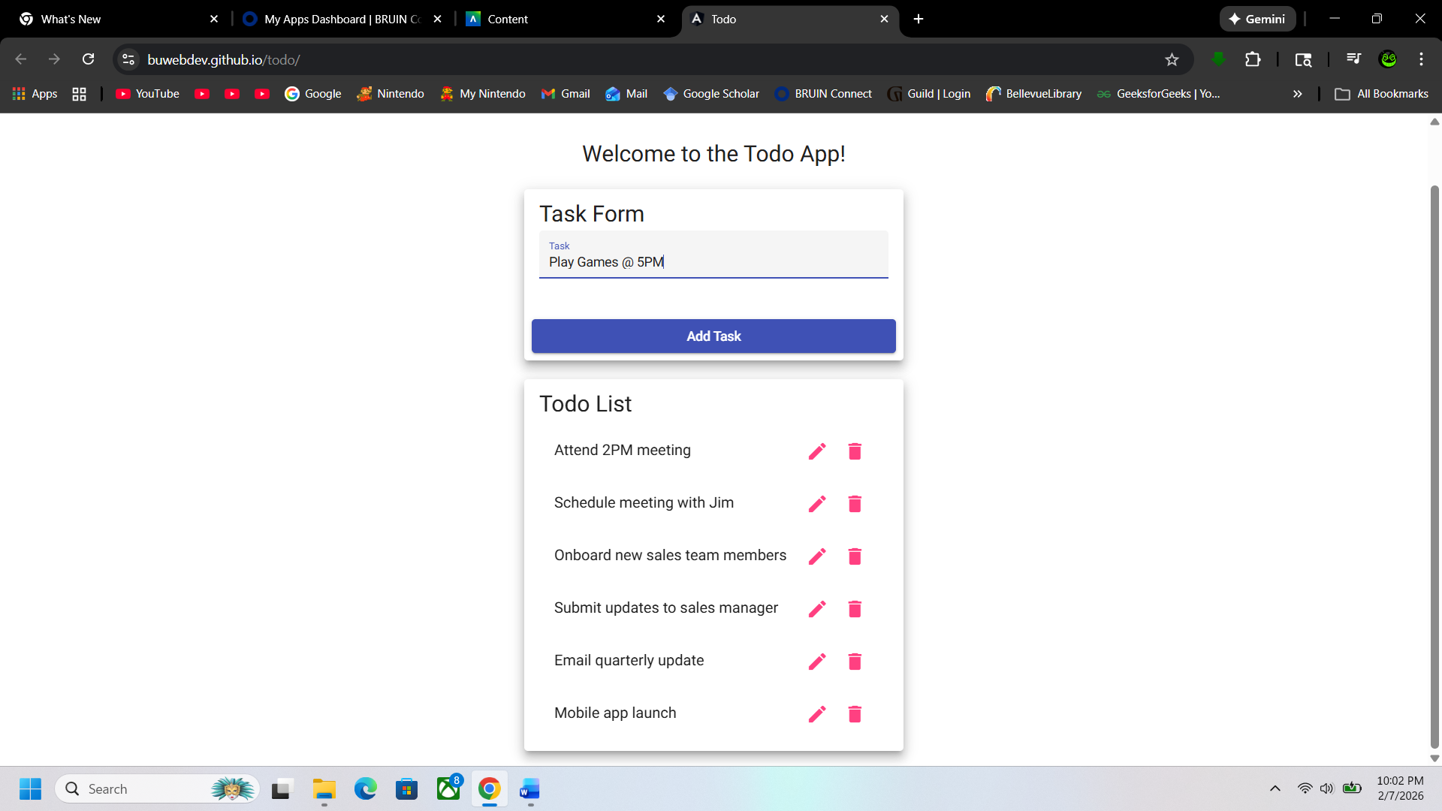
2 | Click “Add Task”. | Clicking the “Add Task” button will add the entered task item to the list. | Yes | Yes
3 | Confirm the added task item is correct. | The added task item will be appended to the bottom of the list. | Yes | Yes  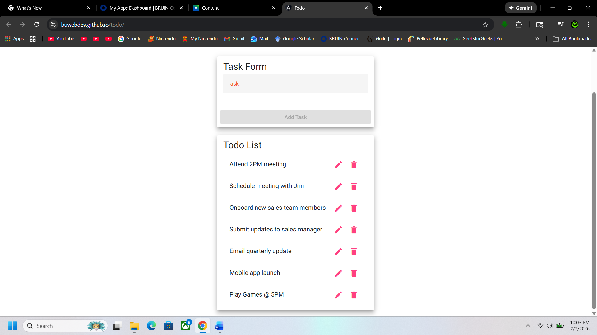
4 | Add another task item. | The Todo app will support multiple entries. | Yes | Yes  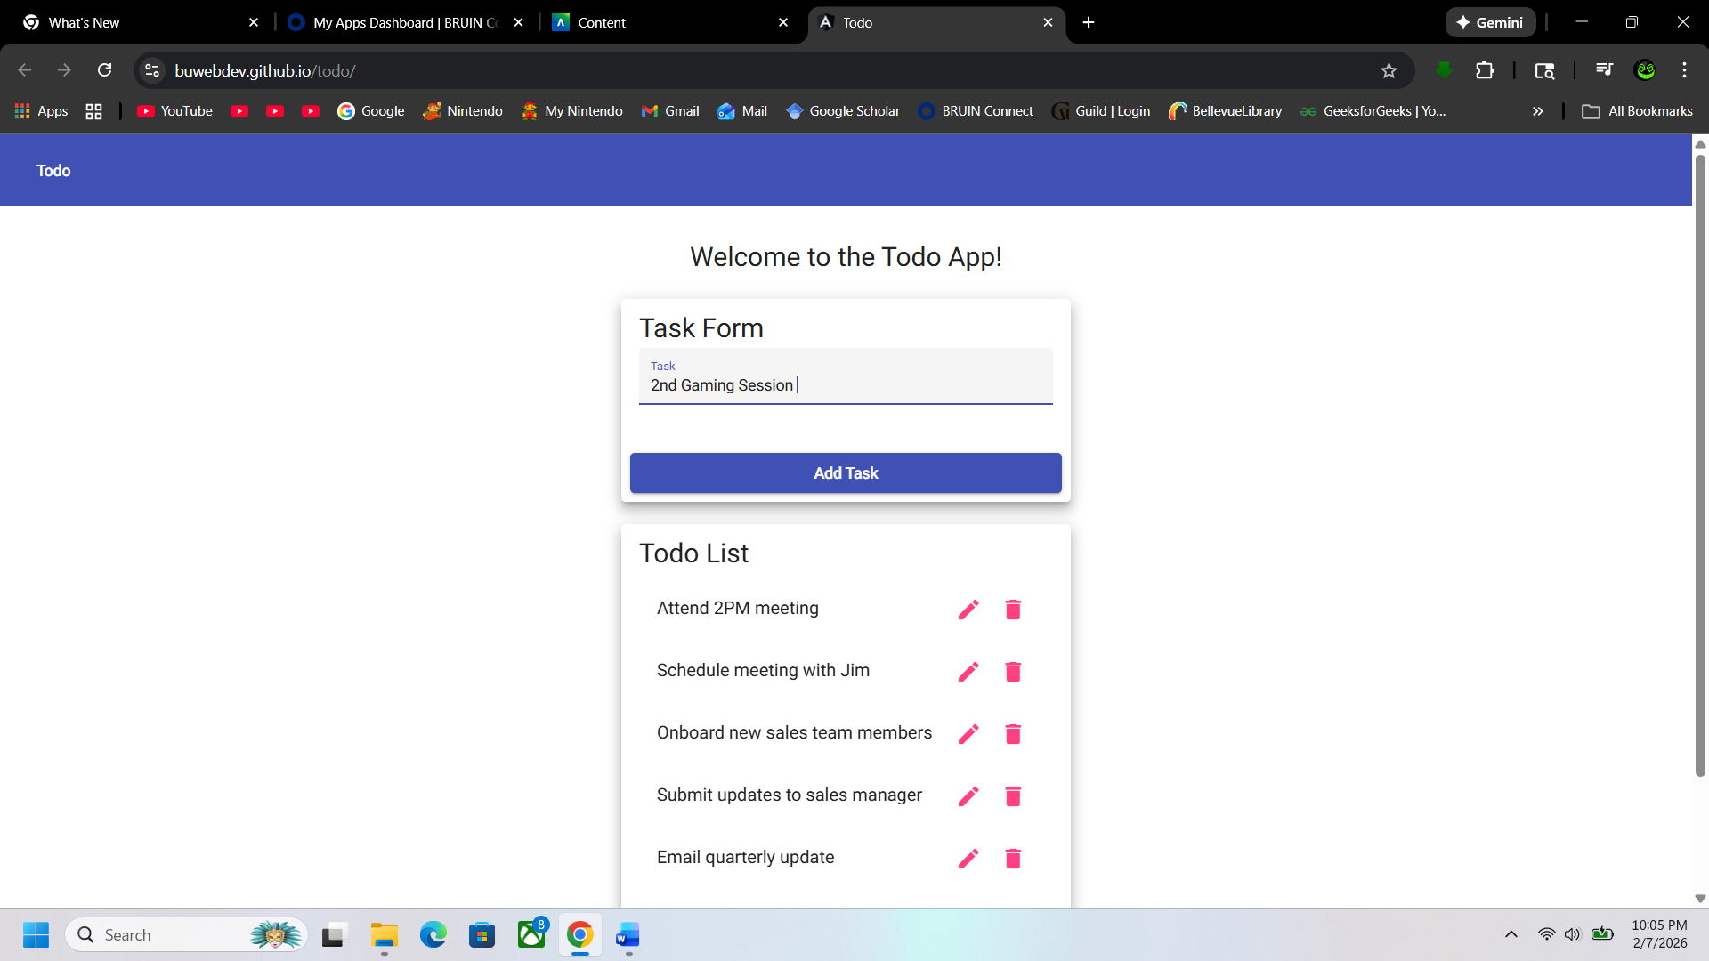
5 | Confirm the added task item is correct. | The added task item will be appended to the bottom of the list. | Yes | Yes  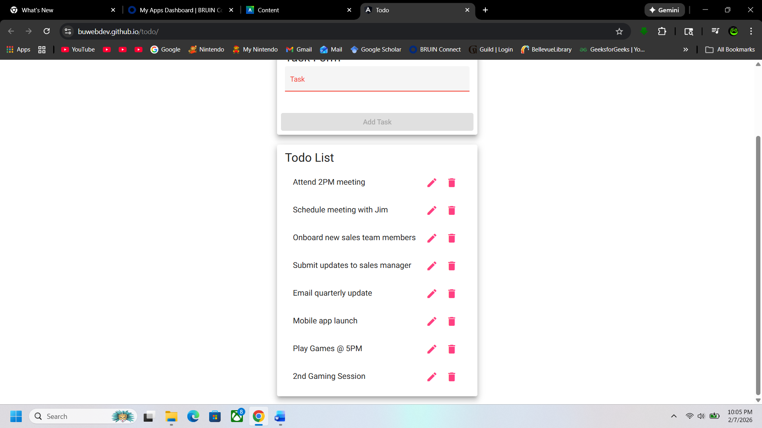
Comments | Juan “Was able to make a task with no issues on both a laptop running windows and, on an iPad, running iOS.”

Test 3 | View List
 | Test Objective: The list is visible and dynamically supports adding, deleting, and editing features. | Developer: Zac Baker  Date tested: 2026/02/04 | Peer tester: Juan Macias Vasquez  Date tested: <20226/02/06>
Step | Action | Expected results: | Developer  pass/fail | Tester pass/fail  + Screenshot
1 | Confirm the default list is visible. | The page will show the list in a clearly marked and visible area. | Yes | Yes  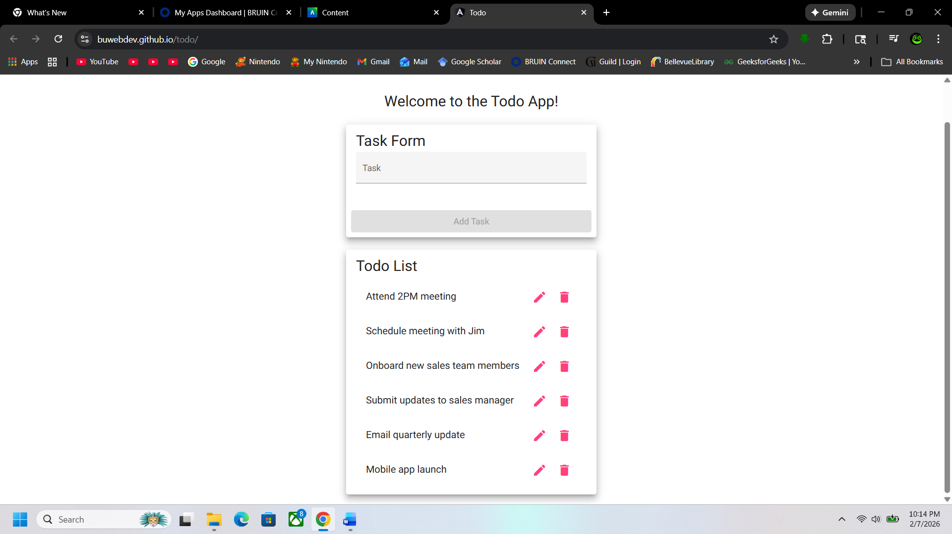
2 | Confirm the list shows added task items. | Added tasks will be visible in the dedicated list area. | Yes | Yes  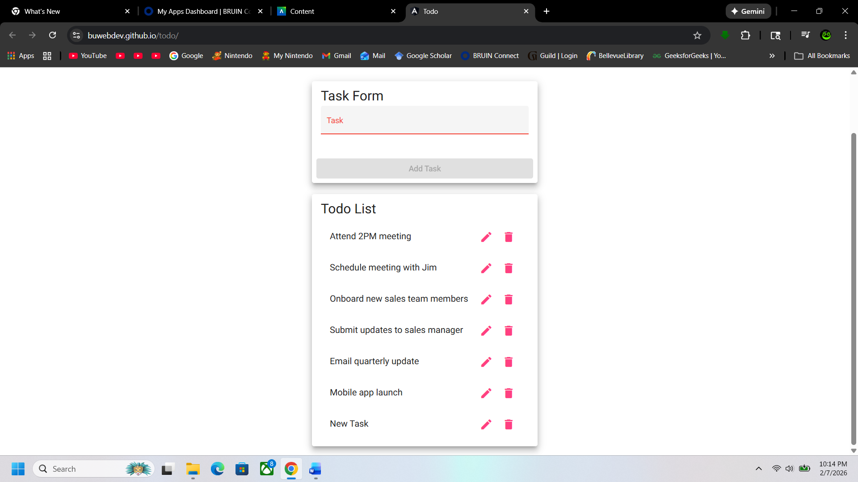
3 | Confirm the list shows deleted task items. | Deleted tasks affect the order and size of the list. | Yes | Yes  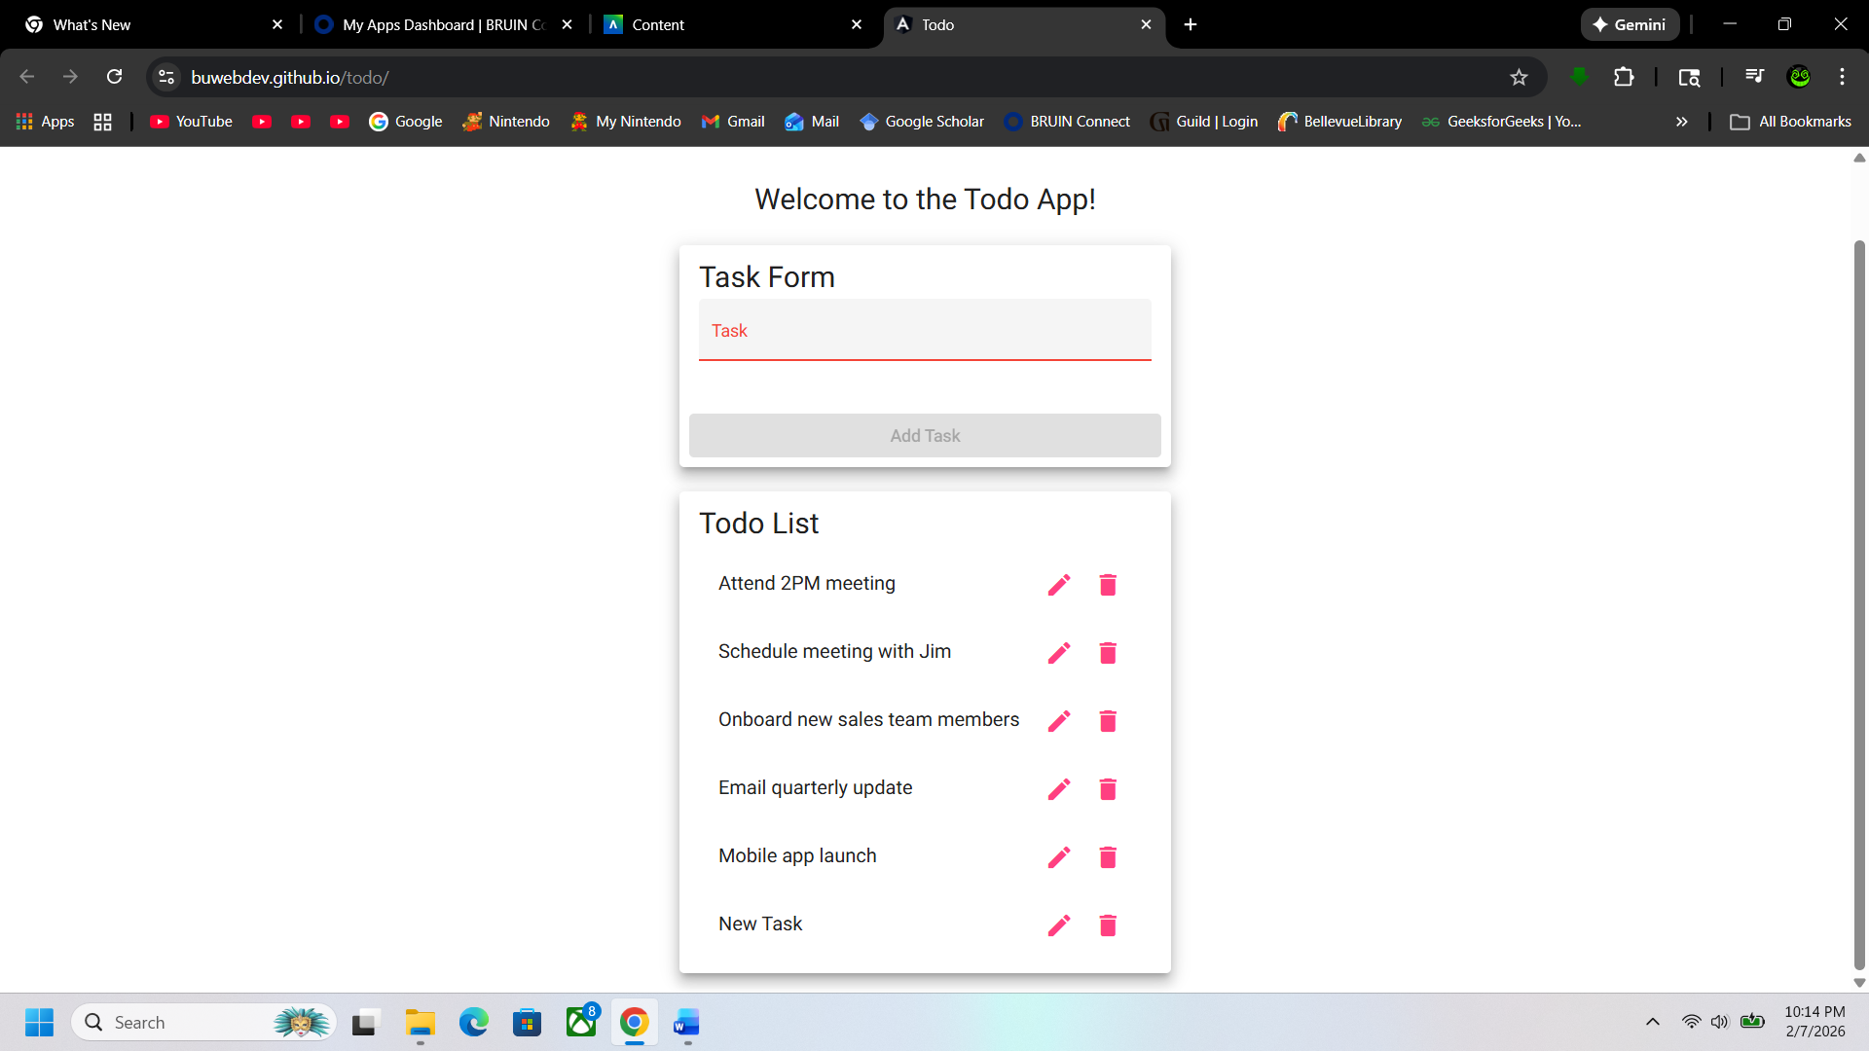
4 | Refresh the browser page. | Refreshing the page will change the entered task items. | Yes | Yes  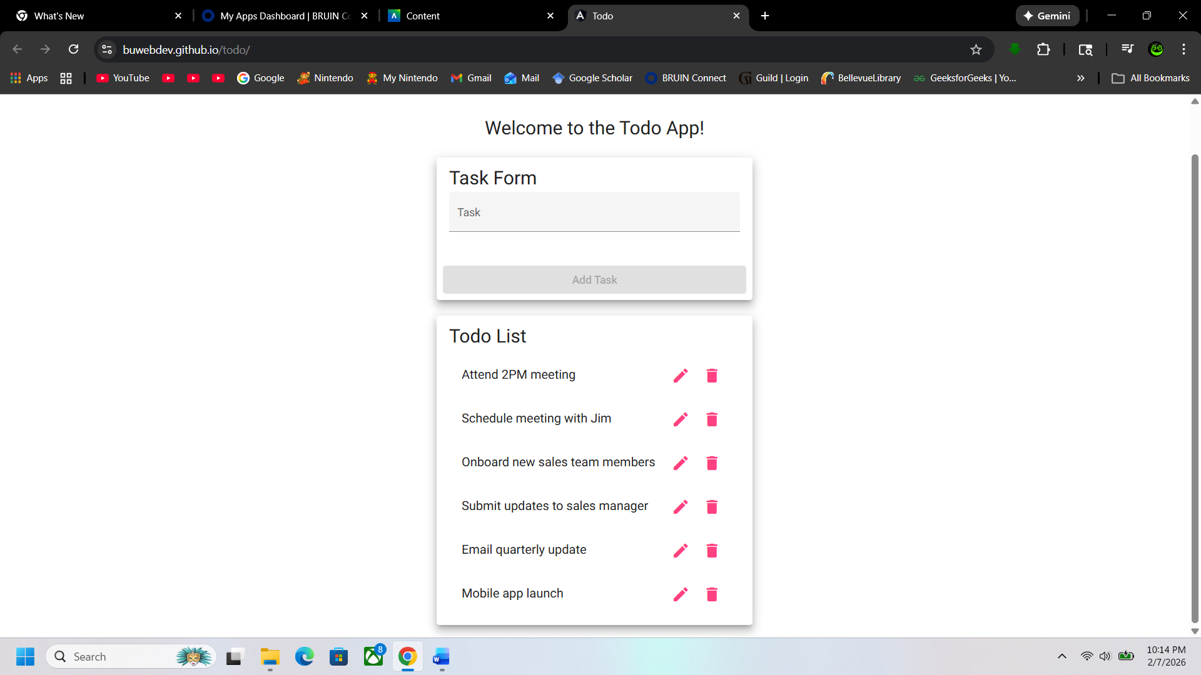
5 | Confirm the default list is visible. | The default list task items will be displayed on refresh. | Yes | Yes
Comments | Juan “Was able to view the list on both a Windows Laptop with Chrome and on an iPad.”

Test 4 | Delete Task Item
 | Test Objective: Users can delete task items. | Developer: Zac Baker  Date tested: 2026/02/04 | Peer tester: Juan Macias Vasquez  Date tested: <20226/02/06>
Step | Action | Expected results: | Developer  pass/fail | Tester pass/fail  + Screenshot
1 | Click the trash icon to the right of a task item. | The delete button icon is functional and readily available. | Yes | Yes  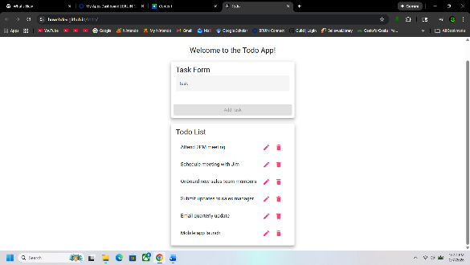
2 | Confirm the task has been deleted. | The delete button deletes the associated task item. | Yes | Yes  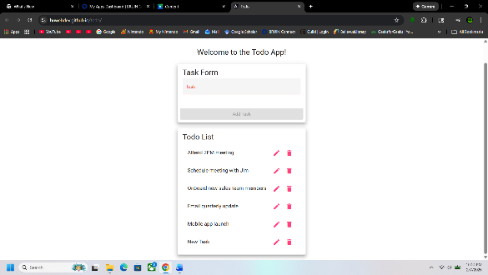
3 | Click the trash icon to the right of ALL task item. | All task items can be deleted. | Yes | Yes
4 | Confirm ALL task items have been deleted. | All task items are deleted showing a blank list. | Yes | Yes 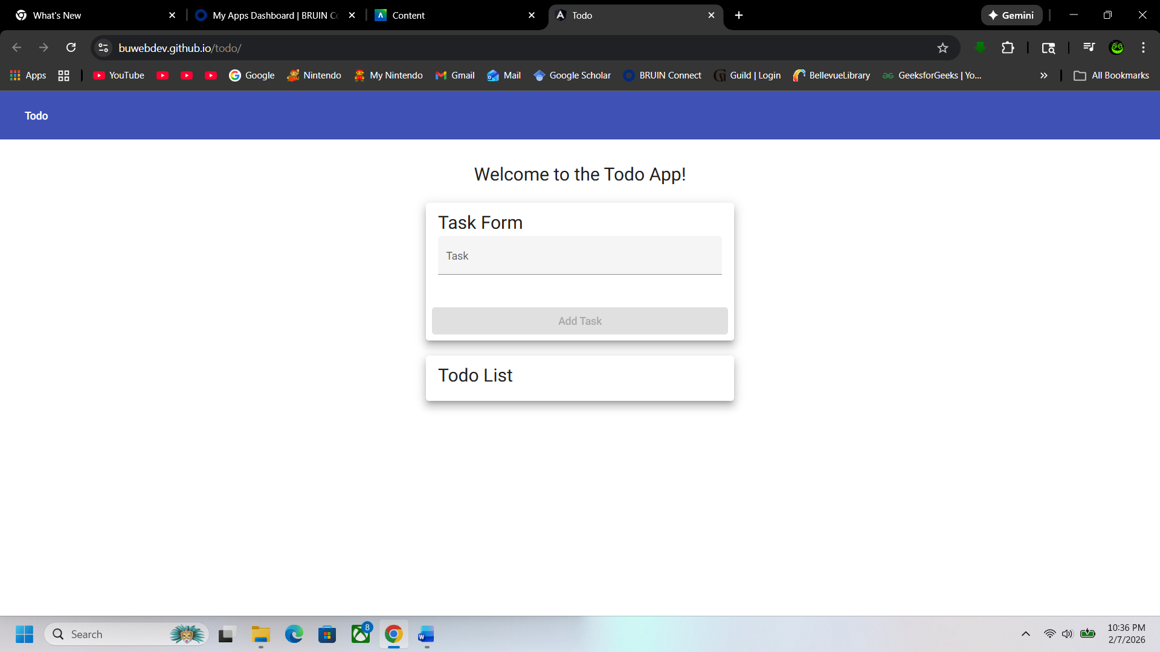
Comments | Juan “Was able to delete an item from the list on both a Windows Laptop with Chrome and on an iPad.”

Test 5 | Edit Task Item
 | Test Objective: Users can edit existing task items. | Developer: Zac Baker  Date tested: 2026/02/04 | Peer tester: Juan Macias Vasquez  Date tested: <20226/02/06>
Step | Action | Expected results: | Developer  pass/fail | Tester pass/fail  + Screenshot
1 | Click the pencil icon to the right of task item. | The edit button icon is functional and readily available. | Yes | Yes
2 | Enter updated task name. | There will be a dedicated input field that users may utilize to enter and update task item name. | Yes | Yes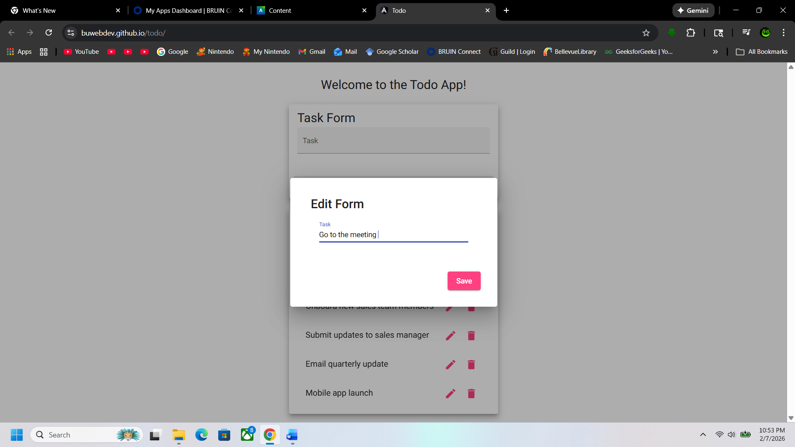
3 | Click “Save”. | There will be a save button or feature that allows the edit to be saved. | Yes | Yes
4 | Confirm task item has been edited successfully. | The list will show the updated task item name in the list area. | Yes | Yes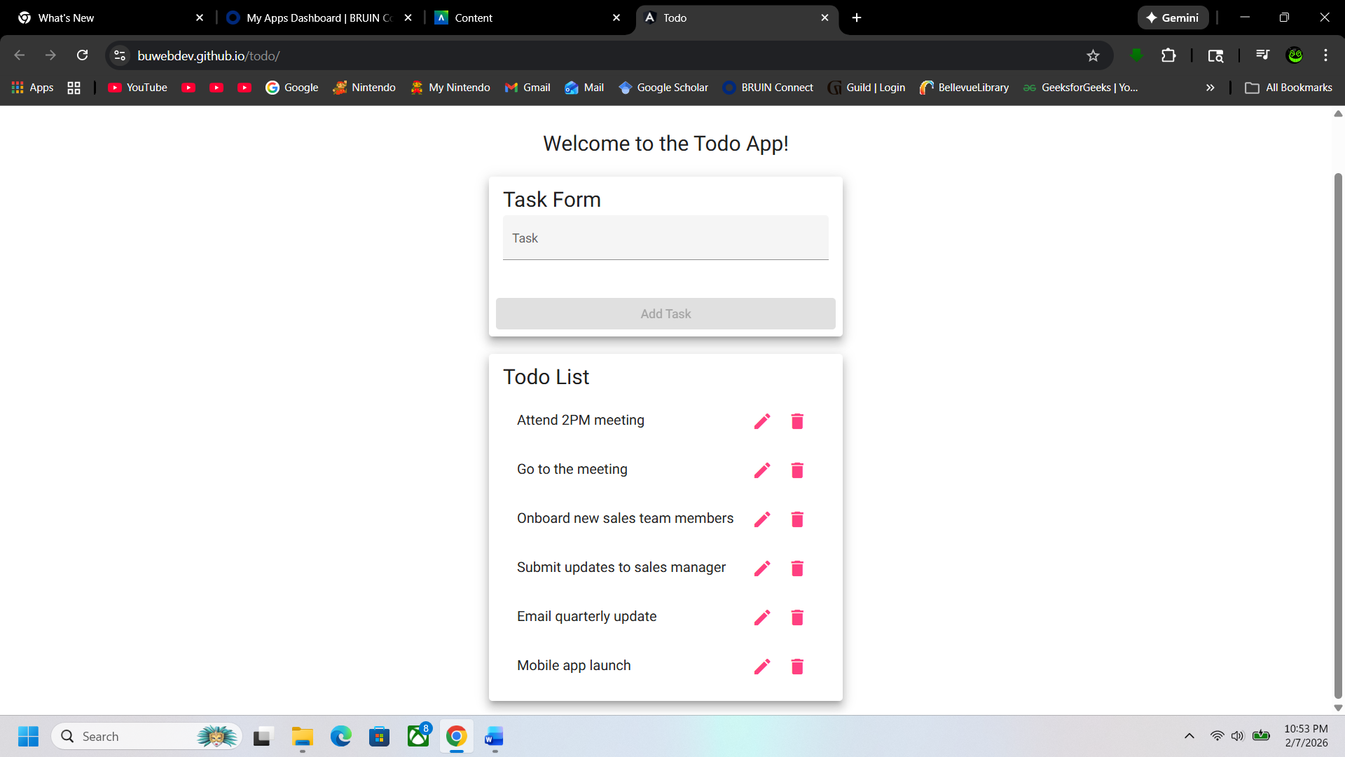
Comments | Was able to edit an item and had no issues with the edit form popping up after clicking the button.

