**Week 6 M8: Programming Assignment  
Array List Test**

Juan Macias Vasquez

Bellevue University

CSD402-H323 Java for Programmers (2261-DD)

**Jack Lusby**

September 21st, 2025

**Week 6 M8: Programming Assignment**

**Array List Test**

**GitHub Repository Link:**

<https://github.com/Juan551School/csd-402>

**Java Code**

//Juan Macias Vasquez

//Bellevue University

//CSD402-H323 Java for Programmers (2261-DD)

//Jack Lusby

//September 21st, 2025 Updated on September 13th, 2025

**package** arrayList;

**import** java.util.ArrayList;

**import** java.util.Scanner;

**public** **class** JuanArrayListTest {

// the method to find the maximum value in the ArrayList

**public** **static** Integer max(ArrayList<Integer> list) {

**if** (list == **null** || list.isEmpty()) {

**return** 0; // return 0 if the list is empty

}

Integer largest = list.get(0); // assume that the first element is the largest

**for** (Integer num : list) {

**if** (num > largest) {

largest = num;

}

}

**return** largest; //return the largest value that is displayed to the user

}

**public** **static** **void** main(String[] args) {

Scanner scanner = **new** Scanner(System.***in***);

ArrayList<Integer> numbers = **new** ArrayList<>();

System.***out***.println("Enter integers (0 to stop, 0 will be included):");

**while** (**true**) {

**int** input = scanner.nextInt();

numbers.add(input); // add input to list

**if** (input == 0) {

**break**; // stop when user enters 0 and finish

}

}

// check for the max

Integer largest = *max*(numbers);

// Display the result

System.***out***.println("The largest number in the list is: " + largest);

scanner.close();

}

}

**Picture of Code Running**

**Test 1**

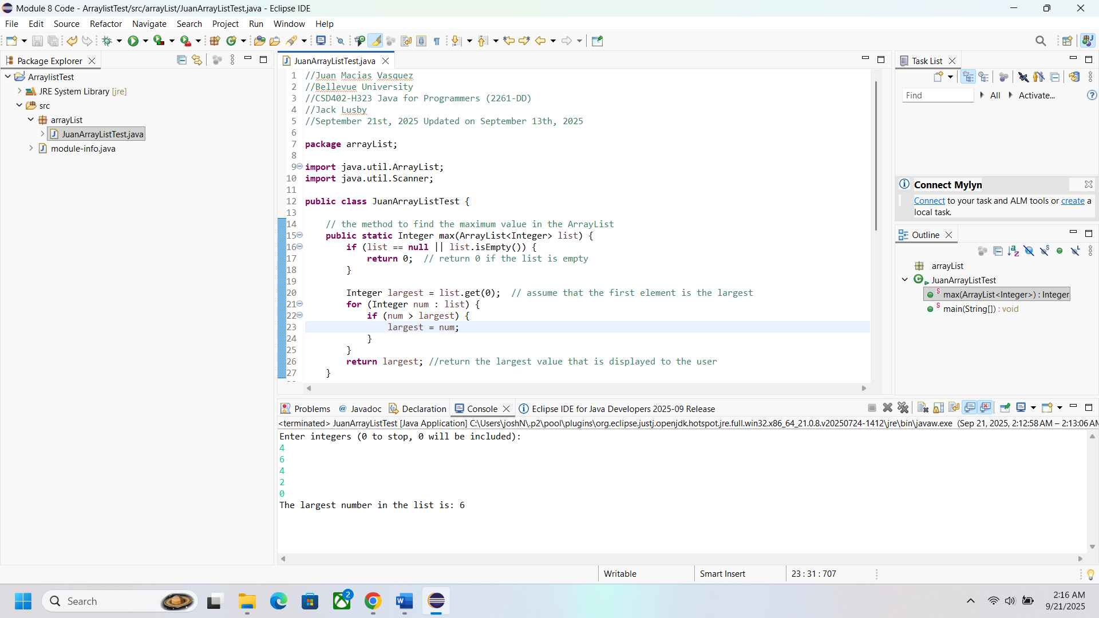

**Test 2** including a negative number to see if that does anything

