**Week 6 M9: Programming Assignment  
Array List and Reading File**

Juan Macias Vasquez

Bellevue University

CSD402-H323 Java for Programmers (2261-DD)

**Jack Lusby**

September 21st, 2025

**Week 6 M9: Programming Assignment**

**Array List and Reading File**

**GitHub Repository Link:**

<https://github.com/Juan551School/csd-402>

**Program 1 Array List with String**

**Java Code**

//Juan Macias Vasquez

//Bellevue University

//CSD402-H323 Java for Programmers (2261-DD)

//Jack Lusby

//September 21st, 2025 Updated on September 13th, 2025

**package** arrayListString;

**import** java.util.ArrayList;

**import** java.util.Scanner;

**public** **class** ArrayListFruit {

**public** **static** **void** main(String[] args) {

ArrayList<String> words = **new** ArrayList<>();

words.add("Apple");

words.add("Banana");

words.add("Cherry");

words.add("Mango");

words.add("Grape");

words.add("Kiwi");

words.add("Lemon");

words.add("Lime");

words.add("Strawberry");

words.add("Dragon Fruit");

// Print of all the elements using for-each loop

System.***out***.println("ArrayList contents:");

**for** (String word : words) {

System.***out***.println(word);

}

// Ask user which element to display with the number starting at 0

Scanner scanner = **new** Scanner(System.***in***);

System.***out***.print("\nEnter the index of the element you want to see again (0–9): ");

String input = scanner.nextLine();

**try** {

// convert the string to an integer

Integer indexObj = Integer.*parseInt*(input);

// Integer -> int

**int** index = indexObj;

System.***out***.println("Element at index " + index + ": " + words.get(index));

} **catch** (IndexOutOfBoundsException e) {

System.***out***.println("Exception thrown: Out of Bounds");

} **catch** (NumberFormatException e) {

System.***out***.println("Invalid input: please enter a valid integer.");

}

scanner.close();

}

}

**Picture of Code Running**

**Normal Test**

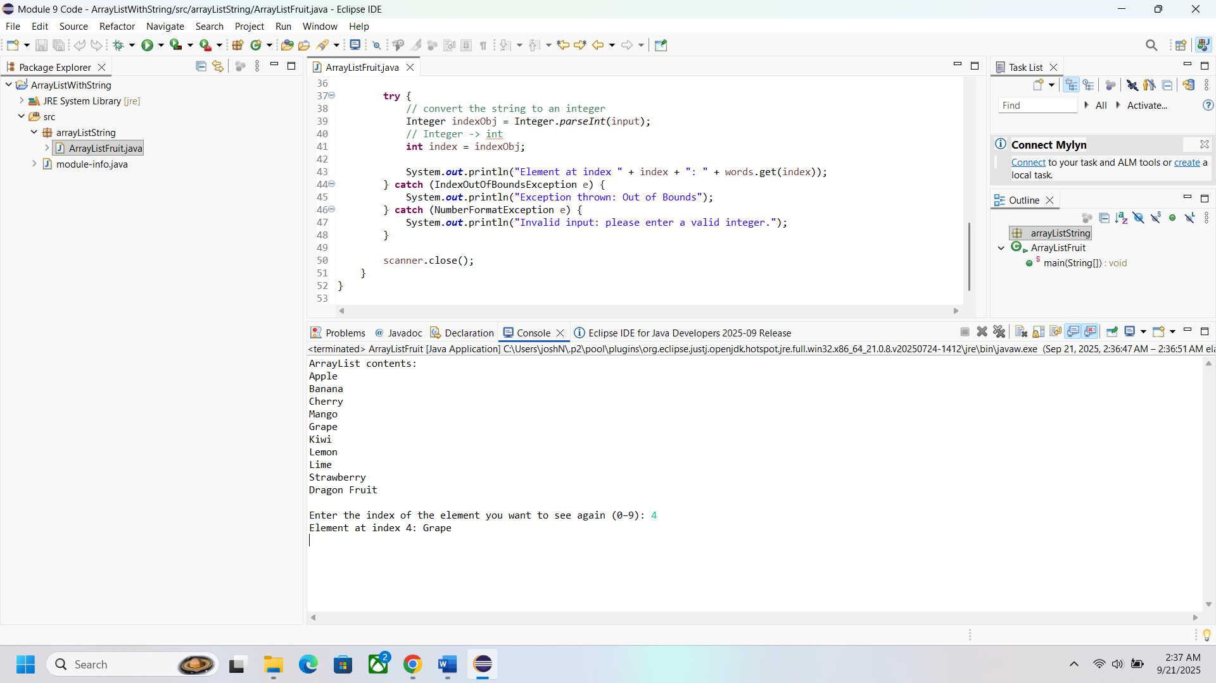

**Test with invalid number**

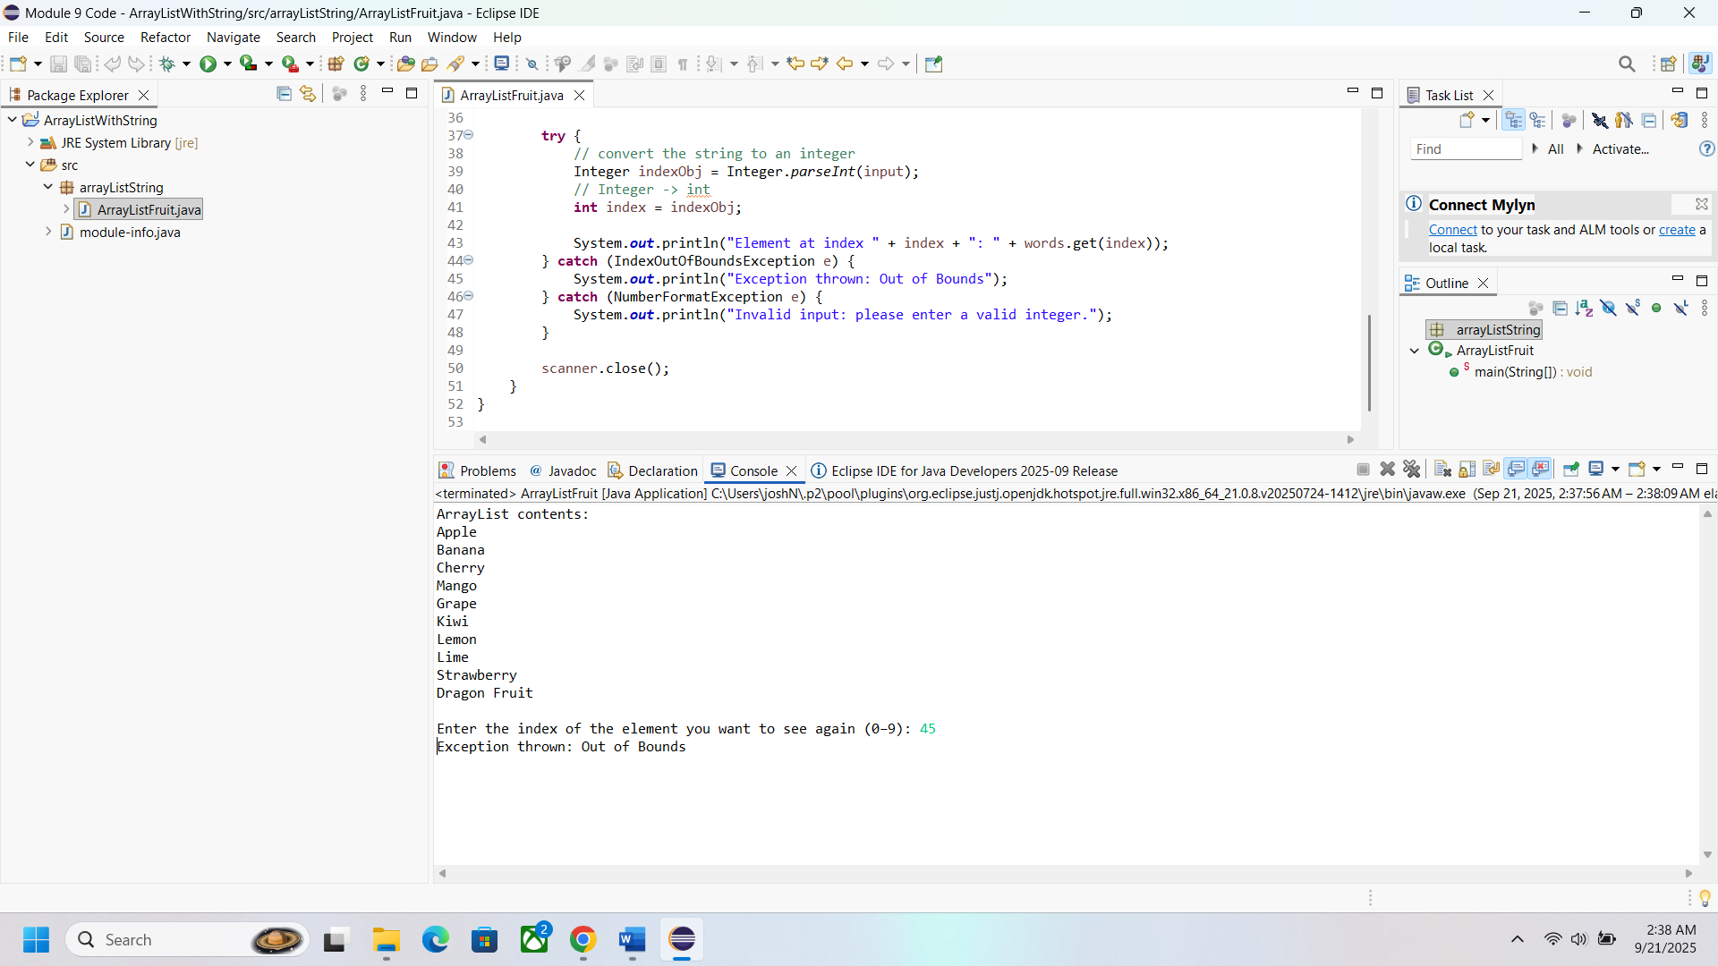

**Test with letters instead of number**

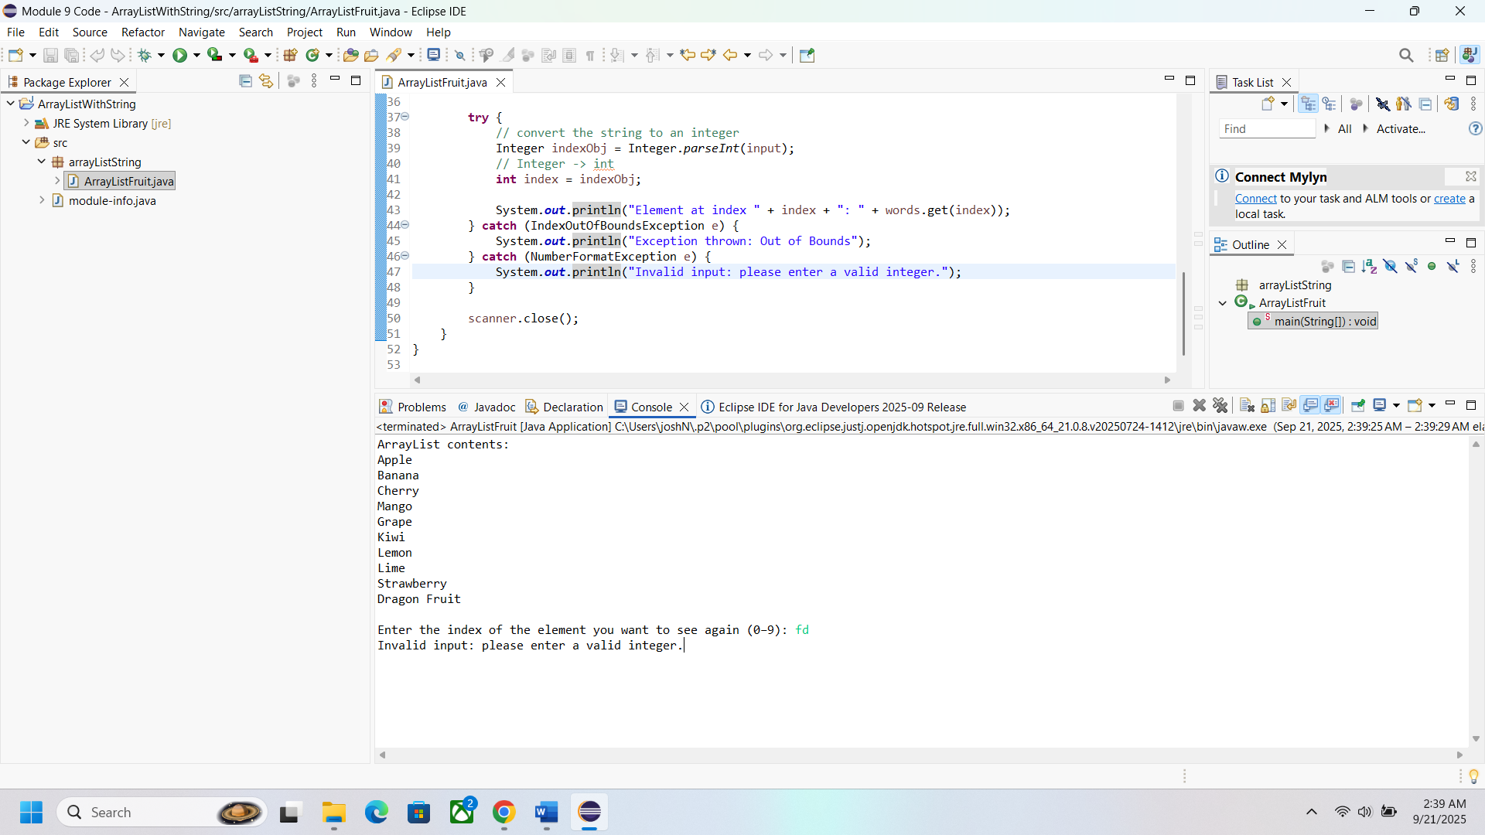

**Program 2 External File Numbers**

**Java Code**

//Juan Macias Vasquez

//Bellevue University

//CSD402-H323 Java for Programmers (2261-DD)

//Jack Lusby

//September 21st, 2025 Updated on September 13th, 2025

**package** externalFileNumbers;

**import** java.io.*;

**import** java.util.Random;

**import** java.util.Scanner;

**public** **class** ExternalNumberFile {

**public** **static** **void** main(String[] args) {

File file = **new** File("data.file");

Random rand = **new** Random();

**try** {

// File Writer with "append = true" will append if file exists

FileWriter fw = **new** FileWriter(file, **true**);

BufferedWriter bw = **new** BufferedWriter(fw);

// Write 10 random numbers

**for** (**int** i = 0; i < 10; i++) {

**int** number = rand.nextInt(100); // random 0–99

bw.write(number + " ");

}

bw.newLine(); // separate runs

bw.close();

fw.close();

// Read and display the file

Scanner reader = **new** Scanner(file);

System.***out***.println("\nContents of data.file:");

**while** (reader.hasNextLine()) {

System.***out***.println(reader.nextLine());

}

reader.close();

} **catch** (IOException e) {

System.***out***.println("An error occurred while working with the file.");

e.printStackTrace();

}

}

}

**Picture of Code Running**

**First run**

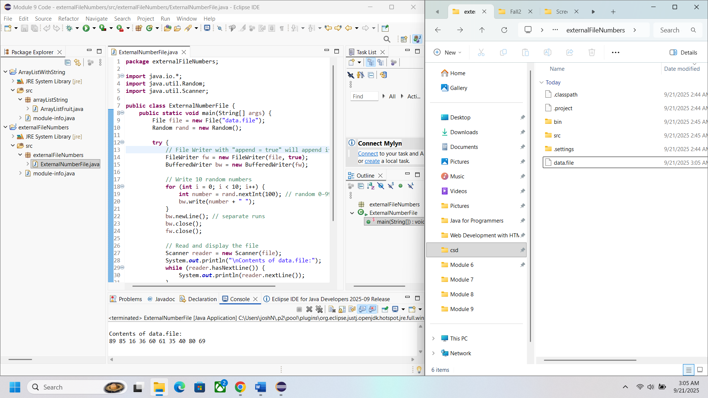

**Third run and checking file contents**

