Week 1 M1: Programming Assignment
Java FX Cards

Juan Macias Vasquez
Bellevue University
CSD420-H323 Advanced Java Programming (2261-DD)
Jack Lusby
October 26th, 2025

Week 1 M1: Programming Assignment
Java FX Cards
GitHub Repository Link:
https://github.com/Juan551School/csd-420
Java Code
Main.java
package application;

import javafx.application.Application;
import javafx.stage.Stage;
import javafx.scene.Scene;
import javafx.scene.layout.BorderPane;

public class Main extends Application {
@Override
public void start(Stage primaryStage) {
try {
BorderPane root = new BorderPane();
Scene scene = new Scene(root,400,400);
scene.getStylesheets().add(getClass().getResource("application.css").toExternalForm());
primaryStage.setScene(scene);
primaryStage.show();
} catch(Exception e) {
e.printStackTrace();
}
}

public static void main(String[] args) {
launch(args);
}
}

RandomcardDisplay.java
//Juan Macias Vasquez
//Bellevue University
//CSD420-H323 Advanced Java Programming (2261-DD)
//Jack Lusby
//October 26th, 2025
//RandomcardDisplay.java

package application;

import javafx.application.Application;
import javafx.geometry.Pos;
import javafx.scene.Scene;
import javafx.scene.control.Button;
import javafx.scene.image.Image;
import javafx.scene.image.ImageView;
import javafx.scene.layout.HBox;
import javafx.scene.layout.VBox;
import javafx.stage.Stage;

import java.io.File;
import java.util.ArrayList;
import java.util.Collections;
import java.util.List;

public class RandomCardDisplay extends Application {

private static final int NUM_CARDS = 4;
private static final String CARD_PATH = "AssignmentCards"; // Folder where images are stored

private final HBox cardBox = new HBox(10);

@Override
public void start(Stage primaryStage) {
cardBox.setAlignment(Pos.CENTER);

// Load and display the first set of random cards
displayRandomCards();

// Refresh button with Lambda Expression
Button refreshButton = new Button("Refresh");
refreshButton.setOnAction(e -> displayRandomCards());

// Layout
VBox root = new VBox(15, cardBox, refreshButton);
root.setAlignment(Pos.CENTER);

// Scene setup
Scene scene = new Scene(root, 600, 400);
primaryStage.setTitle("Random Card Display");
primaryStage.setScene(scene);
primaryStage.show();
}

private void displayRandomCards() {
cardBox.getChildren().clear();
List<Integer> deck = new ArrayList<>();

// Fill the deck with numbers 1–52
for (int i = 1; i <= 52; i++) {
deck.add(i);
}

// Shuffle and select the first 4 cards
Collections.shuffle(deck);

for (int i = 0; i < NUM_CARDS; i++) {
String imagePath = CARD_PATH + File.separator + deck.get(i) + ".png";
Image image = new Image(new File(imagePath).toURI().toString());
ImageView imageView = new ImageView(image);
imageView.setFitWidth(100);
imageView.setPreserveRatio(true);
cardBox.getChildren().add(imageView);
}
}

public static void main(String[] args) {
launch(args);
}
}

I had to add the card folder to the same file as the java folder
Picture of card folder location
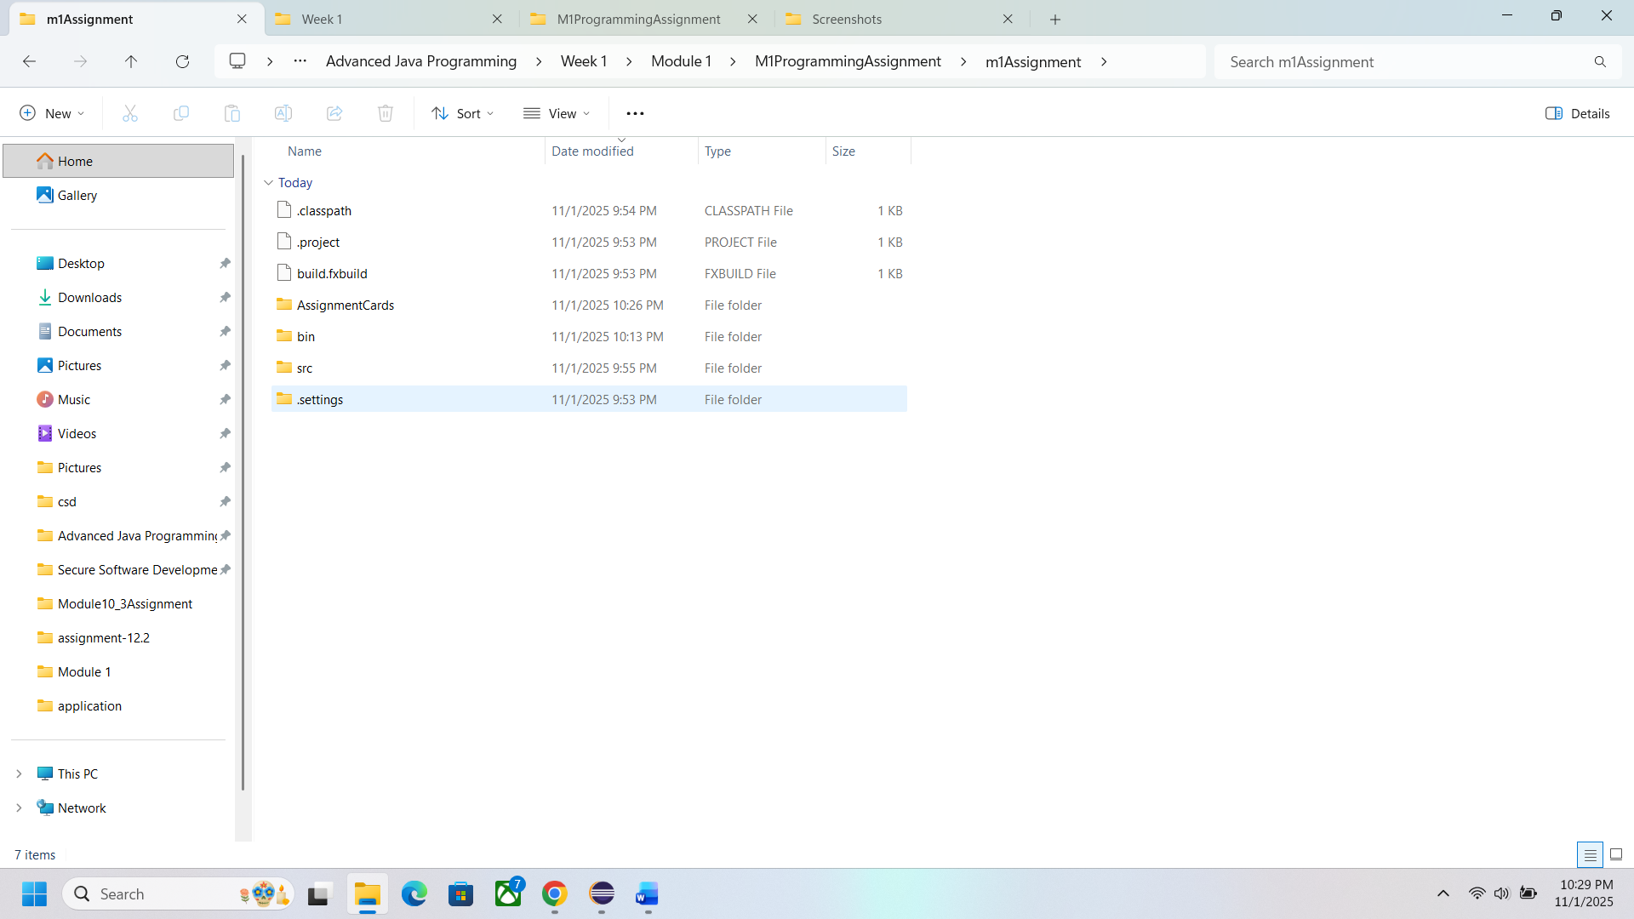

Pictures of program Running
