Week 4 M5: Programming Assignment
Collection of Words Sorter

Juan Macias Vasquez
Bellevue University
CSD420-H323 Advanced Java Programming (2261-DD)
Jack Lusby
November 16th, 2025

Week 4 M5: Programming Assignment
Collection of Words Sorter
GitHub Repository Link:
https://github.com/Juan551School/csd-420
Java Code
WordSorter.java
//Juan Macias Vasquez
//Bellevue University
//CSD420-H323 Advanced Java Programming (2261-DD)
//Jack Lusby
//November 16th, 2025
//WordSorter.java

package m5assignment;

import java.io.File;
import java.io.FileNotFoundException;
import java.util.Scanner;
import java.util.Set;
import java.util.TreeSet;
import java.util.ArrayList;

public class WordSorter {

public static void main(String[] args) {

// Checks to automatically removes duplicates and keeps the words in a sorted order
Set<String> wordsAscending = new TreeSet<>();

try {
File file = new File("collection_of_words.txt"); //The name of the file
Scanner scanner = new Scanner(file);

while (scanner.hasNext()) {
wordsAscending.add(scanner.next().toLowerCase());
}

scanner.close();

} catch (FileNotFoundException e) {
System.out.println("The file collection_of_words.txt was not found.");
return;
}

// Display in ascending order
System.out.println("Ascending Order:");
for (String word : wordsAscending) {
System.out.println(word);
}

// Create descending order version
ArrayList<String> descending = new ArrayList<>(wordsAscending);
descending.sort((a, b) -> b.compareTo(a));

System.out.println("\nDescending Order:");
for (String word : descending) {
System.out.println(word);
}

// Run test code
runTests(wordsAscending, descending);
}

// The Test Code
public static void runTests(Set<String> asc, ArrayList<String> desc) {
System.out.println("\n=== Running Tests ===");

// Test 1: Ascending set has no duplicates
boolean noDuplicates = asc.size() == new ArrayList<>(asc).size();
System.out.println("Test 1 - No Duplicates: " + (noDuplicates ? "PASS" : "FAIL"));

// Test 2: Ascending list is sorted A -> Z
boolean ascendingSorted = isAscending(new ArrayList<>(asc));
System.out.println("Test 2 - Ascending Sorted: " + (ascendingSorted ? "PASS" : "FAIL"));

// Test 3: Descending list is sorted Z -> A
boolean descendingSorted = isDescending(desc);
System.out.println("Test 3 - Descending Sorted: " + (descendingSorted ? "PASS" : "FAIL"));
}

private static boolean isAscending(ArrayList<String> list) {
for (int i = 0; i < list.size() - 1; i++) {
if (list.get(i).compareTo(list.get(i + 1)) > 0) {
return false;
}
}
return true;
}

private static boolean isDescending(ArrayList<String> list) {
for (int i = 0; i < list.size() - 1; i++) {
if (list.get(i).compareTo(list.get(i + 1)) < 0) {
return false;
}
}
return true;
}
}

Text File Code
collection_of_words.txt
apple banana orange apple grape peach banana lemon kiwi lime grape mango cherry mango lime

(The file had duplicates to make sure it didn’t keep them after running)

Pictures of Code running
Ascending Order:
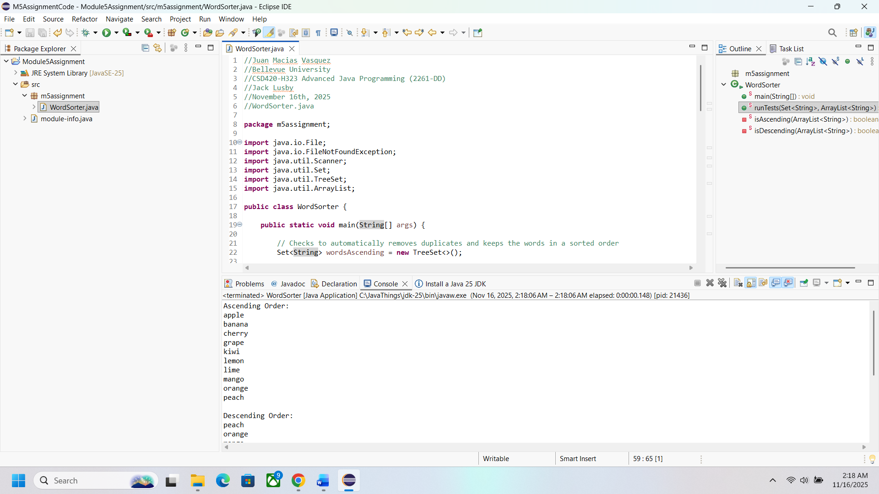

Descending Order:
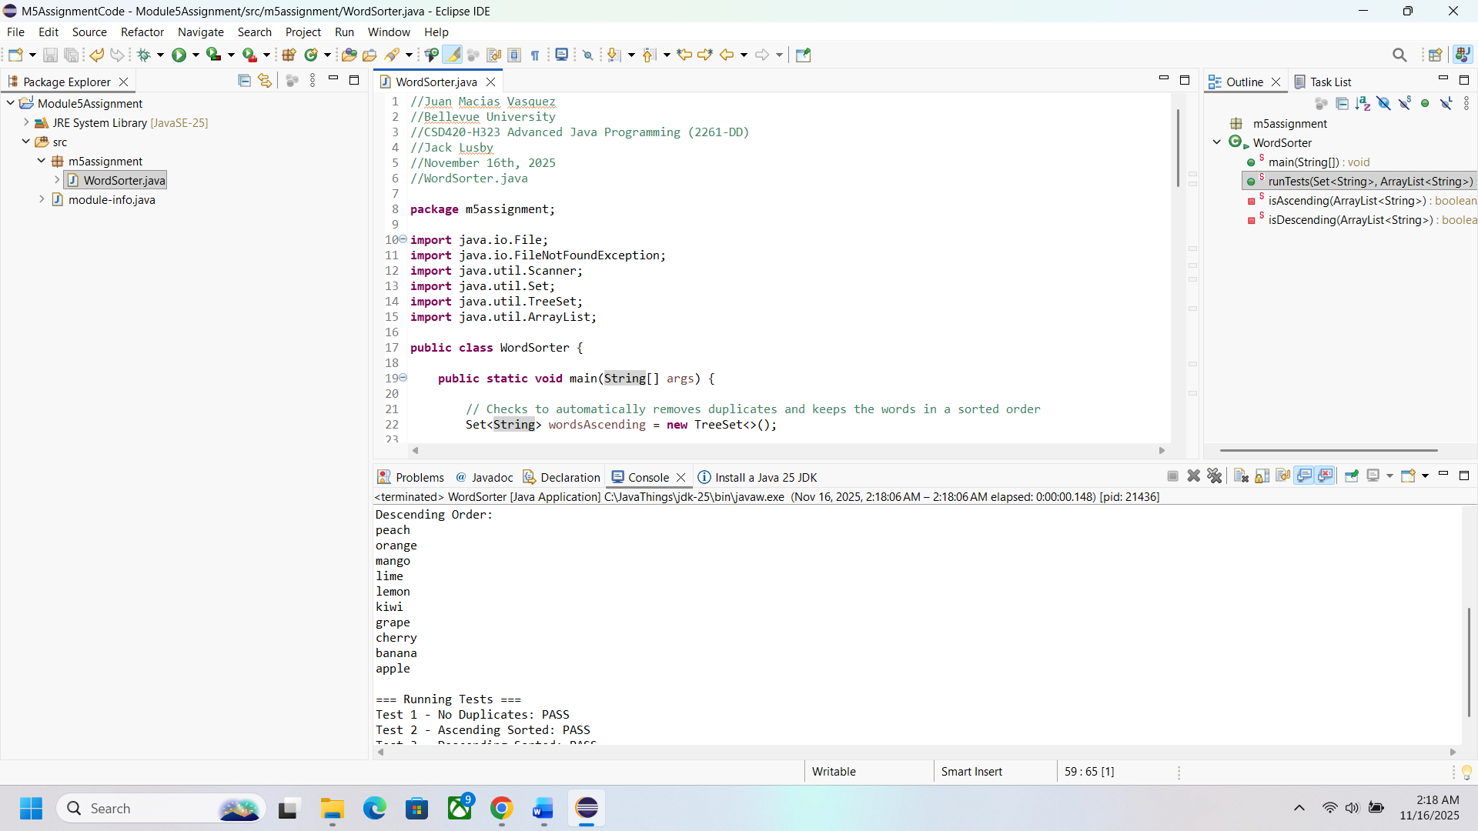
Running Tests
