Week 7 M9: Programming Assignment
MySQL and Java

Juan Macias Vasquez
Bellevue University
CSD420-H323 Advanced Java Programming (2261-DD)
Jack Lusby
December 7th, 2025

Week 7 M9: Programming Assignment
MySQL and Java
GitHub Repository Link:
https://github.com/Juan551School/csd-420
I did have to change some of the things because my IDE is Eclipse not NetBeans and I had SQL 8 not 5 but I was able to get things to work and make the tables from the java program and see the changes in my SQL command line.
I ran it in this order
Run in this order:
- CreateTable.java
  - Should print something like “Table created.”
- InsertData.java
  - Should print “Data inserted.”
- Select5.java
  - Should print rows from the database.
Pictures of Program Running
Java Programs
CreateTable.java
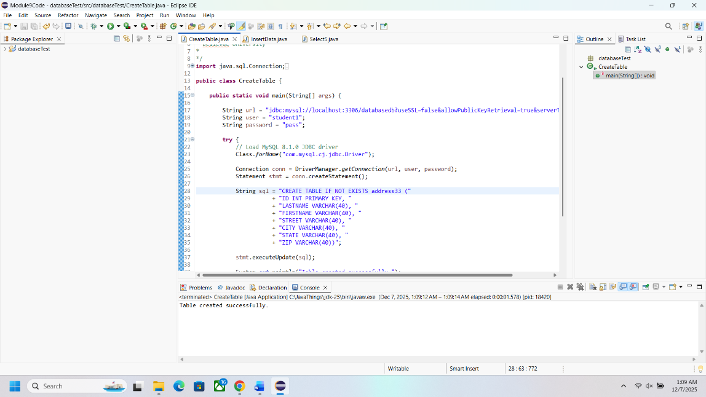
Insertdata.java (tried to take screenshot after running it already)
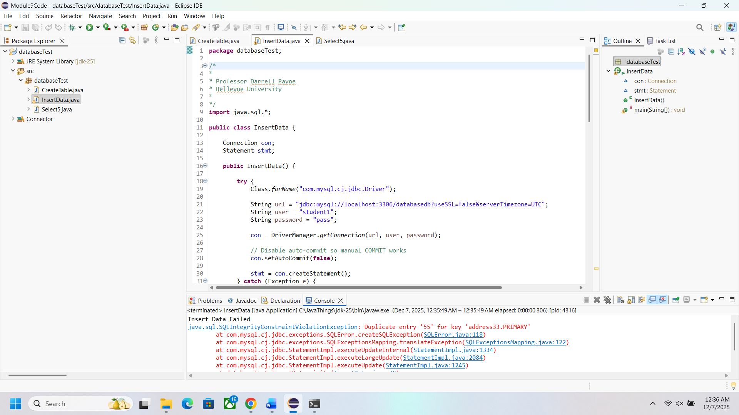
Select5.java
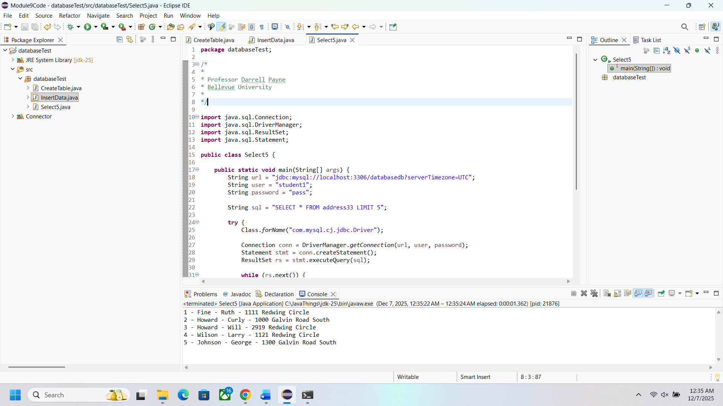

Pictures of SQL Command Line
Making users for SQL
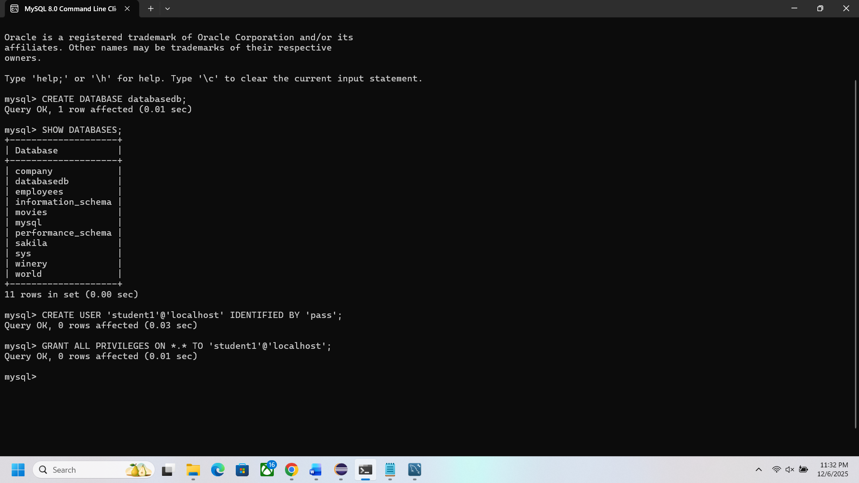
SQL After Java Programs make information
