Week 8 M10: Programming Assignment
Fan Database Updater

Juan Macias Vasquez
Bellevue University
CSD420-H323 Advanced Java Programming (2261-DD)
Jack Lusby
December 14th, 2025

Week 8 M10: Programming Assignment
Fan Database Updater
GitHub Repository Link:
https://github.com/Juan551School/csd-420
What I inserted originally in the SQL
INSERT INTO fans (ID, firstname, lastname, favoriteteam)
VALUES
(1, 'John', 'Doe', 'Red'),
(2, 'Jane', 'Smith', 'Blue');
Java Code
FanApp.java
//Juan Macias Vasquez
//Bellevue University
//CSD420-H323 Advanced Java Programming (2261-DD)
//Jack Lusby
//December 14th, 2025
//FanApp.java

package module10program;

import javax.swing.*;
import java.awt.*;

public class FanApp extends JFrame {

private static final long serialVersionUID = 1L;

private JTextField txtId = new JTextField(10);
private JTextField txtFirst = new JTextField(20);
private JTextField txtLast = new JTextField(20);
private JTextField txtTeam = new JTextField(20);

private JButton btnDisplay = new JButton("Display");
private JButton btnUpdate = new JButton("Update");

private FanDAO dao = new FanDAO();

//The Display for the User
public FanApp() {
setTitle("Fan Viewer / Updater");
setDefaultCloseOperation(JFrame.EXIT_ON_CLOSE);
setSize(400, 250);
setLocationRelativeTo(null);

JPanel panel = new JPanel(new GridLayout(5, 2, 5, 5));
// The Information that is filled out by the User and what the user sees
panel.add(new JLabel("ID:"));
panel.add(txtId);
panel.add(new JLabel("First Name:"));
panel.add(txtFirst);
panel.add(new JLabel("Last Name:"));
panel.add(txtLast);
panel.add(new JLabel("Favorite Team:"));
panel.add(txtTeam);

//The Buttons on the Display Window
panel.add(btnDisplay);
panel.add(btnUpdate);

add(panel);

btnDisplay.addActionListener(e -> displayFan());
btnUpdate.addActionListener(e -> updateFan());
}

private void displayFan() {
String idText = txtId.getText().trim();

if (idText.isEmpty()) {
JOptionPane.showMessageDialog(this, "Please enter an ID.");
return;
}

// Error messages and making sure the user puts in an int
try {
int id = Integer.parseInt(idText);
Fan fan = dao.getFanById(id);

if (fan != null) {
txtFirst.setText(fan.getFirstName());
txtLast.setText(fan.getLastName());
txtTeam.setText(fan.getFavoriteTeam());
} else {
JOptionPane.showMessageDialog(this, "Fan not found.");
}
} catch (NumberFormatException ex) {
JOptionPane.showMessageDialog(this, "ID must be a number.");
} catch (Exception ex) {
JOptionPane.showMessageDialog(this, ex.getMessage());
}
}

private void updateFan() {
String idText = txtId.getText().trim();

if (idText.isEmpty()) {
JOptionPane.showMessageDialog(this, "Please enter an ID.");
return;
}

try {
int id = Integer.parseInt(idText);

Fan fan = new Fan(
id,
txtFirst.getText().trim(),
txtLast.getText().trim(),
txtTeam.getText().trim()
);

boolean updated = dao.updateFan(fan);
// In case it messes up again / Error Codes
if (updated) {
JOptionPane.showMessageDialog(this, "Record updated successfully.");
} else {
JOptionPane.showMessageDialog(this, "Update failed. Check the ID.");
}

// Make sure a proper input is added
} catch (NumberFormatException ex) {
JOptionPane.showMessageDialog(this, "ID must be a number.");
} catch (Exception ex) {
JOptionPane.showMessageDialog(this, ex.getMessage());
}
}

public static void main(String[] args) {
SwingUtilities.invokeLater(() -> new FanApp().setVisible(true));
}
}

Fan.java
//Juan Macias Vasquez
//Bellevue University
//CSD420-H323 Advanced Java Programming (2261-DD)
//Jack Lusby
//December 14th, 2025
//Fan.java

package module10program;

public class Fan {

private int id;
private String firstName;
private String lastName;
private String favoriteTeam;

public Fan(int id, String firstName, String lastName, String favoriteTeam) {
this.id = id;
this.firstName = firstName;
this.lastName = lastName;
this.favoriteTeam = favoriteTeam;
}

public int getId() { return id; }
public String getFirstName() { return firstName; }
public String getLastName() { return lastName; }
public String getFavoriteTeam() { return favoriteTeam; }
}

FanDAO.java
//Juan Macias Vasquez
//Bellevue University
//CSD420-H323 Advanced Java Programming (2261-DD)
//Jack Lusby
//December 14th, 2025
//FanDAO.java (Fan Data Access Object)

package module10program;

import java.sql.*;

public class FanDAO {

// The URL and sign in information used
private static final String URL =
"jdbc:mysql://localhost:3306/databasedb?useSSL=false&allowPublicKeyRetrieval=true&serverTimezone=UTC";
private static final String USER = "student1";
private static final String PASS = "pass";

public Fan getFanById(int id) throws SQLException {
String sql = "SELECT * FROM fans WHERE ID = ?";

try (Connection conn = DriverManager.getConnection(URL, USER, PASS);
PreparedStatement ps = conn.prepareStatement(sql)) {

ps.setInt(1, id);
ResultSet rs = ps.executeQuery();

if (rs.next()) {
return new Fan(
rs.getInt("ID"),
rs.getString("firstname"),
rs.getString("lastname"),
rs.getString("favoriteteam")
);
}
}
return null;
}

public boolean updateFan(Fan fan) throws SQLException {
String sql =
"UPDATE fans SET firstname=?, lastname=?, favoriteteam=? WHERE ID=?";

try (Connection conn = DriverManager.getConnection(URL, USER, PASS);
PreparedStatement ps = conn.prepareStatement(sql)) {

ps.setString(1, fan.getFirstName());
ps.setString(2, fan.getLastName());
ps.setString(3, fan.getFavoriteTeam());
ps.setInt(4, fan.getId());

return ps.executeUpdate() == 1;
}
}
}

Pictures of Code running
At the start
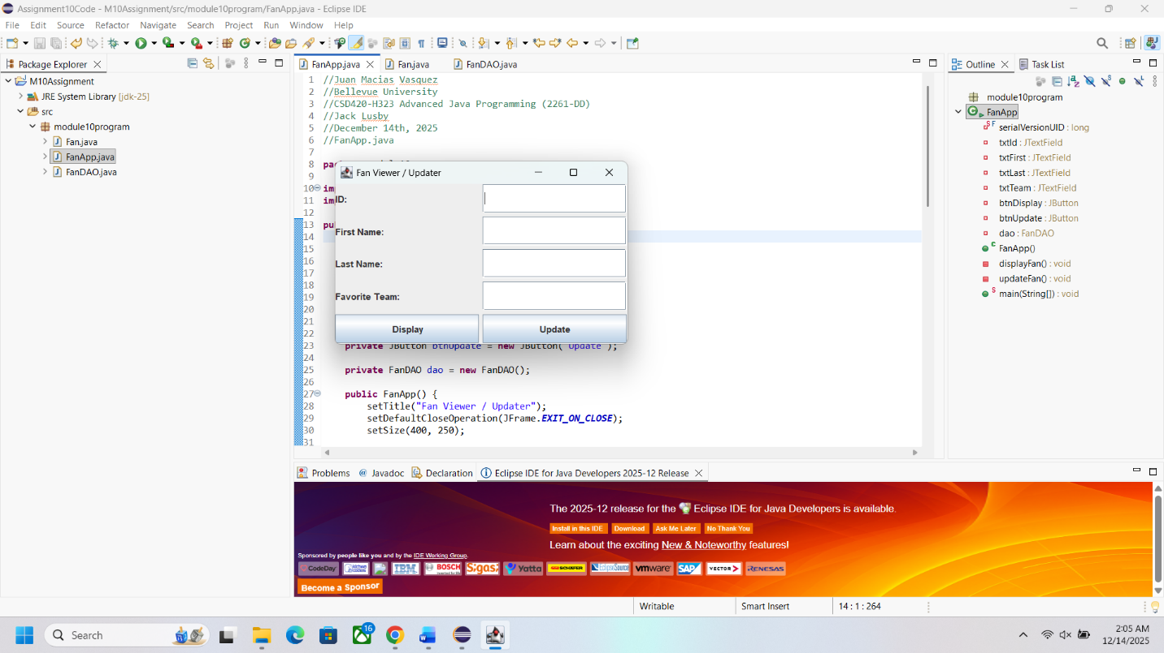

After adding information for an update
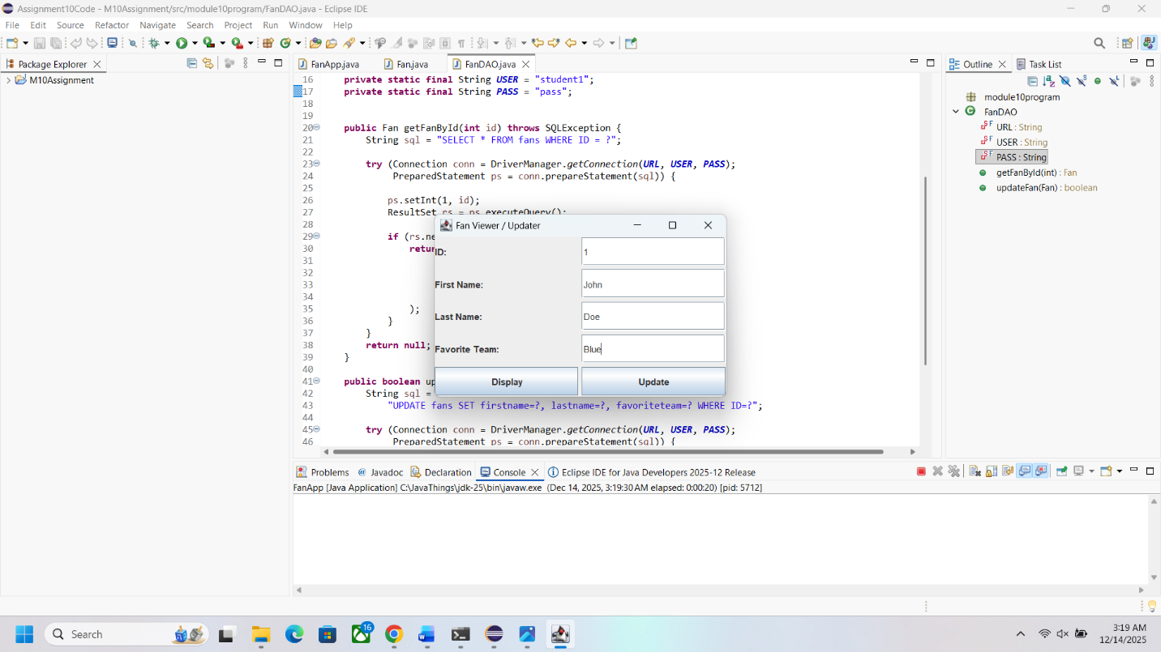

Record Update Screen 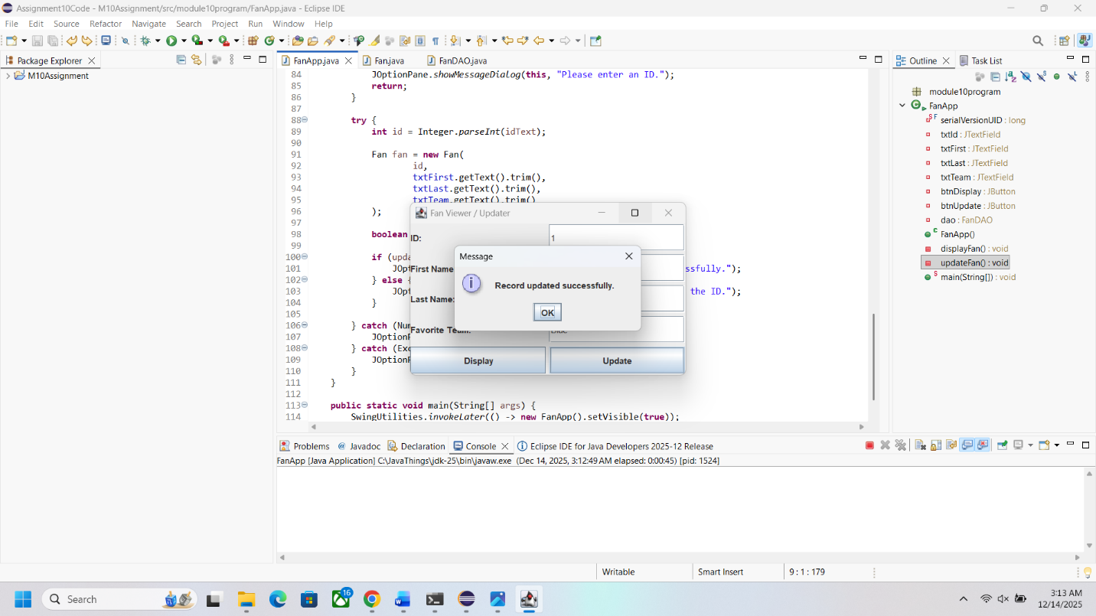

After using display and checking the SQL Command Line Table
