Week 4 M4: Programming Assignment
Link Test 50000 vs 500000 integers

Juan Macias Vasquez
Bellevue University
CSD420-H323 Advanced Java Programming (2261-DD)
Jack Lusby
November 8th, 2025

Week 4 M4: Programming Assignment
Link Test 50000 vs 500000 integers
GitHub Repository Link:
https://github.com/Juan551School/csd-420
Java Code
//Juan Macias Vasquez
//Bellevue University
//CSD420-H323 Advanced Java Programming (2261-DD)
//Jack Lusby
//November 6th, 2025
//LinkedListTraversal.java

package projectM4;

import java.util.LinkedList;
import java.util.ListIterator;

public class LinkedListTraversal {

public static void main(String[] args) {
// First the test with 50,000 integers
testTraversalTime(50000);

// Then test with 500,000 integers
testTraversalTime(500000);
}

/**
* This will tests traversal performance using iterator and get(index)for the given number of integers.
*/

public static void testTraversalTime(int size) {
LinkedList<Integer> list = new LinkedList<>();

// Fill the LinkedList
for (int i = 0; i < size; i++) {
list.add(i);
}

System.out.println("\nTesting with " + size + " integers:");

// Traversal using Iterator
long startTime = System.nanoTime();
ListIterator<Integer> iterator = list.listIterator();
while (iterator.hasNext()) {
iterator.next();
}
long endTime = System.nanoTime();
long iteratorTime = endTime - startTime;
System.out.println("Iterator traversal time: " + iteratorTime / 1_000_000.0 + " ms");

// Traversal using get
startTime = System.nanoTime();
for (int i = 0; i < list.size(); i++) {
list.get(i);
}
endTime = System.nanoTime();
long getIndexTime = endTime - startTime;
System.out.println("get(index) traversal time: " + getIndexTime / 1_000_000.0 + " ms");

System.out.println("Difference (get - iterator): " +
(getIndexTime - iteratorTime) / 1_000_000.0 + " ms");
}
}
/*
Results:
When you run the program, you will probably notice that:
• Traversing the LinkedList using an iterator is faster.
• Traversing using get(index) becomes extremely slow, especially for the 500,000 elements.
Reason:
• The `get(index)` method in LinkedList requires traversal from the start (or end) of the list to reach the specified index. This makes it **O(n)** per access.
• When done in a loop (n times), the total time complexity becomes **O(n²)**.
• The iterator, on the other hand, moves sequentially from one node to the next, which is **O(n)** overall.

After a couple tries
Average example output:
Testing with 50000 integers:
Iterator traversal time: 1.9 ms
get(index) traversal time: 950 ms

The Testing with 500000 integers:
Iterator traversal time: 5.1 ms
get(index) traversal time: 290000 ms

In Conclusion
• The iterator is the correct way to traverse LinkedLists.
• Using get(index) is inefficient for large lists due to repeated linear scans.
*/

Pictures of Code Running
50000 integers
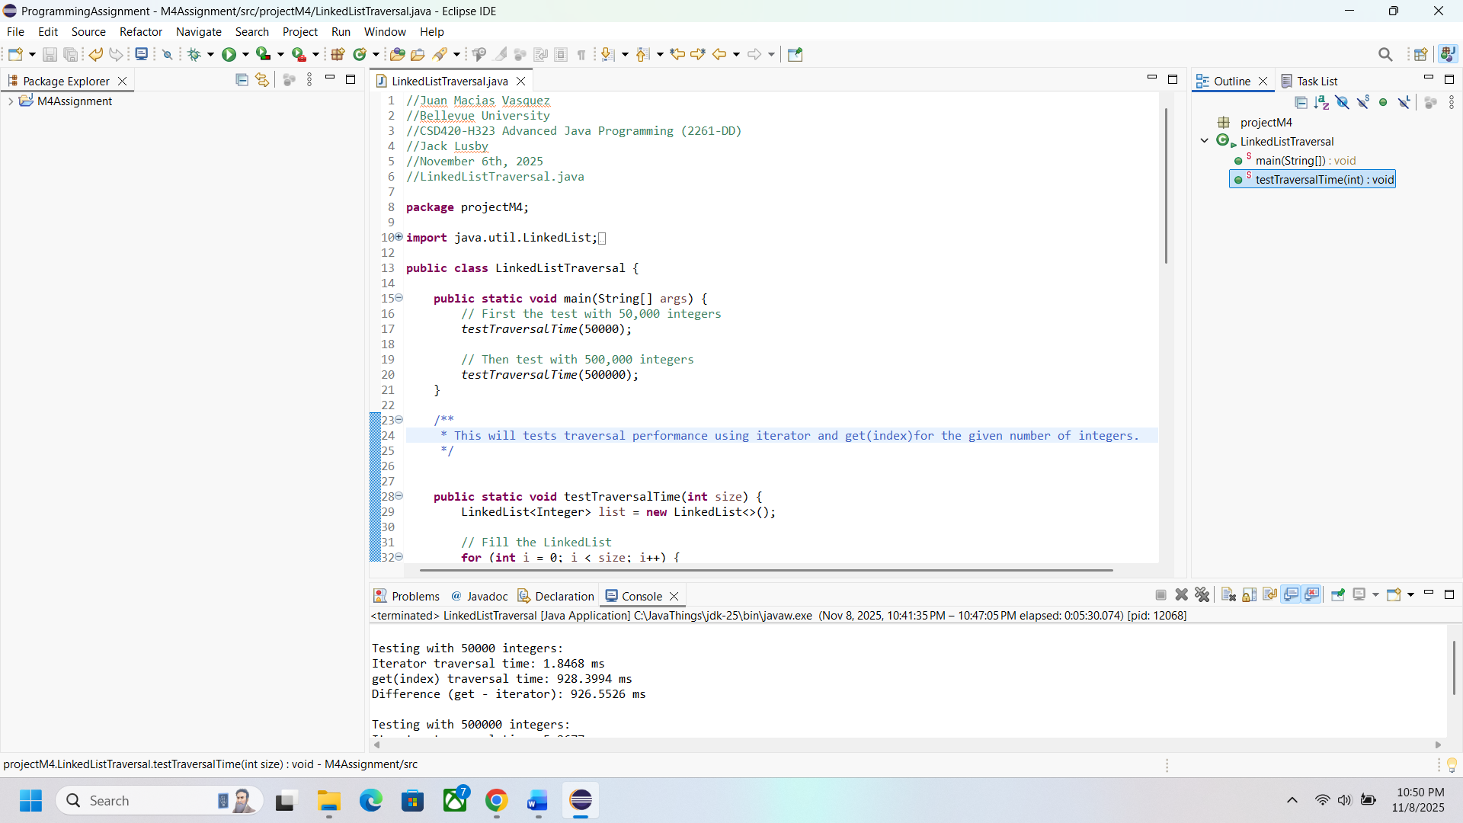
500000 integers
