Week 6 M7: Programming Assignment
JavaFX and CSS

Juan Macias Vasquez
Bellevue University
CSD420-H323 Advanced Java Programming (2261-DD)
Jack Lusby
November 30th, 2025

Week 6 M7: Programming Assignment
JavaFX and CSS
GitHub Repository Link:
https://github.com/Juan551School/csd-420
Java Code
FourCircleStyle.java
//Juan Macias Vasquez
//Bellevue University
//CSD420-H323 Advanced Java Programming (2261-DD)
//Jack Lusby
//November 30rd, 2025
//FourCircleStyle.java

package m7Assignment;

import javafx.application.Application;
import javafx.scene.Scene;
import javafx.scene.layout.HBox;
import javafx.scene.shape.Circle;
import javafx.stage.Stage;

public class FourCircleStyle extends Application {

@Override
public void start(Stage stage) {
// White-filled circles using class
Circle c1 = new Circle(50);
c1.getStyleClass().add("plaincircle");

Circle c2 = new Circle(50);
c2.getStyleClass().add("plaincircle");

// Red circle using ID
Circle c3 = new Circle(50);
c3.setId("redcircle");

// Green circle using ID
Circle c4 = new Circle(50);
c4.setId("greencircle");

HBox pane = new HBox(20);
pane.getChildren().addAll(c1, c2, c3, c4);

Scene scene = new Scene(pane, 450, 150);

// Load CSS file
scene.getStylesheets().add("mystyle.css");

stage.setTitle("Circle CSS Demo");
stage.setScene(scene);
stage.show();
}

public static void main(String[] args) {
launch(args);
}
}

CircleStyleTest.java
//Juan Macias Vasquez
//Bellevue University
//CSD420-H323 Advanced Java Programming (2261-DD)
//Jack Lusby
//November 30rd, 2025
//CircleStyleTest.java
package m7Assignment;

import javafx.scene.shape.Circle;

public class CircleStyleTest {

public static void main(String[] args) {
testCircleStyles();
}

public static void testCircleStyles() {
Circle testWhite = new Circle(50);
testWhite.getStyleClass().add("plaincircle");

Circle testRed = new Circle(50);
testRed.setId("redcircle");

Circle testGreen = new Circle(50);
testGreen.setId("greencircle");

//check if normal circle was added
assert testWhite.getStyleClass().contains("plaincircle") : "White circle class not applied";
//check if the color red was added
assert testRed.getId().equals("redcircle") : "Red circle ID not applied";
//check if the color Green was added
assert testGreen.getId().equals("greencircle") : "Green circle ID not applied";

System.out.println("All style tests passed!");
}
}

Css Code
mystyle.css
/* Class for white fill and black stroke */
.plaincircle {
-fx-fill: white;
-fx-stroke: black;
}

/* Optional border/dash style (shown in assignment) */
.circleborder {
-fx-stroke-width: 5;
-fx-stroke-dash-array: 12 2 4 2;
}

/* ID selector for red circle */
#redcircle {
-fx-fill: red;
-fx-stroke: red;
}

/* ID selector for green circle */
#greencircle {
-fx-fill: green;
-fx-stroke: green;
}

Pictures of Code Running
Without Css file
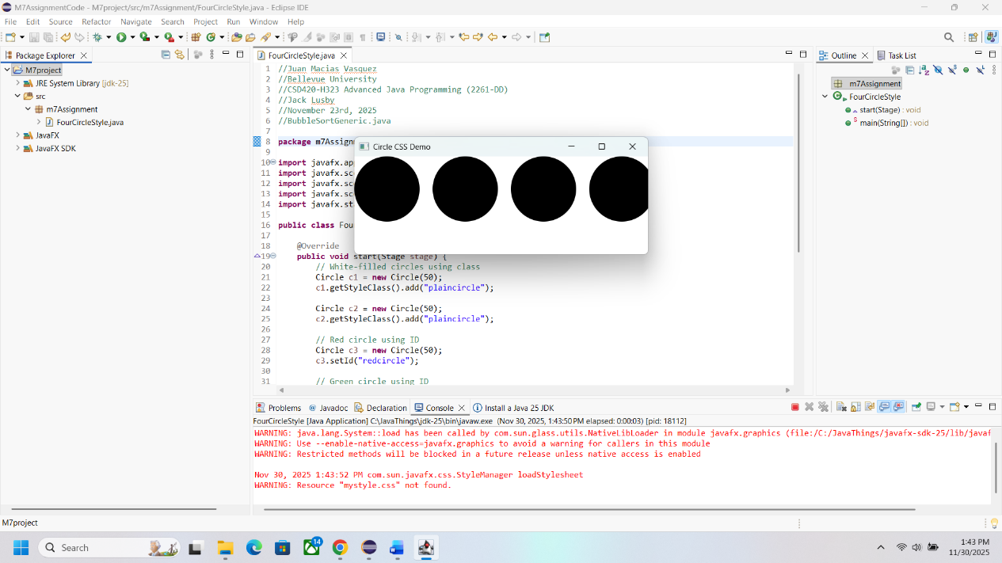
With CSS file
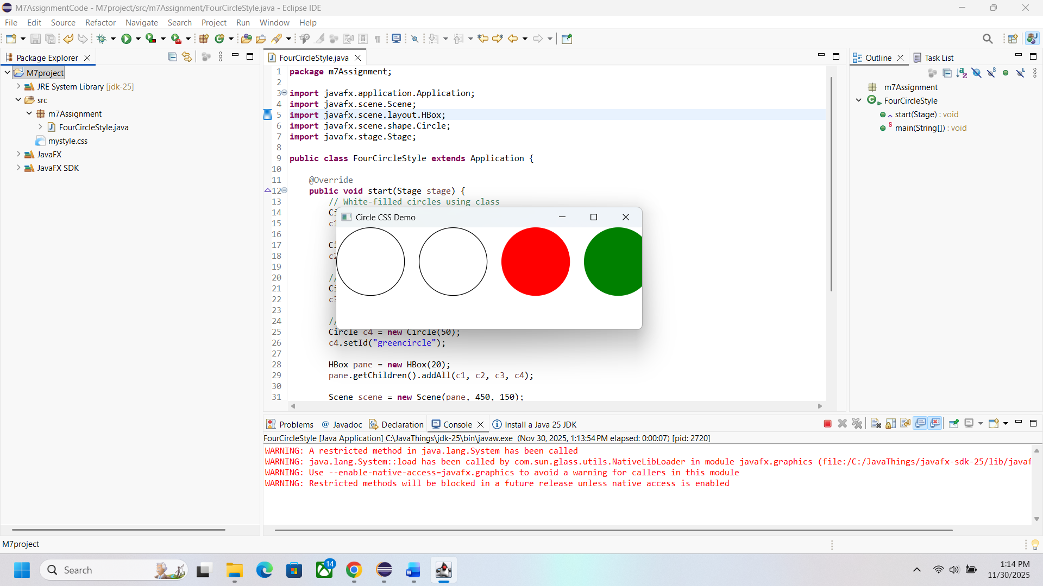
Color Check