Week 2 M2: Programming Assignment
Read, Write, and Create File

Juan Macias Vasquez
Bellevue University
CSD420-H323 Advanced Java Programming (2261-DD)
Jack Lusby
November 1st, 2025

Week 2 M2: Programming Assignment
Read, Write, and Create File
GitHub Repository Link:
https://github.com/Juan551School/csd-420
Java Code
WriteData.java
//Juan Macias Vasquez
//Bellevue University
//CSD420-H323 Advanced Java Programming (2261-DD)
//Jack Lusby
//November 1st, 2025
//WriteData.java

package m2Project;
import java.io.*;
import java.util.Random;

public class WriteData {
public static void main(String[] args) {
String fileName = "Macias_datafile.dat"; //The name of the file
Random rand = new Random();

try (PrintWriter output = new PrintWriter(new FileWriter(fileName, true))) {
// Write 5 random integers from 0-99
output.print("Integers: ");
for (int i = 0; i < 5; i++) {
int value = rand.nextInt(100); // Random int 0–99
output.print(value + " ");
}

output.println(); // New line

// Write 5 random doubles
output.print("Doubles: ");
for (int i = 0; i < 5; i++) {
double value = rand.nextDouble() * 100; // Random double 0–100
output.printf("%.2f ", value);
}

output.println(); // New line
output.println("-----------------------------");

System.out.println("Data successfully written to " + fileName);
} catch (IOException e) {
System.out.println("Error writing to file: " + e.getMessage());
}
}
}

ReadData.java
//Juan Macias Vasquez
//Bellevue University
//CSD420-H323 Advanced Java Programming (2261-DD)
//Jack Lusby
//November 1st, 2025
//ReadData.java

package m2Project;

import java.io.*;
import java.util.Scanner;

public class ReadData {
public static void main(String[] args) {
String fileName = "Macias_datafile.dat"; // The name of the file

try (Scanner input = new Scanner(new File(fileName))) {
System.out.println("Reading data from " + fileName + ":\n");
while (input.hasNextLine()) {
System.out.println(input.nextLine());
}
} catch (FileNotFoundException e) {
System.out.println("File not found: " + fileName);
}
}
}

Pictures of Program Running
WriteData.java
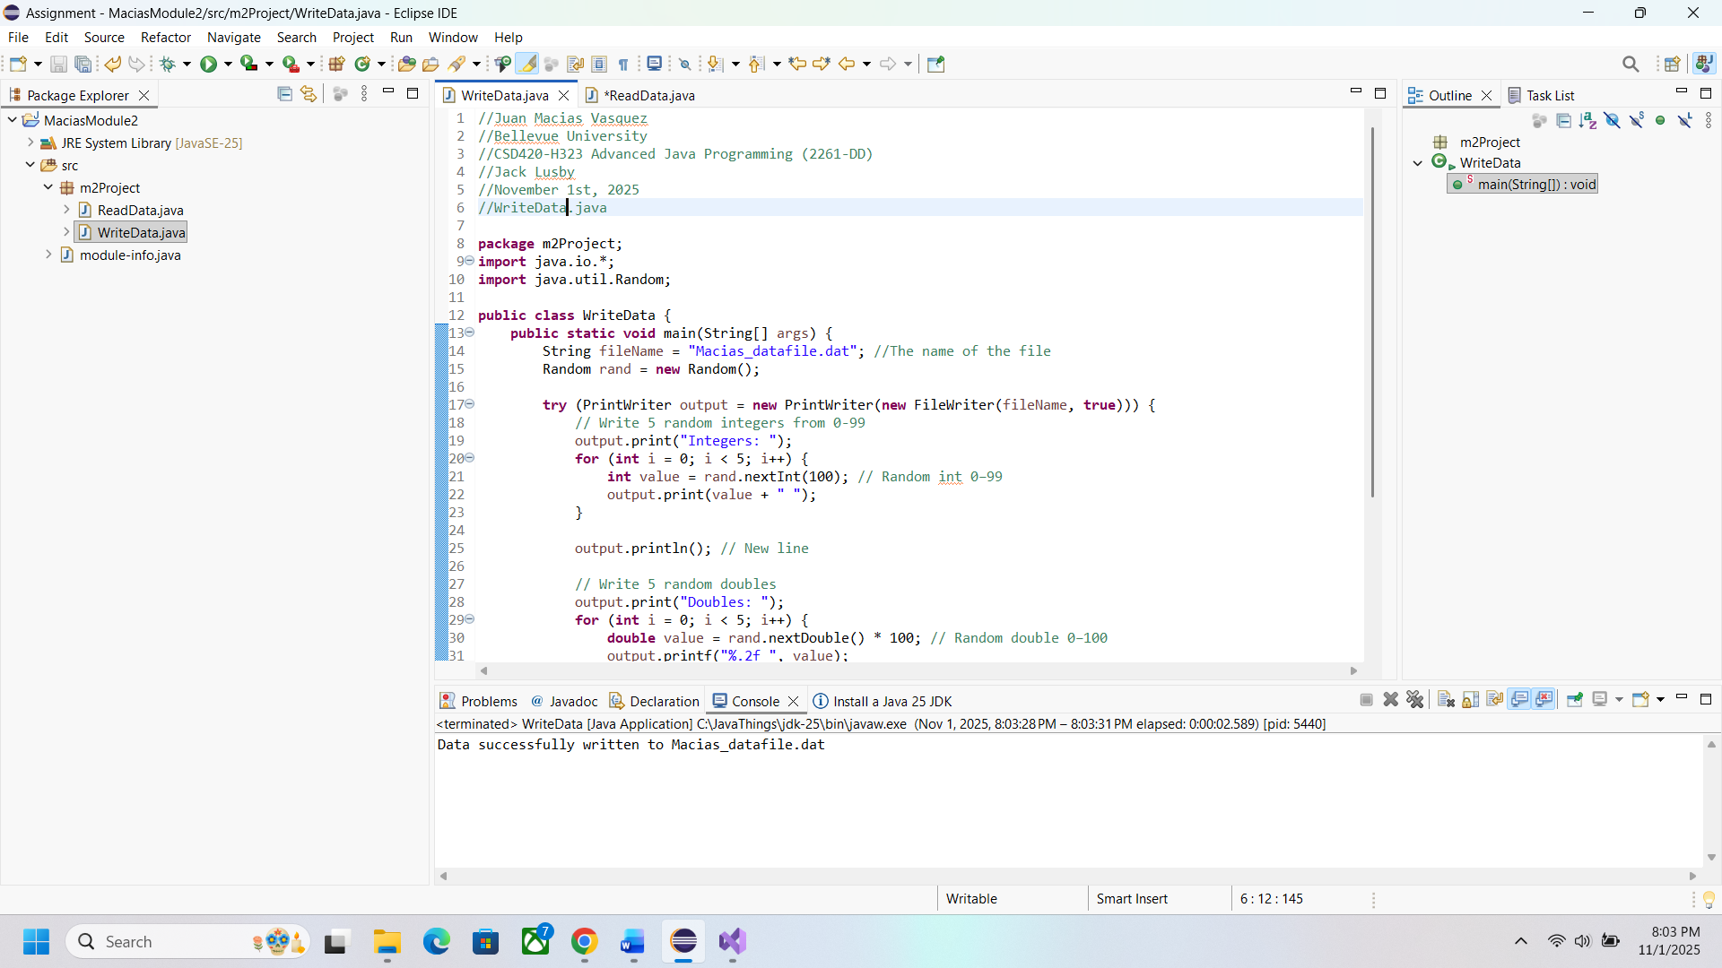
ReadData.java
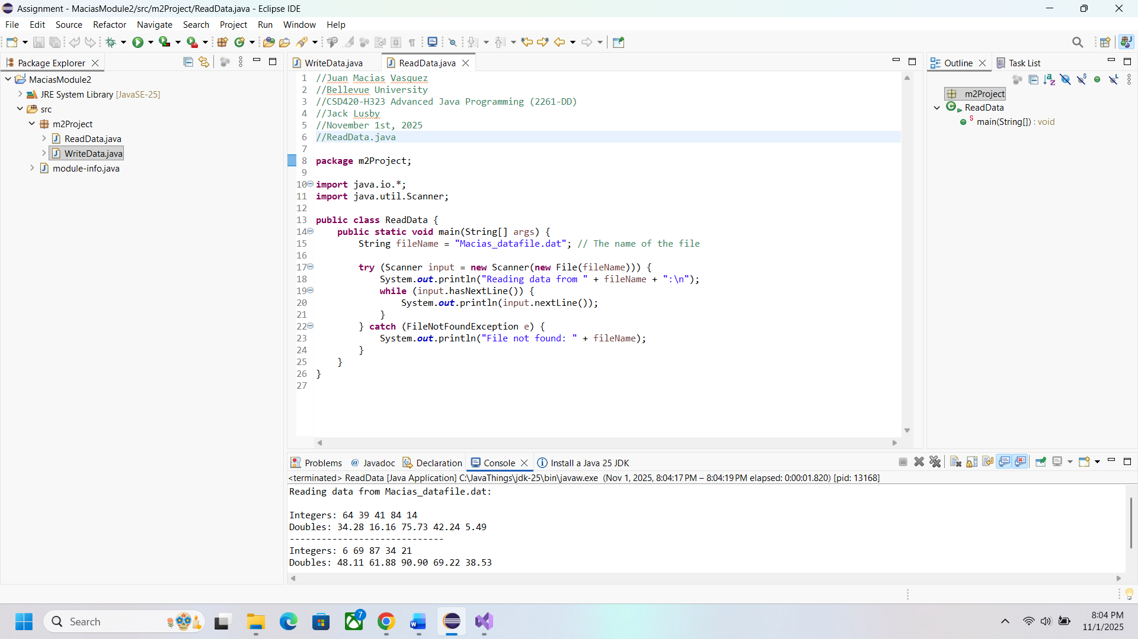

Picture of the data File
