Week 2 Module 3 Assignment
Working with JSP Forms

Juan Macias Vasquez
Bellevue University
CSD430-H323 ServerSide Development (2265-DD)
Jack Lusby
January 25th, 2026

Week 2 Module 3 Assignment
Working with JSP Forms
GitHub Repository
https://github.com/Juan551School/csd-430
The files are feedbackForm.jsp for collecting the user input and feedbackResult.jsp for displaying the submitted data in an HTML table. The Links for the jsp code files on the server are http://localhost:8080/Module3Assignment/feedbackForm.jsp and http://localhost:8080/Module3Assignment/FeedbackResult.jsp.
Code Used
feedbackForm.jsp
<%@ page language="java" contentType="text/html; charset=UTF-8" %>
<!--
Juan Macias Vasquez
Bellevue University
CSD430-H323 ServerSide Development (2265-DD)
Jack Lusby
Module 3 Assignment
Java Scriptlet – Data Display
January 25th, 2026
-->
<!DOCTYPE html>

<html>
<head>
<title>Video Game Feedback Form</title>
</head>
<body>

<h2>Video Game Feedback</h2>
<p>Please provide feedback on your recent gaming experience.</p>

<form action="FeedbackResult.jsp" method="post">

<!-- Text input -->
<label>Player Name (Gamertag):</label><br>
<input type="text" name="playerName" required><br><br>

<!-- Text input -->
<label>Game Title:</label><br>
<input type="text" name="gameTitle" required><br><br>

<!-- Radio buttons -->
<label>Overall Rating:</label><br>
<input type="radio" name="rating" value="Excellent" required> Excellent<br>
<input type="radio" name="rating" value="Good"> Good<br>
<input type="radio" name="rating" value="Average"> Average<br>
<input type="radio" name="rating" value="Poor"> Poor<br><br>

<!-- Dropdown -->
<label>Gameplay Difficulty:</label><br>
<select name="difficulty">
<option value="Easy">Easy</option>
<option value="Normal">Normal</option>
<option value="Hard">Hard</option>
<option value="Very Hard">Very Hard</option>
</select><br><br>

<!-- Textarea -->
<label>Comments or Suggestions:</label><br>
<textarea name="comments" rows="4" cols="40"></textarea><br><br>

<input type="submit" value="Submit Feedback">

</form>

</body>
</html>

feedbackResult.jsp at
<%@ page language="java" contentType="text/html; charset=UTF-8" %>
<!--
Juan Macias Vasquez
Bellevue University
CSD430-H323 ServerSide Development (2265-DD)
Jack Lusby
Module 3 Assignment
Java Scriptlet – Data Display
January 25th, 2026
-->
<%
// Retrieve submitted form data
String playerName = request.getParameter("playerName");
String gameTitle = request.getParameter("gameTitle");
String rating = request.getParameter("rating");
String difficulty = request.getParameter("difficulty");
String comments = request.getParameter("comments");
%>

<!DOCTYPE html>
<html>
<head>
<title>Game Feedback Results</title>

</head>
<body>

<h2>Video Game Feedback Summary</h2>
<p>The following feedback was submitted by the player:</p>

<table class="feedbackTable">

<tr>
<th>Field</th>
<th>Description</th>
<th>Submitted Value</th>
</tr>
<tr>
<td>Player Name</td>
<td>Name of the player submitting feedback</td>
<td><%= playerName %></td>
</tr>
<tr>
<td>Game Title</td>
<td>Name of the video game reviewed</td>
<td><%= gameTitle %></td>
</tr>
<tr>
<td>Overall Rating</td>
<td>Player's overall satisfaction</td>
<td><%= rating %></td>
</tr>
<tr>
<td>Gameplay Difficulty</td>
<td>Perceived difficulty level</td>
<td><%= difficulty %></td>
</tr>
<tr>
<td>Comments</td>
<td>Additional player feedback or suggestions</td>
<td><%= comments %></td>
</tr>
</table>

</body>
</html>

Pictures of code running
feedbackForm.jsp at http://localhost:8080/Module3Assignment/feedbackForm.jsp
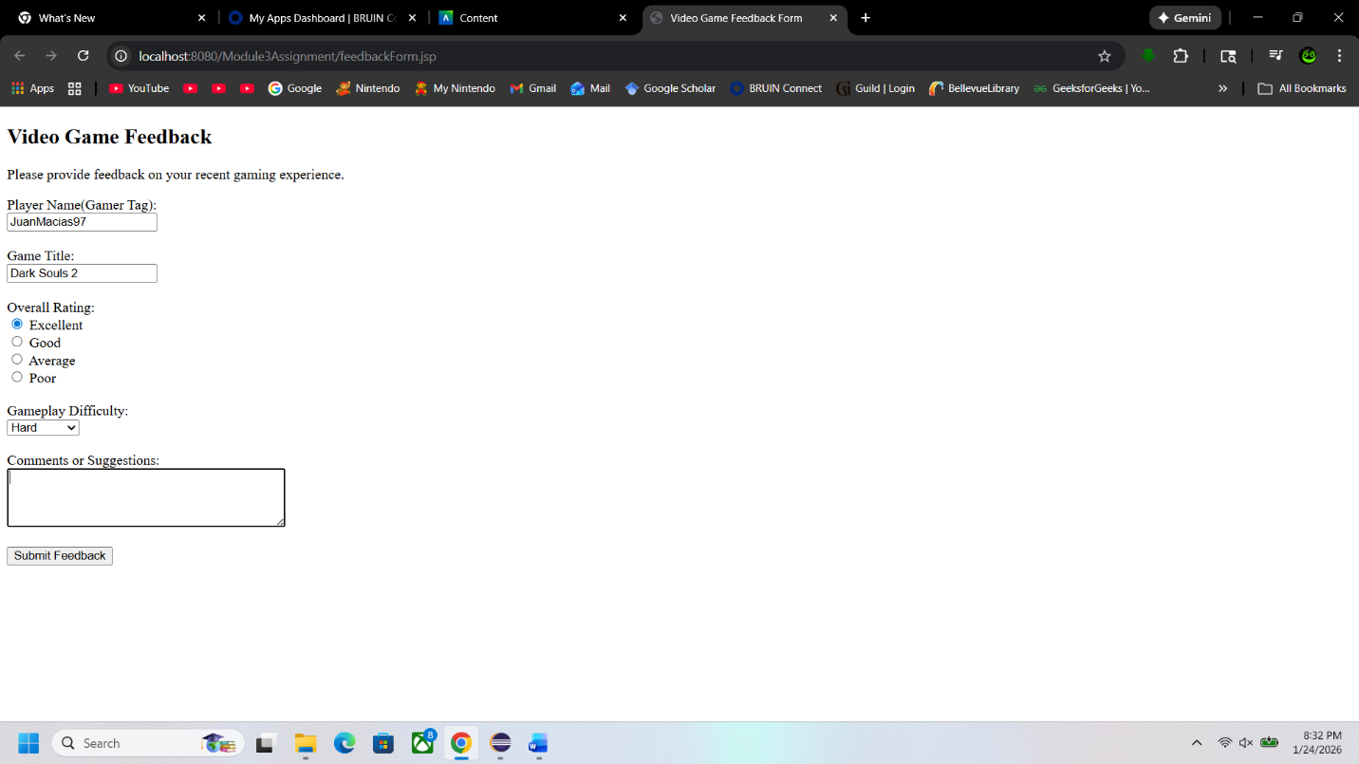
feedbackResult.jsp at http://localhost:8080/Module3Assignment/FeedbackResult.jsp
