Week 1 Module 2 Assignment
Java Scriptlet – Data Display

Juan Macias Vasquez
Bellevue University
CSD430-H323 ServerSide Development (2265-DD)
Jack Lusby
January 18th, 2026

Week 1 Module 2 Assignment
Java Scriptlet – Data Display
GitHub Repository
https://github.com/Juan551School/csd-430
I chose “A book you have enjoyed reading.”
What the webpages address was http://localhost:8080/Module2_JSP/favoriteBooks.jsp
Code Used
favoriteBooks.jsp
<%@ page import="java.util.ArrayList" %>
<%@ page import="java.util.Arrays" %>

<%
/* Juan Macias Vasquez
Bellevue University
CSD430-H323 ServerSide Development (2265-DD)
Jack Lusby
Module 2 Assignment
Java Scriptlet – Data Display
January 18th, 2026
*/

/*
Java Scriptlet Section
this section holds only Java code.
it creates and stores book data using
an ArrayList of String arrays.
*/
// Include other display items such as field and recode descriptions, title, and overall data description.
class Book {
String title;
String author;
String genre;

Book(String title, String author, String genre) {
this.title = title;
this.author = author;
this.genre = genre;
}
}

ArrayList<Book> books = new ArrayList<Book>();

// Data will have a minimum of 5 records with three fields.
books.add(new Book("The Hobbit and Lord of the Rings", "J.R.R. Tolkien", "Fantasy"));
books.add(new Book("Drago Ball", "Akira Toriyama", "Action-adventure, Fantasy, Manga"));
books.add(new Book("Tokyo Ghoul", "Sui Ishid", "Dark fantasy, Manga"));
books.add(new Book("Dune", "Frank Herbert", "Science Fiction"));
books.add(new Book("Demon Slayer", "Koyoharu Gotouge", "Action-Adventure, Fantasy, Manga"));
%>

<!DOCTYPE html>
<html>
<head>
<title>Favorite Books Data</title>
<link rel="stylesheet" type="text/css" href="styles.css">
</head>

<body>

<h1>Favorite Books I Have Enjoyed Reading</h1>

<p class="description">
This web page displays books that I have enjoyed reading.
The data is organized into topical categories such as book title, author, and genre.
The information is dynamically generated using JSP Scriptlets.
</p>

<h2>The Field Descriptions</h2>
<ul>

<li><strong>Title</strong> The name of the book</li>
<li><strong>Author</strong> The author who wrote the book</li>
<li><strong>Genre</strong> The category or type of book</li>
</ul>

<h2>Book Data Table</h2>

<table>
<thead>
<tr>
<th>Title</th>
<th>Author</th>
<th>Genre</th>
</tr>
</thead>

<tbody>
<%
/*
* ==========================================
* Scriptlet is used only for the looping logic
* HTML remains outside Java code
* ==========================================
*/
for (Book book : books) {
%>
<tr>
<td><%= book.title %></td>
<td><%= book.author %></td>
<td><%= book.genre %></td>
</tr>
<%
}
%>
</tbody>
</table>

<p class="footer">
Total number of books displayed:
<strong><%= books.size() %></strong>
</p>

</body>
</html>

styles.css
@charset "UTF-8";
body {
font-family: Arial, sans-serif;
background-color: #f4f4f4;
margin: 30px;
}

h1, h2 {
color: #333;
}

.description {
background-color: #ffffff;
padding: 15px;
border-left: 5px solid #4CAF50;
margin-bottom: 20px;
}

table {
width: 80%;
border-collapse: collapse;
background-color: #ffffff;
}

table th, table td {
border: 1px solid #ccc;
padding: 10px;
text-align: left;
}

table th {
background-color: #4CAF50;
color: white;
}

tr:nth-child(even) {
background-color: #f2f2f2;
}

.footer {
margin-top: 20px;
font-style: italic;
}

Pictures
IDE With Code
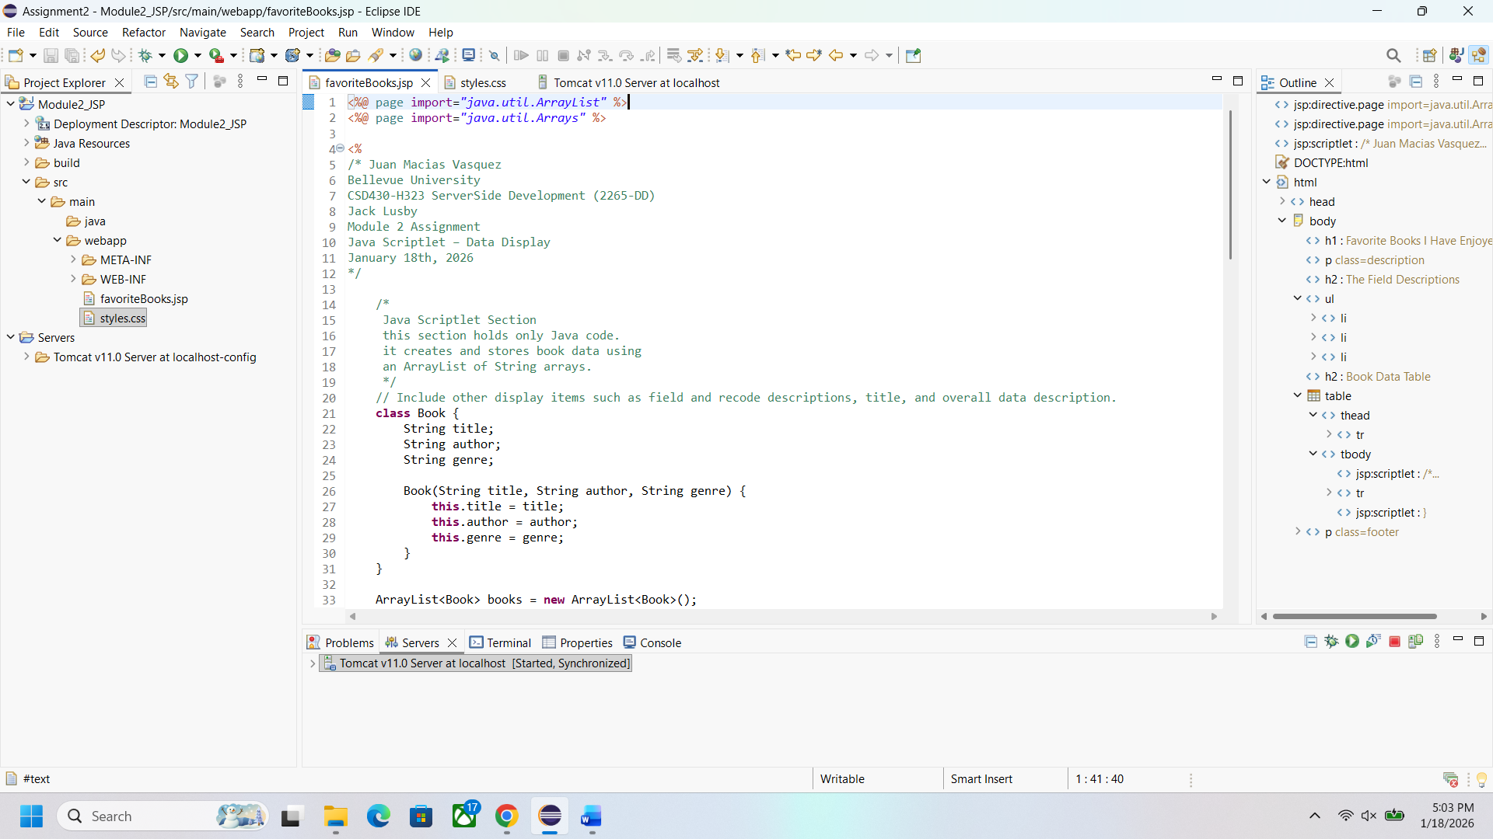
Webpage
