Week 1 Module 1 Assignment
Project Setup and Repository

Juan Macias Vasquez
Bellevue University
CSD430-H323 ServerSide Development (2265-DD)
Jack Lusby
January 18th, 2026

Week 1 Module 1 Assignment
Project Setup and Repository
GitHub Repository
https://github.com/Juan551School/csd-430
Code of index.jsp
<%@ page language="java" contentType="text/html; charset=UTF-8"
pageEncoding="UTF-8" %>

<!DOCTYPE html>
<html>
<head>
<meta charset="UTF-8">
<title>Module 1 JSP Test</title>
</head>
<body>

<h1>Welcome to My First JSP Page (Module 1 assignment)</h1>

<%
// Java code inside JSP Scriptlet
String studentName = "Juan Macias Vasquez";
int year = java.time.Year.now().getValue();
%>

<p>
Student Name: <strong><%= studentName %></strong>
</p>

<p>
Current Year: <strong><%= year %></strong>
</p>

<p>
This page demonstrates:
</p>

<ul>
<li>Java code inside JSP</li>
<li>HTML structure</li>
<li>Dynamic content generation</li>
</ul>

</body>
</html>

TomCat File Folder
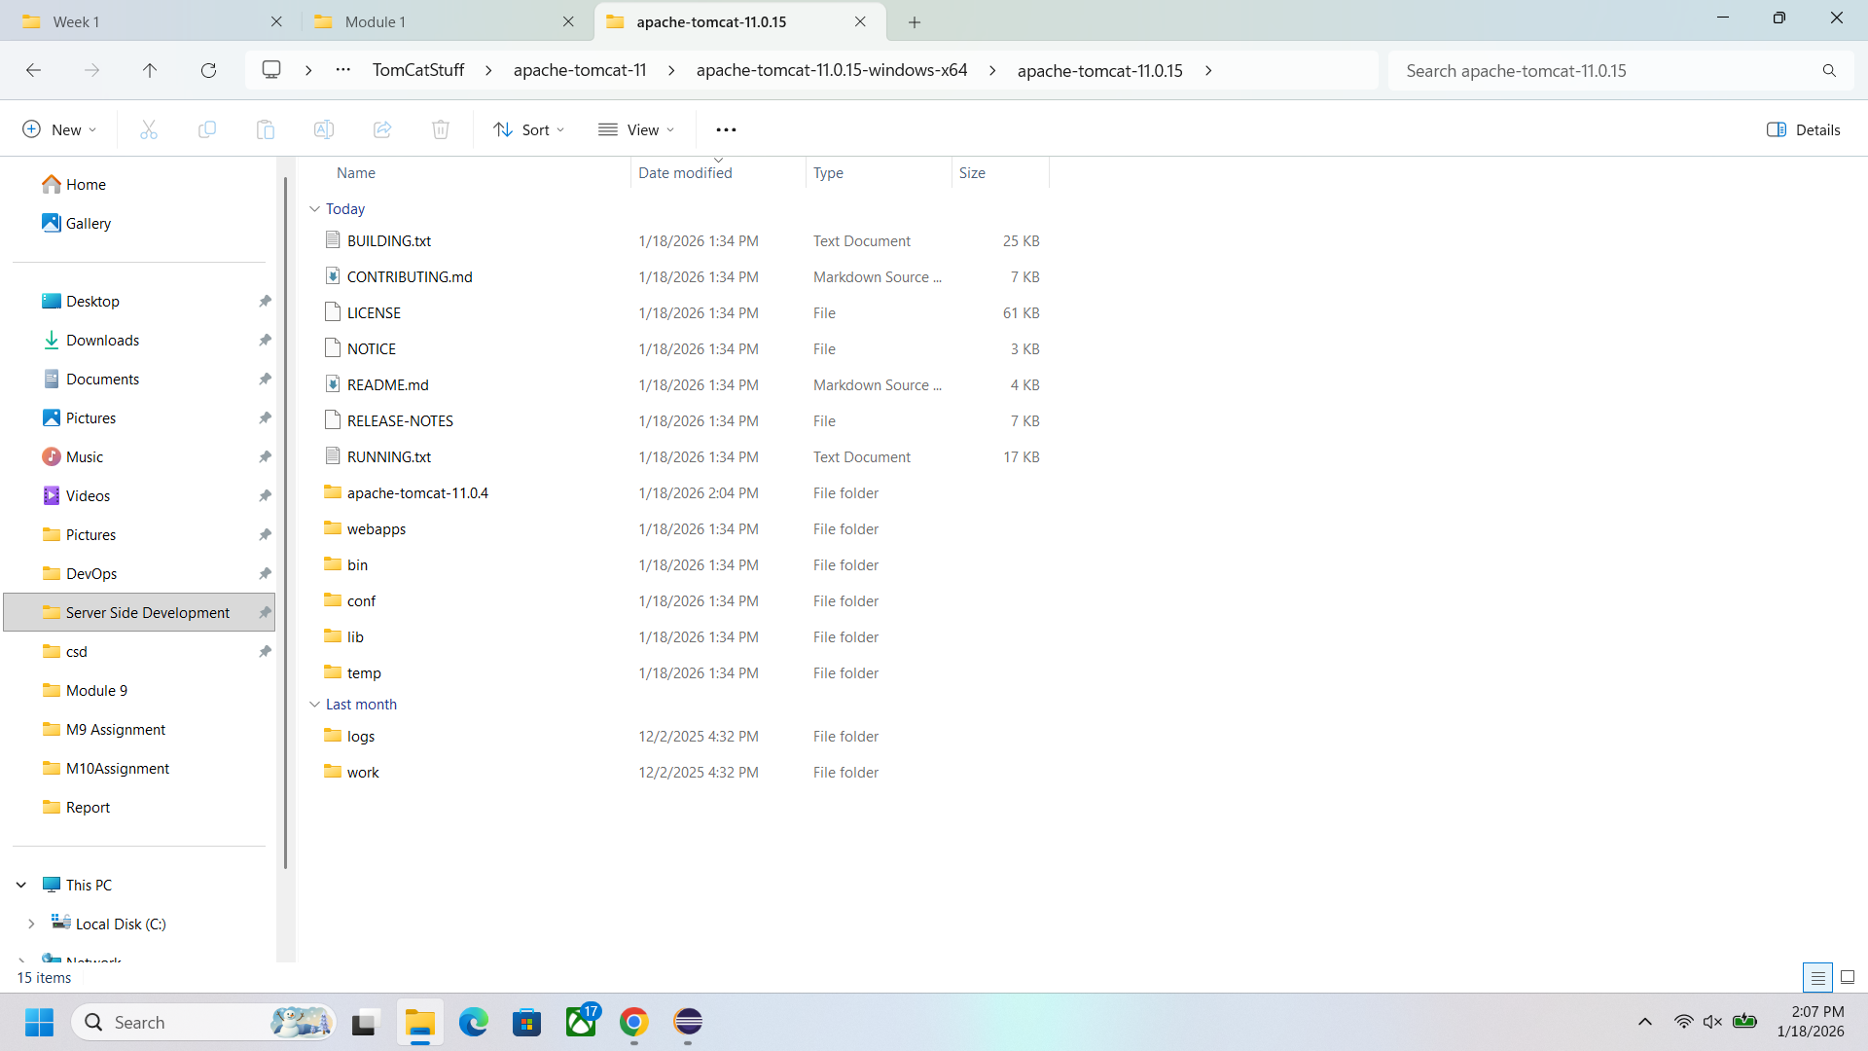
Choosing Server information for Eclipse
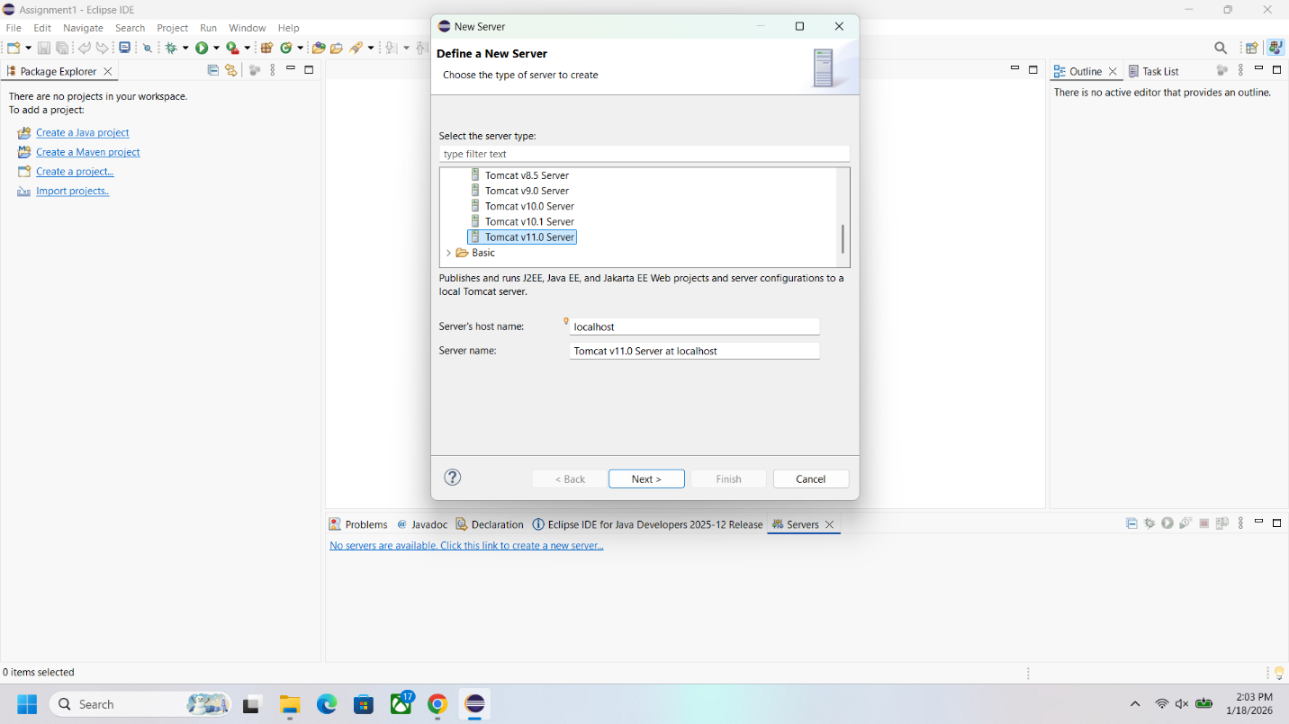

Picture of Eclipse after adding tomcat
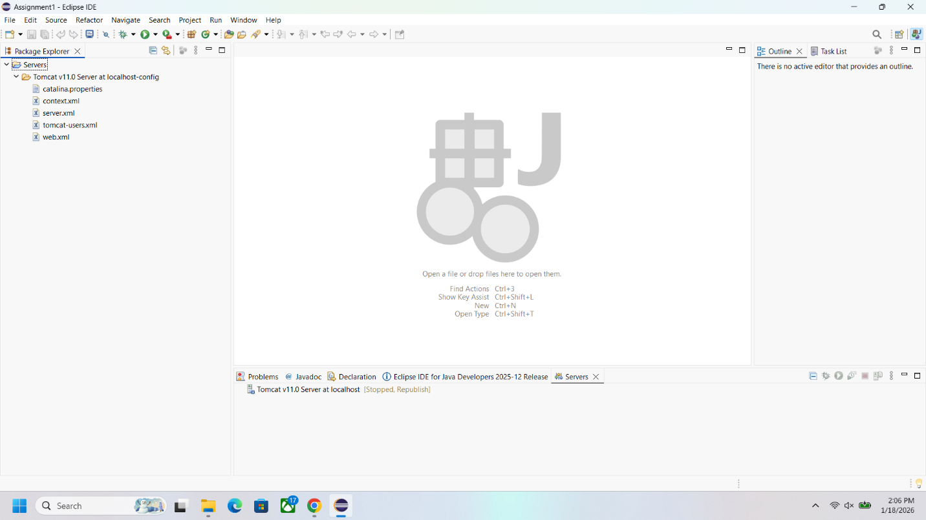

Picture of Code
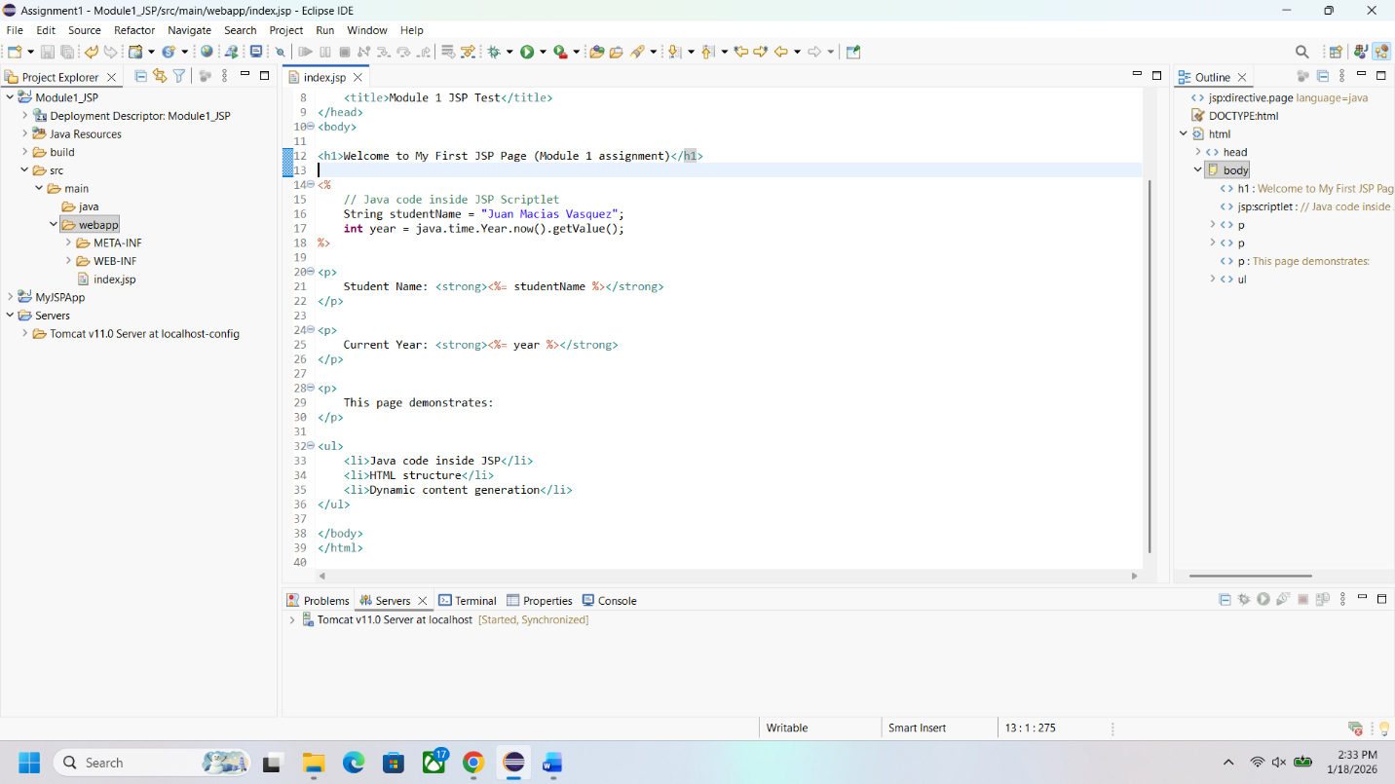

Picture of Webpage
