Week 4 Modules 5 & 6 Assignment
Project Part 1

Juan Macias Vasquez
Bellevue University
CSD430-H323 ServerSide Development (2265-DD)
Jack Lusby
February 8th, 2026

Week 4 Modules 5 & 6 Assignment
Project Part 1

GitHub Repository
https://github.com/Juan551School/csd-430
Used 10 Movies as the data used
Had to add mysql-connector-java-<version>.jar to the project to get it to work
Link used to run program http://localhost:8080/Assignment5and6part1/movies.jsp
Code Used
index.jsp
<%@ page language="java" contentType="text/html; charset=UTF-8"
pageEncoding="UTF-8"%>

<%
/*
Juan Macias Vasquez
Bellevue University
CSD430-H323 ServerSide Development (2265-DD)
Jack Lusby
Module 5and6 Assignment
Project Part 1
February 8th, 2026
*/
%>

<!DOCTYPE html>
<html>
<head>
<title>CSD430 Projects</title>
</head>
<body>
<h1>CSD430 Project Index</h1>

<ul>
<li><a href="movies.jsp">Module 6 – View Movies</a></li>
</ul>
</body>
</html>

movies.jsp
<%@ page language="java" contentType="text/html; charset=UTF-8"
pageEncoding="UTF-8"%>
<%@ page import="model.MovieBean,java.sql.*,java.util.*" %>

<%
/*
Juan Macias Vasquez
Bellevue University
CSD430-H323 ServerSide Development (2265-DD)
Jack Lusby
Module 5and6 Assignment
Project Part 1
February 8th, 2026
*/
%>

<!DOCTYPE html>
<html>
<head>
<title>Movie Database</title>
</head>
<body>

<h1>Movie Database Viewer</h1>
<p>Select a Movie ID to view its details.</p>

<%
MovieBean bean = new MovieBean();
ArrayList<Integer> movieIds = bean.getMovieIds();
%>

<form method="post">
<label for="movie_id">Movie ID:</label>
<select name="movie_id">
<%
for (int id : movieIds) {
%>
<option value="<%= id %>"><%= id %></option>
<%
}
%>
</select>
<input type="submit" value="View Movie">
</form>

<%
if (request.getParameter("movie_id") != null) {
int selectedId = Integer.parseInt(request.getParameter("movie_id"));
ResultSet rs = bean.getMovieById(selectedId);

if (rs.next()) {
%>

<%
/*
The 5 feilds used and details they have for the movies
*/
%>

<h2>Movie Details</h2>

<table border="1">
<thead>
<tr>
<th>ID</th>
<th>Title</th>
<th>Genre</th>
<th>Release Year</th>
<th>Director</th>
<th>Rating</th>
</tr>
</thead>
<tbody>
<tr>
<td><%= rs.getInt("movie_id") %></td>
<td><%= rs.getString("title") %></td>
<td><%= rs.getString("genre") %></td>
<td><%= rs.getInt("release_year") %></td>
<td><%= rs.getString("director") %></td>
<td><%= rs.getDouble("rating") %></td>
</tr>
</tbody>
</table>

<%
}
}
%>

</body>
</html>

MovieBean.java
//Juan Macias Vasquez
//Bellevue University
//CSD430-H323 ServerSide Development (2265-DD)
//Jack Lusby
//Module 5and6 Assignment
//Project Part 1
//February 8th, 2026

package model;

import java.sql.*;
import java.util.ArrayList;

public class MovieBean {

private Connection conn;

public MovieBean() throws Exception {
Class.forName("com.mysql.cj.jdbc.Driver");
conn = DriverManager.getConnection(
"jdbc:mysql://localhost:3306/CSD430",
"student1",
"pass"
);
}

public ArrayList<Integer> getMovieIds() throws SQLException {
ArrayList<Integer> ids = new ArrayList<>();
Statement stmt = conn.createStatement();
ResultSet rs = stmt.executeQuery("SELECT movie_id FROM juan_movies_data");
while (rs.next()) {
ids.add(rs.getInt("movie_id"));
}
return ids;
}

public ResultSet getMovieById(int id) throws SQLException {
PreparedStatement ps = conn.prepareStatement(
"SELECT * FROM juan_movies_data WHERE movie_id = ?"
);
ps.setInt(1, id);
return ps.executeQuery();
}
}

csd430_movies.sql
-- =====================================================
-- Course: CSD430
-- Assignment: Modules 5 & 6 Assignment - Working with CRUD-READ, JDBC, & JavaBeans
-- Database: CSD430
-- User: student1
-- Password: pass
-- Topic: Movies
-- =====================================================

-- Remove database if it already exists (optional but helpful for grading)
DROP DATABASE IF EXISTS CSD430;

-- Create database
CREATE DATABASE CSD430;
USE CSD430;

-- Create user
CREATE USER IF NOT EXISTS 'student1'@'localhost' IDENTIFIED BY 'pass';

-- Grant permissions so JavaBean can access the database
GRANT ALL PRIVILEGES ON CSD430.* TO 'student1'@'localhost';
FLUSH PRIVILEGES;

-- -----------------------------------------------------
-- Drop table if it exists
-- -----------------------------------------------------
DROP TABLE IF EXISTS juan_movies_data;

-- -----------------------------------------------------
-- Create movies table
-- -----------------------------------------------------
CREATE TABLE juan_movies_data (
movie_id INT AUTO_INCREMENT PRIMARY KEY,
title VARCHAR(100) NOT NULL,
genre VARCHAR(50) NOT NULL,
release_year INT NOT NULL,
director VARCHAR(100) NOT NULL,
rating DECIMAL(2,1) NOT NULL
);

-- -----------------------------------------------------
-- Insert the movie records (minimum 10)
-- -----------------------------------------------------
INSERT INTO juan_movies_data
(title, genre, release_year, director, rating)
VALUES
('The Hobbit: An Unexpected Journey', 'Fantasy', 2012, 'Peter Jackson', 7.8),
('The Lord of the Rings: The Fellowship of the Ring', 'Fantasy', 2001, 'Peter Jackson', 8.8),
('Star Wars: Episode III – Revenge of the Sith', 'Sci-Fi', 2005, 'George Lucas', 7.6),
('The Dark Knight', 'Action', 2008, 'Christopher Nolan', 9.0),
('The Matrix', 'Sci-Fi', 1999, 'Wachowski Sisters', 8.7),
('The Godfather', 'Crime', 1972, 'Francis Ford Coppola', 9.2),
('The Hangover', 'Comedy', 2009, 'Todd Phillips', 7.7),
('John Wick', 'Action', 2014, 'Chad Stahelski', 7.4),
('Joker', 'Drama', 2019, 'Todd Phillips', 8.4),
('Spider-Man', 'Action', 2002, 'Sam Raimi', 7.4);

-- -----------------------------------------------------
-- Verify table creation and data
-- -----------------------------------------------------
SELECT * FROM josh_movies_data;

Pictures of Website Running
Code Running in Eclipse
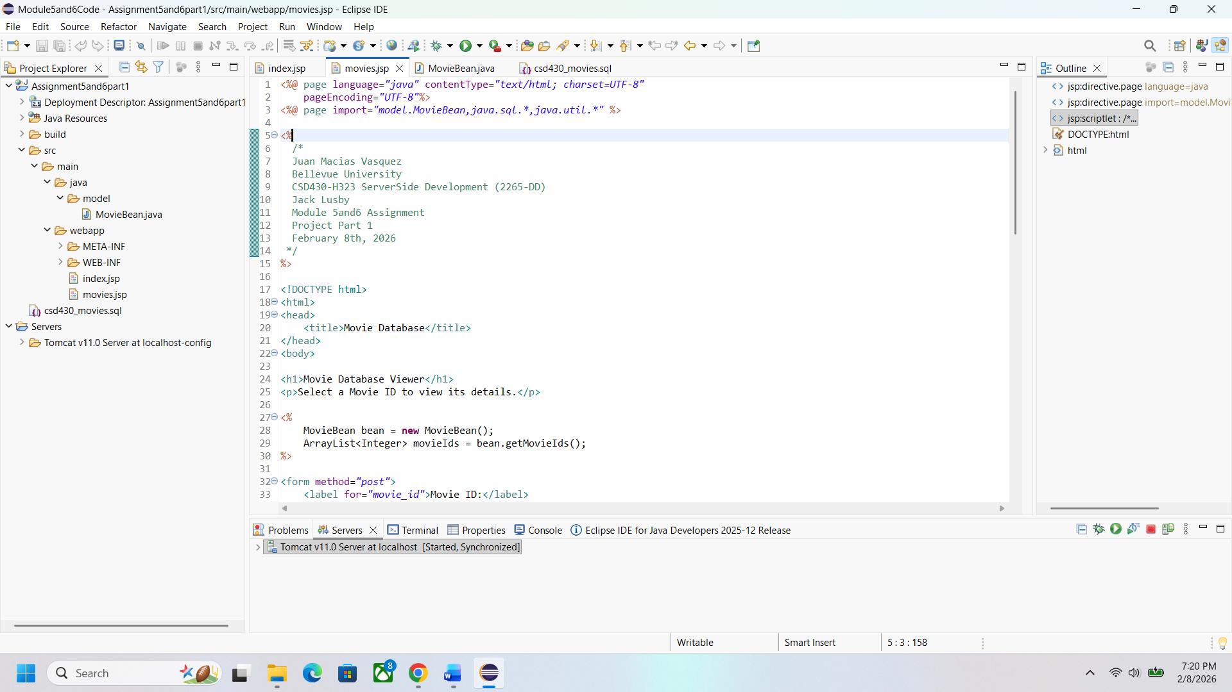

First look when website runs
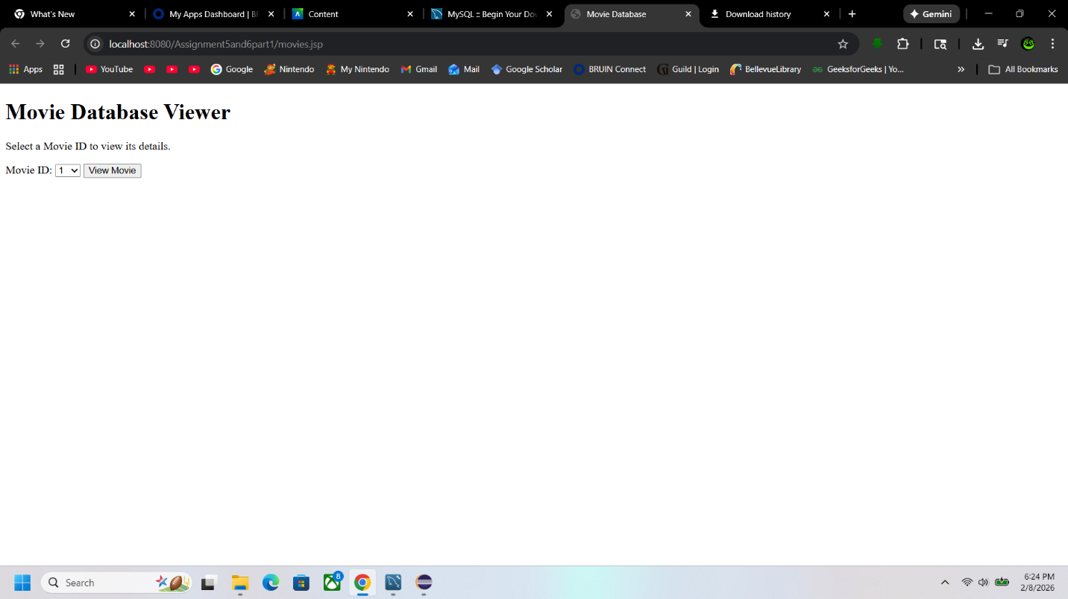

Drop Down Menu
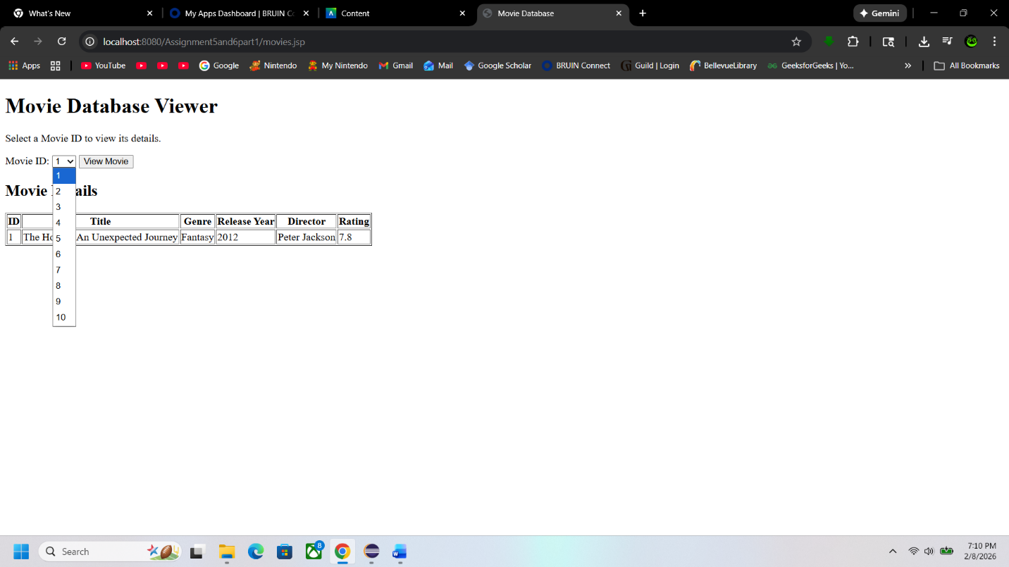
Selected option
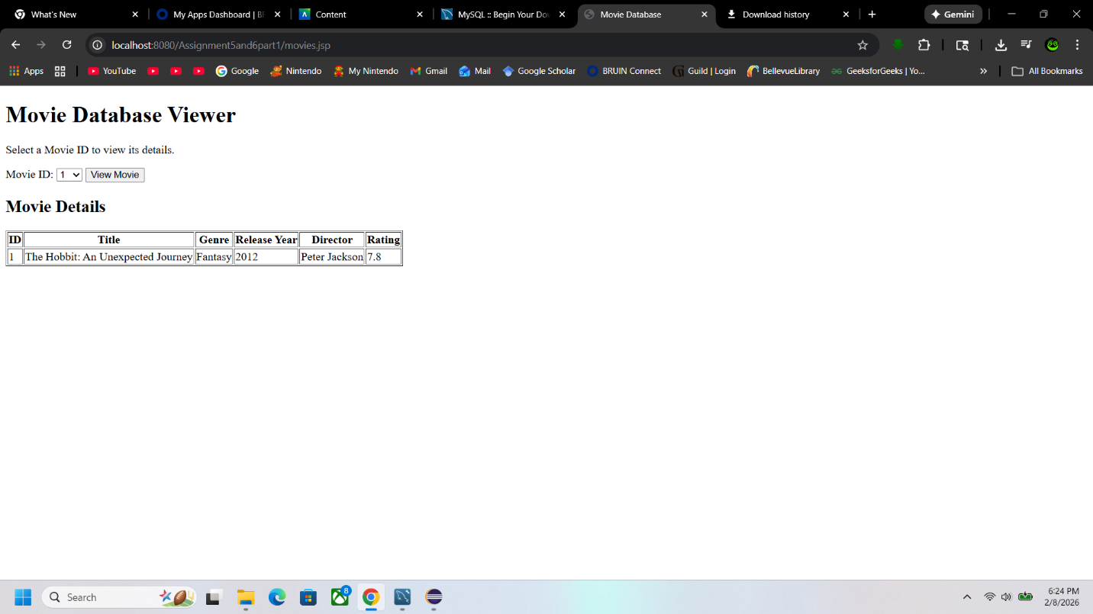

Another Selected Option
