Week 7 Modules 9 Assignment
Project Part 4

Juan Macias Vasquez
Bellevue University
CSD430-H323 ServerSide Development (2265-DD)
Jack Lusby
February 27th, 2026

Week 7 Modules 9 Assignment
Project Part 4

GitHub Repository
https://github.com/Juan551School/csd-430
New Update: Added a delete feature
Code
index.jsp (Updated)
<%@ page language="java" contentType="text/html; charset=UTF-8"
pageEncoding="UTF-8"%>

<%
/*
Juan Macias Vasquez
Bellevue University
CSD430-H323 ServerSide Development (2265-DD)
Jack Lusby
Module 9 Assignment
Project Part 4
2026 Updated February 28th, 2026
*/
%>

<!DOCTYPE html>
<html>
<head>
<title>Movie Database Home</title>
</head>
<body>

<h1>Movie Database System</h1>

<p>This application allows users to view and add movies to the database.</p>

<h2>Navigation</h2>

<ul>
<li><a href="movies.jsp">View Movie by ID</a></li>
<li><a href="addMovie.jsp">Add New Movie</a></li>
<li><a href="updateMovie.jsp">Update Movie</a></li>
<li><a href="deleteMovies.jsp">Delete Movie</a></li>
</ul>

</body>
</html>

MovieBean.Java (Updated)
/*
Juan Macias Vasquez
Bellevue University
CSD430-H323 ServerSide Development (2265-DD)
Jack Lusby
Module 8 Assignment
Project Part 4
Updated February 28th, 2026
*/

package model;

import java.sql.*;
import java.util.ArrayList;

/*
This JavaBean handles:
- Database connection
- Retrieving movie IDs
- Retrieving a movie by ID
- Adding a new movie
- Delete movie by ID (New for part 4)
- Retrieving all movies
*/

public class MovieBean {

// DATABASE CONNECTION SETTINGS
private String url = "jdbc:mysql://localhost:3306/csd430";
private String username = "student1";
private String password = "pass"; // <-- change if needed

// -------------------------------------------------
// Establish database connection
// -------------------------------------------------
public Connection getConnection() throws Exception {
Class.forName("com.mysql.cj.jdbc.Driver");
return DriverManager.getConnection(url, username, password);
}

// -------------------------------------------------
// Retrieve all Movie IDs (for dropdown)
// -------------------------------------------------
public ArrayList<Integer> getMovieIds() {

ArrayList<Integer> ids = new ArrayList<>();

try {
Connection conn = getConnection();
String sql = "SELECT movie_id FROM juan_movies_data";
PreparedStatement ps = conn.prepareStatement(sql);
ResultSet rs = ps.executeQuery();

while (rs.next()) {
ids.add(rs.getInt("movie_id"));
}

rs.close();
ps.close();
conn.close();

} catch (Exception e) {
e.printStackTrace();
}

return ids;
}

// -------------------------------------------------
// Retrieve a single movie by ID
// -------------------------------------------------
public ResultSet getMovieById(int id) {

ResultSet rs = null;

try {
Connection conn = getConnection();
String sql = "SELECT * FROM juan_movies_data WHERE movie_id = ?";
PreparedStatement ps = conn.prepareStatement(sql);
ps.setInt(1, id);
rs = ps.executeQuery();

} catch (Exception e) {
e.printStackTrace();
}

return rs;
}

// -------------------------------------------------
// Add a new movie to the database
// -------------------------------------------------
public void updateMovie(int id, String title, String genre, int year, String director, double rating) {
try {
Connection conn = getConnection();
String sql = "UPDATE juan_movies_data SET title=?, genre=?, release_year=?, director=?, rating=? WHERE movie_id=?";
PreparedStatement ps = conn.prepareStatement(sql);

ps.setString(1, title);
ps.setString(2, genre);
ps.setInt(3, year);
ps.setString(4, director);
ps.setDouble(5, rating);
ps.setInt(6, id);

ps.executeUpdate();
conn.close();
} catch (Exception e) {
e.printStackTrace();
}
}
public void addMovie(String title, String genre, int releaseYear,
String director, double rating) {

try {
Connection conn = getConnection();

String sql = "INSERT INTO juan_movies_data "
+ "(title, genre, release_year, director, rating) "
+ "VALUES (?, ?, ?, ?, ?)";

PreparedStatement ps = conn.prepareStatement(sql);

ps.setString(1, title);
ps.setString(2, genre);
ps.setInt(3, releaseYear);
ps.setString(4, director);
ps.setDouble(5, rating);

ps.executeUpdate();

ps.close();
conn.close();

} catch (Exception e) {
e.printStackTrace();
}
}

// -------------------------------------------------
// Delete movie by ID
// -------------------------------------------------
public void deleteMovie(int id) {

try {
Connection conn = getConnection();

String sql = "DELETE FROM juan_movies_data WHERE movie_id = ?";
PreparedStatement ps = conn.prepareStatement(sql);

ps.setInt(1, id);

ps.executeUpdate();

ps.close();
conn.close();

} catch (Exception e) {
e.printStackTrace();
}
}

// -------------------------------------------------
// Retrieve ALL movies with a s afe version using ArrayList
// -------------------------------------------------
public ArrayList<String[]> getAllMovies() {

ArrayList<String[]> list = new ArrayList<>();

try {
Connection conn = getConnection();
String sql = "SELECT * FROM juan_movies_data";
PreparedStatement ps = conn.prepareStatement(sql);
ResultSet rs = ps.executeQuery();

while (rs.next()) {

String[] row = new String[6];

row[0] = String.valueOf(rs.getInt("movie_id"));
row[1] = rs.getString("title");
row[2] = rs.getString("genre");
row[3] = String.valueOf(rs.getInt("release_year"));
row[4] = rs.getString("director");
row[5] = String.valueOf(rs.getDouble("rating"));

list.add(row);
}

rs.close();
ps.close();
conn.close();

} catch (Exception e) {
e.printStackTrace();
}

return list;
}
}

deleteMovies.jsp (New File)
<%@ page import="model.MovieBean" %>
<%@ page import="java.util.ArrayList" %>

<%
/*
Juan Macias Vasquez
Bellevue University
CSD430-H323 ServerSide Development (2265-DD)
Jack Lusby
Module 9 Assignment
Project Part 4
2026 Updated February 28th, 2026
This page displays all movies and lets you delete by movie_id.
*/

// Create bean object
MovieBean movie = new MovieBean();

// Check if delete request was submitted
String deleteId = request.getParameter("movieId");

if (deleteId != null) {
int id = Integer.parseInt(deleteId);
movie.deleteMovie(id);
}

// Get updated movie list
ArrayList<String[]> movies = movie.getAllMovies();
ArrayList<Integer> ids = movie.getMovieIds();
%>

<!DOCTYPE html>
<html>
<head>
<title>Delete Movies</title>
</head>
<body>

<h1>Movie Database Records</h1>

<p>
This page displays all movies stored in the juan_movies_data table.
Select a Movie ID from the dropdown to delete a record.
</p>

<!-- ========================= -->
<!-- TABLE DISPLAY SECTION -->
<!-- ========================= -->

<table border="1">
<thead>
<tr>
<th>Movie ID</th>
<th>Title</th>
<th>Genre</th>
<th>Release Year</th>
<th>Director</th>
<th>Rating</th>
</tr>
</thead>
<tbody>

<%
if (movies.size() > 0) {

for (String[] row : movies) {
%>
<tr>
<td><%= row[0] %></td>
<td><%= row[1] %></td>
<td><%= row[2] %></td>
<td><%= row[3] %></td>
<td><%= row[4] %></td>
<td><%= row[5] %></td>
</tr>
<%
}

} else {
%>
<tr>
<td colspan="6">No Records Found</td>
</tr>
<%
}
%>

</tbody>
</table>

<br><br>

<!-- DELETE FORM SECTION -->

<h2>Delete a Movie</h2>

<form method="post" action="deleteMovies.jsp">

<label>Select Movie ID:</label>

<select name="movieId">

<%
for (Integer id : ids) {
%>
<option value="<%= id %>"><%= id %></option>
<%
}
%>

</select>

<input type="submit" value="Delete Movie">

</form>

</body>
</html>

All other pages stayed the same
movies.jsp
addMovie.jsp
movies.jsp
csd430_movies.sql

Pictures
Picture of New code running in Eclipse
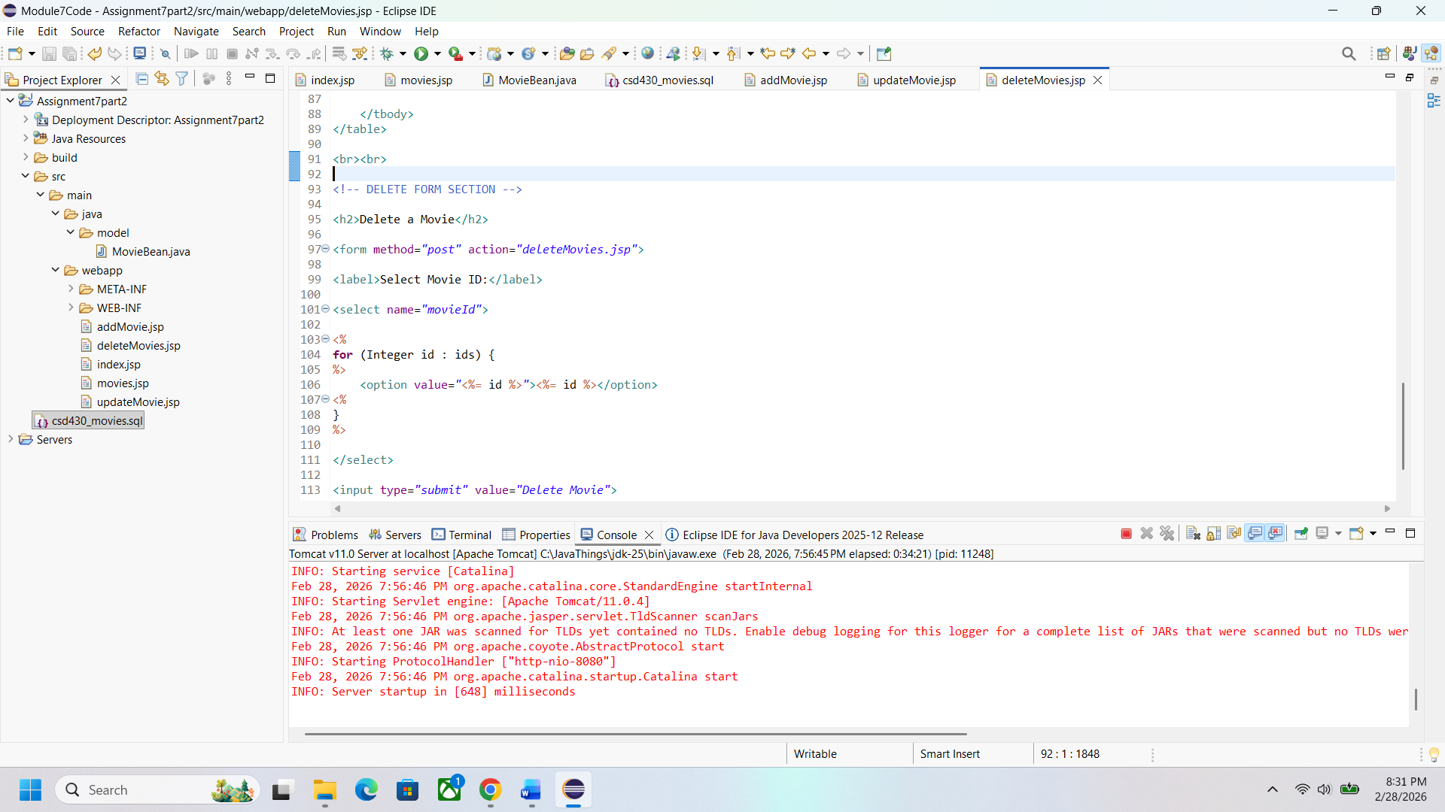

Index Page Updated
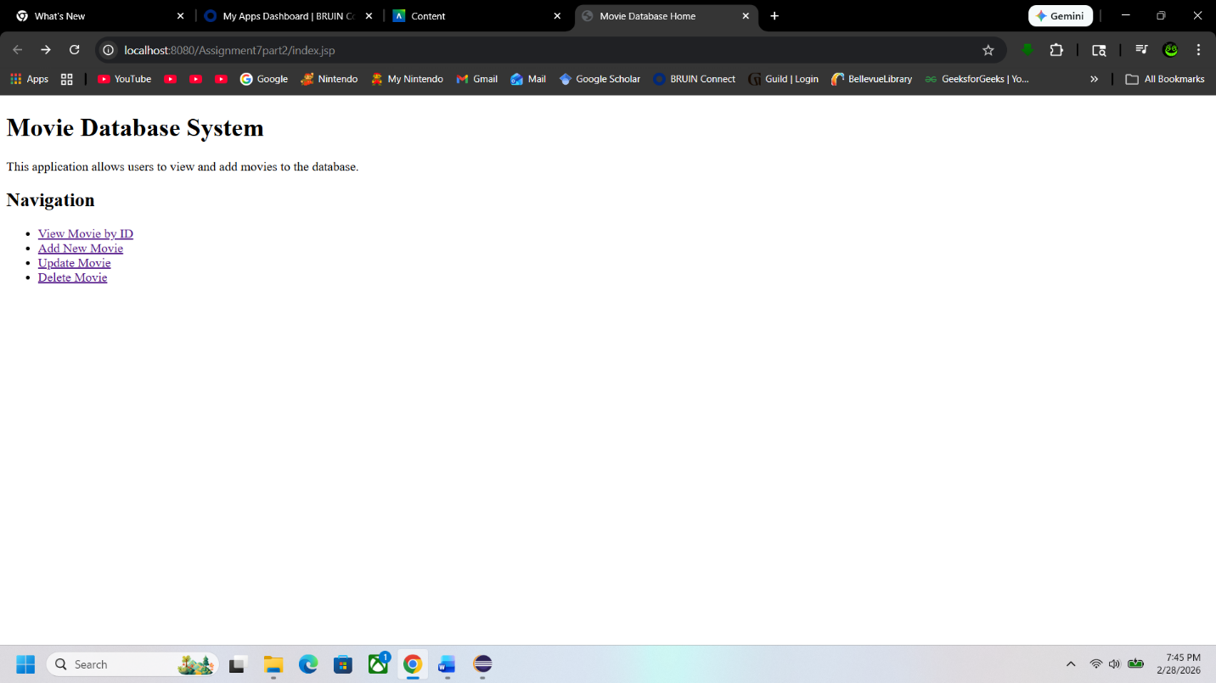
First Look at Delete Page
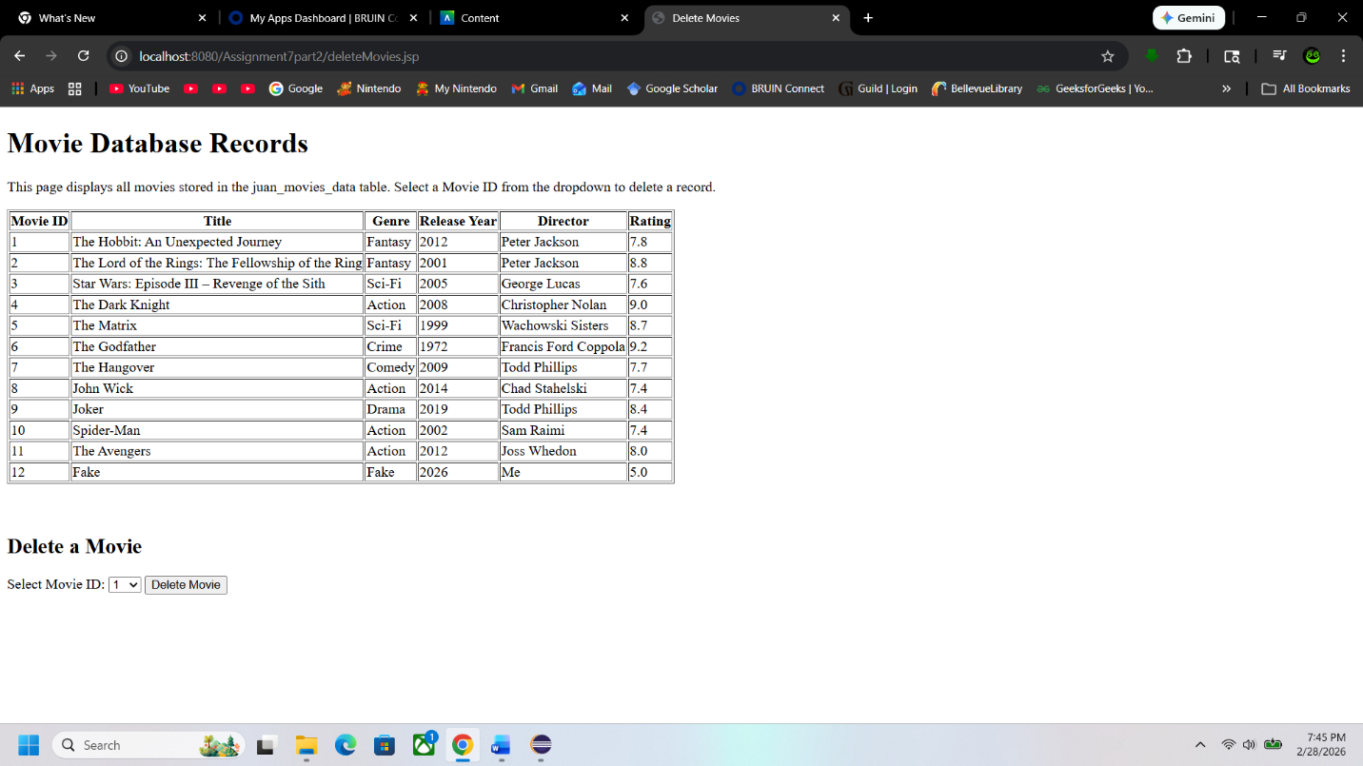

Dropdown Menu on Page Working
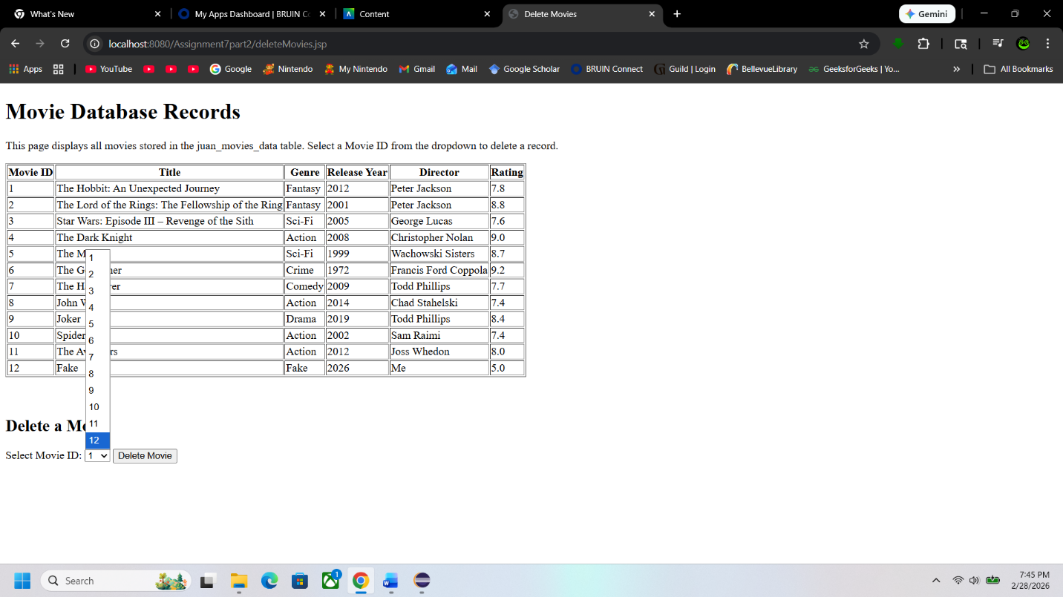
After Deleting Item
