Week 6 Modules 8 Assignment
Project Part 3

Juan Macias Vasquez
Bellevue University
CSD430-H323 ServerSide Development (2265-DD)
Jack Lusby
February 22nd, 2026

Week 6 Modules 8 Assignment
Project Part 3

GitHub Repository
https://github.com/Juan551School/csd-430
Used 10 Movies as the data used
Code
index.jsp (Updated)
<%@ page language="java" contentType="text/html; charset=UTF-8"
pageEncoding="UTF-8"%>

<%
/*
Juan Macias Vasquez
Bellevue University
CSD430-H323 ServerSide Development (2265-DD)
Jack Lusby
Module 8 Assignment
Project Part 3
February 22nd, 2026
*/
%>

<!DOCTYPE html>
<html>
<head>
<title>Movie Database Home</title>
</head>
<body>

<h1>Movie Database System</h1>

<p>This application allows users to view and add movies to the database.</p>

<h2>Navigation</h2>

<ul>
<li><a href="movies.jsp">View Movie by ID</a></li>
<li><a href="addMovie.jsp">Add New Movie</a></li>
<li><a href="updateMovie.jsp">Update Movie</a></li>
</ul>

</body>
</html>

movies.jsp
<%@ page language="java" contentType="text/html; charset=UTF-8"
pageEncoding="UTF-8"%>
<%@ page import="model.MovieBean,java.sql.*,java.util.*" %>

<%
/*
Juan Macias Vasquez
Bellevue University
CSD430-H323 ServerSide Development (2265-DD)
Jack Lusby
Module 8 Assignment
Project Part 3
February 22nd, 2026
*/
%>

<!DOCTYPE html>
<html>
<head>
<title>Movie Database Viewer</title>
</head>
<body>

<h1>Movie Database Viewer</h1>
<p>Select a Movie ID to view its details.</p>

<%
MovieBean bean = new MovieBean();
ArrayList<Integer> movieIds = bean.getMovieIds();
%>

<form method="post">
<label for="movie_id">Movie ID:</label>

<select name="movie_id">
<%
for (int id : movieIds) {
%>
<option value="<%= id %>"><%= id %></option>
<%
}
%>
</select>

<input type="submit" value="View Movie">
</form>

<%
if (request.getParameter("movie_id") != null) {

int selectedId = Integer.parseInt(request.getParameter("movie_id"));
ResultSet rs = bean.getMovieById(selectedId);

if (rs != null && rs.next()) {
%>

<h2>Movie Details</h2>

<table border="1">
<thead>
<tr>
<th>ID</th>
<th>Title</th>
<th>Genre</th>
<th>Release Year</th>
<th>Director</th>
<th>Rating</th>
</tr>
</thead>
<tbody>
<tr>
<td><%= rs.getInt("movie_id") %></td>
<td><%= rs.getString("title") %></td>
<td><%= rs.getString("genre") %></td>
<td><%= rs.getInt("release_year") %></td>
<td><%= rs.getString("director") %></td>
<td><%= rs.getDouble("rating") %></td>
</tr>
</tbody>
</table>

<%
}
}
%>

</body>
</html>

addMovie.jsp
<%@ page language="java" contentType="text/html; charset=UTF-8"
pageEncoding="UTF-8"%>
<%@ page import="model.MovieBean" %>
<%@ page import="java.util.ArrayList" %>

<%
/*
Juan Macias Vasquez
Bellevue University
CSD430-H323 ServerSide Development (2265-DD)
Jack Lusby
Module 8 Assignment
Project Part 3
February 22nd, 2026
*/
%>

<!DOCTYPE html>
<html>
<head>
<title>Add New Movie</title>
</head>
<body>

<h1>Add a New Movie</h1>

<p>Fill in the form below. The Movie ID is automatically generated.</p>

<form method="post">

<label>Title:</label>
<input type="text" name="title" required><br><br>

<label>Genre:</label>
<input type="text" name="genre" required><br><br>

<label>Release Year:</label>
<input type="number" name="release_year" required><br><br>

<label>Director:</label>
<input type="text" name="director" required><br><br>

<label>Rating:</label>
<input type="number" step="0.1" name="rating" required><br><br>

<input type="submit" value="Add Movie">

</form>

<hr>

<%
MovieBean bean = new MovieBean();

// If form submitted, insert record
if (request.getParameter("title") != null) {

String title = request.getParameter("title");
String genre = request.getParameter("genre");
int releaseYear = Integer.parseInt(request.getParameter("release_year"));
String director = request.getParameter("director");
double rating = Double.parseDouble(request.getParameter("rating"));

bean.addMovie(title, genre, releaseYear, director, rating);
%>

<p><strong>Movie successfully added!</strong></p>

<%
}

// Retrieve all movies using ArrayList
ArrayList<String[]> movies = bean.getAllMovies();
%>

<h2>All Movies in Database</h2>

<table border="1">
<thead>
<tr>
<th>ID</th>
<th>Title</th>
<th>Genre</th>
<th>Release Year</th>
<th>Director</th>
<th>Rating</th>
</tr>
</thead>
<tbody>

<%
for (String[] row : movies) {
%>

<tr>
<td><%= row[0] %></td>
<td><%= row[1] %></td>
<td><%= row[2] %></td>
<td><%= row[3] %></td>
<td><%= row[4] %></td>
<td><%= row[5] %></td>
</tr>

<%
}
%>

</tbody>
</table>

</body>
</html>

updateMovie.jsp (New File)
<%@ page import="model.MovieBean,java.sql.*,java.util.*" %>

<%
/*
Juan Macias Vasquez
Bellevue University
CSD430-H323 ServerSide Development (2265-DD)
Jack Lusby
Module 8 Assignment
Project Part 3
February 22nd, 2026
*/
%>

<!DOCTYPE html>
<html>
<head>
<title>Update Movie</title>
</head>
<body>

<h1>Update Movie Record</h1>

<%
MovieBean bean = new MovieBean();
ArrayList<Integer> ids = bean.getMovieIds();
%>

<!-- Select Movie -->
<form method="post">
<label>Select Movie ID:</label>
<select name="movie_id">
<% for (int id : ids) { %>
<option value="<%= id %>"><%= id %></option>
<% } %>
</select>
<input type="submit" value="Load Movie">
</form>

<hr>

<%
if (request.getParameter("movie_id") != null && request.getParameter("update") == null) {

int id = Integer.parseInt(request.getParameter("movie_id"));
ResultSet rs = bean.getMovieById(id);

if (rs.next()) {
%>

<!-- Update Form -->
<form method="post">
<p><strong>Movie ID:</strong> <%= id %></p>
<input type="hidden" name="movie_id" value="<%= id %>">

Title: <input type="text" name="title" value="<%= rs.getString("title") %>"><br><br>
Genre: <input type="text" name="genre" value="<%= rs.getString("genre") %>"><br><br>
Release Year: <input type="number" name="release_year" value="<%= rs.getInt("release_year") %>"><br><br>
Director: <input type="text" name="director" value="<%= rs.getString("director") %>"><br><br>
Rating: <input type="number" step="0.1" name="rating" value="<%= rs.getDouble("rating") %>"><br><br>

<input type="hidden" name="update" value="true">
<input type="submit" value="Update Movie">
</form>

<%
}
}
%>

<%
if (request.getParameter("update") != null) {

int id = Integer.parseInt(request.getParameter("movie_id"));

bean.updateMovie(
id,
request.getParameter("title"),
request.getParameter("genre"),
Integer.parseInt(request.getParameter("release_year")),
request.getParameter("director"),
Double.parseDouble(request.getParameter("rating"))
);

ResultSet rs = bean.getMovieById(id);
rs.next();
%>

<!-- Display The Updated Record -->
<h2>Updated Movie Record</h2>

<table border="1">
<tr>
<th>ID</th><th>Title</th><th>Genre</th><th>Year</th><th>Director</th><th>Rating</th>
</tr>
<tr>
<td><%= rs.getInt("movie_id") %></td>
<td><%= rs.getString("title") %></td>
<td><%= rs.getString("genre") %></td>
<td><%= rs.getInt("release_year") %></td>
<td><%= rs.getString("director") %></td>
<td><%= rs.getDouble("rating") %></td>
</tr>
</table>

<% } %>

</body>
</html>

MovieBean.java
/*
Juan Macias Vasquez
Bellevue University
CSD430-H323 ServerSide Development (2265-DD)
Jack Lusby
Module 8 Assignment
Project Part 3
Updated February 22nd, 2026
*/

package model;

import java.sql.*;
import java.util.ArrayList;

/*
This JavaBean handles:
- Database connection
- Retrieving movie IDs
- Retrieving a movie by ID
- Adding a new movie
- Retrieving all movies
*/

public class MovieBean {

// DATABASE CONNECTION SETTINGS
private String url = "jdbc:mysql://localhost:3306/csd430";
private String username = "student1";
private String password = "pass"; // <-- change if needed

// -------------------------------------------------
// Establish database connection
// -------------------------------------------------
public Connection getConnection() throws Exception {
Class.forName("com.mysql.cj.jdbc.Driver");
return DriverManager.getConnection(url, username, password);
}

// -------------------------------------------------
// Retrieve all Movie IDs (for dropdown)
// -------------------------------------------------
public ArrayList<Integer> getMovieIds() {

ArrayList<Integer> ids = new ArrayList<>();

try {
Connection conn = getConnection();
String sql = "SELECT movie_id FROM juan_movies_data";
PreparedStatement ps = conn.prepareStatement(sql);
ResultSet rs = ps.executeQuery();

while (rs.next()) {
ids.add(rs.getInt("movie_id"));
}

rs.close();
ps.close();
conn.close();

} catch (Exception e) {
e.printStackTrace();
}

return ids;
}

// -------------------------------------------------
// Retrieve a single movie by ID
// -------------------------------------------------
public ResultSet getMovieById(int id) {

ResultSet rs = null;

try {
Connection conn = getConnection();
String sql = "SELECT * FROM juan_movies_data WHERE movie_id = ?";
PreparedStatement ps = conn.prepareStatement(sql);
ps.setInt(1, id);
rs = ps.executeQuery();

} catch (Exception e) {
e.printStackTrace();
}

return rs;
}

// -------------------------------------------------
// Add a new movie to the database
// -------------------------------------------------
public void updateMovie(int id, String title, String genre, int year, String director, double rating) {
try {
Connection conn = getConnection();
String sql = "UPDATE juan_movies_data SET title=?, genre=?, release_year=?, director=?, rating=? WHERE movie_id=?";
PreparedStatement ps = conn.prepareStatement(sql);

ps.setString(1, title);
ps.setString(2, genre);
ps.setInt(3, year);
ps.setString(4, director);
ps.setDouble(5, rating);
ps.setInt(6, id);

ps.executeUpdate();
conn.close();
} catch (Exception e) {
e.printStackTrace();
}
}
public void addMovie(String title, String genre, int releaseYear,
String director, double rating) {

try {
Connection conn = getConnection();

String sql = "INSERT INTO juan_movies_data "
+ "(title, genre, release_year, director, rating) "
+ "VALUES (?, ?, ?, ?, ?)";

PreparedStatement ps = conn.prepareStatement(sql);

ps.setString(1, title);
ps.setString(2, genre);
ps.setInt(3, releaseYear);
ps.setString(4, director);
ps.setDouble(5, rating);

ps.executeUpdate();

ps.close();
conn.close();

} catch (Exception e) {
e.printStackTrace();
}
}

// -------------------------------------------------
// Retrieve ALL movies with a s afe version using ArrayList
// -------------------------------------------------
public ArrayList<String[]> getAllMovies() {

ArrayList<String[]> list = new ArrayList<>();

try {
Connection conn = getConnection();
String sql = "SELECT * FROM juan_movies_data";
PreparedStatement ps = conn.prepareStatement(sql);
ResultSet rs = ps.executeQuery();

while (rs.next()) {

String[] row = new String[6];

row[0] = String.valueOf(rs.getInt("movie_id"));
row[1] = rs.getString("title");
row[2] = rs.getString("genre");
row[3] = String.valueOf(rs.getInt("release_year"));
row[4] = rs.getString("director");
row[5] = String.valueOf(rs.getDouble("rating"));

list.add(row);
}

rs.close();
ps.close();
conn.close();

} catch (Exception e) {
e.printStackTrace();
}

return list;
}
}

csd430_movies.sql
-- =====================================================
-- Course: CSD430
-- Assignment: Modules 5 & 6 Assignment - Working with CRUD-READ, JDBC, & JavaBeans
-- Database: CSD430
-- User: student1
-- Password: pass
-- Topic: Movies
-- =====================================================

-- Remove database if it already exists
DROP DATABASE IF EXISTS CSD430;

-- Create database
CREATE DATABASE CSD430;
USE CSD430;

-- Create user
CREATE USER IF NOT EXISTS 'student1'@'localhost' IDENTIFIED BY 'pass';

-- Grant permissions so JavaBean can access the database
GRANT ALL PRIVILEGES ON CSD430.* TO 'student1'@'localhost';
FLUSH PRIVILEGES;

-- -----------------------------------------------------
-- Drop table if it exists
-- -----------------------------------------------------
DROP TABLE IF EXISTS juan_movies_data;

-- -----------------------------------------------------
-- Create movies table
-- -----------------------------------------------------
CREATE TABLE juan_movies_data (
movie_id INT AUTO_INCREMENT PRIMARY KEY,
title VARCHAR(100) NOT NULL,
genre VARCHAR(50) NOT NULL,
release_year INT NOT NULL,
director VARCHAR(100) NOT NULL,
rating DECIMAL(2,1) NOT NULL
);

-- -----------------------------------------------------
-- Insert the movie records (minimum 10)
-- -----------------------------------------------------
INSERT INTO juan_movies_data
(title, genre, release_year, director, rating)
VALUES
('The Hobbit: An Unexpected Journey', 'Fantasy', 2012, 'Peter Jackson', 7.8),
('The Lord of the Rings: The Fellowship of the Ring', 'Fantasy', 2001, 'Peter Jackson', 8.8),
('Star Wars: Episode III – Revenge of the Sith', 'Sci-Fi', 2005, 'George Lucas', 7.6),
('The Dark Knight', 'Action', 2008, 'Christopher Nolan', 9.0),
('The Matrix', 'Sci-Fi', 1999, 'Wachowski Sisters', 8.7),
('The Godfather', 'Crime', 1972, 'Francis Ford Coppola', 9.2),
('The Hangover', 'Comedy', 2009, 'Todd Phillips', 7.7),
('John Wick', 'Action', 2014, 'Chad Stahelski', 7.4),
('Joker', 'Drama', 2019, 'Todd Phillips', 8.4),
('Spider-Man', 'Action', 2002, 'Sam Raimi', 7.4);

-- -----------------------------------------------------
-- Verify table creation and data
-- -----------------------------------------------------
SELECT * FROM juan_movies_data;

Pictures of Code Running
New Update Movie Page
1st Look
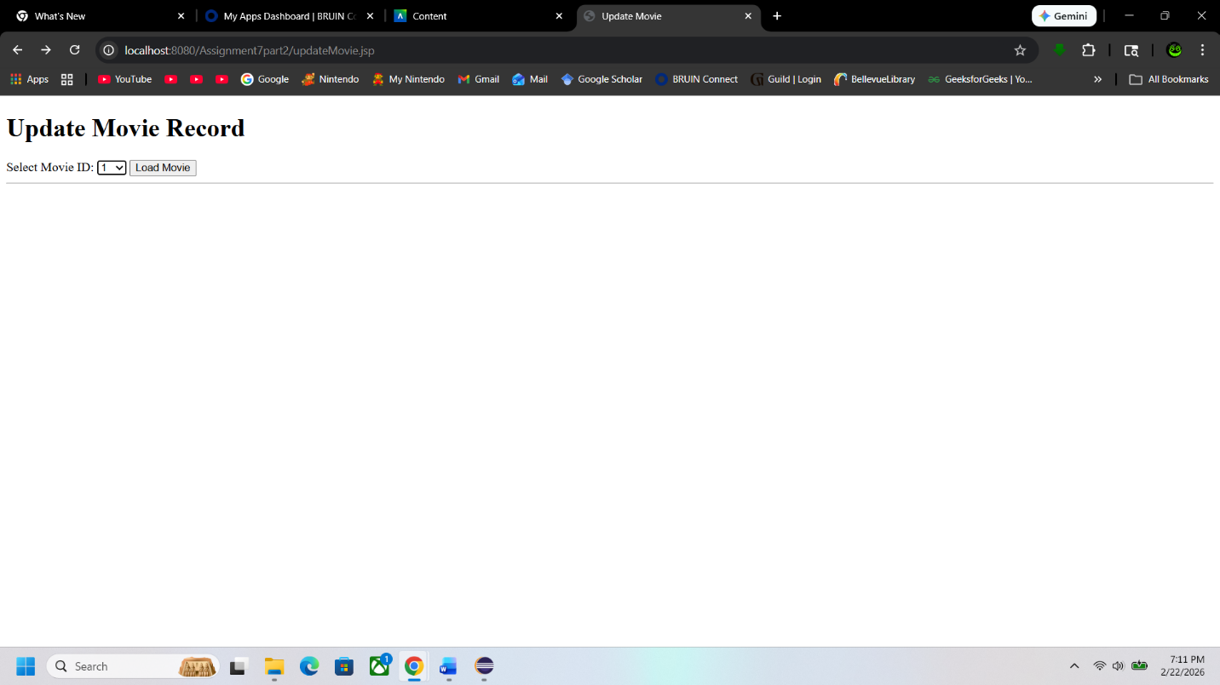
Viewing a Movie
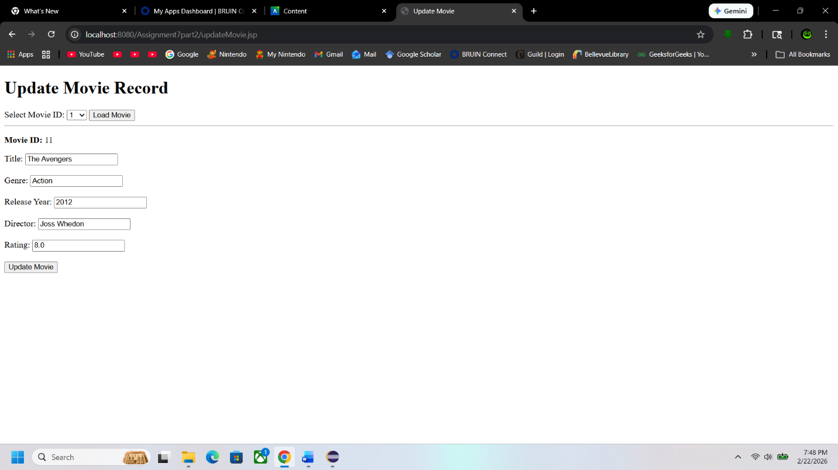
Update Text
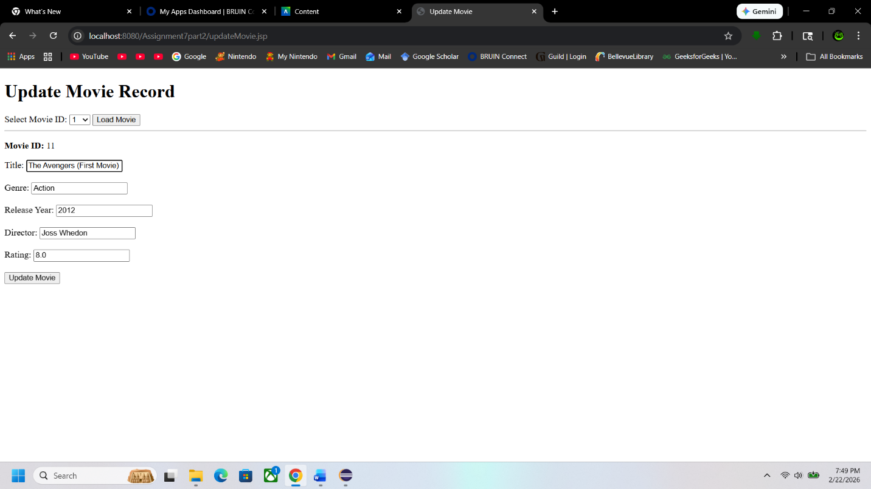
Movie Update
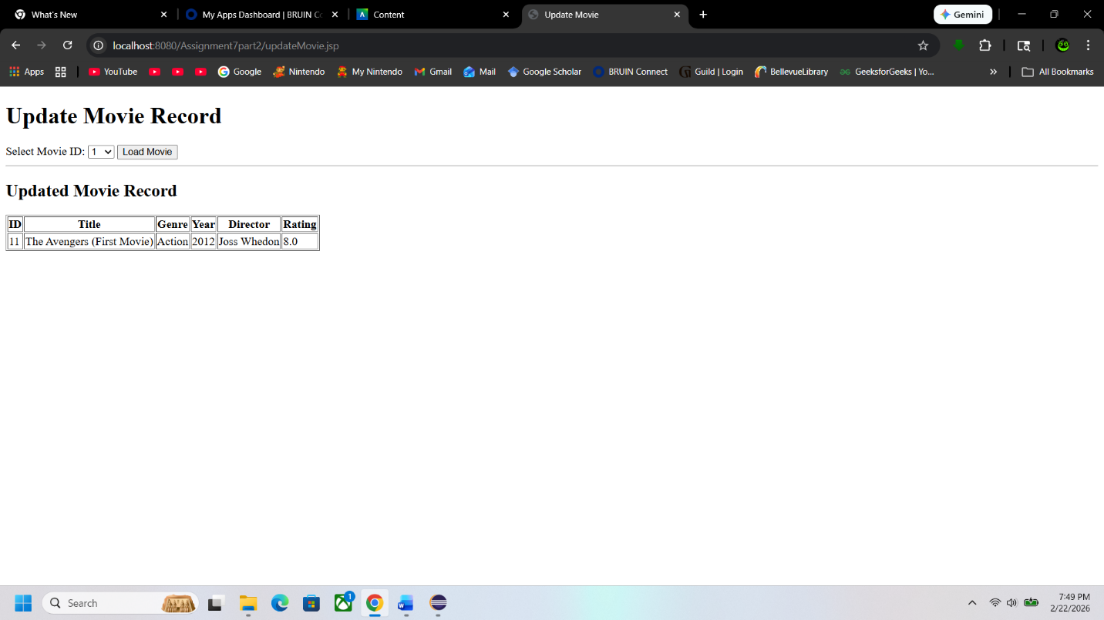

Database View
After changing in update 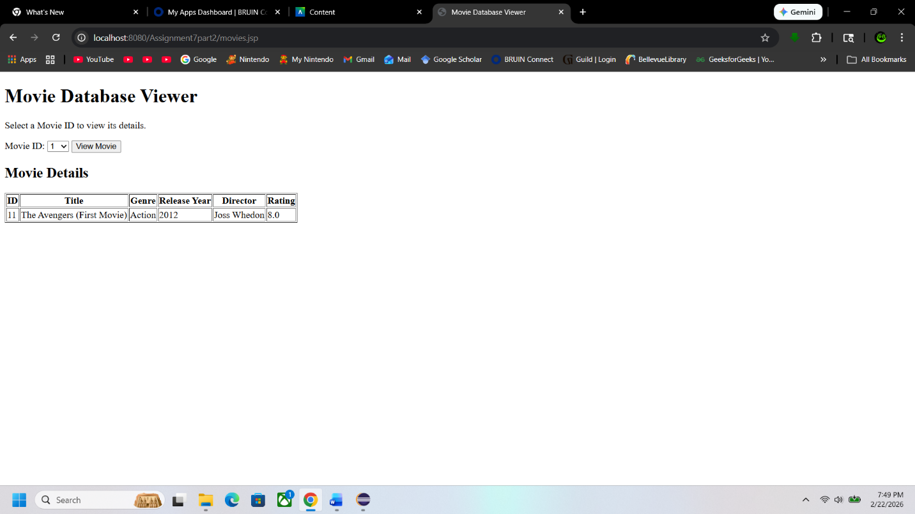
Add New Movie
Movie updated in list
