Week 8 Module 10.2 Assignment
JSON format

Juan Macias Vasquez
Bellevue University
CSD440-H323 Server-Side Scripting (2265-DD)
Jack Lusby
May 15th, 2026

Week 8 Module 10.2 Assignment
JSON format
GitHub Repository
https://github.com/Juan551School/csd-440

Code File
JuanJSON.php
<?php
/*
Juan Macias Vasquez
Bellevue University
CSD440-H323 Server-Side Scripting (2265-DD)
Jack Lusby
April 26th, 2026
Module 10 Assignment
JuanJSON.php
*/

// Check if the form was submitted
if ($_SERVER["REQUEST_METHOD"] == "POST") {

// Collect the form data (IN this case Full Name and contact infomration plus Favorite Porgramming langugae) and also remove extra spaces
$firstName = trim($_POST["firstName"]);
$lastName = trim($_POST["lastName"]);
$email = trim($_POST["email"]);
$phone = trim($_POST["phone"]);
$city = trim($_POST["city"]);
$state = trim($_POST["state"]);
$zipCode = trim($_POST["zipCode"]);
$favoriteLanguage = trim($_POST["favoriteLanguage"]);

// Check for empty fields
if (
empty($firstName) || empty($lastName) ||
empty($email) || empty($phone) ||
empty($city) || empty($state) ||
empty($zipCode) || empty($favoriteLanguage)
) {

$errorMessage = "Error: All fields are required.";

} else {

// Create an associative array
$studentData = array(
"First Name" => $firstName,
"Last Name" => $lastName,
"Email" => $email,
"Phone" => $phone,
"City" => $city,
"State" => $state,
"Zip Code" => $zipCode,
"Favorite Programming Language" => $favoriteLanguage
);

// Convert array to JSON format
$jsonData = json_encode($studentData, JSON_PRETTY_PRINT);
}
}
?>

<!DOCTYPE html>
<html lang="en">
<head>
<meta charset="UTF-8">
<title>JSON Form Assignment</title>

<style>
body {
font-family: Arial, sans-serif;
background-color: #f4f4f4;
margin: 20px;
}

h1 {
color: #333;
}

form {
background-color: white;
padding: 20px;
width: 400px;
border-radius: 10px;
box-shadow: 0px 0px 5px gray;
}

label {
font-weight: bold;
}

input {
width: 100%;
padding: 8px;
margin-top: 5px;
margin-bottom: 15px;
}

input[type="submit"] {
background-color: #007BFF;
color: white;
border: none;
cursor: pointer;
}

input[type="submit"]:hover {
background-color: #0056b3;
}

.output {
background-color: white;
padding: 20px;
margin-top: 20px;
width: 500px;
border-radius: 10px;
box-shadow: 0px 0px 5px gray;
}

.error {
color: red;
font-weight: bold;
}

pre {
background-color: #efefef;
padding: 15px;
border-radius: 5px;
}
</style>
</head>

<body>

<h1>PHP JSON Form Assignment</h1>

<form method="post" action="">

<label>First Name:</label>
<input type="text" name="firstName">

<label>Last Name:</label>
<input type="text" name="lastName">

<label>Email:</label>
<input type="email" name="email">

<label>Phone Number:</label>
<input type="text" name="phone">

<label>City:</label>
<input type="text" name="city">

<label>State:</label>
<input type="text" name="state">

<label>Zip Code:</label>
<input type="text" name="zipCode">

<label>Favorite Programming Language:</label>
<input type="text" name="favoriteLanguage">

<input type="submit" value="Submit Form">

</form>

<?php
// Display error message if fields are missing
if (isset($errorMessage)) {
echo "<div class='output'>";
echo "<p class='error'>$errorMessage</p>";
echo "</div>";
}

// Display JSON output if successful
if (isset($jsonData)) {
echo "<div class='output'>";
echo "<h2>JSON Encoded Data</h2>";
echo "<pre>$jsonData</pre>";
echo "</div>";
}
?>

</body>
</html>

Pictures of Webpage
After Loading
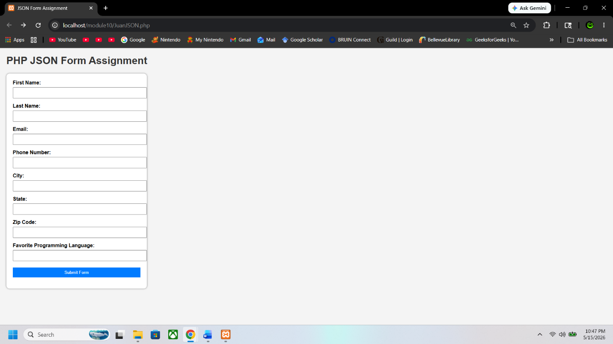

Information Input
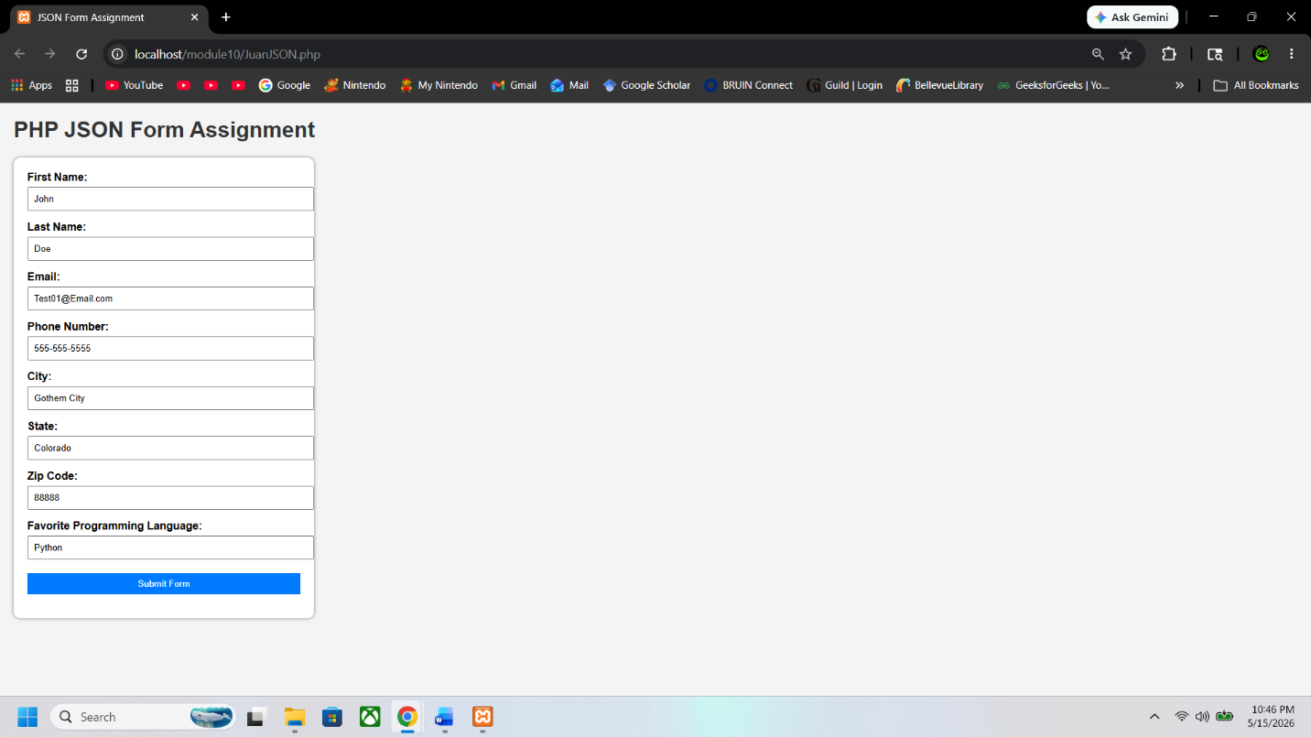

After Submitting Form
