Week 7 Module 9.2 Assignment
MySQLi Baseball Part 2

Juan Macias Vasquez
Bellevue University
CSD440-H323 Server-Side Scripting (2265-DD)
Jack Lusby
May 9th, 2026

Week 7 Module 9.2 Assignment
MySQLi Baseball Part 2
GitHub Repository
https://github.com/Juan551School/csd-440

New Code (The Three Files Added)
JuanIndex.php
<!DOCTYPE html>
<html>

<!--
// JuanCreateTable.php
// Module 9 Assignment Part 1 of 3
// Main Purpose is to make an index page that connects to the other two
-->

<head>
<title>Baseball Database Index</title>
</head>
<body>

<h1>Baseball Player Database System</h1>

<ul>
<li><a href="JuanForm.php">Add Player Record</a></li>
<li><a href="JuanQuery.php">Search Players</a></li>
<li><a href="JuanCreateTable.php">Create a table</a></li>
<li><a href="JuanPopulateTable.php">Populate the Table</a></li>
<li><a href="JuanQueryTable.php">See the Table</a></li>
<li><a href="JuanDropTable.php">Drop the Table</a></li>
</ul>

</body>
</html>

JuanForm.php
<?php
// JuanCreateTable.php
// Module 9 Assignment Part 2 of 3
// Main Purpose is to make forms to put into the table

// The login information to the database
$servername = "localhost";
$username = "student1";
$password = "pass";
$dbname = "baseball_01";

$conn = new mysqli($servername, $username, $password, $dbname);

$message = "";

// Check connection
if ($conn->connect_error) {
die("Connection failed: " . $conn->connect_error);
}

// Insert data when form is submitted
if (isset($_POST['submit'])) {

$name = $_POST['name'];
$team = $_POST['team'];
$position = $_POST['position'];
$avg = $_POST['avg'];
$home_runs = $_POST['home_runs'];

// FIXED: correct table + correct columns
$sql = "INSERT INTO players (name, team, position, batting_avg, home_runs)
VALUES ('$name', '$team', '$position', '$avg', '$home_runs')";

if ($conn->query($sql) === TRUE) {
$message = "Player added successfully!";
} else {
$message = "Error: " . $conn->error;
}
}
?>

<!DOCTYPE html>
<html>
<head>
<title>Add Baseball Player</title>
</head>
<body>

<h1>Add Baseball Player</h1>

<!-- Success/Error Message -->
<p><?php echo $message; ?></p>

<!-- Player Form -->
<form method="post">
Player Name: <br>
<input type="text" name="name" required><br><br>

Team: <br>
<input type="text" name="team"><br><br>

Position: <br>
<input type="text" name="position"><br><br>

Batting Average: <br>
<input type="text" name="avg"><br><br>

Home Runs: <br>
<input type="number" name="home_runs"><br><br>

<input type="submit" name="submit" value="Add Player">
</form>

<br>

<!-- Navigation -->
<a href="JuanIndex.php">Back to Home</a>

</body>
</html>

JuanQuery.php
<?php
// JuanCreateTable.php
// Module 9 Assignment Part 3 of 3
// Main Purpose is a Query page to search based on user form input

// The login information to the database
$servername = "localhost";
$username = "student1";
$password = "pass";
$dbname = "baseball_01";

$conn = new mysqli($servername, $username, $password, $dbname);

$result = null;

if (isset($_POST['search'])) {

$search = $_POST['searchTerm'];

// FIXED: correct table + correct column
$sql = "SELECT * FROM players WHERE name LIKE '%$search%'";
$result = $conn->query($sql);
}
?>

<!DOCTYPE html>
<html>
<head>
<title>Search Players</title>
</head>
<body>

<h1>Search Baseball Players</h1>

<form method="post">
Enter Player Name:
<input type="text" name="searchTerm">
<input type="submit" name="search" value="Search">
</form>

<br>

<table border="1">
<tr>
<th>ID</th>
<th>Name</th>
<th>Team</th>
<th>Position</th>
<th>Batting Avg</th>
<th>Home Runs</th>
</tr>

<?php
if ($result && $result->num_rows > 0) {
while ($row = $result->fetch_assoc()) {
echo "<tr>
<td>{$row['id']}</td>
<td>{$row['name']}</td>
<td>{$row['team']}</td>
<td>{$row['position']}</td>
<td>{$row['batting_avg']}</td>
<td>{$row['home_runs']}</td>
</tr>";
}
} elseif (isset($_POST['search'])) {
echo "<tr><td colspan='6'>No results found</td></tr>";
}
?>

</table>

<br>
<a href="JuanIndex.php">Back to Home</a>

</body>
</html>

Pictures of Code Running
Index page
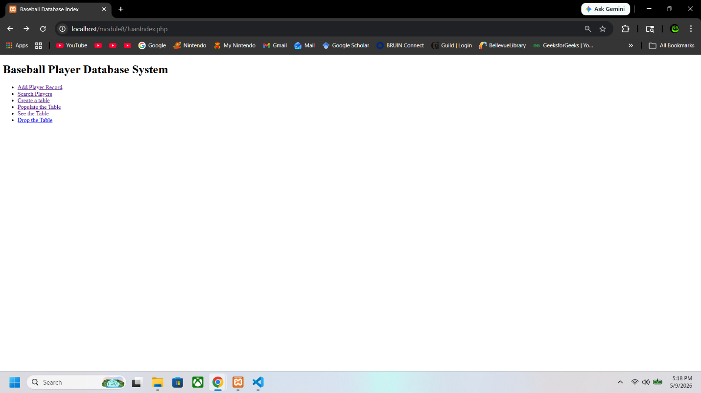
Adding Player Record
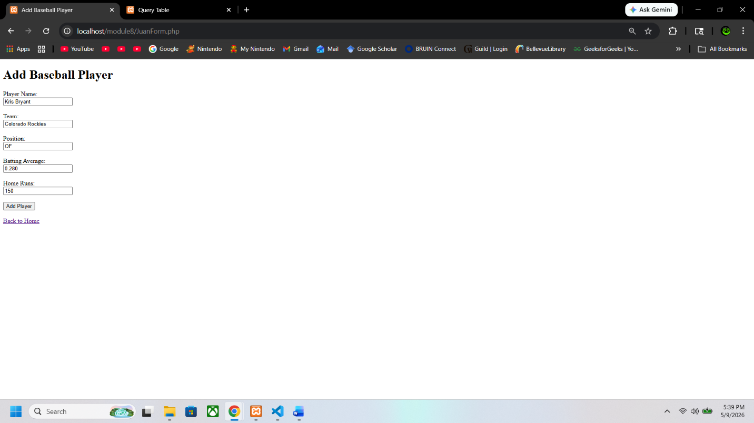

Record added successfully
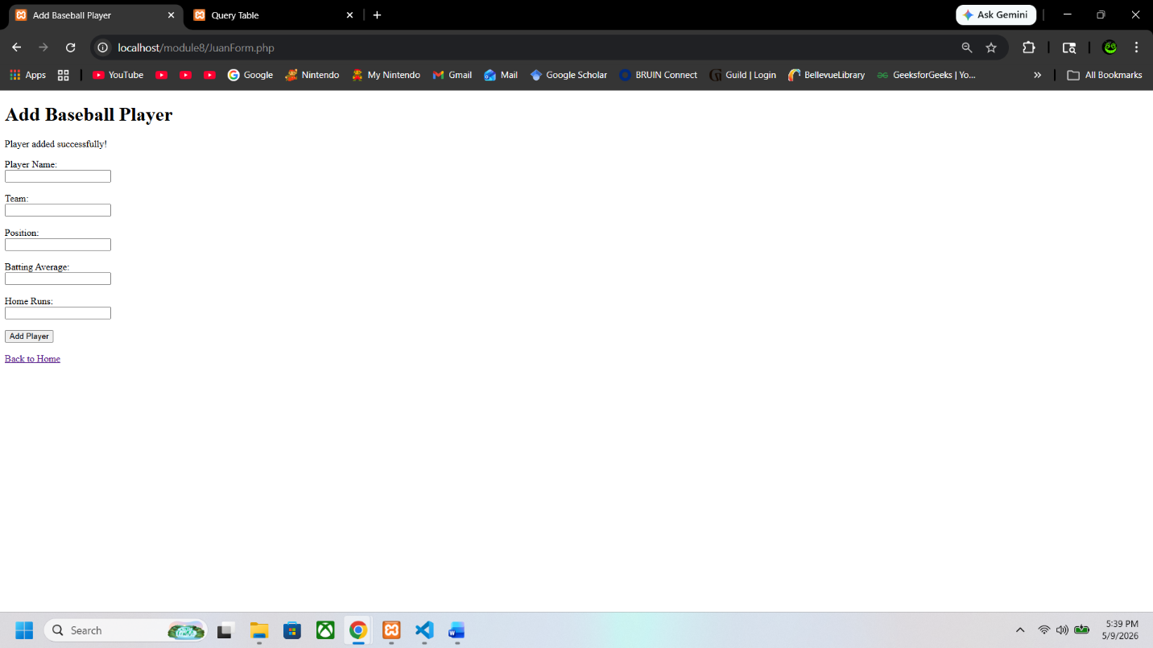

Search Player Page at start
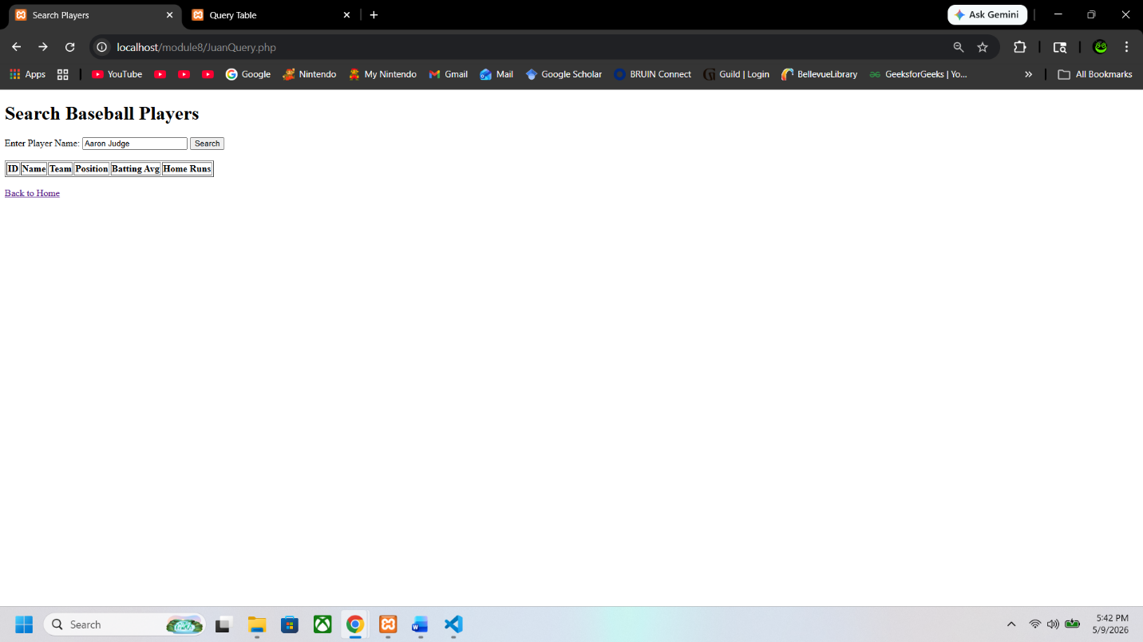

Search player successfully found
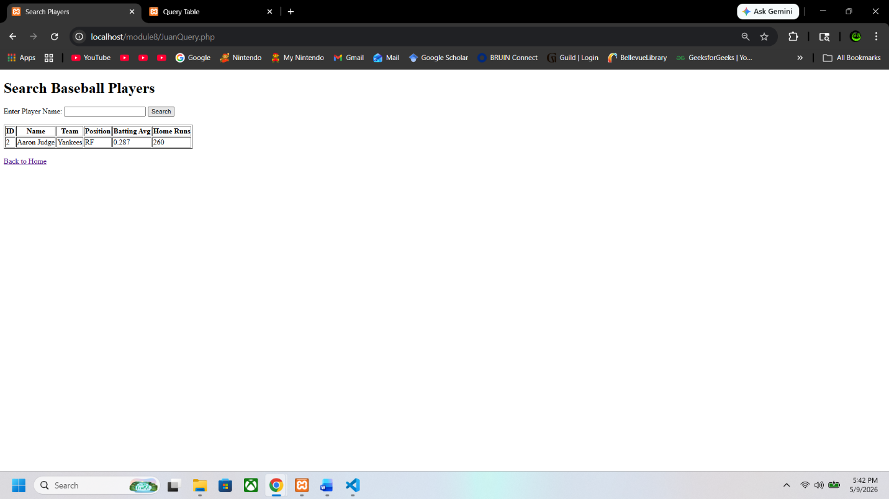
Player table with the player added
