Week 6 Module 8.2 Assignment
MySQLi Baseball

Juan Macias Vasquez
Bellevue University
CSD440-H323 Server-Side Scripting (2265-DD)
Jack Lusby
May 2nd, 2026

Week 6 Module 8.2 Assignment
MySQLi Baseball
GitHub Repository
https://github.com/Juan551School/csd-440

Code
JuanCreateTable.php
<?php
// JuanCreateTable.php
// Module 8 Assignment Part 1 of 4
// Main Purpose is to create players table in baseball_01 database

$servername = "localhost";
$username = "student1";
$password = "pass";

// STEP 1: connect WITHOUT database
$conn = new mysqli($servername, $username, $password);

// Check connection
if ($conn->connect_error) {
die("Connection failed: " . $conn->connect_error);
}

// STEP 2: create database
$sql = "CREATE DATABASE IF NOT EXISTS baseball_01";
if ($conn->query($sql) === TRUE) {
echo "Database ready.<br>";
} else {
die("Error creating database: " . $conn->error);
}

// STEP 3: reconnect WITH database
$conn = new mysqli($servername, $username, $password, "baseball_01");

// STEP 4: create table
$sql = "CREATE TABLE IF NOT EXISTS games (
id INT AUTO_INCREMENT PRIMARY KEY,
title VARCHAR(100) NOT NULL,
genre VARCHAR(50),
platform VARCHAR(50),
release_year INT,
rating DECIMAL(3,1)
)";

if ($conn->query($sql) === TRUE) {
echo "Table 'players' created successfully!";
} else {
echo "Error creating table: " . $conn->error;
}

$conn->close();
?>

JuanDropTable.php
<?php
// JuanDropTable.php
// Module 8 Assignment Part 2 of 4
// Purpose to drop the players table

$servername = "localhost";
$username = "student1";
$password = "pass";
$dbname = "baseball_01";

$conn = new mysqli($servername, $username, $password, $dbname);

if ($conn->connect_error) {
die("Connection failed: " . $conn->connect_error);
}

$sql = "DROP TABLE players";

if ($conn->query($sql) === TRUE) {
echo "Table dropped successfully!";
} else {
echo "Error dropping table: " . $conn->error;
}

$conn->close();
?>

<!DOCTYPE html>
<html>
<head>
<title>Drop Table</title>
</head>
<body>
<h2>Drop Table Page</h2>
</body>
</html>

JuanPopulateTable.php
<?php
// YourNamePopulateTable.php
// Module 8 Assignment Part 3 of 4
// Purpose is to insert the data into players table

$servername = "localhost";
$username = "student1";
$password = "pass";
$dbname = "baseball_01";

$conn = new mysqli($servername, $username, $password, $dbname);

if ($conn->connect_error) {
die("Connection failed: " . $conn->connect_error);
}

// Insert multiple rows
// I Dont really know anything about baseball so I just googled for this random information
$sql = "INSERT INTO players (name, team, position, batting_avg, home_runs)
VALUES
('Mike Trout', 'Angels', 'CF', 0.301, 350),
('Aaron Judge', 'Yankees', 'RF', 0.287, 260),
('Mookie Betts', 'Dodgers', 'RF', 0.295, 240),
('Freddie Freeman', 'Dodgers', '1B', 0.300, 320),
('Shohei Ohtani', 'Dodgers', 'DH', 0.310, 200)";

if ($conn->query($sql) === TRUE) {
echo "Records inserted successfully!";
} else {
echo "Error inserting data: " . $conn->error;
}

$conn->close();
?>

<!DOCTYPE html>
<html>
<head>
<title>Populate Table</title>
</head>
<body>
<h2>Populate Table Page</h2>
</body>
</html>

JuanQueryTable.php
<?php
// YourNameQueryTable.php
// Module 8 Assignment Part 4 of 4
// Purpose for query and display players table data

$servername = "localhost";
$username = "student1";
$password = "pass";
$dbname = "baseball_01";

$conn = new mysqli($servername, $username, $password, $dbname);

if ($conn->connect_error) {
die("Connection failed: " . $conn->connect_error);
}

$sql = "SELECT * FROM players";
$result = $conn->query($sql);
?>

<!DOCTYPE html>
<html>
<head>
<title>Query Table</title>
</head>
<body>

<h2>Players Table</h2>

<table border="1">
<tr>
<th>ID</th>
<th>Name</th>
<th>Team</th>
<th>Position</th>
<th>Batting Avg</th>
<th>Home Runs</th>
</tr>

<?php
if ($result->num_rows > 0) {
while($row = $result->fetch_assoc()) {
echo "<tr>
<td>{$row['id']}</td>
<td>{$row['name']}</td>
<td>{$row['team']}</td>
<td>{$row['position']}</td>
<td>{$row['batting_avg']}</td>
<td>{$row['home_runs']}</td>
</tr>";
}
} else {
echo "<tr><td colspan='6'>No records found</td></tr>";
}

$conn->close();
?>

</table>

</body>
</html>

Pictures of Code Running
Creating Table
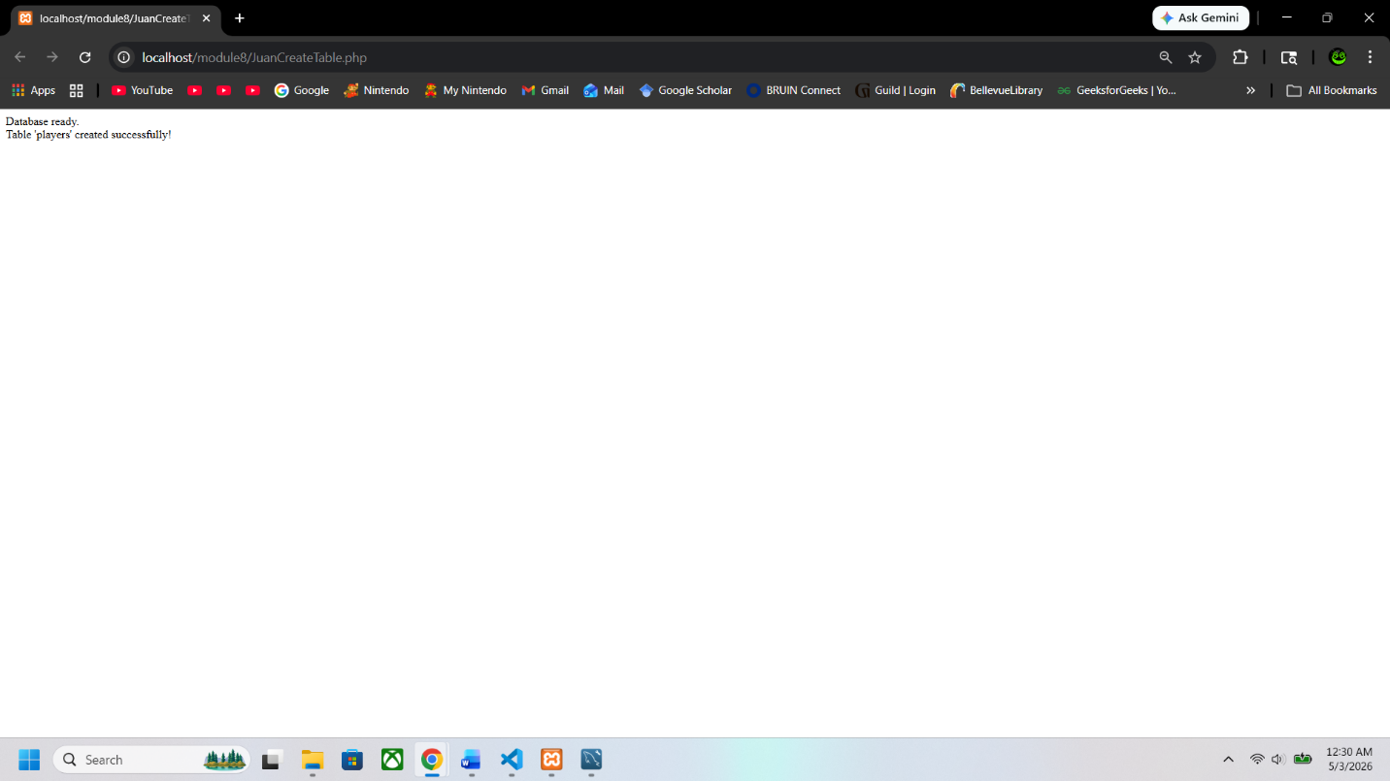
Populating the Table
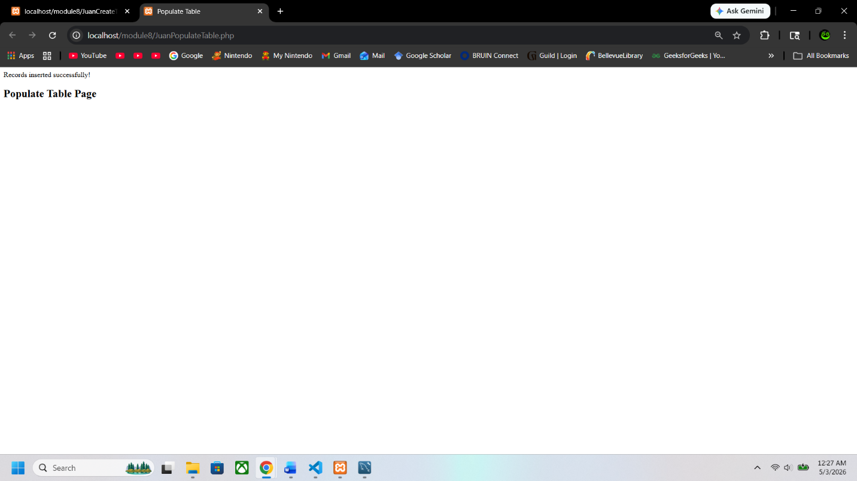

Showing the Table
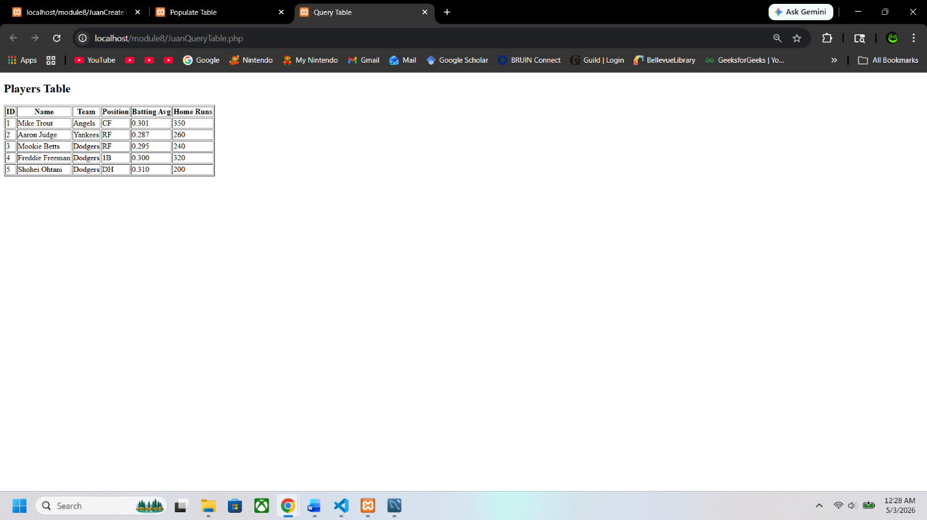
Drop Table
