Week 2 Module 3.2 Assignment
Addition Table

Juan Macias Vasquez
Bellevue University
CSD440-H323 Server-Side Scripting (2265-DD)
Jack Lusby
April 2nd, 2026

Week 2 Module 3.2 Assignment
Addition Table
GitHub Repository
https://github.com/Juan551School/csd-440

Code

Functions.php
<!--
Name: Juan Macias Vasquez
File: JuanTable2.php
Module 3 Assignment
Bellevue University
CSD440-H323 Server-Side Scripting (2265-DD)
Jack Lusby
April 2nd, 2026
-->

<?php

/**
* Function: addNumbers
* Purpose: Takes two numbers and returns their sum
*/
function addNumbers($num1, $num2) {
return $num1 + $num2;
}
?>

JuanTable3.php
/*
Name: Juan Macias Vasquez
File: JuanTable2.php
Module 3 Assignment
Bellevue University
CSD440-H323 Server-Side Scripting (2265-DD)
Jack Lusby
April 2nd, 2026

Description:
This program creates an HTML table using nested loops.
For each cell, two random numbers are generated.
A function (from an external file) is used to calculate their sum.
*/

// Adds external function file
include "functions.php";
?>

<!DOCTYPE html>
<html lang="en">
<head>
<meta charset="UTF-8">
<title>PHP Table with Function</title>
<style>
table {
border-collapse: collapse;
margin: 20px auto;
}
td {
border: 1px solid black;
padding: 10px;
text-align: center;
width: 60px;
}
</style>
</head>

<body>

<h2 style="text-align:center;">Random Sum Table</h2>

<table>
<?php
// Outer loop (rows)
for ($row = 1; $row <= 5; $row++) {
?>
<tr>
<?php
// Inner loop (columns)
for ($col = 1; $col <= 5; $col++) {

// Generate two random numbers
$num1 = rand(1, 50);
$num2 = rand(1, 50);

// Call function from external file
$sum = addNumbers($num1, $num2);
?>
<td>
<?php echo $num1 . " + " . $num2 . " = " . $sum; ?>
</td>
<?php
}
?>
</tr>
<?php
}
?>
</table>

</body>
</html>

Pictures of webpage working
Test 1
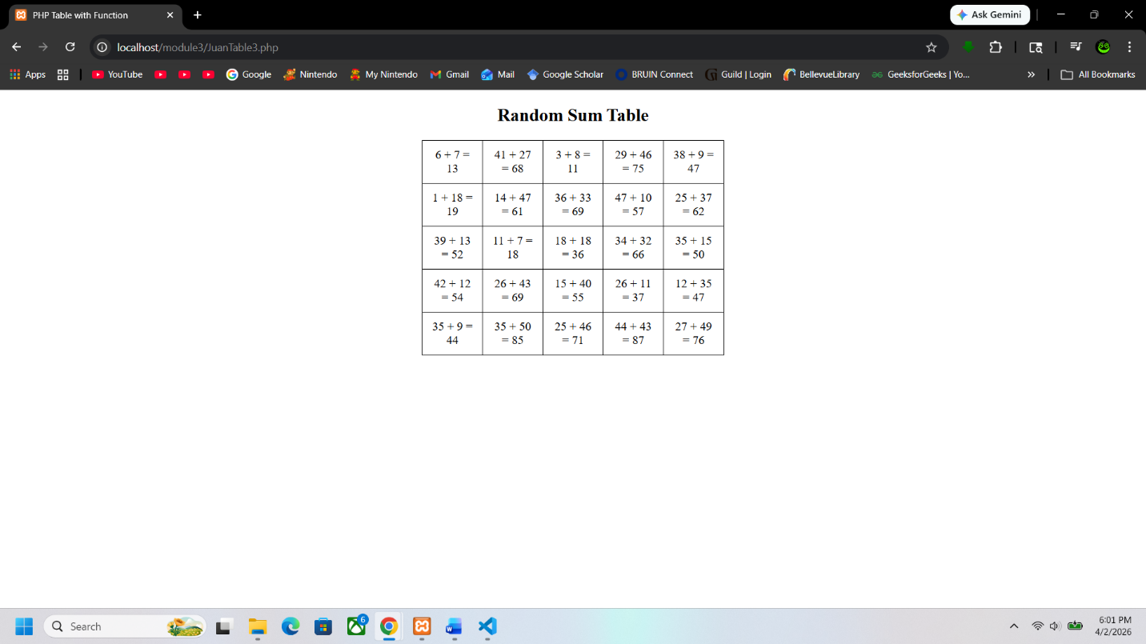
Test 2
