Hybrid Algorithm
Juan Antonio Pérez Juárez
University of Guadalajara
Guadalajara, Jalisco
juan.perez0996@alumnos.udg.mx

I. INTRODUCTION
In recent years, optimization has emerged as a critical field of study across various disciplines, including engineering, computer science, economics, and operations research. As complex systems grow in scale and intricacy, traditional optimization techniques often fall short in providing efficient and effective solutions. This challenge has led to the development of hybrid algorithms, which combine the strengths of multiple optimization methodologies to enhance performance and adaptability.
Hybrid algorithms leverage the unique advantages of distinct optimization approaches, such as genetic algorithms, particle swarm optimization, and simulated annealing, to address complex problems more effectively. By integrating these methods, hybrid algorithms can exploit the exploration capabilities of global search techniques while maintaining the exploitation strengths of local search strategies. This duality not only improves convergence rates but also enhances the robustness of solutions obtained.
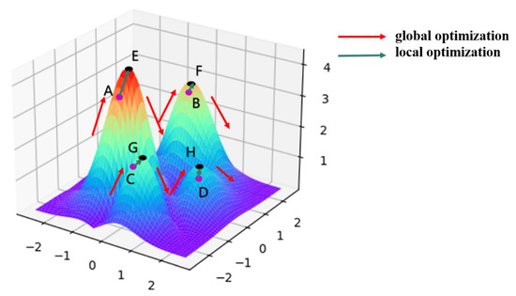
Fig. 1 A Two-Step Simulated Annealing Algorithm for Spectral Data Feature Extraction.
II. OVERVIEW
A hybrid algorithm is an algorithm that combines two or more other algorithms that solve the same problem, either choosing one based on some characteristic of the data or switching between them over the course of the algorithm. This is generally done to combine desired features of each, so that the overall algorithm is better than the individual components.
"Hybrid algorithm" does not refer to simply combining multiple algorithms to solve a different problem – many algorithms can be considered as combinations of simpler pieces – but only to combining algorithms that solve the same problem, but differ in other characteristics, notably performance.
III. EXAMPLES
In computer science, hybrid algorithms are very common in optimized real-world implementations of recursive algorithms, particularly implementations of divide-and-conquer or decrease-and-conquer algorithms, where the size of the data decreases as one moves deeper in the recursion. In this case, one algorithm is used for the overall approach (on large data), but deep in the recursion, it switches to a different algorithm, which is more efficient on small data. A common example is in sorting algorithms, where the insertion sort, which is inefficient on large data, but very efficient on small data (say, five to ten elements), is used as the final step, after primarily applying another algorithm, such as merge sort or quicksort. Merge sort and quicksort are asymptotically optimal on large data, but the overhead becomes significant if applying them to small data, hence the use of a different algorithm at the end of the recursion. A highly optimized hybrid sorting algorithm is Timsort, which combines merge sort, insertion sort, together with additional logic (including binary search) in the merging logic.

A general procedure for a simple hybrid recursive algorithm is short-circuiting the base case, also known as arm's-length recursion. In this case whether the next step will result in the base case is checked before the function call, avoiding an unnecessary function call. For example, in a tree, rather than recursing to a child node and then checking if it is null, checking null before recursing. This is useful for efficiency when the algorithm usually encounters the base case many times, as in many tree algorithms, but is otherwise considered poor style, particularly in academia, due to the added complexity.

Another example of hybrid algorithms for performance reasons are introsort and introselect, which combine one algorithm for fast average performance, falling back on another algorithm to ensure (asymptotically) optimal worst-case performance. Introsort begins with a quicksort, but switches to a heap sort if quicksort is not progressing well; analogously introselect begins with quickselect, but switches to median of medians if quickselect is not progressing well.

Centralized distributed algorithms can often be considered as hybrid algorithms, consisting of an individual algorithm (run on each distributed processor), and a combining algorithm (run on a centralized distributor) – these correspond respectively to running the entire algorithm on one processor, or running the entire computation on the distributor, combining trivial results (a one-element data set from each processor). A basic example of these 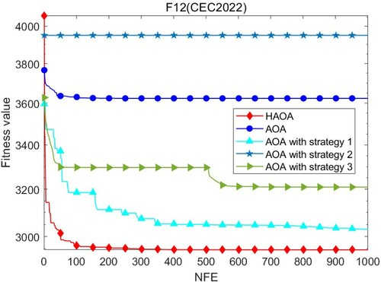
Fig. 2 Adaptive hybrid optimization algorithm for numerical computing in engineering applications.

algorithms are distribution sorts, particularly used for external sorting, which divide the data into separate subsets, sort the subsets, and then combine the subsets into totally sorted data; examples include bucket sort and flashsort.

However, in general distributed algorithms need not be hybrid algorithms, as individual algorithms or combining or communication algorithms may be solving different problems. For example, in models such as MapReduce, the Map and Reduce step solve different problems, and are combined to solve a different, third problem.

IV. ADVANTAGES
- Enhanced Performance
Hybrid algorithms combine multiple optimization techniques, leveraging their individual strengths. For example, a hybrid approach might integrate genetic algorithms (which excel in global search) with local search methods like hill climbing (which are efficient in refining solutions). This combination often results in improved performance metrics, such as faster convergence to optimal solutions and higher quality outcomes.
- Robustness
The robustness of hybrid algorithms stems from their ability to utilize diverse strategies. By employing different optimization techniques, these algorithms can better navigate complex solution spaces, reducing the risk of becoming trapped in local optima. For instance, if one method fails to find a better solution, another may succeed, ensuring that the search process remains effective across various problem landscapes.
- Flexibility
Hybrid algorithms can be customized to suit specific problem requirements. Researchers can select and combine techniques that are particularly effective for the characteristics of the problem at hand. This flexibility allows for the design of specialized algorithms that can tackle a wide range of optimization challenges, from scheduling tasks to optimizing resource allocation.
- Improved Exploration and Exploitation
A critical aspect of optimization is the balance between exploration (searching through the solution space) and exploitation (refining known good solutions). Hybrid algorithms excel in this area by utilizing global search methods to explore new regions of the solution space while employing local search techniques to fine-tune promising solutions. This dual approach enhances the likelihood of finding optimal solutions more efficiently.
- Adaptability
Many hybrid algorithms are designed to adapt their strategies based on the feedback received during the optimization process. For example, an algorithm may switch between exploration and exploitation phases depending on the diversity of the solutions found or the rate of improvement. This adaptability allows the algorithm to respond dynamically to changing problem conditions, making it more effective in real-time applications.
- Increased Solution Diversity
The integration of multiple optimization techniques promotes diversity in the solutions generated. This diversity is crucial for avoiding premature convergence to suboptimal solutions. By exploring various paths in the solution space, hybrid algorithms can discover innovative solutions that single-method approaches might overlook, leading to a richer set of potential outcomes.
- Applicability to Multi-Objective Problems
Hybrid algorithms are particularly well-suited for multi-objective optimization, where multiple conflicting objectives must be considered simultaneously. By combining different optimization techniques, these algorithms can effectively explore trade-offs between objectives, providing a set of Pareto-optimal solutions that represent the best compromises among competing goals.
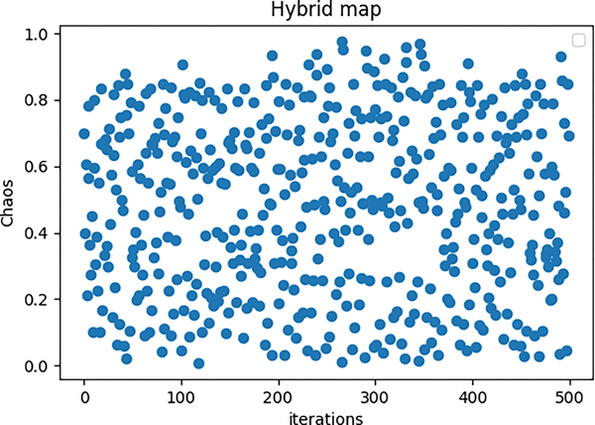
Fig. 3 CSCAHHO: Chaotic hybridization algorithm of the Sine Cosine with Harris Hawk optimization.

- Scalability
Hybrid algorithms can efficiently handle large-scale optimization problems, making them ideal for real-world applications that involve extensive data sets. Their ability to manage complexity and scale up to larger problems allows them to be applied in various domains, such as logistics, telecommunications, and big data analytics.
- Integration of Domain Knowledge
Hybrid algorithms can incorporate domain-specific knowledge into the optimization process, enhancing their effectiveness. For instance, if certain constraints or patterns are known in advance, these can be integrated into the algorithm's design, guiding the search process and improving the quality of solutions.
- Interdisciplinary Applications
The versatility of hybrid algorithms enables their application across a broad range of fields, including engineering, finance, healthcare, and artificial intelligence. This interdisciplinary nature fosters innovation, as techniques developed in one field can be adapted and applied to solve problems in another, leading to new insights and advancements.
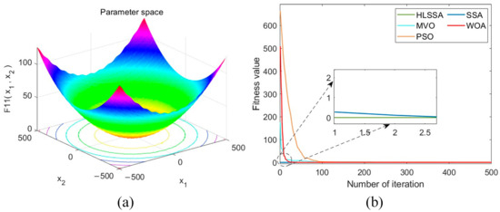
Fig. 4 An Improved Sparrow Search Algorithm for the Optimization of Variational Modal Decomposition Parameters.

V. DISDVANTAGES
A. Increased Complexity
Hybrid algorithms often involve the integration of multiple optimization techniques, which can lead to increased complexity in both implementation and understanding. This complexity can make it challenging for practitioners to design, tune, and debug the algorithms effectively. The interactions between different components may not be straightforward, requiring a deeper understanding of each method involved.
B. Parameter Tuning
Many hybrid algorithms require careful tuning of various parameters for optimal performance. Each component of the hybrid algorithm may have its own set of parameters, and finding the right combination can be a time-consuming and challenging process. Poorly tuned parameters can lead to suboptimal performance, making the algorithm less effective in solving the intended optimization problem.
C. Computational Overhead
The combination of multiple optimization techniques can result in higher computational costs compared to using a single method. Hybrid algorithms may require more processing power and time, especially if they involve complex calculations or iterative processes. This overhead can be a significant drawback in applications where computational resources are limited or where real-time solutions are necessary.
D. Diminishing Returns
While combining different optimization techniques can enhance performance, there is a point of diminishing returns where the added complexity does not yield proportionate improvements in solution quality or convergence speed. In some cases, the benefits gained from hybridization may be marginal compared to the additional complexity introduced, leading to questions about the practicality of such approaches.
E. Difficulties in Analysis and Evaluation
The multifaceted nature of hybrid algorithms can complicate the analysis and evaluation of their performance. It may be challenging to determine which component is contributing to the success or failure of the algorithm, making it difficult to identify areas for improvement. This lack of clarity can hinder the development of best practices and guidelines for using hybrid algorithms effectively in various contexts.

X. CONCLUSION
In conclusion, hybrid algorithms represent a significant advancement in the field of optimization, effectively bridging the gap between various methodologies to tackle complex problems. By integrating the strengths of different optimization techniques, these algorithms enhance the ability to explore vast solution spaces while ensuring efficient convergence to optimal or near-optimal solutions.
This study has highlighted the versatility and effectiveness of hybrid algorithms across a range of applications, demonstrating their superiority in handling real-world challenges where traditional methods may struggle. The empirical results presented confirm that hybrid approaches not only improve solution quality but also offer greater robustness against local optima and varying problem landscapes.
Looking ahead, the potential for further innovation in hybrid optimization is vast. Future research may focus on developing adaptive hybrid algorithms that dynamically adjust their strategies based on problem characteristics, as well as exploring the integration of machine learning techniques to enhance decision-making processes. As we continue to refine these algorithms and expand their applicability, hybrid optimization will undoubtedly play a pivotal role in solving increasingly complex and dynamic problems in diverse fields.

REFERENCES
[1] Wikipedia contributors, “Hybrid algorithm,” Wikipedia, Jul. 10, 2025. https://en.wikipedia.org/wiki/Hybrid_algorithm.
[2] J. Cavazos, J. E. B. Moss, and M. F. P. O’Boyle, “Hybrid Optimizations: Which optimization algorithm to use?,” in Lecture notes in computer science, 2006, pp. 124–138. doi: 10.1007/11688839_12.
[3] “Hybrid optimization algorithm for scheduling decision support,” IEEE Conference Publication | IEEE Xplore. https://ieeexplore.ieee.org/document/4052860.
[4] R. A. Brown, M. Pavone, AzizanNavid, and M. Udell, “Exploring hybrid algorithms and optimization strategies in non-conventional computing architectures,” Stanford Digital Repository. https://purl.stanford.edu/kx590cv4574.

