Perceptron
Juan Antonio Pérez Juárez
University of Guadalajara
Guadalajara, Jalisco
juan.perez0996@alumnos.udg.mx

I. INTRODUCTION
The Perceptron is widely recognized as the fundamental building block of artificial neural networks. It is a simple algorithm used in supervised learning, specifically designed for binary classification tasks. Functioning as a linear classifier, the Perceptron enables the separation of data into two distinct categories by learning a decision boundary.

While a single Perceptron has inherent limitations regarding the complexity of data it can process, it serves as the essential unit for more complex architectures known as Multilayer Perceptrons (MLP). Understanding the Perceptron is crucial for grasping the mechanics of modern artificial intelligence and deep learning, as it represents the simplest form of a neural network.

II. HISTORICAL AND BIOLOGICAL CONTEXT
The concept of the Perceptron draws its inspiration directly from biology, specifically the structure and function of the biological neuron. In a biological system, a neuron receives electrical signals through dendrites. These signals accumulate in the cell body, and if the signal strength exceeds a certain threshold, the neuron "fires," sending an electrical impulse down the axon to other neurons via synapses.

- The Rosenblatt Model
Frank Rosenblatt developed the artificial Perceptron in 1957 at the Cornell Aeronautical Laboratory. He mathematically modeled this biological process: the "dendrites" are represented by input data, the "cell body" performs a weighted sum of these inputs, and the "axon" is the output determined by an activation function.

- The AI Winter
The history of the Perceptron also includes a significant period of stagnation. In 1969, Marvin Minsky and Seymour Papert published a critique highlighting that a single Perceptron could not solve non-linearly separable problems, such as the XOR (Exclusive OR) logic gate. This observation led to a drastic decline in funding and interest in neural networks, a period often referred to as the first "AI Winter," until the development of multilayer networks later revitalized the field.

III. ALGORITHMIC ARCHITECTURE
The operation of a Perceptron is mathematical and deterministic. It processes input data to produce a single binary output (0 or 1). The architecture consists of several key elements: inputs, weights, and a bias.

- The Mathematical Process
The algorithm assigns a weight ($w$) to each input value ($x$), representing the importance of that input. It also includes a bias ($b$), a constant value that allows the activation function to be shifted, ensuring the model does not always output zero when inputs are zero. The core calculation is the weighted sum of the inputs plus the bias: $\sum w_i x_i + b$.

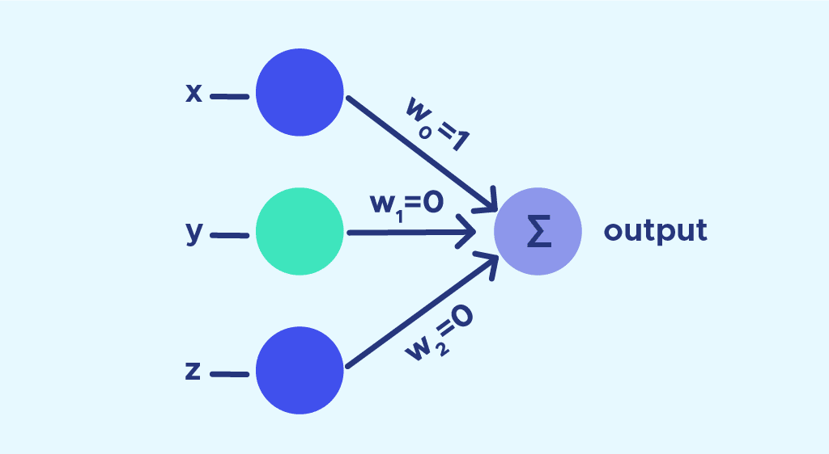
Fig. 1 The image depicts a simple perceptron neural network with three input nodes (x, y, z) connected to an output node (Σ) via weighted connections (w). This is a fundamental architecture used in early neural network models.

- Activation and Decision
Once the weighted sum is calculated, it is passed through an activation function. In the classic Perceptron, this is typically a step function (Heaviside function). If the resulting sum is greater than 0, the output is 1; otherwise, the output is 0. This mechanism creates a linear decision boundary (a line in 2D or a plane in 3D) that separates the data classes.

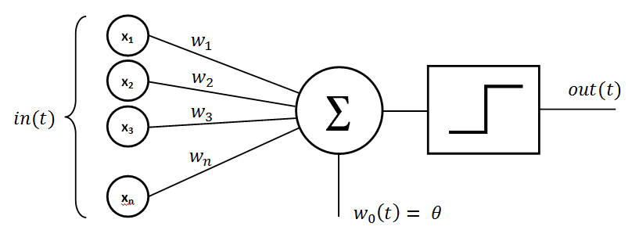
Fig. 2 The image depicts a simple perceptron neural network with input values (in(t)), weighted connections (w1, w2, w3, ..., wn), a summation node (Σ), and an output (out(t)). This is a fundamental architecture used in early neural network models.

IV. FROM SINGLE UNITS TO MULTILAYER NETWORKS
To overcome the limitations of the single Perceptron—specifically its inability to handle non-linear data like the XOR problem—researchers developed the Multilayer Perceptron (MLP). An MLP is a feedforward network that connects multiple Perceptrons in a hierarchical structure.

- Layered Structure
An MLP consists of three distinct types of layers:

- Input Layer: This layer receives raw data features.
- Hidden Layers: Located between the input and output, these layers process features and allow the network to learn complex, non-linear relationships.
- Output Layer: This layer produces the final prediction or classification.

- Forward and Backward Propagation
The MLP operates using two main phases. In Forward Propagation, data flows from the input layer through the hidden layers to the output layer to generate a prediction. To learn, the network uses Backpropagation. The algorithm compares the predicted output to the actual target to calculate the error (loss). This error is then propagated backward through the network to update the weights and biases, improving the model's accuracy over time. Unlike the simple step function of the original Perceptron, MLPs often use differentiable activation functions, such as Sigmoid or ReLU, to facilitate this learning process.

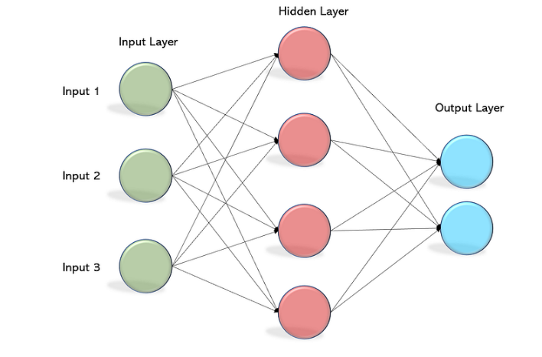
Fig. 3 The image depicts a simple neural network architecture with an input layer, a hidden layer, and an output layer. The input layer consists of three input nodes, the hidden layer has four nodes, and the output layer has two nodes. This type of network is a fundamental building block of more complex deep learning models.

V. MATHEMATICAL CONVERGENCE AND LEARNING RULES
Beyond the structural architecture, the Perceptron is defined by a specific online learning algorithm that processes training examples one at a time. This process is governed by precise mathematical rules regarding weight updates and convergence guarantees.

- The Learning Algorithm
The learning process involves iterating through training samples and updating weights only when a misclassification occurs. The update rule is defined as:
wi(t+1)=wi(t)+α⋅(d−y)⋅xiw i (t+1)=w i (t)+α⋅(d−y)⋅x i
​Here, $w_i$ represents the weight, $\alpha$ is the learning rate (a constant between 0 and 1), $d$ is the desired target output, and $y$ is the actual output. This formula ensures that the weights are adjusted in the direction that reduces the error for that specific input.

- Convergence Theorem
A critical theoretical aspect of the Perceptron is the "Perceptron Convergence Theorem." This theorem states that if the training dataset is linearly separable (meaning a hyperplane exists that can perfectly separate the classes), the algorithm is guaranteed to terminate and find a solution in a finite number of steps. However, if the data is not linearly separable, the algorithm will never converge and the weights will oscillate indefinitely. This mathematical reality reinforces the necessity of Multilayer Perceptrons for solving complex, non-linear real-world problems.

XI. CONCLUSION
The Perceptron stands as the cornerstone of artificial intelligence, bridging the gap between biological inspiration and mathematical execution. While its initial formulation by Rosenblatt provided a revolutionary way to model learning, its inability to solve non-linear problems—proven by the Convergence Theorem—highlighted the necessity for deeper architectures.
Today, the evolution from the single Perceptron to the Multilayer Perceptron has enabled machines to master complex tasks, from pattern recognition to predictive modeling. By integrating the simple linear decision capability of the Perceptron with the hierarchical processing of hidden layers and Backpropagation, modern neural networks have overcome early theoretical limitations to become the dominant force in machine learning.

REFERENCES
[1] DataScientest, "Perceptrón: ¿Qué es y para qué sirve?," DataScientest.com. https://datascientest.com/es/perceptron-que-es-y-para-que-sirve
[2] R. Khandelwal, "Multilayer Perceptrons in Machine Learning: A Comprehensive Guide," DataCamp. https://www.datacamp.com/es/tutorial/multilayer-perceptrons-in-machine-learning
[3] Wikipedia contributors, "Perceptrón," Wikipedia, The Free Encyclopedia. https://es.wikipedia.org/wiki/Perceptr%C3%B3n

