Multi-level thresholding image segmentation
Juan Antonio Pérez Juárez
University of Guadalajara
Guadalajara, Jalisco
juan.perez0996@alumnos.udg.mx

I. INTRODUCTION
Image segmentation is a crucial step in image processing and computer vision, enabling the extraction of meaningful information from digital images. Among various segmentation techniques, multi-level thresholding has gained significant attention due to its ability to effectively partition images into distinct regions based on intensity values. This method extends the traditional binary thresholding approach by applying multiple thresholds, thereby facilitating the segmentation of complex images with varying characteristics.

In recent years, the demand for advanced segmentation techniques has surged, driven by applications in fields such as medical imaging, remote sensing, and industrial inspection. Multi-level thresholding not only enhances the accuracy of segmentation but also improves the robustness of image analysis, making it an essential tool for researchers and practitioners alike. This paper presents a comprehensive review of multi-level thresholding methods, exploring their theoretical foundations, implementation strategies, and performance metrics. Additionally, we discuss the challenges associated with selecting optimal thresholds and propose novel solutions to address these issues.

By investigating the latest advancements in multi-level thresholding techniques, this article aims to contribute to the ongoing discourse in the field of image segmentation, providing insights that may inspire future research and applications.

II. OPTIMIZATION
Multi-level thresholding for image segmentation is one of the key techniques in image processing. Although numerous methods have been introduced, it remains challenging to achieve stable and satisfactory thresholds when segmenting images with various unknown properties. This paper proposes an equilibrium optimizer algorithm to find the optimal multi-level thresholds for grayscale images. The proposed algorithm AEO (advanced equilibrium optimizer) uses two sub-populations to balance exploration and exploitation during the multi-level threshold search process. Two mutation schemes are proposed for the sub-population to prevent them from being trapped in local optima. AEO offers a repair function to avoid generating duplicate thresholds. The performance of AEO is evaluated on multiple benchmark images. Experimental results demonstrate that AEO has an outstanding ability for multi-level threshold image segmentation in terms of cross-entropy, signal-to-noise ratio (PSNR), structural similarity index measure (SSIM), and feature similarity index (FSIM).

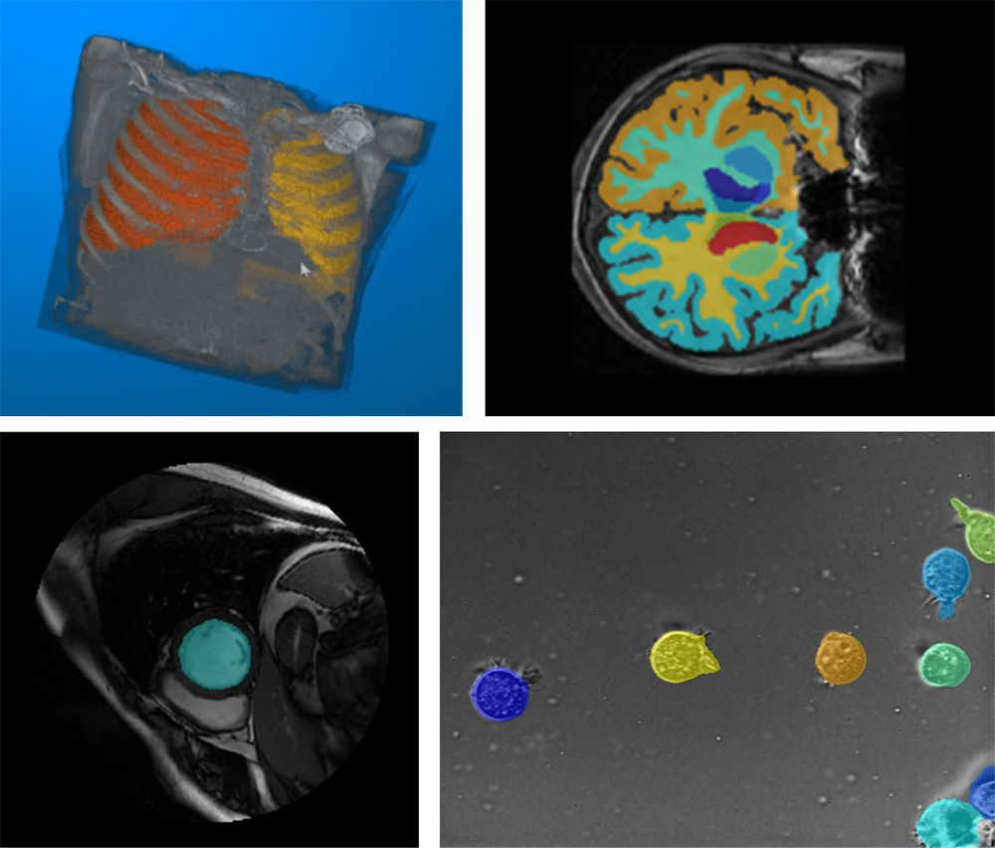
Fig. 1 Examples of segmentation using Medical Imaging Toolbox™, including (clockwise from upper left) lungs in a CT scan, a brain in an MRI scan, cells in a microscopy image, and the left ventricle in a cardiac MRI.
III. IMAGE SEGMENTATION
Is the process of partitioning a digital image into multiple image segments, also known as image regions or image objects (sets of pixels). The goal of segmentation is to simplify and/or change the representation of an image into something that is more meaningful and easier to analyze. Image segmentation is typically used to locate objects and boundaries (lines, curves, etc.) in images. More precisely, image segmentation is the process of assigning a label to every pixel in an image such that pixels with the same label share certain characteristics.

The result of image segmentation is a set of segments that collectively cover the entire image, or a set of contours extracted from the image (see edge detection). Each of the pixels in a region are similar with respect to some characteristic or computed property, such as color, intensity, or texture. Adjacent regions are significantly different with respect to the same characteristic(s). When applied to a stack of images, typical in medical imaging, the resulting contours after image segmentation can be used to create 3D reconstructions with the help of geometry reconstruction algorithms like marching cubes.

IV. APLICATIONS
- Content-based image retrieval.
- Machine vision.
- Medical imaging and imaging studies in biomedical research, including volume rendered images from computed tomography, magnetic resonance imaging, as well as volume electron microscopy techniques such as FIB-SEM.
  - Locate tumors and other pathologies.
  - Measure tissue volumes.
  - Diagnosis, study of anatomical structure.
  - Surgery planning.
  - Virtual surgery simulation.
  - Intra-surgery navigation.
  - Radiotherapy.
  - Digital Pathology and Histopathology. Nuclei instance segmentation in variously stained whole slide images (WSIs) refers to the automatic delineation of individual cells' nuclei borders. This task is a specialized subproblem of instance segmentation, with high practical importance in biomedical research and diagnostics (e.g. cell counting, morphometric feature extraction, tumor grading, prognostic biomarker extraction).[15] The modern approach to the problem is the use of deep learning architectures developed to encompass the main challenges of separating overlapping or fused nuclei.
- Object detection.
- Pedestrian detection.
- Face detection.
- Brake light detection.
- Locate objects in satellite images (roads, forests, crops, etc.).
- Recognition Tasks.
- Face recognition.
- Fingerprint recognition.
- Iris recognition.
- Prohibited Item at Airport security checkpoints.
- Traffic control systems.
- Video surveillance.
- Video object co-segmentation and action localization.

V. GROUPS OF IMAGE SEGMENTATION
A. Semantic segmentation is an approach detecting, for every pixel, the belonging class. For example, in a figure with many people, all the pixels belonging to persons will have the same class id and the pixels in the background will be classified as background.
B. Instance segmentation is an approach that identifies, for every pixel, the specific belonging instance of the object. It detects each distinct object of interest in the image. For example, when each person in a figure is segmented as an individual object.
C. Panoptic segmentation combines both semantic and instance segmentation. Like semantic segmentation, panoptic segmentation is an approach that identifies, for every pixel, the belonging class. Moreover, like in instance segmentation, panoptic segmentation distinguishes different instances of the same class.

VI. THRESHOLDING
The simplest method of image segmentation is called the thresholding method. This method is based on a clip-level (or a threshold value) to turn a gray-scale image into a binary image.
The key of this method is to select the threshold value (or values when multiple-levels are selected). Several popular methods are used in industry including the maximum entropy method, balanced histogram thresholding, Otsu's method (maximum variance), and k-means clustering.
Recently, methods have been developed for thresholding computed tomography (CT) images. The key idea is that, unlike Otsu's method, the thresholds are derived from the radiographs instead of the (reconstructed) image.
New methods suggest the use of multi-dimensional, fuzzy rule-based, non-linear thresholds. In these approaches, the decision regarding each pixel's membership in a segment is based on multi-dimensional rules derived from fuzzy logic and evolutionary algorithms, considering factors such as image lighting, environment, and application.

Fig. 2 Original Image.
VII. CLUSTERING METHODS
The K-means algorithm is an iterative technique that is used to partition an image into K clusters. The basic algorithm is:
- Pick K cluster centers, either randomly or based on some heuristic method, for example K-means++.
- Assign each pixel in the image to the cluster that minimizes the distance between the pixel and the cluster center.
- Re-compute the cluster centers by averaging all the pixels in the cluster.
- Repeat steps 2 and 3 until convergence is attained (i.e. no pixels change clusters).
In this case, distance is the squared or absolute difference between a pixel and a cluster center. The difference is typically based on pixel color, intensity, texture, and location, or a weighted combination of these factors. K can be selected manually, randomly, or by a heuristic. This algorithm is guaranteed to converge, but it may not return to the optimal solution. The quality of the solution depends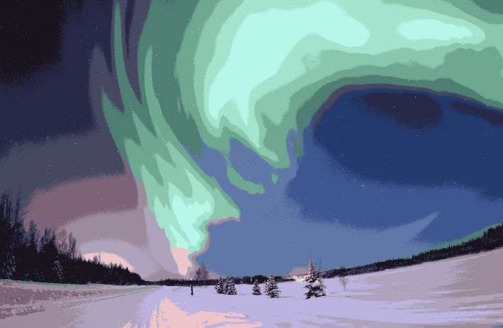
Fig. 3 Image after running k-means with k = 16.

on the initial set of clusters and the value of K.
The Mean Shift algorithm is a technique that is used to partition an image into an unknown apriori number of clusters. This has the advantage of not having to start with an initial guess of such parameter which makes it a better general solution for more diverse cases.

VIII. COMPRESSION-BASSED METHODS
Compression based methods postulate that the optimal segmentation is the one that minimizes, over all possible segmentations, the coding length of the data. The connection between these two concepts is that segmentation tries to find patterns in an image and any regularity in the image can be used to compress it. The method describes each segment by its texture and boundary shape. Each of these components is modeled by a probability distribution function and its coding length is computed as follows:

- The boundary encoding leverages the fact that regions in natural images tend to have a smooth contour. This prior is used by Huffman coding to encode the difference chain code of the contours in an image. Thus, the smoother a boundary is, the shorter coding length it attains.
- Texture is encoded by lossy compression in a way similar to minimum description length (MDL) principle, but here the length of the data given the model is approximated by the number of samples times the entropy of the model. The texture in each region is modeled by a multivariate normal distribution whose entropy has a closed form expression. An interesting property of this model is that the estimated entropy bounds the true entropy of the data from above. This is because among all distributions with a given mean and covariance, normal distribution has the largest entropy. Thus, the true coding length cannot be more than what the algorithm tries to minimize.
For any given segmentation of an image, this scheme yields the number of bits required to encode that image based on the given segmentation. Thus, among all possible segmentations of an image, the goal is to find the segmentation which produces the shortest coding length. This can be achieved by a simple agglomerative clustering method. The distortion in the lossy compression determines the coarseness of the segmentation and its optimal value may differ for each image. This parameter can be estimated heuristically from the contrast of textures in an image. For example, when the textures in an image are similar, such as in camouflage images, stronger sensitivity and thus lower quantization is required.

XI. EDGE DETECTION
Edge detection is a well-developed field of its own within image processing. Region boundaries and edges are closely related, since there is often a sharp adjustment in intensity at the region boundaries. Edge detection techniques have therefore been used as the base of another segmentation technique.

The edges identified by edge detection are often disconnected. To segment an object from an image, however, one needs closed region boundaries. The desired edges are the boundaries between such objects or spatial-taxons. Spatial-taxons are information granules, consisting of a crisp pixel region, stationed at abstraction levels within a hierarchical nested scene architecture. They are like the Gestalt psychological designation of figure-ground, but are extended to include foreground, object groups, objects and salient object parts. Edge detection methods can be applied to the spatial-taxon region, in the same manner they would be applied to a silhouette. This method is particularly useful when the disconnected edge is part of an illusory contour.
Segmentation methods can also be applied to edges obtained from edge detectors. Lindeberg and Li developed an integrated method that segments edges into straight and curved edge segments for parts-based object recognition, based on a minimum description length (MDL) criterion that was optimized by a split-and-merge-like method with candidate breakpoints obtained from complementary junction cues to obtain more likely points at which to consider partitions into different segments.
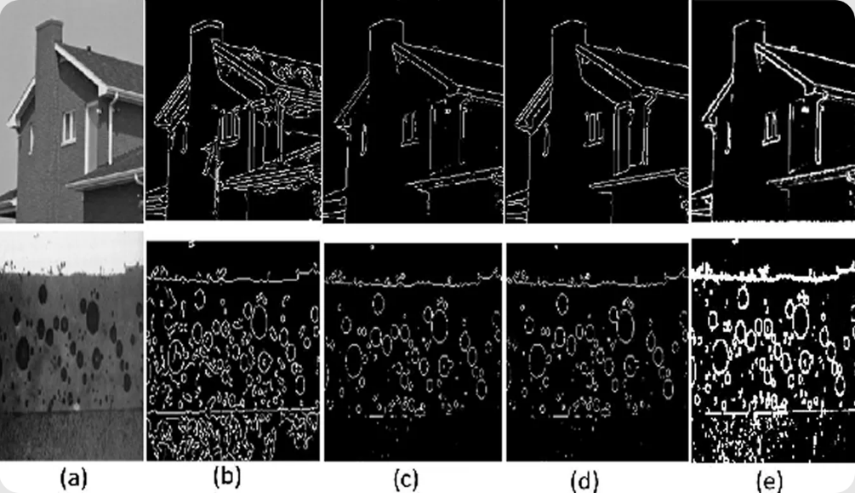
Fig 4. Example showing the original image alongside outputs from different edge detection methods

X. CONCLUSION
In conclusion, multi-level thresholding image segmentation represents a powerful approach for effectively partitioning images into meaningful regions based on intensity values. This technique not only enhances the accuracy of segmentation but also addresses the complexities inherent in various imaging modalities. Throughout this paper, we have reviewed the theoretical foundations of multi-level thresholding, explored diverse methodologies, and highlighted their applications across multiple domains, including medical imaging, remote sensing, and industrial inspection.

Despite its advantages, challenges remain in the optimal selection of thresholds, which can significantly impact segmentation performance. Future research should focus on developing adaptive and automated thresholding techniques that leverage machine learning and artificial intelligence to improve accuracy and reduce computational complexity. Additionally, the integration of multi-level thresholding with other image processing techniques could further enhance segmentation results.

As the field of image processing continues to evolve, the insights provided in this article aim to foster further exploration and innovation in multi-level thresholding methods, ultimately contributing to more effective image analysis solutions. By addressing the existing challenges and embracing new technologies, we can unlock the full potential of multi-level thresholding in various applications, paving the way for advancements in image segmentation and analysis.

REFERENCES
[1] P. Hu, Y. Han, Z. Zhang, S.-C. Chu, and J.-S. Pan, “A multi-level thresholding image segmentation algorithm based on equilibrium optimizer,” Scientific Reports, vol. 14, no. 1, p. 29728, Nov. 2024, doi: 10.1038/s41598-024-81075-w.
[2] Wikipedia contributors, “Image segmentation,” Wikipedia, Nov. 17, 2025. https://en.wikipedia.org/wiki/Image_segmentation.
[3] MathWorks, “What is image segmentation?,” MATLAB & Simulink. https://www.mathworks.com/discovery/image-segmentation.html
[4] A. Vina, “Edge detection in image processing: explained.” https://www.ultralytics.com/blog/edge-detection-in-image-processing-explained.

