Chromatic Accessibility in Latin American University Websites: A Large-Scale Survey of WCAG Contrast Compliance
Anonymous Authors for Double-Blind Peer Review
(Author details and institutional affiliations omitted per JGED double-blind review policy)

Abstract
Web accessibility audits at scale have historically concentrated on North American and European institutions, leaving higher education in Latin America largely unexamined. We crawled the homepages of 464 Latin American university websites across 17 countries and successfully extracted computed text/background colour pairs from 259 of them (41,360 pairs in total). Each pair was converted from sRGB to CIELAB and evaluated against the WCAG 2.2 contrast thresholds, with the axe-core accessibility engine as an automated cross-check ($r=0.347$). We find that 21.6% of all colour pairs fail the AA threshold, and 93.4% of sites contain at least one critical failure. A pair-level chi-square test suggests compliance differs by country ($χ^{2}=1625.04$, $df=16$, $p<0.001$, Cramér’s $V=0.198$), but because colour pairs are clustered within sites rather than independent, we treat this as exploratory: a site-level test on the true unit of analysis (255 sites, countries with $≥$5 sites) is not significant ($χ^{2}=22.92$, $df=15$, $p=0.086$). A within-site typography effect (large text failing less often) does not survive site-clustered sandwich standard errors ($p=0.473$), although continuous font size in pixels retains a small association with failure ($p=0.027$). Unsupervised clustering of the failing pairs in the full CIELAB $L^{*}a^{*}b^{*}$ space supports the initial hypothesis: near-neutral, low-chroma clusters consistent with the “light grey on white” pattern account for 80.0% of all failing pairs, with four smaller chromatic clusters spanning the remaining 20.0%.
Keywords: Colour contrast, Chromatic accessibility, WCAG 2.2, CIELAB colour space, Web accessibility, Information design.

1 Introduction
Web accessibility is frequently framed as a compliance checkbox rather than as a problem of information design: which visual choices allow a message to be perceived by the range of readers who will actually encounter it. Colour contrast between text and its background is one of the most consequential of those choices, because unlike many other accessibility barriers it is silent: a page can look complete to a sighted designer working under ideal lighting on a calibrated monitor while remaining functionally illegible to a large fraction of visitors.
Large-scale, empirical audits of contrast compliance exist, most notably WebAIM’s annual scan of the top one million global home pages (WebAIM, 2026), which finds low-contrast text on 83.9% of pages and identifies it as the most commonly detected accessibility issue, a position it has held in every edition since 2019. Such global scans report an aggregate world figure, though, and are not designed to, and do not, break results out for Latin American higher education specifically. Latin American higher education has not, to our knowledge, been the subject of a comparable regional survey. This is a meaningful gap: university websites are a primary public-facing channel for admissions, financial aid, and academic information, and design conventions, content management systems, and institutional resourcing in the region differ enough from those studied elsewhere that findings cannot simply be assumed to transfer.
This paper reports a large-scale survey of chromatic accessibility on the homepages of Latin American universities. Rather than relying on a small hand-picked sample, we build a stratified list of institutions from an open, community-maintained directory, crawl each homepage with a real browser engine to capture computed (post-CSS) colour pairs, and classify every pair against the WCAG 2.2 (World Wide Web Consortium (W3C), 2023) contrast thresholds. We ask two questions. First, at what rate do these institutions fail contrast requirements, and does that rate vary systematically by country? Second, what visual pattern, if any, characterises the colours involved in a failure? The second question matters because the answer determines what kind of intervention would actually help: a narrow pattern (e.g., light grey body text) suggests a simple style-guide fix, while a diffuse one suggests a more structural design-literacy problem.
The contributions of this work are: (1) the first large-scale regional survey of chromatic accessibility for Latin American university homepages, built from a stratified sample of 464 institutions across 17 countries; (2) a site-level, clustering-aware statistical treatment of the country question that distinguishes a descriptive pair-level pattern from a confirmed site-level effect; (3) an unsupervised characterisation, in the full CIELAB colour space, of the visual patterns underlying contrast failures in this region, showing that two low-chroma, near-neutral clusters (a near-white and a mid-grey pattern) jointly dominate, with four smaller chromatic clusters accounting for the remainder.

2 Related Work
Contrast and legibility research inside the graphic design literature has largely focused on typography and reading performance rather than on regulatory thresholds. Weingerl, Nedeljković & Pušnik (2022) studied the visibility and legibility of short words under controlled experimental conditions, establishing that legibility judgments depend jointly on typographic and perceptual factors rather than on any single variable in isolation, a finding that motivates our decision to treat contrast as one factor among several (font size, weight) rather than in isolation. Punsongserm & Suvakunta (2025) conducted a technical review of typeface choice, type size, and colour contrast in government mobile applications, and, closer to our own setting, identified legibility and colour-contrast problems in public-sector mobile applications and argued that existing government standards do not address them in sufficient detail; we examine the contrast dimension of that problem, in a different modality and region, for university websites. In a related display context, Jović et al. (2026) review the literature on text legibility in augmented reality and identify colour and contrast among the ten parameters that govern it, together with background influence and environmental illumination. Ofosu-Asare (2024) examined usability and design evaluation techniques for online learning environments, noting that accessibility in educational digital products is usually assessed qualitatively or on small samples rather than through a large-scale automated survey, which is the gap this paper addresses directly for the chromatic dimension. Within this journal, colour reproduction has mostly been studied on the print side, including how ink drying systems shape the final printed result (Saad et al., 2021); the screen-side counterpart, whether the sRGB colours chosen for web interfaces are distinguishable enough to be read, is the problem this paper addresses.
The conceptual foundation of our study rests on the universal web accessibility argument advanced by Henry, Abou-Zahra & Brewer (2014), who established that accessibility is not a special-case concern for users with disabilities but a universal quality requirement: low contrast degrades legibility for all users under adverse ambient conditions (sunlight, low-quality screens, ageing displays), making compliance with WCAG contrast thresholds a baseline quality requirement rather than a minority accommodation. Rello & Baeza-Yates (2013) showed with eye-tracking that font choice alone measurably changes reading performance for readers with dyslexia, a population whose needs are not captured by automated WCAG pass/fail audits; this supports looking beyond a binary threshold test, which is why we also analyse failures in continuous CIELAB space.
The closest direct precedent in the Latin American higher-education domain is the body of work by Acosta-Vargas and collaborators, who have conducted the most systematic prior surveys of university website accessibility in the region. Their 2018 study (Acosta-Vargas, Acosta & Lujan-Mora, 2018) evaluated 348 Latin American university websites against WCAG 2.0, finding frequent violations (most often missing alternative text for images); it is the closest benchmark against which our 93.4% per-site failure rate and our 21.6% pair-level failure rate should be positioned. A subsequent heuristic method for users with low vision (Acosta-Vargas, Salvador-Ullauri & Lujan-Mora, 2019), applied to 30 Latin American university websites, argued that automatic tools alone do not give an adequate picture of accessibility barriers; this is one reason we do not stop at the WCAG pass/fail ratio and also characterise failing pairs in the full CIELAB $L^{*}a^{*}b^{*}$ space. Their 2020 dataset (Acosta-Vargas, González & Luján-Mora, 2020) makes the evaluation data for 368 pages publicly available, enabling direct comparison with automated-tool outputs; our study is methodologically complementary in that we use a different pipeline (computed-style extraction via Playwright rather than a WAVE rule-engine scan) and restrict the analysis to the chromatic dimension specifically, extracting every text/background colour pair in CIELAB coordinates rather than returning a binary pass/fail per element, which allows us to characterise the failure patterns in continuous colour space. More recent work by the same group confirms that the contrast failure pattern extends beyond the university sector: Acosta-Vargas et al. (2022) found contrast errors to be the dominant accessibility barrier in 50 top-ranked e-commerce websites (83.1% of failures classified as “perceivable” violations), and a complementary study of 50 popular Android applications available in Ecuador (Acosta-Vargas et al., 2021) found text contrast among the recurring barriers (9.2% of detected problems), placing our university-website result within a broader pattern of accessibility problems in Latin American digital products.

3 Methodology

3.1 Site selection
We built the candidate list from the Hipo/university-domains-list open dataset, filtered to the 19 countries of Latin America, and drew a stratified random sample across countries (capped per country to avoid Brazil and Mexico dominating the list). The final list contained 464 domains across 17 countries. Bolivia and Venezuela are absent: the source dataset lists them under their official names (“Bolivia, Plurinational State of”; “Venezuela, Bolivarian Republic of”), which our country-name filter did not match, so they were excluded at the sampling stage (see Limitations).

3.2 Crawling
Each homepage was visited with a headless Chromium browser (Playwright), identifying our crawler with a descriptive user agent and honoring robots.txt (fetched with the same identifying user agent, since fetching it with a generic client triggers 403 responses on several sites and would otherwise cause valid, crawlable sites to be excluded by mistake). Requests were rate-limited to one every two seconds. Of the 464 domains, 278 (59.9%) were successfully rendered; the remainder were unreachable, timed out, or were excluded by robots.txt (see Table 1).

3.3 Colour pair extraction
For each of the 278 reachable sites we revisited the live page a second time and, via getComputedStyle(), extracted every visible text node’s computed text colour together with its effective background colour, resolved by walking up the DOM ancestor chain until a non-transparent background is found, since a text element’s immediate parent is frequently transparent. Elements with zero width/height, display:none, visibility:hidden, or zero opacity were discarded. This step requires a live browser rather than the raw HTML saved during crawling, because a serialised DOM does not inline externally linked CSS; computing style from the saved markup alone would silently fall back to browser defaults. This yielded 41,360 colour pairs from 259 sites (19 sites returned no usable pairs, typically due to navigation during evaluation).

3.4 Contrast calculation and cross-validation
Each pair’s WCAG relative luminance and contrast ratio were computed directly from sRGB, and each pair was independently converted from sRGB to CIELAB (International Commission on Illumination (CIE), 2007) ($D_{65}$ illuminant) for the clustering analysis. As a cross-check, we additionally ran the axe-core accessibility engine (the library underlying most commercial accessibility linters) against the same live page and recorded its colour-contrast violation and pass counts.

3.5 Classification and aggregation
Following WCAG 2.2, each pair was classified as fail, AA, or AAA using thresholds that depend on text size: 3:1 (AA) / 4.5:1 (AAA) for large text ($≥$24px, or $≥$18.66px bold), and 4.5:1 (AA) / 7:1 (AAA) otherwise. Results were aggregated per site (median ratio, % of pairs failing AA, whether the site has at least one critical failure).

3.6 Statistical analysis
We tested independence between country and AA compliance with a $χ^{2}$ test (continuity-corrected, restricted to countries having $≥30$ pairs) and we report Cramér’s $V$ as the effect size. This test, like any test run on the 41,360-pair table, treats colour pairs as independent observations, but pairs from the same site share a common design system and are not independent draws, a form of pseudo-replication that inflates the effective sample size and can make a null or weak site-level effect appear significant at the pair level. To address this directly rather than only flag it, we repeat the country comparison at the site level, the unit at which country actually varies: a $χ^{2}$ test on each site’s binary critical-failure status, and a Kruskal-Wallis test on each site’s continuous %AA-failure, both restricted to the 16 countries with $≥$5 sites (255 of 259 sites). We fit a logistic regression of pair-level failure on country, font size, and whether the text qualifies as “large,” and repeat it with site-clustered sandwich standard errors (generalised estimating equations, independence working correlation, clustered by site) to check which effects survive proper clustering rather than only the country effect. We clustered the failing pairs’ text-colour coordinates in the full, standardised CIELAB $L^{*}a^{*}b^{*}$ space with $k$-means, rather than the $a^{*}b^{*}$ chroma plane alone, since WCAG failure is a function of luminance and a chroma-only clustering would place every achromatic colour at the origin regardless of lightness; we searched $k∈\{2,…,20\}$ for a silhouette-optimal solution before fixing $k=6$ for interpretability (Results).

4 Results
Table 1. Crawl outcomes for the 464 sampled domains.
Outcome | Count
Successfully rendered | 278
Unreachable / timed out / other error | 167
Excluded by robots.txt | 19
Across the 41,360 extracted colour pairs, 21.6% fail the applicable WCAG AA threshold, 16.6% meet AA but not AAA, and 61.8% meet AAA (Figure 1). At the site level, 93.4% of the 259 successfully analysed homepages contain at least one critical (failing) pair, and the median site has 20.1% of its pairs failing AA, so failures are not concentrated in a handful of outlier institutions; they are the norm. This per-page failure rate is higher than WebAIM’s 83.9% figure for the global top one million home pages (WebAIM, 2026), though the two figures come from different detection pipelines applied to different populations and should be read as an order-of-magnitude reference rather than a controlled comparison (Limitations).
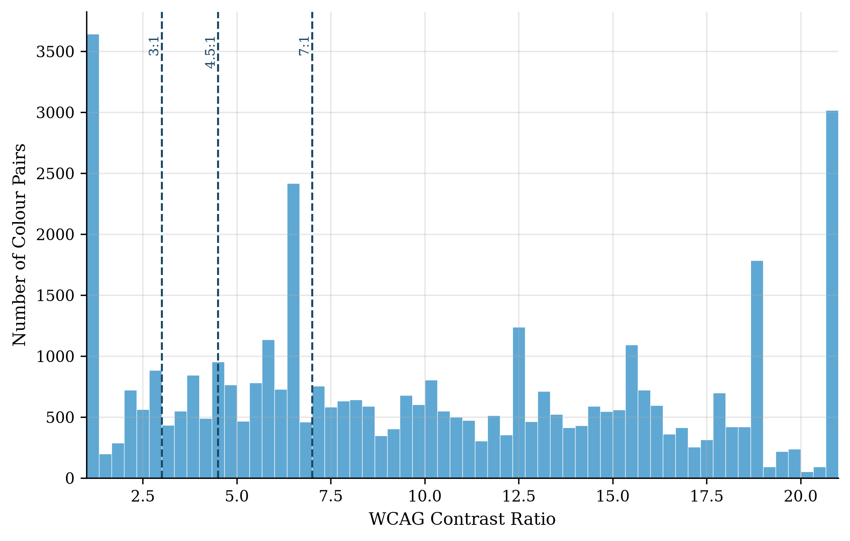
Figure 1. Distribution of WCAG contrast ratios across the 41,360 extracted colour pairs, with the AA and AAA thresholds marked.
Table 2. Descriptive statistics by country (16 countries with $≥$5 sites; 255 of 259 sites).
Country | Sites | Median % AA-fail | % sites, $≥$1 critical fail
Argentina | 27 | 22.0 | 96.3
Chile | 27 | 15.0 | 96.3
Brazil | 25 | 12.5 | 92.0
Colombia | 26 | 19.0 | 100.0
Ecuador | 24 | 20.1 | 91.7
Peru | 21 | 25.4 | 81.0
Costa Rica | 19 | 24.0 | 94.7
Mexico | 15 | 9.0 | 73.3
Dominican Republic | 15 | 33.6 | 100.0
El Salvador | 13 | 15.5 | 100.0
Guatemala | 10 | 22.3 | 100.0
Nicaragua | 9 | 33.3 | 88.9
Panama | 7 | 14.3 | 100.0
Cuba | 6 | 31.6 | 100.0
Honduras | 6 | 22.9 | 83.3
Paraguay | 5 | 15.6 | 100.0
Table 2 gives descriptive statistics by country before turning to the significance question. The pair-level test suggests compliance varies by country ($χ^{2}=1625.04$, $df=16$, $p<0.001$, Cramér’s $V=0.198$; Figure 2), and the pair-level logistic regression finds most country coefficients individually significant (e.g., Paraguay: $β=−2.23$, $p<0.001$; Cuba: $β=+0.57$, $p<0.001$). We do not take this at face value: because pairs are clustered within sites, the pair-level test’s effective sample size (41,360) overstates independent information, and its $p$-values should be read as optimistic. The site-level test, restricted to the 255 sites in the 16 countries with $≥$5 sites, is not significant either on critical-failure status ($χ^{2}=22.92$, $df=15$, $p=0.086$) or on continuous %AA-failure (Kruskal-Wallis $H=20.55$, $p=0.152$). Because the site-level critical-failure rate is high (most countries have few or no compliant sites), several cells of the country $×$ failure contingency table have an expected count well below the conventional rule-of-thumb minimum of 5 for the chi-squared approximation to be reliable (minimum expected count $=0.33$); as a sensitivity check we therefore also ran a 10,000-iteration Monte Carlo permutation test (shuffling critical-failure status across sites within the same country distribution and recomputing $χ^{2}$ each time), which agrees closely with the asymptotic result ($p=0.086$), so this is not an artefact of the chi-squared approximation breaking down. We therefore report the country effect as a real but unresolved pattern (visible and directionally consistent at the pair level, but not confirmed at the site level with the sample sizes available here) rather than as a confirmed finding, and we do not treat the specific per-country coefficients above as reliable individually. We initially expected typography to be on firmer ground, reasoning that because “large text” varies within a site (a single page mixes body and heading sizes) its effect would not be vulnerable to the same between-site clustering concern. This expectation does not survive a direct check: refitting the logistic regression with site-clustered sandwich standard errors (a generalised estimating equations specification, independence working correlation, clustered by site) rather than pooled naive ones leaves the large-text coefficient unchanged in size ($β=−0.10$) but no longer significant ($p=0.473$, versus $p=0.022$ pooled), so we do not treat it as a reliable finding. Raw font size in pixels fares better: it retains a significant, though far more modest, positive association with failure under the same clustered specification ($β=+0.0108$, $p=0.027$, versus $p<0.001$ pooled). Of the two typography variables tested, only continuous font size in pixels survives cluster-adjusted inference, and only marginally; the categorical large-text effect does not.
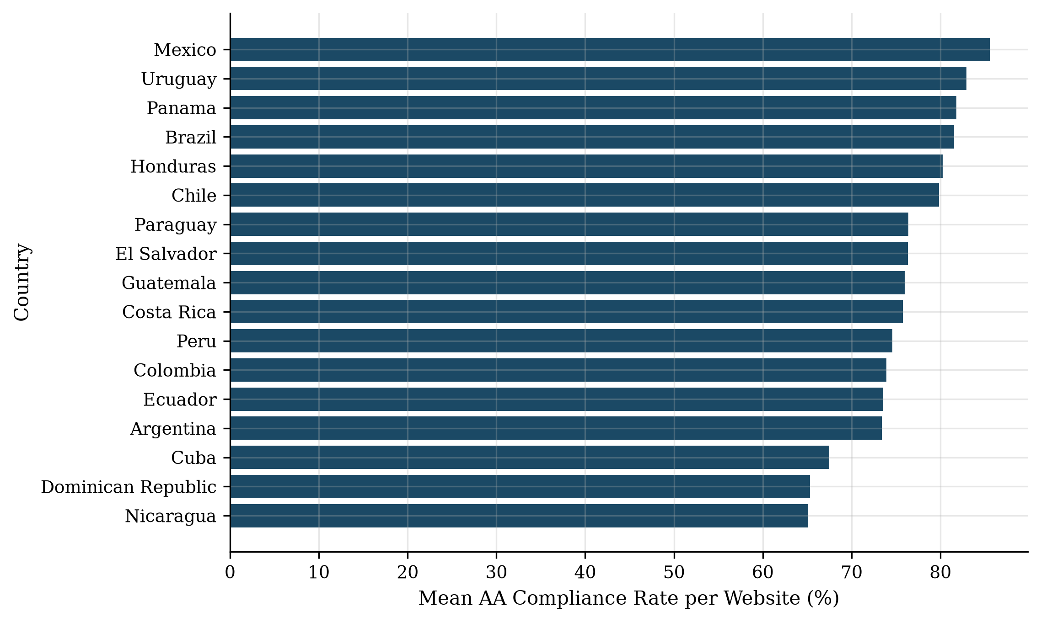
Figure 2. Mean AA compliance rate by country at the website level ($n≥3$ sites per country, 17 countries including Uruguay, 259 total sites; descriptive; see main text for why the associated significance test is not treated as confirmatory). Note that Table 2 restricts descriptive statistics to the 16 countries with $n≥5$ sites (255 sites).
We clustered the 8,925 failing pairs’ text-colour coordinates in the full, standardised CIELAB $L^{*}a^{*}b^{*}$ space with $k$-means at $k=6$ (silhouette $=0.796$); we cluster on all three coordinates, not $a^{*}b^{*}$ alone, since WCAG failure is governed by luminance and a chroma-only projection would collapse every achromatic colour (black, grey, white) onto the origin regardless of its lightness, which would settle the composition question by construction rather than measure it. We searched silhouette over $k∈\{2,…,20\}$ as a sensitivity check rather than selecting $k$ by silhouette maximisation: the score does not have a clear interior maximum over that range, so we fix $k=6$ for interpretability. The resulting partition separates the low-chroma pairs into two clusters at different lightness levels rather than merging them: a near-white cluster (mean $L^{*}=99.5$, chroma $≈0.2$, 60.1% of failing pairs) and a mid-grey cluster (mean $L^{*}=51.7$, chroma $≈5.0$, 19.9%), together 80.0% of all failing pairs, with four markedly smaller chromatic clusters (4.1% to 6.1% of pairs each, chroma 41.6–78.4) spanning red, blue, yellow-green, and green regions of the plane (Figure 3). The near-white cluster’s lightness ($L^{*}=99.5$, indistinguishable from pure white) is consistent with the background-image detection artefact discussed in Limitations: at least part of this cluster is likely mislabelled text-over-image rather than genuinely near-white text. Agreement between our contrast-ratio-based failure count and axe-core’s independent colour-contrast violation count is positive but moderate ($r=0.347$ across sites), which is expected given the two tools differ in which elements they consider evaluable (axe-core additionally skips certain non-text and gradient cases that our extraction still captures).
Table 3. The 10 most frequent failing colour pairs, with median WCAG contrast ratio and median CIELAB $ΔE$ (CIE76). $ΔE$ is evaluated using Euclidean distance in CIELAB space (CIE76), which provides an intuitive, geometrically transparent distance metric directly aligned with the $k$-means feature space, whereas CIEDE2000 incorporates complex perceptual weighting factors unnecessary for standard Euclidean clustering.
Text (hex) | Background (hex) | $n$ pairs | Ratio (median) | $ΔE$ (median)
#FFFFFF | #FFFFFF | 2,379 | 1.00 | 0.0
#777777 | #FFFFFF | 186 | 4.48 | 50.0
#9F6B6B | #F2F2F2 | 172 | 3.92 | 50.2
#E33B3B | #FFFFFF | 160 | 4.24 | 89.4
#FFFFFF | #EDEDED | 137 | 1.17 | 6.3
#BFAC51 | #FFFFFF | 124 | 2.27 | 57.0
#999999 | #FFFFFF | 116 | 2.85 | 36.8
#00BCD4 | #FFFFFF | 87 | 2.30 | 48.8
#FFFFFF | #F2F2F2 | 81 | 1.12 | 4.5
#959595 | #FFFFFF | 76 | 3.00 | 38.3
Table 3 shows that the single most frequent failing pair, by a wide margin, is white text on a white background (2,379 occurrences, $ΔE=0$). We cannot fully distinguish two explanations from the extracted data: text genuinely styled to match its background (a fully invisible pair), and text rendered over a photographic or gradient background-image, which our background-colour resolution (Methodology, Limitations) would also record as white-on-white, since it only inspects background-color up the DOM ancestor chain. Both explanations describe real accessibility failures, but only the first is a literal invisible-text pattern; the practical implication (this is the single largest identifiable failure signature in the dataset) holds either way.
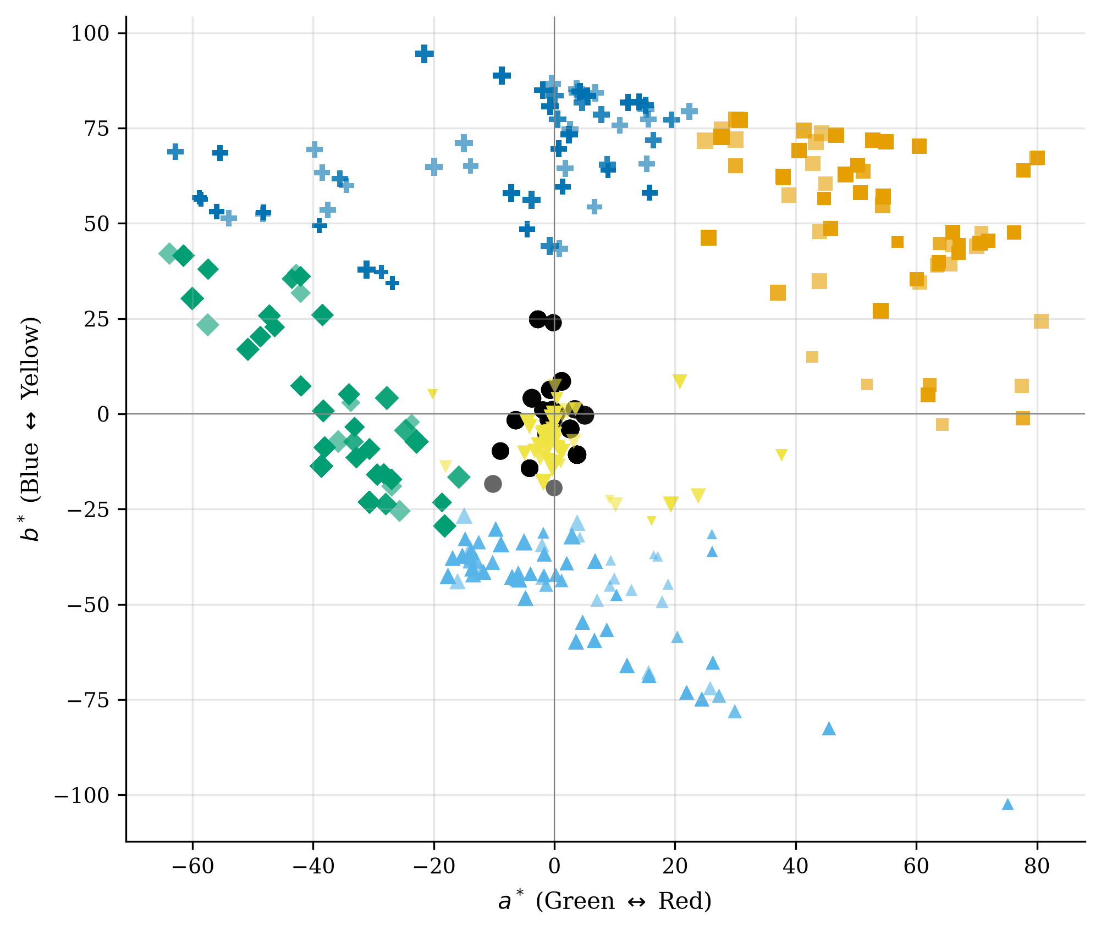
Figure 3. Failing pairs’ text-colour coordinates projected onto the CIELAB $a^{*}b^{*}$ plane, coloured by $k$-means cluster ($k=6$, computed in the full $L^{*}a^{*}b^{*}$ space); point size encodes $L^{*}$ (lightness).

5 Discussion
That most Latin American university homepages fail WCAG contrast requirements mirrors findings from other regions and is, on its own, unsurprising. Our working hypothesis, drawn from common assumptions in the accessibility-audit literature, was that failures would concentrate in familiar patterns such as light grey text on white, text over unmasked photographic backgrounds, and unverified interaction states (hover/focus/visited). The clustering result supports the low-chroma part of that hypothesis directly: near-neutral clusters consistent with the “light grey on white” pattern account for 80.0% of failing pairs, split by our full-$L^{*}a^{*}b^{*}$ clustering into a near-white cluster ($L^{*}=99.5$, 60.1%) and a mid-grey cluster ($L^{*}=51.7$, 19.9%), not merely one of several comparable clusters. The near-white cluster’s dominance is likely inflated by the background-image blind spot discussed in Limitations, since text over an unmasked photograph would also resolve as a near-white failing pair under our extraction method rather than as a distinct chromatic cluster; the mid-grey cluster is not subject to that concern, since $L^{*}=51.7$ is far from the near-white artefact region. Even allowing for that overlap in the near-white cluster, the remaining chromatic clusters, saturated brand colours used directly as text colour, are each individually small (4.1% to 6.1% of pairs), so the practical intervention implied by our results is closer to the field’s existing assumption than we initially expected: a style-guide fix targeting low-contrast neutral and grey text would address the large majority of observed failures, with saturated brand-colour misuse a secondary, smaller pattern.
For the institutions themselves, a style guide targeting low-contrast neutral (grey-on-white) text would directly address the large majority of the failures we observe. The smaller chromatic clusters are still worth a secondary mention: a plausible, though untested, explanation for that residual is institutional brand palettes (a university’s primary colour used directly as a text colour, regardless of what it sits on) rather than a single stylistic trend (Figure 4 renders the most frequent grey and saturated failing pairs as measured). We have not tested this explanation against each institution’s declared brand colours, and treat it as a hypothesis for future work rather than a finding.
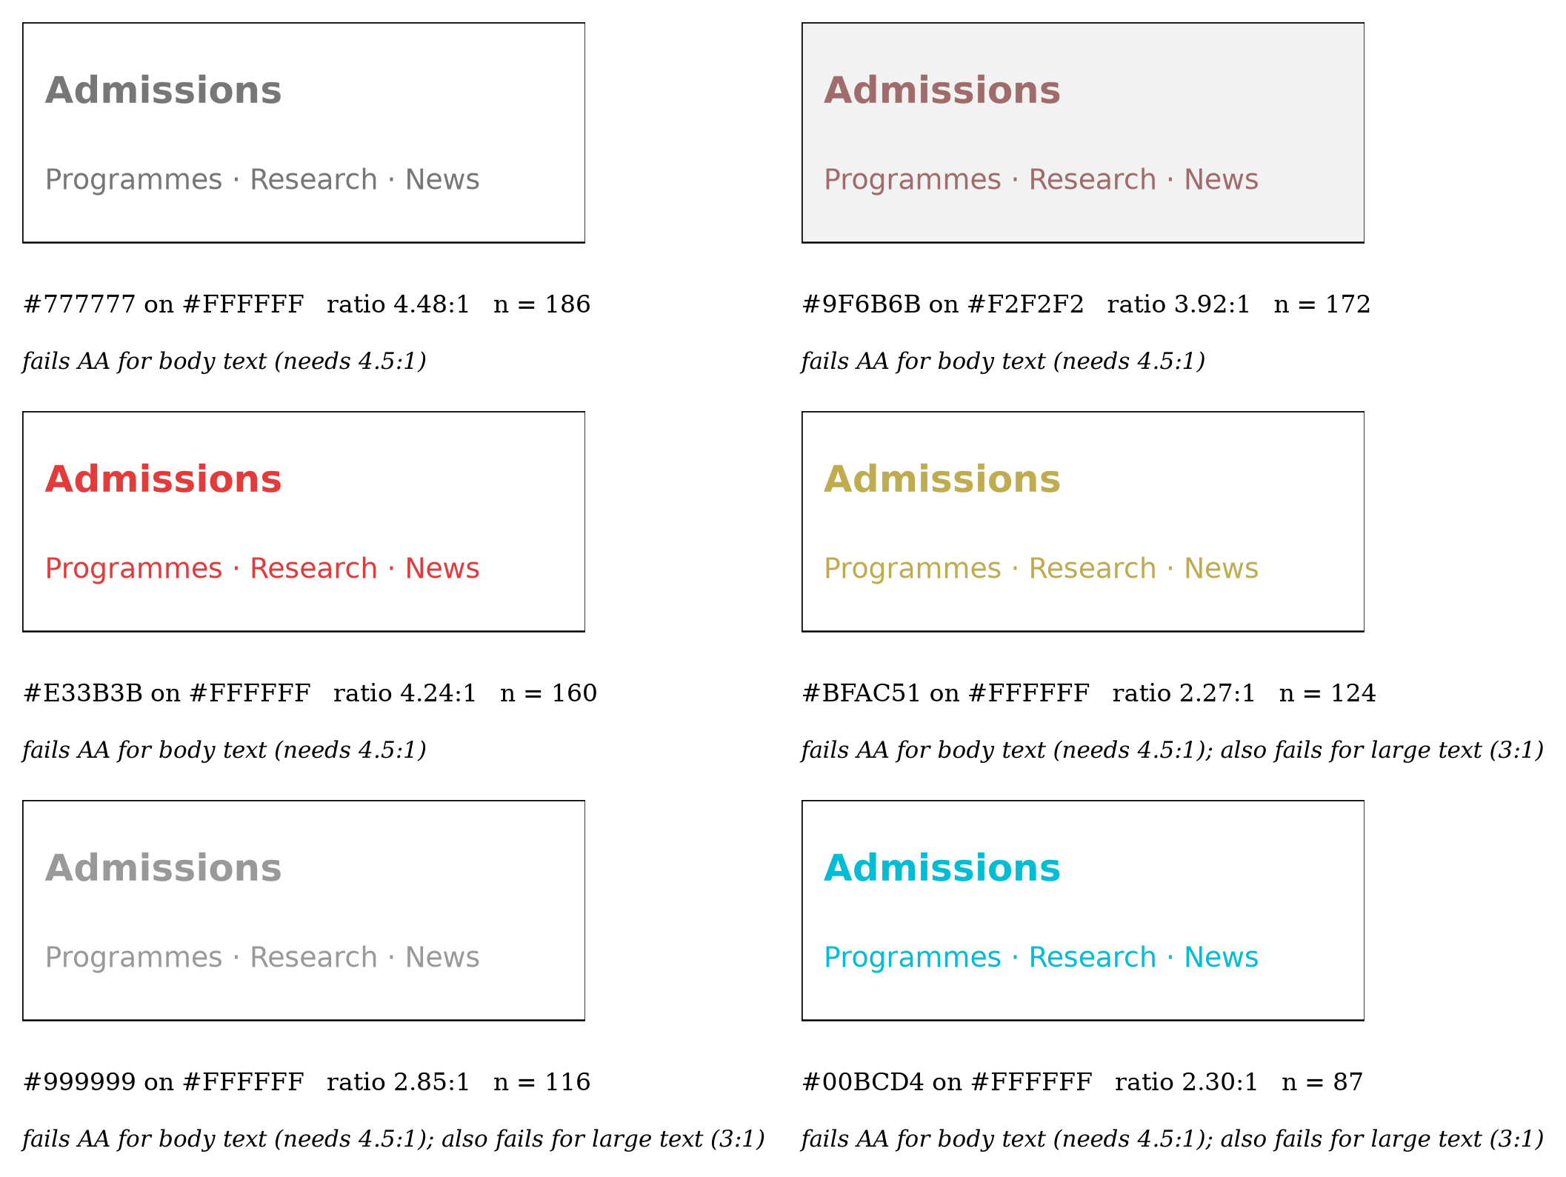
Figure 4. The six most frequent failing text/background pairs in Table 3 that contain visible text (white-on-white and white-on-light-grey pairs omitted), rendered with the measured colours. Each panel gives the colours, the median WCAG contrast ratio, and the number of occurrences; the specimen text is illustrative and no institution is identified. Grey-on-white pairs (left column, top and bottom) and saturated colours used directly as text (red, olive, cyan) both appear among the most frequent failures.
A note on the WCAG contrast formula itself, relevant to interpreting the residual variance our models leave unexplained: WCAG’s ratio is based on relative luminance, not on a perceptually uniform distance measure. Two pairs with identical WCAG ratios can differ substantially in perceived contrast, which is part of why our CIELAB-space clustering was necessary in the first place: the WCAG ratio alone cannot distinguish the qualitatively different failure patterns we report.

6 Limitations
This study has several limitations. First, we crawled homepages only, not full sites; a homepage that passes may sit atop a site with far worse compliance on interior pages (or vice versa). Second, we measured only colour contrast, which is one of many WCAG success criteria; a chromatically compliant site can still be inaccessible on other dimensions (keyboard navigation, alt text, semantic structure). We also measured only the static rendered state of each page, so the interaction-state part of our initial hypothesis (hover, focus, and visited colours) was not tested. Third, the crawl captures a single point in time (August 2026); institutional websites are redesigned periodically, so these figures are not stable indefinitely. Fourth, Bolivia and Venezuela were excluded by a country-name mismatch in our sampling filter (the source lists them under their official names), so the 17-country sample does not cover every country in the region; we did not re-crawl them afterwards because a later crawl would not be comparable with the August 2026 snapshot. Fifth, and most consequential for how the country results should be read: colour pairs are clustered within sites (a single homepage contributes many pairs sharing one design system), so the pair-level $χ^{2}$ and logistic-regression tests overstate independent sample size and their $p$-values are optimistic; the site-level check we report alongside them (255 sites, $p=0.086$) is not significant, so we treat the country pattern as suggestive rather than confirmed and do not rely on individual per-country coefficients. Sixth, we used country as a proxy for institution type because a reliable public/private classification was not available across the source dataset; a finer-grained institutional variable, or a larger site-level sample powered to detect a modest effect, might resolve the country question more conclusively than either test here does. Seventh, our background-colour resolution walks the DOM ancestor chain for a non-transparent background-color and does not inspect background-image; a text element rendered over a photographic or gradient background resolves, incorrectly, against whatever solid colour sits further up the ancestor chain (typically page white). This is a plausible contributor to the single most frequent failing pair in our data (white text on a white background, 2,379 occurrences): at least part of that count is likely mislabelled text-over-image rather than genuinely invisible text, and we cannot currently distinguish the two cases from the extracted data alone. To bound how much this concern could be inflating our headline figures, we recomputed both under the most conservative reading, treating every single one of the 2,379 white-on-white pairs as an artefact and excluding them entirely: the pair-level failure rate drops from 21.6% to 16.8%, and the site-level share with at least one critical failure drops from 93.4% to 90.7% (only 7 of 259 sites, 2.7%, have white-on-white as their only recorded failure). Since at least some of these 2,379 pairs are surely genuine invisible-text bugs rather than background-image artefacts, this exclusion is an upper bound on the artefact’s impact, not a corrected estimate; even so, both headline figures remain qualitatively unchanged. This also means our comparison to WebAIM’s global figure (Results) uses a different detection instrument on a different population and should be read as an order-of-magnitude reference, not a controlled comparison. Finally, the moderate correlation with axe-core reflects genuine methodological differences between contrast-ratio counting and axe-core’s rule engine rather than a validity problem with either approach, but it means the two should be read as complementary rather than interchangeable estimates.

7 Conclusion
A homepage-level survey of 259 Latin American university websites finds that WCAG AA contrast failures are the norm rather than the exception (93.4% of sites affected, 21.6% of all measured pairs); a country effect is visible at the pair level but is not confirmed once the actual unit of analysis (site) and the clustering of pairs within a site are accounted for, and we report it as an open question rather than a settled result. The colours involved in these failures are consistent with our initial hypothesis: unsupervised clustering in the full CIELAB $L^{*}a^{*}b^{*}$ space shows that near-neutral, low-chroma “light grey on white” patterns account for 80.0% of failing pairs, with four smaller chromatic clusters making up the remainder. This suggests that accessibility guidance for this region can prioritise the low-contrast neutral-text pattern as the primary target, while treating brand-palette contrast checking as a secondary recommendation for the smaller residual of saturated-colour failures.

Data Availability
The domain list, crawl logs, extracted colour pairs, and analysis code are permanently archived in a public repository with a persistent DOI. The identifier and repository URL are withheld during double-blind review and will be added upon acceptance.

Funding
This research received no specific grant from any funding agency in the public, commercial, or not-for-profit sectors.

Conflict of Interest
The authors declare that they have no conflict of interest.

Use of Generative AI
The authors used generative AI tools (large language models) as an assistant for language editing, support in writing and debugging analysis code, and LaTeX formatting. The research questions, study design, data collection, execution of the analyses, results, and their interpretation are the authors’ own work; all AI-assisted output was reviewed and verified by the authors, who take full responsibility for the content of this article. No figure was produced with image-generation tools.

Author Contributions
Author contribution statements omitted for double-blind peer review.

References
Acosta-Vargas, P., Acosta, T. & Lujan-Mora, S. (2018), ‘Challenges to assess accessibility in higher education websites: A comparative study of Latin America universities’, IEEE Access 6, 36500–36508. https://doi.org/10.1109/ACCESS.2018.2848978.
Acosta-Vargas, P., González, M. & Luján-Mora, S. (2020), ‘Dataset for evaluating the accessibility of the websites of selected Latin American universities’, Data in Brief 28, 105013. https://doi.org/10.1016/j.dib.2019.105013.
Acosta-Vargas, P., Salvador-Acosta, B., Salvador-Ullauri, L. & Jadán-Guerrero, J. (2022), ‘Accessibility challenges of e-commerce websites’, PeerJ Computer Science 8, e891. https://doi.org/10.7717/peerj-cs.891.
Acosta-Vargas, P., Salvador-Ullauri, A. & Lujan-Mora, S. (2019), ‘A heuristic method to evaluate web accessibility for users with low vision’, IEEE Access 7, 125634–125648. https://doi.org/10.1109/ACCESS.2019.2939068.
Acosta-Vargas, P., Zarate-Estrella, I., Salvador-Ullauri, L., Jadán-Guerrero, J., Guevara, C. & Lara-Alvarez, P. (2021), ‘Towards accessibility and inclusion of native mobile applications available for Ecuador in Google Play Store’, Sustainability 13(20), 11237. https://doi.org/10.3390/su132011237.
Henry, S. L., Abou-Zahra, S. & Brewer, J. (2014), The role of accessibility in a universal Web, in ‘Proceedings of the 11th Web for All Conference (W4A ’14)’. https://doi.org/10.1145/2596695.2596719.
International Commission on Illumination (CIE) (2007), Colorimetry – part 4: CIE 1976 L*a*b* colour space, Technical Report CIE S 014-4/E:2007 (ISO 11664-4:2008), CIE.
https://cie.co.at/publications/colorimetry-part-4-cie-1976-lab-colour-space-0
Jović, A., Žiljak Stanimirović, I., Mikota, M. & Mandić, L. (2026), ‘Design recommendations and future prospects for text legibility in augmented reality’, Journal of Graphic Engineering and Design 17(3), 19–34. https://doi.org/10.24867/JGED-2026-3-019.
Ofosu-Asare, Y. (2024), ‘Enhancing user experience in online learning environments: Design, evaluation, and usability techniques’, Journal of Graphic Engineering and Design 15(4), 45–59. https://doi.org/10.24867/JGED-2024-4-045.
Punsongserm, R. & Suvakunta, P. (2025), ‘Enhancing accessibility of Thai government mobile applications through effective use of typefaces, type sizes, and colour contrast: A technical review’, Journal of Graphic Engineering and Design 16(1). https://doi.org/10.24867/JGED-2025-1-017.
Rello, L. & Baeza-Yates, R. (2013), Good fonts for dyslexia, in ‘Proceedings of the 15th International ACM SIGACCESS Conference on Computers and Accessibility (ASSETS ’13)’, pp. 14:1–14:8. https://doi.org/10.1145/2513383.2513447.
Saad, A. E.-R., Aydemir, C., Özsoy, S. A. & Yenidoǧan, S. (2021), ‘Drying methods of the printing inks’, Journal of Graphic Engineering and Design 12(2), 29–37. https://doi.org/10.24867/JGED-2021-2-029.
WebAIM (2026), ‘The WebAIM million: The 2026 report on the accessibility of the top 1,000,000 home pages’. Accessed: August 20, 2026.
https://webaim.org/projects/million/
Weingerl, P., Nedeljković, U. & Pušnik, N. (2022), ‘Visibility and legibility of five-letter words in different experimental conditions’, Journal of Graphic Engineering and Design 13(3), 51–58. https://doi.org/10.24867/JGED-2022-3-051.
World Wide Web Consortium (W3C) (2023), Web content accessibility guidelines (WCAG) 2.2, Technical report, W3C. W3C Recommendation, 5 October 2023. Available: https://www.w3.org/TR/WCAG22/.

